MyCaster
The quick and simple weather Forecast

Subject Code: MAP524
Assignment #2
Professor: John Selmys
Due Date: April 13, 2015
Date Submitted: April 13, 2015
Student Name: Joel Aro
Seneca Id: 038 040 127
Executive Summary
MyCaster is an Android application that provides up-to-date weather information for Canadian cities. The data used by this application is available to the public, and is provided by the Government of Canada. This data is a compilation of information sent from weather stations around the country, and contains data for all major cities. Once the application is initialized, it will download the dataset from the Government of Canada's Open Source website using the Android device's WiFi or mobile data. Once a copy of the dataset has been made on the device, MyCaster will begin parsing the information to be displayed on screen.

This report will outline MyCaster final features, screenshots of the application, and final thoughts on MyCaster.

MyCaster Description
My application was meant to be fast, easy to use, and informative. The reason for it being developed on the Android platform was because the mobile market is huge, and most people living in North America own and constantly use their mobile device. Based on recent surveys, and online information, Android also is now the leading mobile platform. More than 50% of people living in North America own a phone that has Android capabilities.

MyCaster was meant for people who were always on the move: students, construction workers, offices, teachers, etc. When people want weather information they look for certain things such as the temperature, precipitation, wind speeds, etc. These details are how they decide the clothes they will wear and the accessories they will need to bring with them to get through the day.

When MyCaster is started, it will beginning downloading a file called siteList.xml from the dataset, and place it in a new folder on the user's sdcard called dataset. This file contains information related to cities, such as their code, name in english, name in french, and their province code. Once downloaded the user will be prompted to enter the nearest city to them that they want weather information for. Once selected, MyCaster will create a file called user_config in the dataset folder. This file contains the selected cities information, and is meant to be used for later features such as remembering the user's location. The application will also begin downloading the weather information. The city that the user selected also contains a city code that the Government of Canada uses to identify each city. Using that code, MyCaster will fetch that weather xml file for that city only. For example the data link for Toronto is http://dd.weather.gc.ca/citypage_weather/xml/ON/s0000458_e.xml.
The code in bold is the city code.

Once everything is setup, the data is ready to be displayed. MyCaster splits the information into 4 activities: Day View, Weekly View, Almanac, and the Sunrise/Sunset information. Navigating through these screens is as simple as sliding your finger as if you were turning a page. At the top of each activity is the current time and the time of the last updated, along with how long ago that was.

The first screen after the initial setup is complete is the Day View. This view displays weather information for the current day. In the center of the screen it shows a graphical display of the weather. This graphical display contains 17 different weather icons that I modified using Photoshop to accurately represent the weather.
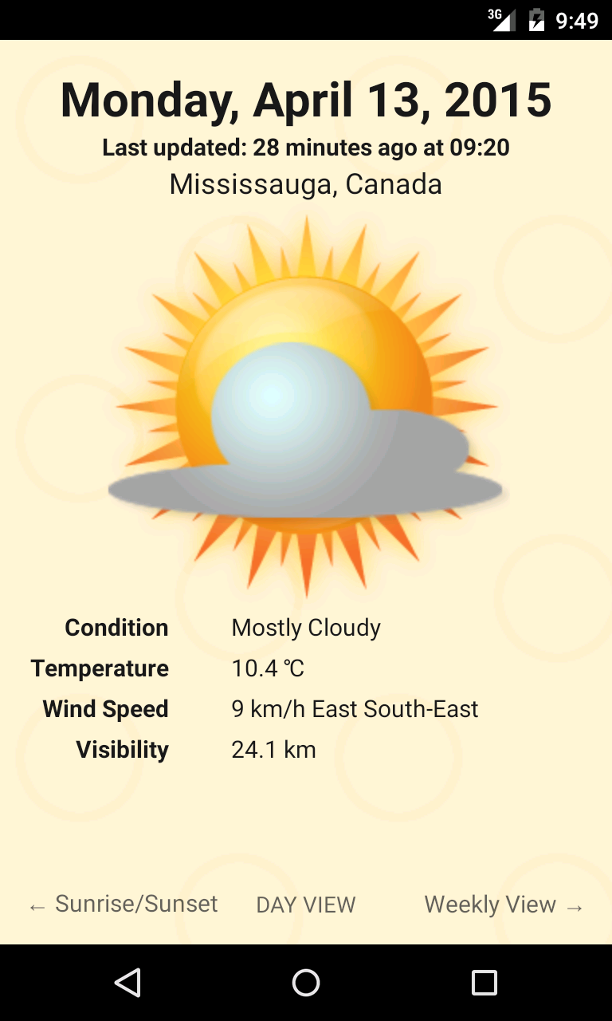Figure 1: Day View screen. Large graphical display in the center, with specific weather information underneath
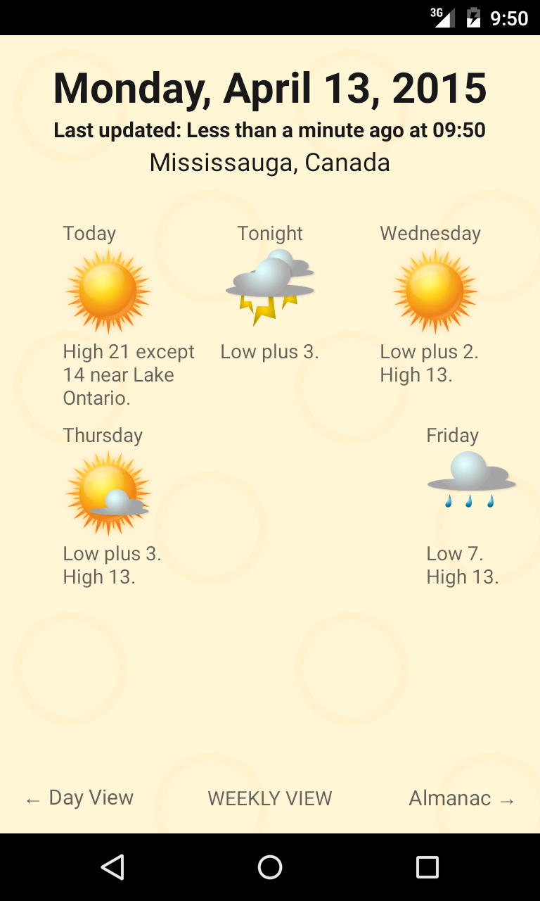Figure 2: Weekly View screen. 5 separate sections each with their own graphical display and information

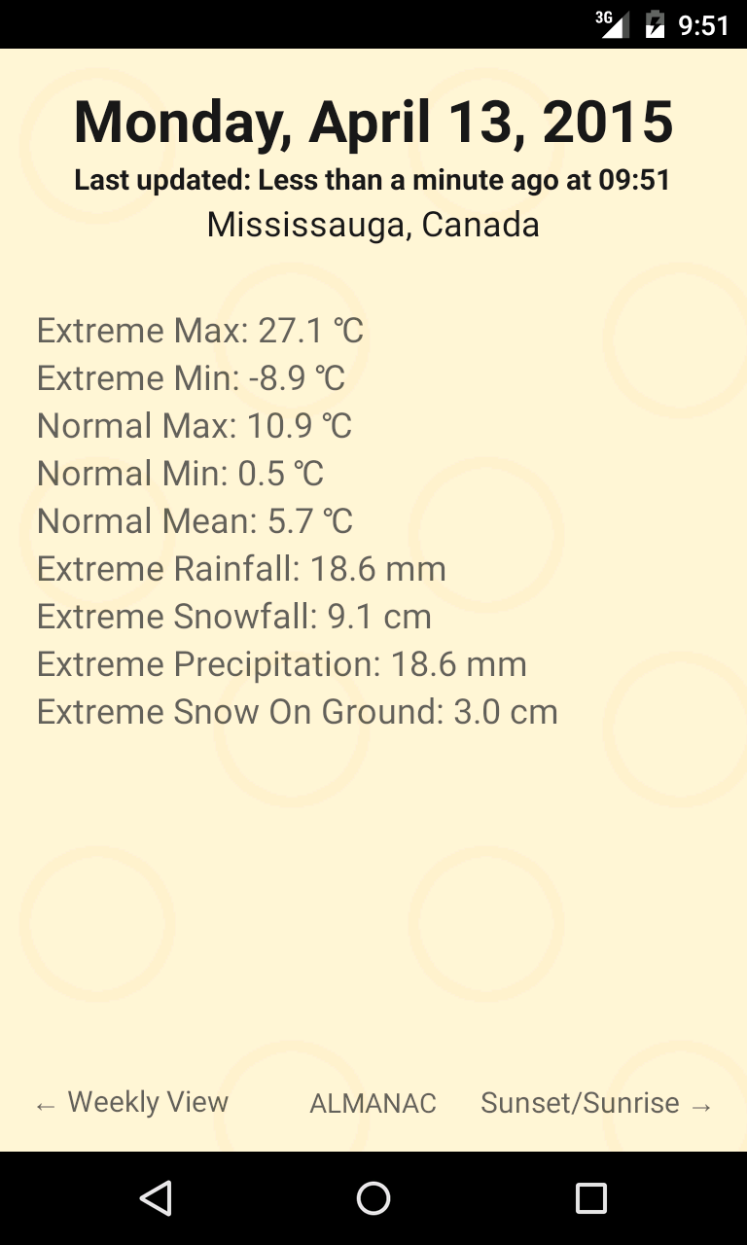Figure 3: Almanac screen. Displays different weather records for each city
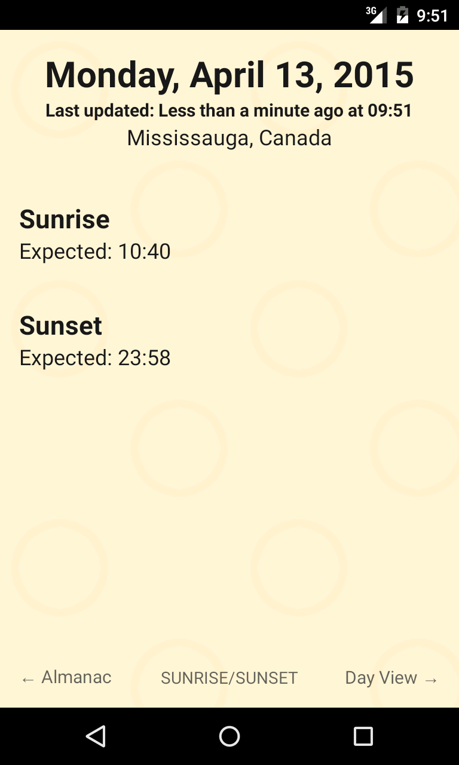Figure 4: Sunrise/Sunset screen. Displays the expected sunrise and sunset for the day

Next is the Weekly View screen. This displays the weather forecast for the next few days. Data is here is meant to be condensed so that the user has access to a lot of information.

The next view is the Almanac. The dataset provides useful information regarding weather records. There is a record for hottest temperature, coldest temperature, average temperature, most rainfall, most snowfall, most snow on the ground, etc. Unfortunately, most cities do not have this information so this screen will not show any data.

The last view is the Sunrise/Sunset information. This view is supposed to show the approximate sunrise time and the approximate sunset time, and also show when it occurred if the event already happened.

List of Features
- Able to choose which city you want to receive weather information for
- Downloads dataset to local storage
- Displays date and time, and time of last update at the top of every screen
- Graphic displays on Day View and Weekly View screens
  - There are 17 custom weather images located in the drawable folder
- Gestures (swiping left and right will switch screens)
- Forecast for current day
- 5 day forecast
- Records for the city(ex. Highest snow on ground)
- Sunrise and sunset estimator

Features Not Implemented
- Settings
  - I setup everything needed for the settings menu, but due to time constraints could not implement it in time.
- Detailed Day View screen
  - Was having trouble parsing the Almanac details and ended up not doing the detailed view. Fixing the XMLHandler was taking a really long time (almost 2 days!) and adding any more to it might break the application, so I decided not to add the detailed view.
- Sunrise Sunset Estimator converted to current timezone
  - Not enough time to implement, after a few tries I decided it was not as important as getting the Almanac implemented.
- Sunrise Sunset Occurrence
  - The dataset ended up not having data for this.

Features Added After Proposal
- Gestures
  - I wanted a quick application that was easy to navigate, and since it was only 4 screens I decided on using the Android's touch screen
- Selecting city
  - The dataset consisted of most of the Canadian cities, so I wanted to have them also available, instead of just keeping the data in Toronto.

Features I Would Add if I Had More Time
- Remembering last city
- Not downloading files if they already exist on the local storage
- Detailed View
- Use of the GPS system to automatically get current location and provide weather information for it
- Comments section. Might be fun talking to other people about the weather
- Menu icon
- A navigation bar at the bottom. Users can swipe or use the navigation bar

Overall Impression of The Application
MyCaster is an okay application. In the end, it is not as great as the top weather application in the Google Play Store, but it gets the job done. If you are looking for something simple and fast, but not as informative then this is the choice. Developing MyCaster definitely helped me understand more about Android development, and Programming in general. Trying to understand how parsing, databases, gestures, and multi-threading worked was a rewarding experience. I also would have added a lot more if I fixed the issue with the Almanac faster. I may try and update it later in the future, once I have free time.

If I do end up working on it, you can follow development on it here: https://github.com/pk400.

