**Data Structure**

**Data Structure**

* A data structure is a storage that is used to to store and organize data.
* It is a way of arranging data on a computer so that iit can be accessed and updated efficiently.
* A data structure is not only used for organizing the data it is also used for processing retrieving and storing data.

**Classificaton of Data Structure**

There are two type of data structure.

1. Linear data structure

1.1 Static Data Structure

1.1.1 Array

1.2 Dynamic Data Structure

1.2.1 Queue

1.2.2 Stack

1.2.3 Linked List

2. Non Linear Data Structue

2.1 Tree

2.2 Graph

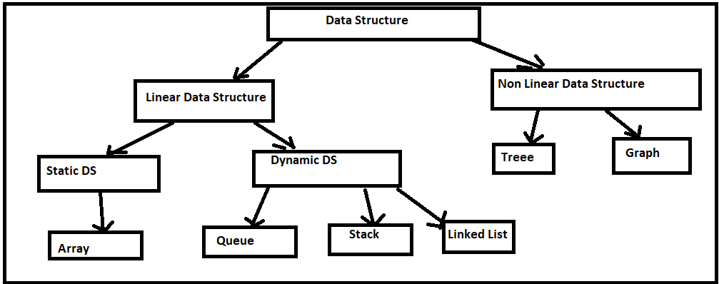

**Linear Data Structure**

* Data Structure in which data elements are arranged sequentially or linearly, where each elements is attached to its previous and next adjucent elements is called a linear data structure.

**Example**=> Array, Stack, Queue, Linked List etc.

**Static Data Structure**

* Static data structure has a fixed memory size. It is easier to access the elements in a static data structure.

**Example**=> Array

**Dynamic Data Structure**

* In dynamic data structure the size is not defined. It can be randomly updated during the runtime which may be considered efficient concerning the memory(space) complexity of the code.

**Example**=> Queue, Stack, Linked List

**Non Linear Data Structure**

* Data Structure where data elements are not placed sequentially are called Non-Linear Data Structure. We can't traverse all the elements in a single run only.

**Example**=> Tree and Graph

**LINKED LIST**

A Linked List is a**linear data structure** which looks like a chain of nodes, where each node is a different element. Unlike Arrays, Linked List elements are not stored at a contiguous location.

**Why linked list data structure needed?**

Here are a few advantages of a linked list that is listed below, it will help you understand why it is necessary to know.

* **Dynamic Data structure:** The size of memory can be allocated or de-allocated at run time based on the operation insertion or deletion.
* **Ease of Insertion/Deletion:** The insertion and deletion of elements are simpler than arrays since no elements need to be shifted after insertion and deletion, Just the address needed to be updated.
* **Efficient Memory Utilization:**As we know Linked List is a dynamic data structure the size increases or decreases as per the requirement so this avoids the wastage of memory.
* **Implementation:**Various advanced data structures can be implemented using a linked list like a stack, queue, graph, hash maps, etc.

**There are three type of linked list**

* Singly Linked List
* Doubly Linked List
* Circular Linked List

**Singly Linked List**

A **singly linked list** is a linear data structure in which the elements are not stored in contiguous memory locations and each element is connected only to its next element using a pointer.

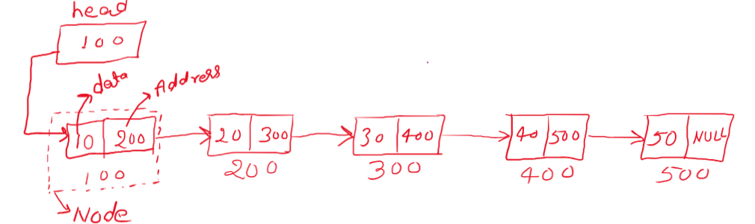

**How to create list**

**Node Structure**

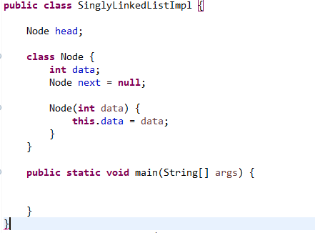

**Insertion of the Singly Linked List**

* At the front of the linked list
* After a given node.
* At the end of the linked list

## [How to Insert a Node at the Front/Beginning of Linked List](https://www.geeksforgeeks.org/insert-a-node-at-front-beginning-of-a-linked-list/)

* Make the first node of Linked List linked to the new node
* Remove the head from the original first node of Linked List
* Make the new node as the Head of the L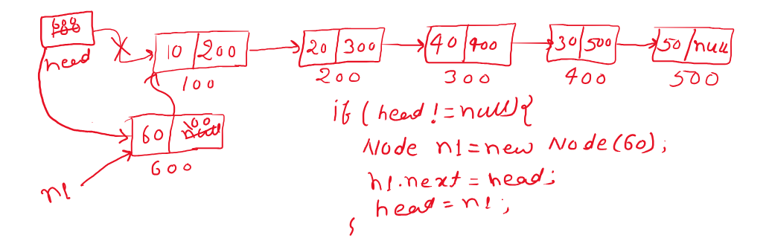inked List.

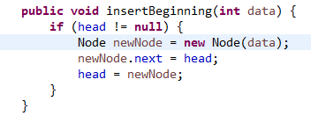

**Complexity Analysis:**

* **Time Complexity:** O(1), We have a pointer to the head and we can directly attach a node and change the pointer. So the Time complexity of inserting a node at the head position is O(1) as it does a constant amount of work.
* **Auxiliary Space:**O(1)

## How to Insert a Node Between of the List

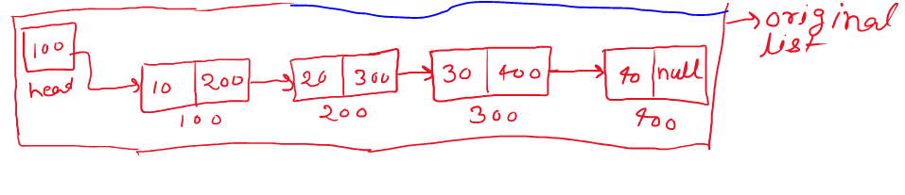In this list need to add new node between of the list

* create the current node from head.
* Do the while loop based on current node. If while loop iteration is equal of position the break the while loop
* Assign current into current of next node.
* Create the new node
* Current.next address assign into the new node of next.
* Assign new node address into the current.next

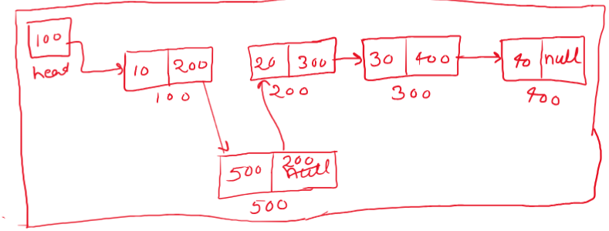

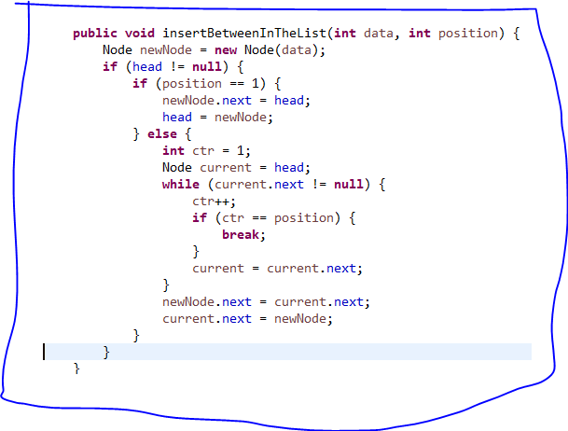

[How to Insert a Node at the End of Linked List](https://www.geeksforgeeks.org/insert-node-at-the-end-of-a-linked-list/)

**Approach:**

To insert a node at the end of a Linked List, we need to:

* Go to the last node of the Linked List
* Change the next pointer of last node from NULL to the new node
* Make the next pointer of new node as NULL to show the end of Linked List

After insertion of new node in the last of the list

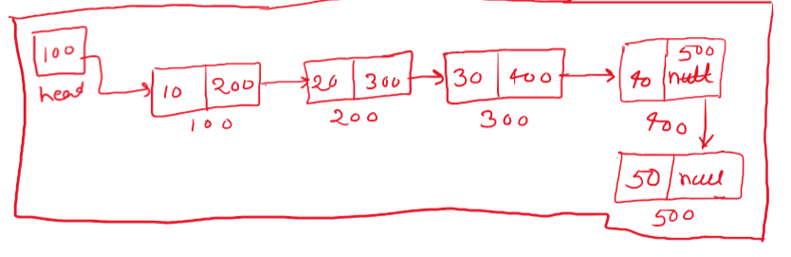

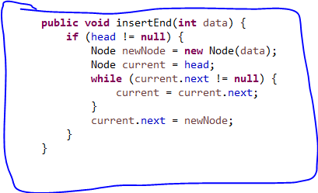

**Full Code of Linked List Operation**

**public** **class** **SinglyLinkedListImpl** {

Node head;

**class** Node {

**int** data;

Node next = **null**;

Node(**int** data) {

**this**.data = data;

}

}

**public void createList**(**int** data) {

Node newNode = **new** Node(data);

**if** (head == **null**) {

head = newNode;

} **else** {

Node current = head;

**while** (current.next != **null**) {

current = current.next;

}

current.next = newNode;

}

}

**public** **void** **displayList**() {

**if** (head != **null**) {

Node current = head;

**while** (current != **null**) {

System.***out***.print(current.data + " ");

current = current.next;

}

System.***out***.println();

}

}

**public** **void** **insertBeginning**(**int** data) {

**if** (head != **null**) {

Node newNode = **new** Node(data);

newNode.next = head;

head = newNode;

}

}

**public** **void** **insertEnd**(**int** data) {

**if** (head != **null**) {

Node newNode = **new** Node(data);

Node current = head;

**while** (current.next != **null**) {

current = current.next;

}

current.next = newNode;

}

}

**public** **void** **insertBetweenInTheList**(**int** data, **int** position) {

Node newNode = **new** Node(data);

**if** (head != **null**) {

**if** (position == 1) {

newNode.next = head;

head = newNode;

} **else** {

**int** ctr = 1;

Node current = head;

**while** (current.next != **null**) {

ctr++;

**if** (ctr == position) {

**break**;

}

current = current.next;

}

newNode.next = current.next;

current.next = newNode;

}

}

}

**public** **void** **reverseList**() {

Node prev = **null**;

Node current = head;

Node next = **null**;

**while** (current != **null**) {

next = current.next;

current.next = prev;

prev = current;

current = next;

}

**if**(prev != **null**) {

head = prev;

}

displayList();

}

**public** **static** **void** main(String[] args) {

SinglyLinkedListImpl list = **new** SinglyLinkedListImpl();

**for** (**int** i = 1; i <= 10; i++) {

list.createList(i);

}

list.displayList();

System.***out***.println("insert beginning of the list");

list.insertBeginning(1 );

list.displayList();

System.***out***.println("insert end of the list");

list.insertEnd(12);

list.displayList();

System.***out***.println("insert between of the list");

list.insertBetweenInTheList(13, 1);

list.displayList();

System.***out***.println("reverse of the list");

list.reverseList();

}

}

**DOUBLY LINKED LIST**

**What is Doubly Linked List?**

A **doubly linked list** (DLL) is a special type of linked list in which each node contains a pointer to the previous node as well as the next node of the linked list.

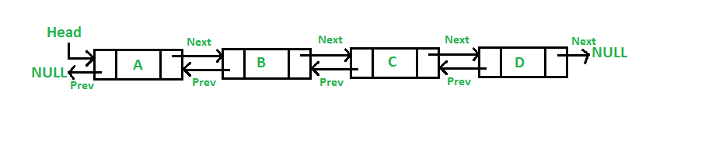

**Doubly Linked List Node Structure**

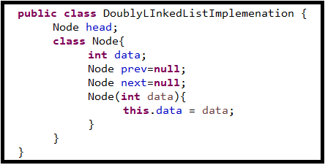

## ****Advantages of Doubly Linked List over the singly linked list:****

* A DLL can be traversed in both forward and backward directions.
* The delete operation in DLL is more efficient if a pointer to the node to be deleted is given.
* We can quickly insert a new node before a given node.
* In a singly linked list, to delete a node, a pointer to the previous node is needed. To get this previous node, sometimes the list is traversed. In DLL, we can get the previous node using the previous pointer.

## ****Disadvantages of Doubly Linked List over the singly linked list:****

* Every node of DLL Requires extra space for a previous pointer.
* All operations require an extra pointer previous to be maintained. For example, in insertion, we need to modify previous pointers together with the next pointers. For example in the following functions for insertions at different positions, we need 1 or 2 extra steps to set the previous pointer.

## Applications of Doubly Linked List:

* It is used by web browsers for backward and forward navigation of web pages
* LRU ( Least Recently Used ) / MRU ( Most Recently Used ) Cache are constructed using Doubly Linked Lists.
* Used by various applications to maintain undo and redo functionalities.
* In Operating Systems, a doubly linked list is maintained by thread scheduler to keep track of processes that are being executed at that time.

**Creation of Doubly Linked List**

* Allocate the new node.
* If head is null then assign new node address to head.
* If head is not null then take the current node and assign the head address.
* Iterate current node till last node until current of next is null.
* Assign the address of new node in side current of next node.
* Assign current address inside the new node of prev.

**public** **void** createDoublyList(**int** data) {

Node newNode = **new** Node(data);

**if**(head == **null**) {

head = newNode;

}**else** {

Node current = head;

**while**(current.next != **null**) {

current = current.next;

}

current.next=newNode;

newNode.prev = current;

}

}

**Insertion of the Doubly Linked List**

* Insert beginning of the Doubly Linked List.
* Insert last of the Doubly Linked List.
* Insert between of the Doubly Linked List.

**Insert beginning of the Doubly Linked List**

* Create the new node and assign the data.
* Check if head is null or not.
* If head is null the assign new node address into the head.
* If head is not null then assign head address into the new node of the next.
* Assign new node address into the head of the prev.
* 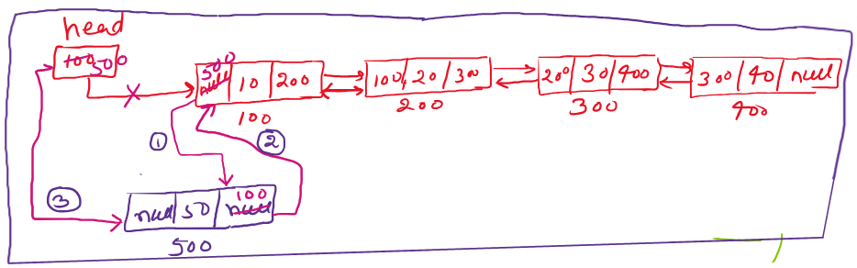Assign new node addres into the head.

**public** **void** insertBeginningOfTheDoublyList(**int** data) {

Node newNode = **new** Node(data);

**if**(head == **null**) {

head = newNode;

}**else** {

newNode.next = head;

head.prev = newNode;

head = newNode;

}

}

**Insert last of the Doubly Linked List**

* Create the new node and assign the data.
* Check if head is null or not.
* If head is null the assign new node address into the head.
* If head is not null the take the current node and assign the head address.
* Iterate the current node until current node of the next is null.
* Assign the new node address into the current node of the next,
* 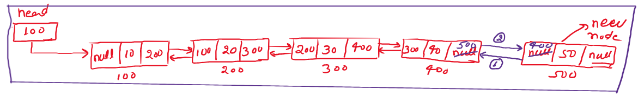Assign the current node address into the new node of the prev.

**public** **void** insertLastOfTheDoublyList(**int** data) {

Node newNode = **new** Node(data);

**if**(head == **null**) {

head = newNode;

}**else** {

Node current = head;

**while**(current.next != **null**) {

current = current.next;

}

current.next = newNode;

newNode.prev = current;

}

}

**Insert between of the Doubly Linked List**

* Create the new node and assign the data.
* Take the position where you want to insert the new node.
* Take the counter variable and assign the default value one.
* Take the current node and assign the head address.
* Iterate the current node until last node of next is null.
* Then check if counter value is equal to the position.
* If counter value is not equal to the position then increment the counter and assign current of next address into the current.
* If counter value is equal of position then break the loop.
* Then assign the current node of next address into the new node of next.
* Assign the new node address into the current node of next of prev.
* Assign current node address into the new node of prev.
* 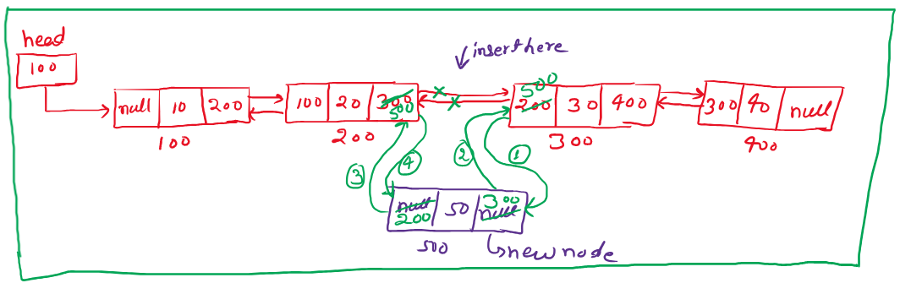Assign new node address into the current node of the next.

**public** **void** insertBetweenOfTheList(**int** data, **int** pos) {

Node newNode = **new** Node(data);

**int** ctr=1;

Node current = head;

**while**(current.next != **null**) {

**if**(ctr == pos) {

**break**;

}

ctr++;

current = current.next;

}

newNode.next = current.next;

current.next.prev = newNode;

newNode.prev = current;

current.next = newNode;

}