**BANKING SYSTEM**

A MINI PROJECT REPORT SUBMITTED IN PARTIAL FULFILLMENT OF THE

REQUIREMENTS FOR THE AWARD OF DEGREE OF

BACHELOR OF ENGINEERING

IN

INFORMATION TECHNOLOGY

BY

V. VINEELA REDDY (1602-14-737-119)

KADALI PRATHYUSHA(1602-14-737-094)



# Department of Information Technology

**VASAVI COLLEGE OF**

**ENGINEERING** (Autonomous)

IBRAHIMBAGH, HYDERABAD – 500031.

2015

# CERTIFICATE

This is to certify that the project work BANKING SYSTEM was carried out by V. Vineela Reddy(1602-14-737-119) and K. Prathyusha(1602-14-737-094) in partial fulfillment of the requirement for the award of Bachelor of Engineering (B.E) in Information Technology by Osmania University during the period 2015-2016 under our guidance.

The results embodied in this project have not been submitted to any other University or Institution for the award of any degree or diploma.

**Internal Guide HOD, Dept. of IT**

**External Examiner**

**ACKNOWLEDGEMENT**

We are greatly indebted to our college, Vasavi College of Engineering, which has provided us the healthy environment to drive us to achieve our ambitions and goals.

We express deep gratitude towards our Principal Dr. K. V. Ramana Murthy and the Head of the Department (HOD) of Information Technology, Dr. N. Vasantha for their valuable suggestions and encouragement during the course of the work. We would like to thank our Internal Guide, Miss. Swapna for her guidance, comments and encouragement during the course of present work.

We owe our hearty regards to all other Professors and staff for their encouragement at each step and their assistance in completion of the project work. Last but not the least; we would like to thank our friends for their co-operation and consistent support.

-Vineela Reddy. Vitta

(1602-14-737-119)

Prathyusha. Kadali

(1602-14-737-094)

**ABSTRACT**

**BANKING SYSTEM**

Getting a loan in our country is a very tiring and complicated process. The main problem is it may take weeks even months for loans to get approved and people have to visit the loan office again and again for document and verification. Here our proposed project automates the loan process from both bankers and account holders side. Here account holders can see various loans provided along with rate of interest and required documents. Here once the customer fills basic enquiry forms. The bank may now cross verify customer details and also request extra documents by sending online alerts to customer email. So that the bank will provide the details to the customer the certificates and forms to submit.

Even we are providing security for the customers for their login and transactions. Bankers can also know the details of all the customers which we storing in a file.

**-K. Prathyusha**

**(1602-14-737-094)**

**V. Vineela Reddy**

**(1602-14-737-119)**

**CONTENTS**

1. INTRODUCTION 5

1.1 GENERAL OVERVIEW OF THE PROBLEM 7

1.2 PROBLEM DEFINITION 8

1.3 OBJECTIVE OF THE SYSTEM 9

1.4 ANALYSIS OF THE PROBLEM 9

1.5 THE PROPOSED SOLUTION STRATEGY 10

1.6 PROJECT BENEFICIARIES 10

2. IMPLEMENTATION 11

2.1 ALGORITHM 12

2.2 SOFTWARE'S USED IN DETAIL 15

3. D F D DIAGRAMS 18

4. RESULTS 23

5. ADVANTAGES AND DISADVANTAGES OF THE PROJECT 32

5.1 ADVANTAGES 32

5.2 DISADVANTAGES 36

6. CONCLUSION AND FUTURE SCOPE 37

6.1 CONCLUSION 38

6.2 FUTURE SCOPE 39

7. BIBLIOGRAPHY 40

**1.INTRODUCTION**

**INTRODUCTION TO BANKING SYSTEM**

“A **bank** is a financial intermediary  that accepts deposits and channels those deposits into lending activities, either directly or through capital markets ”.

A bank connects customers with capital deficits to customers with capital. Deposits initially consisted of grain and later other goods including cattle, agricultural implements, and eventually precious metals such as gold, in the form of easy-to-carry compressed plates.

1."banking" means the business of receiving money on current or deposit account, paying and collecting cheques drawn by or paid in by customers, the making of advances to customers, and includes such other business .

2."banking business" means the business of either or both of the following:

1. receiving from the general public money on current, deposit, savings or other similar account repayable on demand or within less than [3 months] ... or with a period of call or notice of less than that period;

2.paying or collecting cheques drawn by or paid in by customers.

### Channels which provide banks make easy to use banking:

Banks offer many different channels to access their banking and other services:

1.ATM is a machine that dispenses cash and sometimes takes deposits without the need for a human bank teller.

2.A branch is a retail location.

3.Call center.

4.Mail: most banks accept check deposits via mail and use mail to communicate to their customers,

e. g. by sending out statements.

5.Mobile banking: is a method of using one's mobile phone to conduct banking transactions.

6.Online banking: is a term used for performing transactions, payments etc. over the Internet.

7.Relationship Managers: mostly for private banking or business banking, often visiting customers at their homes or businesses.

8.Telephone banking: is a service which allows its customers to perform transactions over the telephone without speaking to a human.

9.Video banking: is a term used for performing banking transactions or professional banking consultations via a remote video and audio connection.

**1.1 GENERAL OVERVIEW OF THE PROBLEM:**

A bank is a commercial or state institution that provides financial services, including issuing money in form of coins, banknotes or debit cards, receiving deposits of money, lending money and processing transactions. A commercial bank accepts deposits from customers and in turn makes loans based on those deposits. Some banks (called Banks of issue) issue bank notes as legal tender. Many banks offer ancillary financial service make additional profit; for example: selling insurance products, investment products or stock broking.

Currently in most jurisdictions commercial banks are regulated and require permission to operate. Operational authority is granted by bank regulatory authorities and provides right to conduct the most fundamental banking services such as accepting deposits and making loans. A commercial bank is usually defined as an institution that provides selected banking services without meeting the legal definition of bank.

Banks have a long history, and have influenced economy and politics for centuries. In history, the primary purpose of a bank was to provide liquidity to trading companies. Banks advanced funds to allow business to purchase inventory, and collected those funds back with interest when the goods are sold. For centuries, the banking industry only dealt with business not customers.

Commercial lending today is a very intense activity, with banks carefully analyzing the financial condition of its business clients to determine the level of risk in each loan transaction. Banking services have expanded to include services directed at individuals and risks in these much smaller transactions are pooled.

**1.2. PROBLEM DEFINATION:**

Although the basic type of services offered by a bank depends upon the type of bank and the country, services provided usually include:

• Taking deposits from their customers and issuing current or checking accounts savings accounts to individuals and business.

• Extending loans to individuals and business

• Cashing cheque

• Facilitating money transactions such as wire transfer and cashier’s cheque

• Consumer & commercial financial advisory services

Financial transactions can be performed through many different channels:

o A branch, banking centre or financial center is a retail location where a bank or financial institution offers a wide array of face to face services to customers.

O ATM is computerized telecommunications device that provides a financial institution’s customers a method of financial transactions in a public space without the need for a human clerk or bank teller

o Online banking is a term used for performing transactions ,payments etc, over internet through a bank, credit union or building society’s secure websites.

**We are mainly concerned with developing a banking system where a Customer can submit his/her deposit amount to bank if he/she has an account or can create a new account in this bank. Customer can also view the status of his/her bank account, can view account balance, can modify and delete it. One can easily maintain the above things if he/she has an account by login through a user name and password given to him.**

**1.3 OBJECTIVE OF THE SYSTEM:**

**To make our banking process easy by using our program, so that we can save our time a lot and even this process makes easier even from the bankers point of view too.**

**1.4 ANALYSIS OF THE PROBLEM:**

The project that we have undertaken aims to develop a banking system that is clean, user-friendly and multi- functional. Development of this application includes a number of fields such that user feels comfortable and the system appears as dynamic to him. The project “Banking System” includes the following functionalities:

• Transactions can be done with minimum user events.

• All transactional details and accounts are stored in files on stable storage

• Customers can view their own account details and can use them as necessary

• Customer can inquire an account and can inquire about interest

• All customer’s data are stored in files on a stable storage

• Account holders have to pass through a login system to enter their accounts

• This system possess password-protected administrative access; thus preventing

whole management system from unauthorized access

• Customer can get help in any time he/she wants

**1.5. THE PROPOSED SOLUTION STRATEGY:**

The application will be extremely beneficial for the Customers intending to use and operate their bank account and will get various benefits in the field of accounts on a clean and user-friendly platform.

•Complex Banking operations and Transaction operations are efficiently handled by the application

•It is cost effective

•It has ease of use along with complete reference

•It is highly secured and less time consuming; hence time wastage can be avoided

•Up to date records of the customers are maintained by the authority

**1.6. PROJECT BENEFICIARIES:**

"Banking System " keeps the day by day tally record as a complete banking. It can keep the information of Account type, account opening form, Deposit, Withdrawal, and Searching the transaction, Transaction report, Individual account opening form, Group Account, loan issues. The exciting part of this project is; it displays Transaction reports, Statistical Summary of Account type and Interest Information .

It becomes easy for the bank people to maintain the records of a account holder. It becomes even more easier for the account holder in a particular bank to check their transaction, money deposited, money withdraw, transaction report, lat login from their accounts.

In day to day life the life of a person is becoming very busy. Each and every second is a count down to them. Our project is to make easy to the particular account holder to check their details with in fraction of seconds instead going to a bank and checking the details.

For example, in our project we included loan issue system. Practically, for a loan details or for a loan issue a person need to visit bank many times once for to know the details of the loan, he/she is eligible for the loan, the rules of the loan, required certificates verification on the other day. Spending lot of time on a single loan matters a lot. So we have come up with an idea in the name of mini project based on banking management system to the solve the problem of time managing.

**2. IMPLEMENTATION**

**2.1 ALGORITHM:**

start

step 1: Create a class called node which can provide us an address slot and data slot to link the information

step 2: In class node we declare long int data types like ph_no, acc_num and bal

step 3: In this class node, declare the next class bank as its friend, so that bank can use its data

step 4: Create a class bank, we declare two pointers (first, p) of class node for dynamic allocation of memory

step 5: And we declare some data types which can be used by functions of this class

step 6: We declare a static variable count to count the customers in the bank

step 7: We declare some functions like login(),menu(),new_acc(),allP_det(),deposit(),withdrawl(),...etc

step 8: By using constructer of this class we make first=NULL

step 9: We will link the program in the following way using all functions of this class bank

step 10: Firstly in the login() we will ask user to opt like

1.Create a new Account

2.Existing account modify

3.Delete an account

4.Exit

step 11: And result is stored in ch, By using switch case

case 1: goto step 12

case 2: go to step 15

case 3: goto step

case 4:goto last stop

step 12: Create new_acc(), asks users details for name and mobile number and displays that persons details

step 13: Next it will ask user for his interest in loan details like 1.Loan Details, 2.Quit, and the option is stored in ch

step 14: If(ch==1) goto 23

else goto step 10

step 15: Create menu() function, goto step 24

step 16: In that function ask user for furthur details like

1. deposit

2. withdrawl

3. check_bal

4. Loan details

5. To display all details

6. To goto previous menu

7. New loan

8. exit and the option is stored in ch

step 17: In switch,

case 1: goto step 18

case 2: goto step 19

case 3:goto step 20

step 18: stop

**********************END OF ALGORITHM*************************

**2.2 SOFTWARE USED IN DETAIL**

SOFTWARE'S USED IN THIS PROJECT : **C++ and DATA STRUCTURES.**

**HISTORY AND FEATURES OF C++:**

[Bjarne Stroustrup](https://en.wikipedia.org/wiki/Bjarne_Stroustrup), the creator of C++

[Bjarne Stroustrup](https://en.wikipedia.org/wiki/Bjarne_Stroustrup), a Danish computer scientist, began his work on C++'s predecessor "C with [Classes](https://en.wikipedia.org/wiki/Class_(computer_programming))" in 1979. The motivation for creating a new language originated from Stroustrup's experience in programming for his Ph.D. thesis. Stroustrup found that [Simula](https://en.wikipedia.org/wiki/Simula) had features that were very helpful for large software development, but the language was too slow for practical use, while [BCPL](https://en.wikipedia.org/wiki/BCPL) was fast but too low-level to be suitable for large software development. When Stroustrup started working in [AT&T Bell Labs](https://en.wikipedia.org/wiki/AT%26T_Bell_Labs), he had the problem of analyzing the [UNIX](https://en.wikipedia.org/wiki/Unix) [kernel](https://en.wikipedia.org/wiki/Kernel_(computer_science)) with respect to [distributed computing](https://en.wikipedia.org/wiki/Distributed_computing). Remembering his Ph.D. experience, Stroustrup set out to enhance the [C](https://en.wikipedia.org/wiki/C_(programming_language))language with[Simula](https://en.wikipedia.org/wiki/Simula)-like features. C was chosen because it was general-purpose, fast, portable and widely used. As well as C and Simula's influences, other languages also influenced C++, including [ALGOL 68](https://en.wikipedia.org/wiki/ALGOL_68),[Ada](https://en.wikipedia.org/wiki/Ada_(programming_language)), [CLU](https://en.wikipedia.org/wiki/CLU_(programming_language)) and [ML](https://en.wikipedia.org/wiki/ML_(programming_language)).

Initially, the class, derived class, [strong typing](https://en.wikipedia.org/wiki/Strong_typing),[inlining](https://en.wikipedia.org/wiki/Inlining) and [default argument](https://en.wikipedia.org/wiki/Default_argument) features were added to C via Stroustrup's "C with Classes" to C compiler, Cpre.

In 1983, it was renamed from *C with Classes* to C++ ("++" being the [increment operator](https://en.wikipedia.org/wiki/Increment_operator) in C). New features were added including [virtual functions](https://en.wikipedia.org/wiki/Virtual_function), function name and [operator overloading](https://en.wikipedia.org/wiki/Operator_overloading), references, constants, type-safe free-store memory allocation (new/delete), improved type checking, and BCPL style single-line comments with two forward slashes (//), as well as the development of a proper compiler for C++, [Cfront](https://en.wikipedia.org/wiki/Cfront).

In 1985, the first edition of [*The C++ Programming Language*](https://en.wikipedia.org/wiki/The_C%2B%2B_Programming_Language) was released, which became the definitive reference for the language, as there was not yet an official standard. The first commercial implementation of C++ was released in October of the same year.

In 1989, C++ 2.0 was released, followed by the updated second edition of *The C++ Programming Language* in 1991. New features in 2.0 included multiple inheritance, abstract classes, static member functions, [const member functions](https://en.wikipedia.org/wiki/Const_correctness), and protected members. In 1990, *The Annotated C++ Reference Manual* was published. This work became the basis for the future standard. Later feature additions included [templates](https://en.wikipedia.org/wiki/Template_(programming)), [exceptions](https://en.wikipedia.org/wiki/Exception_handling), [namespaces](https://en.wikipedia.org/wiki/Namespaces), new [casts](https://en.wikipedia.org/wiki/Cast_(computer_science)), and a [boolean type](https://en.wikipedia.org/wiki/Boolean_datatype).

After the 2.0 update, C++ evolved relatively slowly. In 2011, the [C++11](https://en.wikipedia.org/wiki/C%2B%2B11) standard was released, adding numerous new features, enlarging the standard library further, and providing more facilities to C++ programmers. After a minor [C++14](https://en.wikipedia.org/wiki/C%2B%2B14) update, released in December 2014, various new additions are planned for 2017.

### Philosophy:

Throughout C++'s life, its development and evolution has been informally governed by a set of rules that its evolution should follow:

* It must be driven by actual problems and its features should be useful immediately in real world programs.
* Every feature should be implementable (with a reasonably obvious way to do so).
* Programmers should be free to pick their own programming style, and that style should be fully supported by C++.
* Allowing a useful feature is more important than preventing every possible misuse of C++.
* It should provide facilities for organising programs into well-defined separate parts, and provide facilities for combining separately developed parts.
* No implicit violations of the [type system](https://en.wikipedia.org/wiki/Type_system) (but allow explicit violations; that is, those explicitly requested by the programmer).
* User-created types need to have the same support and performance as built-in types.
* Unused features should not negatively impact created executables (e.g. in lower performance).
* There should be no language beneath C++ (except [assembly language](https://en.wikipedia.org/wiki/Assembly_language)).
* C++ should work alongside other existing [programming languages](https://en.wikipedia.org/wiki/Programming_language), rather than fostering its own separate and incompatible [programming environment](https://en.wikipedia.org/wiki/Programming_environment).
* If the programmer's intent is unknown, allow the programmer to specify it by providing manual control.

### 

C++ is standardized by an [ISO](https://en.wikipedia.org/wiki/International_Organization_for_Standardization) working group known as [JTC1/SC22/WG21](https://en.wikipedia.org/wiki/ISO/IEC_JTC_1/SC_22). So far, it has seen five versions of C++ released and is currently working on releasing [C++17](https://en.wikipedia.org/wiki/C%2B%2B17).

In 1998, the ISO working group standardized C++ for the first time as *ISO/IEC 14882:1998*, which is informally known as*C++98*. In 2003, it published a new version of the C++ standard called *ISO/IEC 14882:2003*, which fixed problems identified in C++98.

In 2005, a technical report was released, called the "[Library Technical Report 1](https://en.wikipedia.org/wiki/C%2B%2B_Technical_Report_1)" (TR1). While not an official part of the standard, it proposed a number of extensions to the standard library.

The next major revision of the standard was informally referred to as "C++0x", but it was not released until 2011.[C++11](https://en.wikipedia.org/wiki/C%2B%2B11) (14882:2011) included most of the library enhancements of TR1, as well as many additions to the core language.

In 2014, [C++14](https://en.wikipedia.org/wiki/C%2B%2B14) (also known as C++1y) was released as a small extension to [C++11](https://en.wikipedia.org/wiki/C%2B%2B11), featuring mainly bug fixes and small improvements.The Draft International Standard ballot procedures completed in mid-August 2014.

After [C++14](https://en.wikipedia.org/wiki/C%2B%2B14), a major revision, informally known as [C++17](https://en.wikipedia.org/wiki/C%2B%2B17), is planned for 2017.

As part of the standardization process, the ISO publishes several kinds of publications. In particular, technical reports and technical specifications are published when "there is the future but not immediate possibility of an agreement to publish an International Standard." Until 2011, three technical reports on C++ were published: TR 19768:2007 (also known as the [C++ Technical Report 1](https://en.wikipedia.org/wiki/C%2B%2B_Technical_Report_1)) on library extensions mostly integrated into C++11, TR 29124:2010 on special mathematical functions, and TR 24733:2011 on decimal floating point arithmetic. The technical specification DTS 18822:2014 (on file system operations) was approved in early 2015, and more technical specifications are in development and pending approval.

## Language:

The C++ language has two main components: a direct mapping of hardware features provided primarily by the C subset, and zero-overhead abstractions based on those mappings. Stroustrup describes C++ as "a light-weight abstraction programming language [designed] for building and using efficient and elegant abstractions";and "offering both hardware access and abstraction is the basis of C++. Doing it efficiently is what distinguishes it from other languages".

**HISTORY AND FEATURES OF DATA STRUCTURES:**

In [computer science](https://en.wikipedia.org/wiki/Computer_science), a **data structure** is a particular way of organizing [data](https://en.wikipedia.org/wiki/Data_(computing)) in a computer so that it can be used[efficiently](https://en.wikipedia.org/wiki/Algorithmic_efficiency).Data structures can implement one or more particular [abstract data types](https://en.wikipedia.org/wiki/Abstract_data_type) (ADT), which are the means of specifying the contract of operations and their [complexity](https://en.wikipedia.org/wiki/Computational_complexity_theory). In comparison, a data structure is a concrete implementation of the contract provided by an ADT.

Different kinds of data structures are suited to different kinds of applications, and some are highly specialized to specific tasks. For example, databases use [B-tree](https://en.wikipedia.org/wiki/B-tree) indexes for small percentages of data retrieval, and [compilers](https://en.wikipedia.org/wiki/Compiler) and databases use dynamic [hash tables](https://en.wikipedia.org/wiki/Hash_table) as look-up tables.

Data structures provide a means to manage large amounts of data efficiently for uses such as large [databases](https://en.wikipedia.org/wiki/Database) and [internet indexing services](https://en.wikipedia.org/wiki/Web_indexing). Usually, efficient data structures are key to designing efficient [algorithms](https://en.wikipedia.org/wiki/Algorithm). Some formal design methods and [programming languages](https://en.wikipedia.org/wiki/Programming_language) emphasize data structures, rather than algorithms, as the key organizing factor in software design. Storing and retrieving can be carried out on data stored in both [main memory](https://en.wikipedia.org/wiki/Main_memory) and in [secondary memory](https://en.wikipedia.org/wiki/Secondary_memory).

## Overview:

Data structures are generally based on the ability of a computer to fetch and store data at any place in its memory, specified by a [pointer](https://en.wikipedia.org/wiki/Pointer_(computer_programming))—a bit string, representing a [memory address](https://en.wikipedia.org/wiki/Memory_address), that can be itself stored in memory and manipulated by the program. Thus, the [array](https://en.wikipedia.org/wiki/Array_data_structure) and [record](https://en.wikipedia.org/wiki/Record_(computer_science)) data structures are based on computing the addresses of data items with [arithmetic operations](https://en.wikipedia.org/wiki/Arithmetic_operations); while the [linked data structures](https://en.wikipedia.org/wiki/Linked_data_structure) are based on storing addresses of data items within the structure itself. Many data structures use both principles, sometimes combined in non-trivial ways (as in [XOR linking](https://en.wikipedia.org/wiki/XOR_linked_list)).

The implementation of a data structure usually requires writing a set of [procedures](https://en.wikipedia.org/wiki/Subroutine) that create and manipulate instances of that structure. The efficiency of a data structure cannot be analyzed separately from those operations. This observation motivates the theoretical concept of an [abstract data type](https://en.wikipedia.org/wiki/Abstract_data_type), a data structure that is defined indirectly by the operations that may be performed on it, and the mathematical properties of those operations (including their space and time cost).

* A [*class*](https://en.wikipedia.org/wiki/Class_(computer_programming)) is a data structure that contains data fields, like a record, as well as various [methods](https://en.wikipedia.org/wiki/Method_(computer_programming)) which operate on the contents of the record. In the context of [object-oriented programming](https://en.wikipedia.org/wiki/Object-oriented_programming), records are known as [plain old data structures](https://en.wikipedia.org/wiki/Plain_old_data_structures) to distinguish them from classes.

## Language support:

Most [assembly languages](https://en.wikipedia.org/wiki/Assembly_language) and some low-level languages, such as [BCPL](https://en.wikipedia.org/wiki/BCPL) (Basic Combined Programming Language), lack built-in support for data structures. On the other hand, many [high-level programming languages](https://en.wikipedia.org/wiki/High-level_programming_language) and some higher-level assembly languages, such as [MASM](https://en.wikipedia.org/wiki/MASM), have special syntax or other built-in support for certain data structures, such as records and arrays. For example, the [C](https://en.wikipedia.org/wiki/C_(programming_language)) and [Pascal](https://en.wikipedia.org/wiki/Pascal_(programming_language)) languages support [structs](https://en.wikipedia.org/wiki/Struct) and records, respectively, in addition to vectors (one-dimensional [arrays](https://en.wikipedia.org/wiki/Array_data_type)) and multi-dimensional arrays.

Most programming languages feature some sort of [library](https://en.wikipedia.org/wiki/Library_(computing)) mechanism that allows data structure implementations to be reused by different programs. Modern languages usually come with standard libraries that implement the most common data structures. Examples are the [C++](https://en.wikipedia.org/wiki/C%2B%2B) [Standard Template Library](https://en.wikipedia.org/wiki/Standard_Template_Library), the [Java Collections Framework](https://en.wikipedia.org/wiki/Java_Collections_Framework), and [Microsoft](https://en.wikipedia.org/wiki/Microsoft)'s[. NET Framework](https://en.wikipedia.org/wiki/.NET_Framework).

Modern languages also generally support [modular programming](https://en.wikipedia.org/wiki/Modular_programming), the separation between the [interface](https://en.wikipedia.org/wiki/Interface_(computing)) of a library module and its implementation. Some provide [opaque data types](https://en.wikipedia.org/wiki/Opaque_data_type) that allow clients to hide implementation details. [Object-oriented programming languages](https://en.wikipedia.org/wiki/Object-oriented_programming_language), such as [C++](https://en.wikipedia.org/wiki/C%2B%2B), [Java](https://en.wikipedia.org/wiki/Java_(programming_language)) and [Smalltalk](https://en.wikipedia.org/wiki/Smalltalk) may use [classes](https://en.wikipedia.org/wiki/Classes_(computer_science)) for this purpose.

**3.DFD DIAGRAMS**

**Creating a new account**

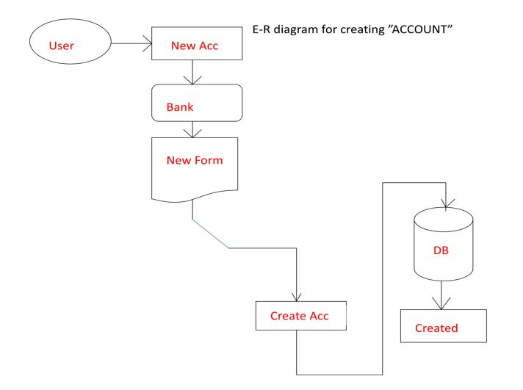

**To deposit or withdraw from account**

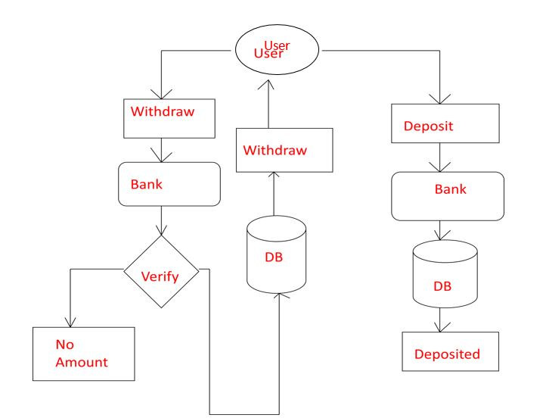

**To modify an account**

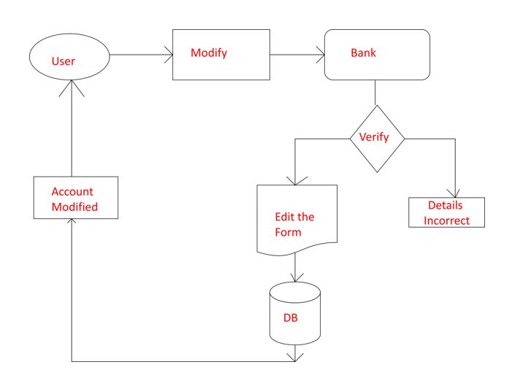

**To delete an account**

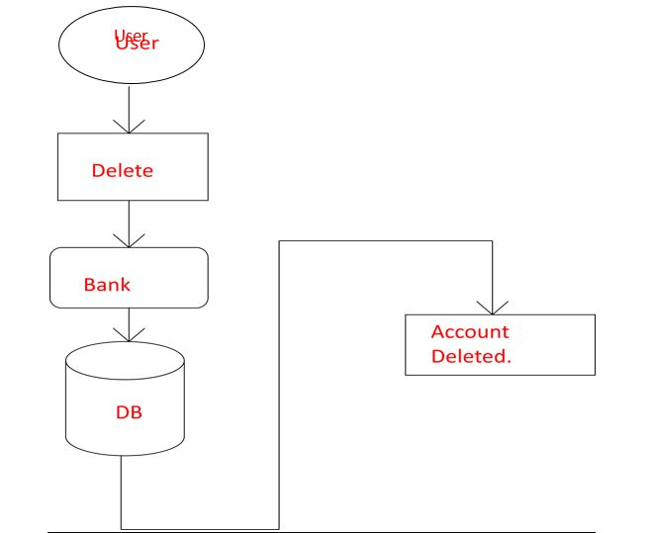

**4.RESULTS**

**Login page**

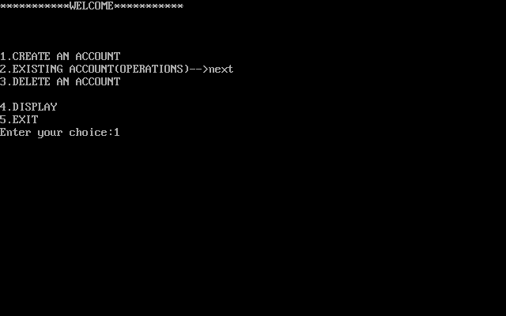

In Login page we are providing four options. To create an account, modifying an existing account, deleting an account, to exit. But the display function is for the bankers point of view so that they can know the details of all the customers in their bank.

Here we are providing a file in which the details of the customers are permanently stored. So that to know the details of any customer, a banker can just open that file.

**Creating an account:**

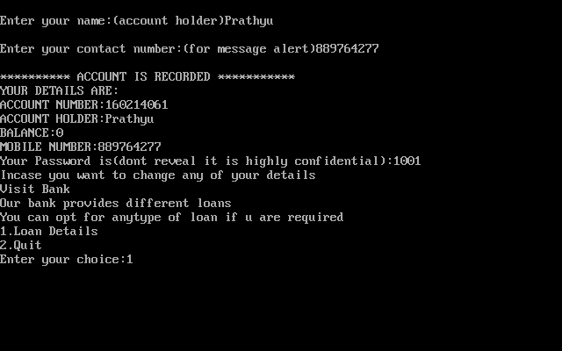

Here we are providing a password for each customer, so that in security purpose there will be no issues. Even we are providing separate password for bankers to see the details of all the customers.

**Opting for a loan(Loan Details):**

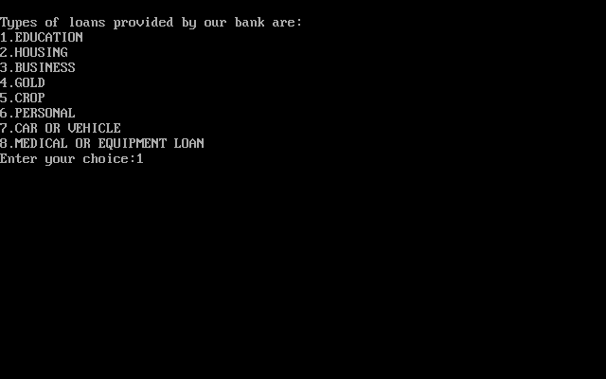

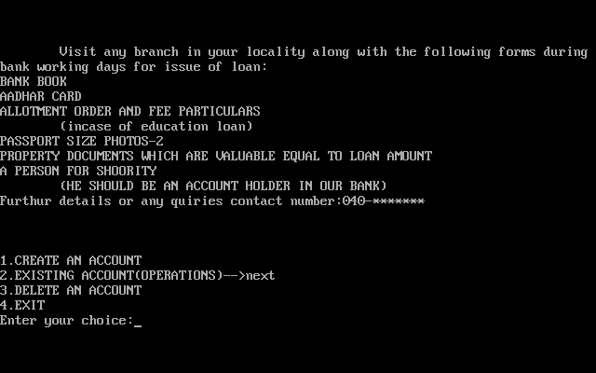

**Operations on existing account:**

**Depositing amount:**

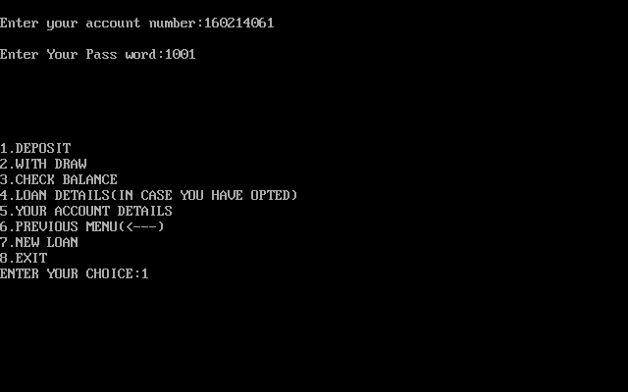

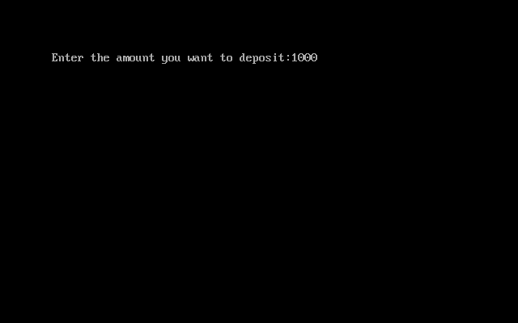

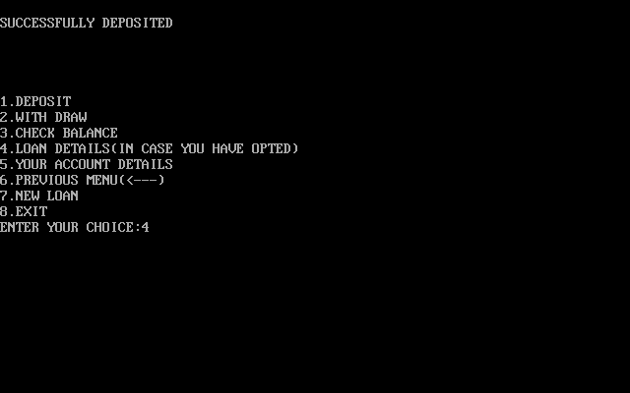

**Loan details:**

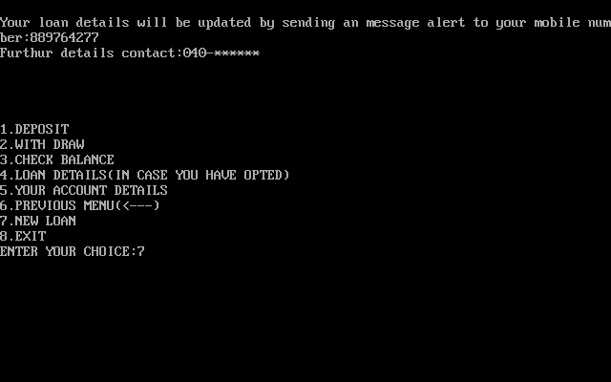

**Deleting an account:**

**If an account exist:**

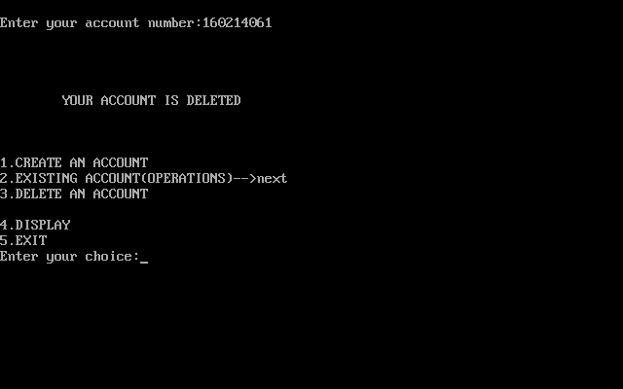

**If no account exist:**

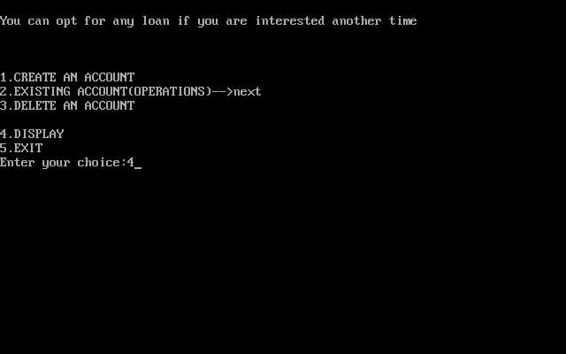

**Exit:**

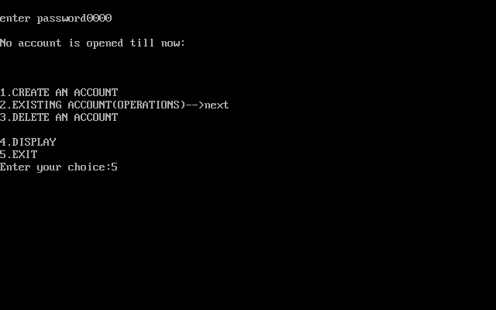

**Details are stored in a file:**

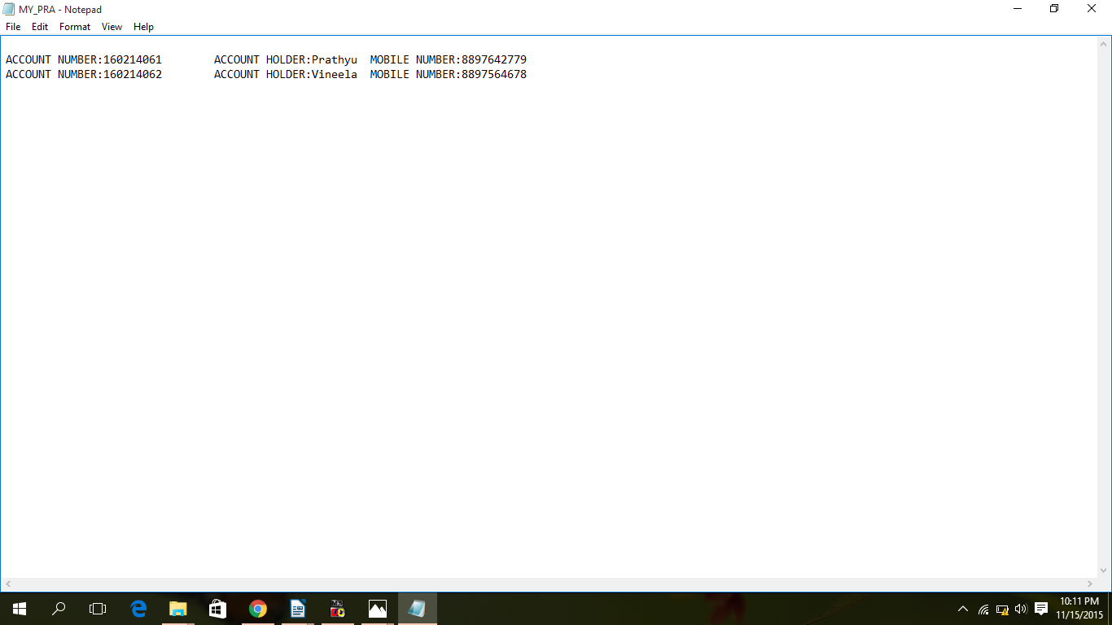

**5.ADVANTAGES AND DISADVANTAGES**

**OF THE PROJECT**

**5.1 Advantages**

Do you know how much money you have in your checking account? If you have just a rough idea, you may want to take a closer look at how you manage and track your account activity. Banking online can make this easier by offering convenient access to your account information and the ability to pay bills and move your money. The following tips will show you how to use these services to your advantage.

**Access your bank accounts anytime, anywhere**

Banking online allows you to securely bank anytime and anywhere you want as long as you have access to the internet. You can use your computer (or, with some banks, your smartphone) to check your balance, transfer money and pay bills on the go. Mobile banking services are generally available to you at no cost, but keep in mind that you may incur charges from your mobile service provider depending on your wireless plan. Some banks also offer features like a mobile website and mobile app to enable on-the-go banking and money management.

## Keep track of account balances to help avoid overdraft fees

Sometimes it's far too easy to lose track of your money when you're busy trying to balance work and family. Banking online can help you keep tabs on your money and account balances. Many banks even let you set up alerts to notify you when your balance is low, if a bill is due, when your paycheck is direct-deposited and more. Alerts are a great way to keep track of the money in your account and help avoid incurring overdraft and late-payment fees.

You can also use your smartphone to check your account via [Mobile Banking](https://www.bankofamerica.com/online-banking/mobile.go) right before you make a purchase. Remember to mentally subtract any checks you've written that haven't been cashed, as well as any automatic payments due to come out of your account soon. Many digital banking services also enable you to transfer funds from your savings account to your eligible checking account to ensure purchases are covered. (Learn more about Bank of America[overdraft solutions](https://www.bankofamerica.com/deposits/manage/faq-overdraft-services.go).)

## Organize your bill payments

[Paying your bills](https://www.bankofamerica.com/onlinebanking/online-bill-pay.go) online can make your banking life much easier. You can avoid the hassle of paper bills, making extra trips to your bank or worrying about checks being lost in the mail. In addition, paying your bills online keeps all of your billing records in one easy-to-find place. You can also set up automatic payments using your debit or credit card.

## See how much you pay, and to whom

Many online banking systems let you see exactly how much you’ve paid to any given company (such as a mortgage provider, dry cleaner or utility company) over a certain period of time. When tax season rolls around, you can easily access a record of all the online payments you've made. For example, you can see an aggregated total of payments to your mobile carrier to figure out how many of those charges could be tax deductible.

## Protect yourself:

Tips for money management through digital banking wouldn't be complete without a note on [online and mobile security](https://www.bankofamerica.com/deposits/manage/online-security-tips.go). Banks take the security of their online services very seriously. In addition to site encryption, most banks also exempt users from liability for fraudulent transactions, guard their users' personal information and ensure accurate as well as fast online transactions.

|  |
| --- |
| Nearly everyone has access to some sort of account with which to conduct the regular business of banking. Access to a financial institution's accounts and other services is often taken for granted. The advantages of banking can become clearer if you review some of the basics. This is even more relevant if you happen to be one of the few that have yet to open a checking or savings account with their local bank. You not only need to know what sort of obvious advantages a bank offers, such as the different features that are available to customers, but also how these relate to you particular needs.   Everyone would agree that one of the basic reasons bank accounts exist is to provide a place to put one's money to keep it safe. While images like stuffing your mattress with money may seem humorous to most of us, there have been times when people have done just that with the money they earned. In other situations, people might carry cash on their persons. The danger with either situation is that if money is stolen or lost, it cannot be replaced. Thus, using a banking service like an account is a good way to protect your assets.  Equally important is the fact that most people who are employed receive paychecks that can be redeemed for cash at banks. Of course, banks have a common policy that requires them to charge a fee for the cashing of someone's paycheck. This may not seem very important since the fees are generally very small. Yet, even a small fee can amount to something over time. The advantage to having a bank account with a local bank is that those fees will be waived if you keep an account with them.   Those same banking institutions also provide features that provide convenient use of accounts whether you want to establish a checking account and use checks to pay bills rather than cash or if you wish to obtain a debit card that can be used in the place of money. Both of these options provide easy access to your funds without being on the premises, physically withdrawing the funds from your checking or savings account.   While the direct advantages of keeping some type of banking account may be obvious to some, there are some indirect benefits as well. What sort of indirect benefits are there? First, the very fact that you have an account may improve your chances of being approved for a loan. It may be especially true if you are attempting to get a personal loan from the bank you have an account with and do business with on a regular basis. Established relationship with regular customers can go along way to help you obtain that personal loan or business loan you need.    Similarly, the fact that you have an existing account with a banking institution might be considered when you are trying to get financing for a loan elsewhere. For example, the lender may want to know if you have an active saving or checking account with a positive balance, so there is no doubt that you will have the ability to pay back These are all just some of the advantages associated with banking. |

* Credit Unions typically pay higher dividend rates on savings
* Credit Unions typically offer lower rates on loans
* Credit Unions typically provide better service; since they are owned and governed by their membership, they tend to prioritize the needs of their members above all else
* Credit Unions operate on a not-for-profit business model, so excess earnings are returned back to the membership in form of competitive rates and lower fees, and sometimes even special dividends
* Many Credit Unions offer the same products and services found at banks
* Credit Unions often have added-value benefits, such as free financial education, discounted theme park tickets, and special member rates for services such as home alarm systems...even discounts at online retailers like Barnes & Noble.

Commercial banking can help a small business by making it easier to manage day-to-day financial tasks. An established commercial account with a bank will make it easier to borrow money when you grow your business. Often a business is assigned a representative who works directly with the company to find the best services and solutions for the issues the business is facing.

For example, the company may save money by outsourcing payroll processing. Banks also offer invoicing services, with personalized invoices, and can set up transfers to other banks which will simplify accounting procedures. Some banks offer retirement account management for your employees as well as other employee benefits. This can save you money, and make it easier to manage all of the services you offer employees. Some banks allow you to make deposits online by scanning checks. Your bank may offer you discounts on your merchant services fees.

**5.2. DISADVANTAGES**

* Credit Unions, and in particular smaller local credit unions, struggle to match the level of convenience (ATMs and branches) that many banks provide their customers, although many CUs are part of shared networks which enhance the breadth of delivery channels available to their members
* Some Credit Unions are limited in their product offerings
* One must qualify for membership to have an account in that particular bank.

**6.CONCLUSION AND FUTURE SCOPE**

6.1.CONCLUSION

“Banking System " keeps the day by day tally record as a complete banking. It can keep the information of Account type, account opening form, Deposit, Withdrawal, and Searching the transaction, Transaction report, Individual account opening form, Group

Account. The exciting part of this project is; it displays Transaction reports, Statistical Summary of Account type and Interest Information.

**COST ESTIMATION OF THE PROJECT:**

For a given set of requirements it is desirable to know how much it will cost to develop the software to satisfy the given requirements, and how much time development will take. These estimates are needed before development is initiated. The primary reason for cost and schedule estimation is to enable the client or developer to perform a cost-benefit analysis and for project monitoring and control. Automation more practical use of these estimates is in bidding for software projects, where the developers must give cost estimates, to a potential client for the development contract.

For a software development project, detailed and accurate cost and schedule estimates are essential prerequisites for managing the project. Otherwise, even simple questions like “is the project late”, “are there cost overruns” and “when is the project likely to complete” cannot be answered. Cost and schedule estimates are also required to determine the staffing level for a project during different phases. It can be safely said that cost and schedule estimates are fundamental to any form of project management and generally always required for a project.

Cost in a project is due to the requirements for software, hardware, and human resources. Hardware resources are such things as the computer time, terminal time, and memory required for the project, whereas software resources include the tools and compilers needed during development. The bulk of the cost of software development is due to the human resources needed, and most cost estimation procedures focus on this aspect. Most cost estimates are determined in terms of person-months (PM). By properly including the “Overheads” (i.e. the cost of hardware, software, office space etc,) in the dollar cost of the person-month, besides including the direct cost of the person-month, most costs for a project can be incorporated by using PM as the basic measure. Estimates can be based in subjective opinion of some person or determined through the user of models. Though there are approaches to structure the opinions of persons for achieving a consensus on the cost estimate it is generally accepted that it is important to have a more scientific approach to estimate though the user of models.

**6.2.FUTURE SCOPE**

The Net Banking System for the recruitment process can be further developed into a separate, automated system with the following enhancements:

* A mail server can be implemented to send mails directly from the system to the inbox of the recipient. The code needed for the same is being implemented except the mail server.
* Help file can be included. The system, as of now, does not support any help facility for the users of the system. A help menu can be provided with a special function key and help command in the main page itself. Help can be either introduced as a separate window, a reference to a printed manual or as one or two line suggestion produced in a fixed screen location.
* The system can use typed commands, as they were once the most common mode of communication with the system. The typed command can be provided through control sequence or function keys or typed word.
* A training module can be included in the system. This module can be used to train the users of the system about the systems usage. The training module can be in the form of a HTML file describing different commands usage and the overall function of the system. This would be a handy tool for the developer to train the HR department people.

It may help collecting perfect management in details. In a very short time, the collection will be obvious, simple and sensible. It will help a person to know the management of passed year perfectly and vividly. It also helps in current all works relative to College. It will be also reduced the cost of collecting the management & collection procedure will go on smoothly.

The present project has been developed to meet the aspirations indicated in the modern age. An attempt has been made through this project to do all work ease & fast. It provide current add, Update, MoveNext, MovePrevious, MoveLast, Find & Delete all facilities to accomplish the desired objectives. The facility Include in this project and the suggested activities have been organized to impart knowledge & develop skill & attitude in the College official works.

**7.BIBLIOGRAPHY**

**BOOKS:**

**MAKE C++ EASY**

-BALA GURU SWAMY

**PROFESSIONAL C++**

-MARC GREGOIRE

**REFERENCES:**

[www.google.com](http://www.google.com/)

[www.cplusplus.com](http://www.cplusplus.com/)

[www.ctutorials.com](http://www.ctutorials.com/)