An example manuscript file

*Peter C. St. John1*

1Biosciences Center, National Renewable Energy Laboratory, Golden CO 80401

# Introduction

A quick demo of writing a manuscript in markdown. More examples can be found from [pandoc-crossref](https://github.com/lierdakil/pandoc-crossref). A reference (*1*), some equations eq. 1, and a figure Figure 1

$$f(x)=x^{2} (1)$$

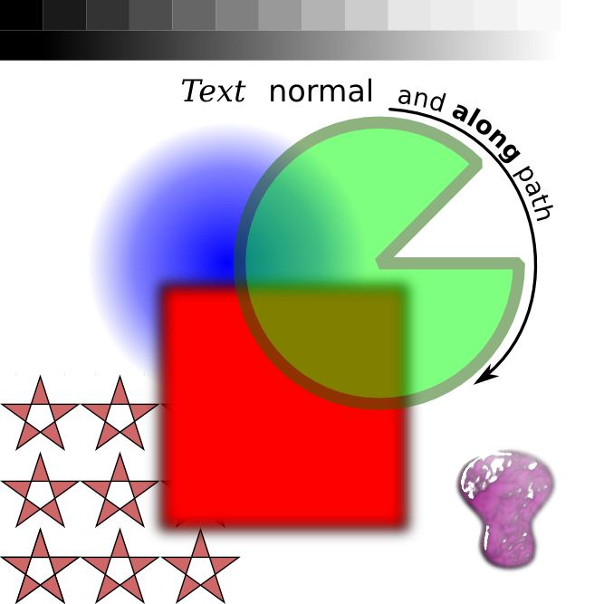

Figure 1: **A test figure title.** Additional descriptions.

# References

1. J. H. Atkins, L. J. Gershell, From the analyst’s couch: Selective anticancer drugs. *Nature Reviews Drug Discovery*. **1**, 491–492 (2002).