# REPORT – CHILD MALNUTRITION ESTIMATES

**Summary**

**Data Set Chosen**: Child malnutrition estimates

**Source**: Combined data set from UNICEF, World Health Organization and World Bank

**Downloaded from**: <http://data.unicef.org/nutrition/malnutrition.html>

**Dataset**



**Data dictionary**



**Software used**: SAS and Excel

**Overview of data set**:

* This data set contains information about malnutrition levels of children (in terms of weight and height) aged below 5 years *across 150 countries* over the *time period 1982 – 2014* for *different income regions*.
* Malnutrition levels have been quantified from samples of below 5 age group in terms of % of population. Variables for malnutrition levels:
  + **Severe Wasting**
  + **Wasting**
  + **Overweight**
  + **Stunting**
  + **Underweight**

No. of Variables: 22

No. of observations: 778

# step 2: code, results and insights

1. Descriptive statistics for the quantitative variables Survey Sample size, Severe wasting, Wasting, overweight, underweight, stunting, Under 5 population is as follows:



Frequency tables for UN region and WHO Income Region





**Problem Statement and Evidences:**

In the year 2014, BBC reported that the malnutrition levels is crossing the danger line.



WHO reports that about 45% of the deaths of children under the age of 5 is due to malnutrition. (*Source: http://www.who.int/mediacentre/factsheets/fs178/en/*)

Being one of the deadliest problems in the world, it still continues to be one of the biggest challenges for all the countries across the world although they are trying to tackle it through their ever-evolving policies around health care and investments into sustainable healthy diets.



1. **3 Charts based on the data**

From the given data set, we’ve attempted to analyze the severity of the malnutrition based conditions in under 5 year population. We’ve expressed this over a bucket of years, across various economic belts (as per World Bank classification). We’ve made the following **assumptions** for deriving insights:

1. All the missing values though unaltered, have not been used to plot the chart. Thus, 527 observations out of the 778 observations have been used.
2. The charts express the percentage of the affected children population below the age of 5 for a particular malnutrition level i.e Severe wasting, Wasting, Overweight, Underweight and Stunting.
3. For plotting the below charts, only Severe wasting, Wasting and Overweight affected population have been considered. This is because all the three levels are defined using a common metric of different standard deviations from median *weight-for-height* of the WHO Child growth standard while Stunting and Underweight levels are based on different underlying metrics which deems them unfit for comparison with the three chosen KPIs.
4. We’ve further *classified* the World bank data on economic belts into High income group and Low income group based on variable ‘WHO Income Region’.

* Low income group: This consists of all the regions that fall under Lower middle income and Low income.
* High income group: This consists of all the regions that fall under the Upper middle income, High income: non OECD and High income: OECD.

1. The years are *classified* into 2 groups (based on variable ‘Year’):

* Before 2000 (including year 2000)
* After 2000

**Chart 1:**

**Breakdown of ‘Weight-for-height’ malnutrition affected children by income group across time**

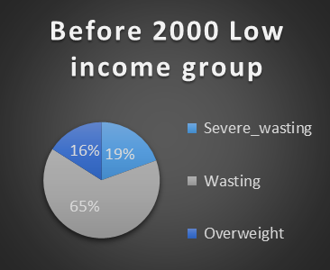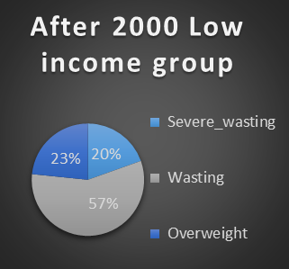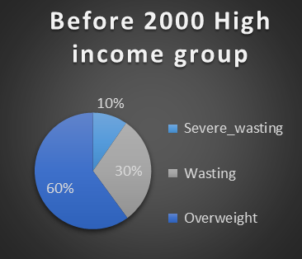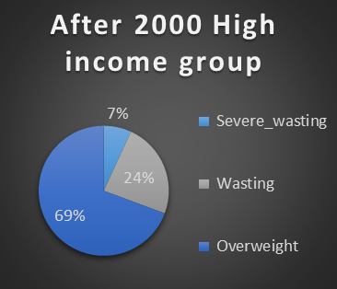

The above chart explains the distribution of ‘weight-for-height’ conditions amongst the affected under 5 population. For e.g. In ‘After 2000 Low income group’ chart, out of all the under 5 age population suffering from ‘weight-for-height’ based malnutrition conditions, 57% are affected by ‘Wasting’, 23% are affected by Severe wasting and 20% are affected by Overweight.

**Insights**:

* Low income group children are majorly affected by ‘Wasting’ condition. The affected population has decreased in the recent decades (decreased from 65% -> 57% in the time range ‘Before 2000’ -> ‘After 2000’)
  + ‘Overweight’ children population has slightly increased in the same time range
  + ‘Severe Wasting’ has had a *negligible change* in the time range
* High income group children are majorly affected by ‘Overweight’ condition and the affected population is on rise in the recent decades. (increased from 60% -> 69% within the time buckets ‘Before 2000’ -> ‘After 2000’)
  + ‘Wasting’ children population has slightly decreased in the same time range
  + ‘Severe Wasting’ has had a *negligible change* in the time range

Using the charts below, we dive deeper into understanding the Wasting and the Overweight affected population in the two income groups in the ‘After 2000’ time bucket to confirm that the trend we see is spread across years and not just across the broad time buckets chosen.

**Chart 2:**

**Affected ‘Overweight’ and ‘Wasting’ population trend in the ‘After 2000’ bucket for the two income groups**

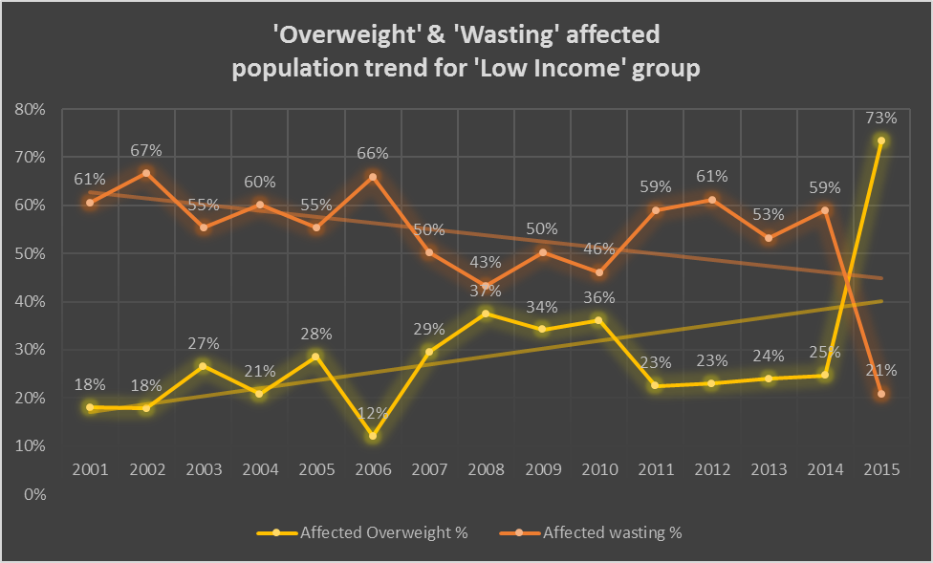

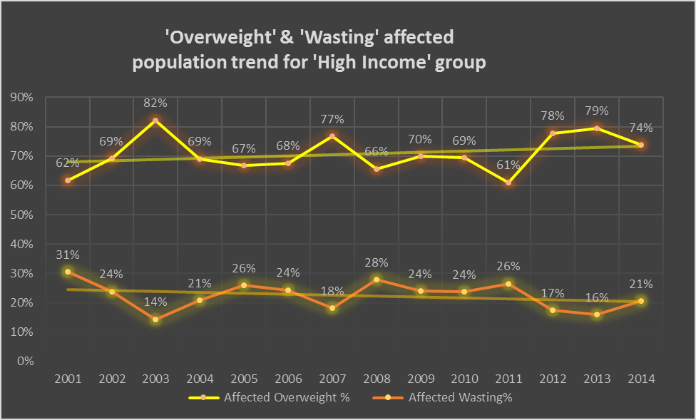

**Insights:**

The above charts confirm that the trend observed in the broad time buckets (‘Before 2000’, ‘After 2000’ are also reflected in the recent years. These trends are:

* ‘Wasting’ condition is on the decrease in recent years
* ‘Overweight’ condition is on the increase in recent years

Further, we would like to explore the spread of ‘Wasting’ and ‘Overweight’ conditions across regions in the recent years (i.e. After 2000 time bucket).

**Chart 3:**

**Spread of Affected ‘Overweight’ and ‘Wasting’ population in ‘After 2000’ time bucket across regions**

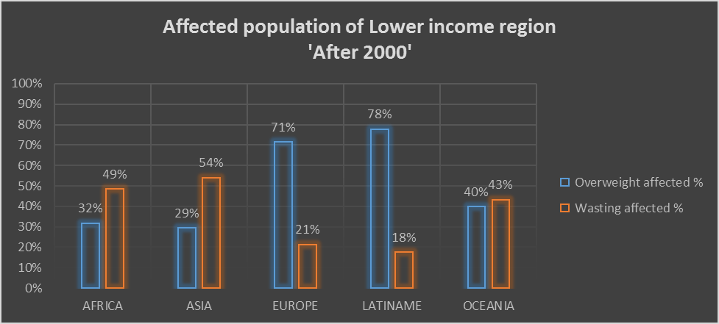

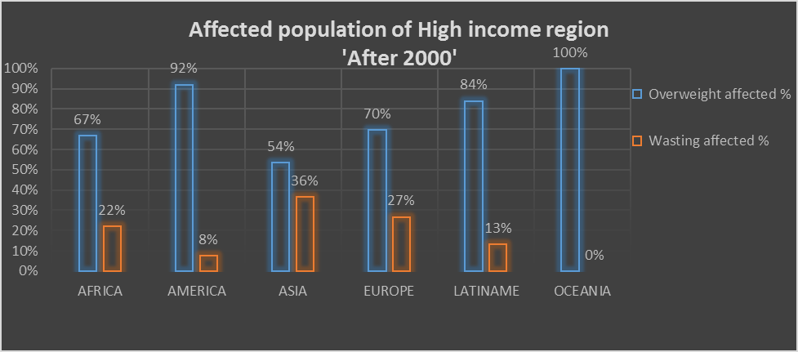

**Insights**:

The above charts explain the percentage of the affected children under the age of 5 by Overweight and Wasting levels of malnutrition, region wise (as per UN standards) grouped into the two income belts.

* Irrespective of the income group, ‘Europe’ and ‘LatinAme’ regions have very high ‘Overweight’ affected children population
* ‘Overweight’ condition is more prevalent in ‘High income’ group while ‘Wasting’ condition is more prevalent in ‘Low income’ group.

# Conclusion

The charts we’ve designed from the combined data set from WHO,World Bank and UNICEF helps us better understand the spread of malnourishment in various regions, economic conditions and time.

Although it would be difficult to find the root cause of a massive problem such as this, we can safely say that:

* The under-malnourishment (Wasting, Severe wasting – levels that are negative standard deviations away from the median height-for-weight of the WHO Child growth standard) has improved over the years.
* The over-malnutrition problem such as Overweight levels has worsened over the years as a general trend.

**Further analysis:**

* Using this general observation, we can drill down further and build upon our analysis to understand the dynamics for a particular country during a particular year.
* Also with more information such as the investment made by the country’s government into healthcare and specific malnutrition projects, we may be able to further extrapolate our results and suggestions about the optimum amount of money to be spent on a particular area may be made.
* Policy analysts may be able to better frame their policies regarding sustainable diets and build a more effective system surrounding this focus area.