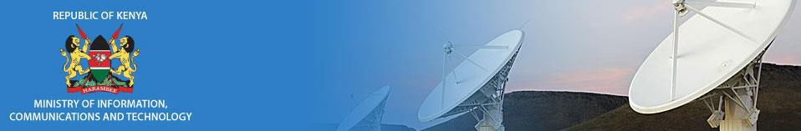

PRESIDENTIAL DIGITAL TALENT PROGRAMME

PROGRESS REPORT

26TH January, 2017

MOICT SUPERVISOR

Mr. Abner Abaga

MOICT BUDDY

Mr. Charles Wanjohi

PDTP INTERNS

Benjy Muiruri Kamau

Louise Mbithe Mathenge Lilies Waihuini Kimathi Milda Mutethia

Paul Muia Muuo

Dominic Korir Kiprotich

ACTIVITIES

- Ministry structure induction

- Introduction to the staff

- Department allocation and reporting

- Duties and projects assigned

- MINISTRY STRUCTURE INDUCTION

Mr. Abaga gave us a detailed explanation of the MoICT structure:

  - The state departments (Broadcasting and Telecommunication, ICT and Innovation). What their functions and duties are.

  - The various ministry departments (Administrative Services, Directorate of Information Services and Directorate of Public Communication). Their responsibilities and functions in

line with the ministry’s agenda.

  - The state corporations under MoICT (CAK, KBC, ICTA, KYEB, Postal Corporation of Kenya, Media Council of Kenya, Konza Technopolis Development Authority). Their functions and

responsibilities in line with MoICT’s goals.

  - The Semi-autonomous government agencies (Kenya Institute of Mass Communication, National Communication Secretariat, Communication Appeal Tribunal). Their functions and

why they are semi-autonomous government agencies.

- INTRODUCTION TO THE STAFF

Mr. Abaga took us to all the departments housed in Teleposta building and the Department of Information at Uchumi House; where he introduced us to all heads of departments and staff in general.

- DEPARTMENT ALLOCATION AND REPORTING

We were allocated to the ICT department in the ministry’s headquarters so that we could first understand the working environment of the ministry as a whole.

The reporting to work was done with strict observance of working hours i.e. 8 am – 5 pm.

- DUTIES AND PROJECTS ASSIGNED

Having been assigned to the ICT department, we were tasked with the responsibility of general user support in the ministry. Also in line with the PDTP mandate and agenda, after interacting with the various departments, we held a meeting with our supervisor and buddy and tabled our ideas on different innovations to optimize activities and processes in the ministry. We are currently doing an exclusive research on the different innovations to ensure an efficient delivery on the same.

Report compiled by LILIES WAIHUINI KIMATHI

