

QUARTERLY REPORT
PERIOD: APRIL – JUNE 2017
ORGANIZATION: ICTA
DEPARTMENT: STANDARDS AND PROCESSES
This quarterly report covers the months of April, May and June 2017. Over this
period, the standards and processes team focused mostly on regional activities, in particular the work on supplier and contractor accreditation.

It consists of the following categories that have been further expound:

- Operating procedures.
- Implementation guidelines.
- Vetting and accreditation committee work plan.
ICT SUPPLIER/CONTRACTOR ACCREDITATION OPERATING PROCEDURE

FLOWCHART

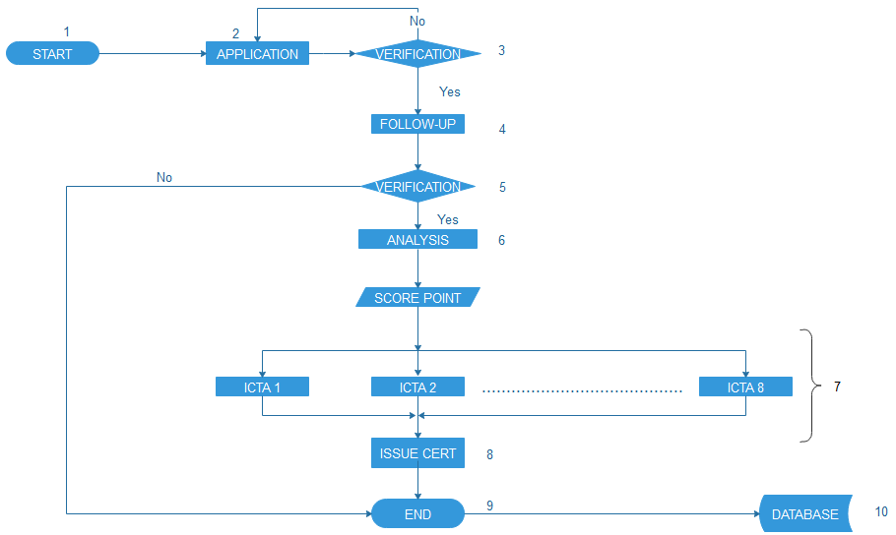

Steps
Step 1: Start of accreditation process
Step 2: Company makes application
Obtain application forms:
- Download from ICTA website
- Hand Picked from ICTA office
- Apply online
Step 3: Verification of the received application forms
- Forms duly /correctly filled
- Attached all necessary documents
Step 4: Follow up
- Calls/site visits to verify information
Step 5: verification
The information gathered from calls and site visit is analyzed. A company/form can be disqualified at this stage due to the following reason(s):
- Non-exist of the company
- Company is incompetent or has engaged in malpractices
- Provision of forge/invalid/incorrect information
Step 5: Analysis
The information collected is analyzed using the criteria document
Step 6: Score point
Make reference to criteria document and the ICT governance standard. The process is done by the secretariat.
Step 7: Categorization
Make reference to the ICT governance standard. The process is done by the secretariat and approved by the committee
Step 8: issue certificates
A signed and approved certificate is issued to the company/firm
Step 9 Update register/ publish information
End the process of accreditation and store the information in the register /database and publish the firm accredit ate on the ICTA website/government gazette

Reporting:
The report should contain:
- Total number of applications received in a particular period of time
- List of firms/companies and their categorization
- Recommendations

CATEGORIZATION CRITERIA DOCUMENT.

REFERENCE | PARTICULARS | MAX POINTS | REMARKS | IMPLEMENTATION GUIDELINE
A | Directors Qualification and work experience. | 15 | Technical Directors [10mks],  5mks for other directors | i) Technical Directors (10 Marks)  Scoring is based on the following.  - Degree (at least BSc in Computer Science, IT or related)– 3.5 marks  - Certification in Project Management – (3.5 marks)  - Work experience in (3) similar assignments as team leader,1 marks per assignment, maximum score (3 marks)  ii) Other Directors (5 marks)  - Work experience in (3) similar assignments as team leader,1 marks per assignment, maximum score (3 marks)  - Certification in Project Management – (2 marks)
B | Staff qualification | 25 | Technical staff in specialized area [20mks],  Other staff [5mks] | ii) Project team – at least 4 persons. (20 Marks – 5 marks for each person)  Scoring is based on the following.  - Degree (at least BSc Computer Science, /IT or related) 2 marks  - Professional certification (1marks)  - Work experience in 3 similar assignments (1 marks)  - Certification in project management (1 mark)
C | Financial status | 30 | Turnover 12 marks  Largest projects in area of Specialization [12 marks]  Cash flow [6 marks] | i) A high turnover ratio (12 marks)  >Average turnover ratio (6 marks)  >Low turnover ratio less than (6 marks)  ii) Specialization (12 marks)  >1 relevant Projects>100M (5MKs)  >2 relevant projects>50M (5Mks)  >1 relevant project>5M (1mks)  >Projects<5M (1 Mark)  iii) Cash flow (6 marks)  >100M in a financial year (3 marks)  >50 M in a financial year (2 marks  >1 M in a f/y (1 mark)
D | Office and service facilities | 10 | 10 marks for adequate office space
E | Firms experience | 20 | Details of development projects undertaken in area of specialization | Demonstrable capacity at firm level by providing evidence of 5 relevant works carried out in government institutions for the last 5 years, evidenced by copy of purchase order or contract and contact details, job completion certificates/ Client testimonials/contracts. (20 marks – 4 marks for each job)
 | TOTAL | 100

CLASSIFICATION OF WORK FOR LOCAL CONTRACTORS

CATEGORY | POINTS | LOCAL CONTRACTOR |  | FOREIGN CONTRACTOR
CATEGORY | POINTS | REGISTRATION FEES (KSHS) | ANNUAL FEES  (KSHS) | REGISTRATION FEES (KSHS) | ANNUAL FEES  (KSHS)
ICTA 1 | 81 – 100
ICTA 2 | 66 – 80
ICTA 3 | 56 – 65
ICTA 4 | 46 – 55
ICTA 5 | 36 – 45
ICTA 6 | 21 – 35
ICTA 7 | 10 – 20
ICTA 8 | Below points

VETTING AND ACCREDITATION COMMITTEE WORKPLAN

 | Activity/Task | KPI | Resources/References | May
 | Activity/Task | KPI | Resources/References | Wk1 | Wk2 | Wk3 | Wk4
1 | Finalization and adoption of accreditation tools and documents | Approved Accreditation instruments | -IT Governance Standard.  -Developers  -Workshop facilitation | 1. Fine tune evaluation criteria and application forms  2. Register of applicants  3. Certificates  4. Operational procedures |  | Workshop to adopt the documentation | Adoption of Automated vetting tools
2 | Capacity Building | Vetting and accreditation skills that are comparable to best practice | Facilitator allowance, workshop facilitation  Airtime |  | Benchmarking with CA, KRA, PPOA and any other | Workshop for training committee members
3 | Strengthen credibility of the process | Means of verifying received company details |  |  | Establish linkage with company registry to confirm company categorizations
4 | Publicity | Publicity programmes carried out | Newspaper advert fee |  |  |  | Newspaper advert, outreach
5 | Approval and adoption of vetting results of seat | Register of accredited ICT suppliers  N/B  Bi-weekly | Tea and snacks

