**MARSABIT COUNTY DIGITAL LITERACY PROGRAMME JUNE – JULY 2017 INSPECTION AND TRAINING REPORT.**

**INTRODUCTON**

Marsabit County, County Code 010 is the largest county in the country with various challenges being a semi-arid county. Water here is a vital commodity and scarce hence very expensive to get. The county enjoys the existence of Chalbi desert a true desert in the country, L. Paradise and Sibiloi National Park. Chalbi desert covers of Chalbi sub-county, parts of North Horr, Leisamis and Loiyangalani sub-counties. Security is a key aspect in the area due to presence of Cattle Bandits thus presence of Kenya Police Reservist in the county.

The county has friendly people; teachers and pupils with the urge to learn and embrace technological change as evidenced during our DLP Project. The county has 173 Public Primary schools and 127 school have already received devices making it about 73% complete.

During this period, I was giving the opportunity to serve as the County ICT Quality Inspector Marsabit County. My key role and responsibilities were as follows:

1. Conduct E-readiness assessment in the public primary schools awaiting installation within the county and prepare the status reports with recommendations.
2. Inspect and verify all DLP installations in schools a guided by ICTOs.
3. Work together with ICTOs to build capacity in teachers on DLP solutions

(Teachers training).

1. Conduct inspection and Acceptance of the DLP devices by the Head teacher, School and the BOM.
2. Plan and coordinate DLP launches across the county.
3. Report any challenges that need Government attention.

**Project Activities**

1. **E-Readiness Inspection**

During the e-readiness inspection we noted that most school had met the basically requirements as outlined i.e. secure cabinet, grilled doors and windows. We also noted that most school had already been inspected during the first phase of the project and had already received gadgets. However, there was need for more fund to enable schools purchase good desks and also improve the overall class outfit. Most classroom need painting and general facelift from floors, walls and chairs and computer friendly desks. Some strong rooms had a few issue like power sockets, incomplete cabinets and ventilations. Among the schools noted were Marsabit Primary, Kalacha Nomadics Girls, Gadamoji primary, Manyatta Jillo, Ruso Primary among others.

Two schools in Marsabit Central Sub-County namely Uwanja wa Ndege and Gubi Kalo are yet to receive the devices.

**2. Capacity Building /Teacher Training**

During the period, I participated in training over 100 teachers across Marsabit Central and North Horr sub-counties. The following were among the notable areas covered on the training;

1. Testing of the DLP devices to confirm functionality
2. Training Teachers on the device handling (Hardware)
3. Device setup and Minor device troubleshooting
4. Training teachers on the use of Net support school tutor console (Software).
5. Device safety storage and best practice

**3. Device Installation**

This was guided by our ICTO and we worked in liaison with head teachers in taking them through on first installations and testing of the devices in the respective school as directed. During the installation we noted most school had not been able to use the devices since they were delivered.

**4. DLP Launch**

We were also part of the team preparing for the DLP Launches across Marsabit County. One of the grand Launch was held at SKM Primary school on July 13th 2017 with the County Commissioner Mr.Magu Mutindika as the chief Guest assisted by Mr. Idris Aden from ICT Authority

MARSABIT DLP ACTIVITITY Summary

|  |  |  |  |
| --- | --- | --- | --- |
| TIME | ACTIVITY | OBJECTIVES | REMARKS |
| June-July-  2017 | **E-Readiness Inspection** | To ascertain the school  readiness status for the implementation of DLP program | Successful |
| July- 2017 | **DLP Launch** | Rollout of the DLP Project Launches Across Marsabit County for all ready schools | successful |
| July -2017 | **Device installation** | To help schools install  Devices and help confirm that the devices are working and ensure proper connections by the teacher is adhered to | Successful |
| June-July-  2017 | Capacity Building  /Teacher Training | To training teacher on the  digital content, device management and minor troubleshooting | Successful  though not all schools |

Observation and Recommendations

1. **Human Capacity**: During inspection we noted that most schools lack human capacity to handle the DLP program. This was evidenced during inspection and teacher training where most teacher were computer illiterate and need computer training to enable them manage the DLP program. We recommend if the ministry will consider computer training program for all teacher. (Computer packages)
2. **Power Backup Connection**: we noted that some school did not have any power backup incase power goes off. However, we noted that almost every school was connected to the national grid. We request that the ministry to provide power backup to all schools
3. **Network Coverage:** During out deployment we noted some school were out of network coverage hence a big problem communicating**.** Some schools with Marsabit Centre and **Rage in North Horr** are examples of such.
4. **Funds**: the fund given to school was too small to build up to standard storage room hence most of them were not fully complete. We recommend if the ministry will consider more funds. This will enable school even buy good desks for pupils which are computer friendly
5. **Lack of tools**: We noted that the ICT authority office lacks tool and equipment to execute its duties fully. We recommend that the authority consider allocation of tools to enable officer on the ground move easily while addressing the support calls. The Authority should consider provision of pool car to enable ICTOs traverse the large county with easy
6. **More ICT Specialist**: based on the vastness of the county, it will be prudent if the authority considers recruiting more personnel at the county level for technical support and training on need basis.
7. **Facilitation and Communication:**

There was a big challenge with facilitations and communication breakdown. We recommend that ICTA to consider facilitation allowance for teams’ deployment to areas with special needs like Marsabit. We had difficulty time settling down. Also of great concern is the methods of communication channels. ICTA should have one command center for any project undertaken to easy communications. We should have an official way of communication known to all players. If its email or social group, we should maintain formal follow.

**It is important to note that as at now no public means from Marsabit to North Horr that operates during the day due to climatic condition that is not favorable buses and small cars, also the distance takes more that 11hrs using public means. Marsabit Moyale is also far it takes a journey of up to 5hrs hence operating from Marsabit while serving the Moyale schools will not be practical.**

Conclusion

Finally, I wish to thank ICT authority and the DLP project secretariat for giving me the opportunity to serve my country in this noble program. Despite all the challenges the project came with, we managed to do what was needed to make it possible. Thanks so much for the financial and material support which made the program a success. To my county supervisor and my teammates, I salute you all and am humbled to have worked with you though within a short period. Your support was immense and the value you have added to my career and skills is priceless. As we go back to our destination I wish you the best and request that we

maintain the same team spirit in serving our country in various capacities.

**REPORT COMPILED BY:**

**KEVIN OMONDI ODHIAMBO**

**REF: 8212363**

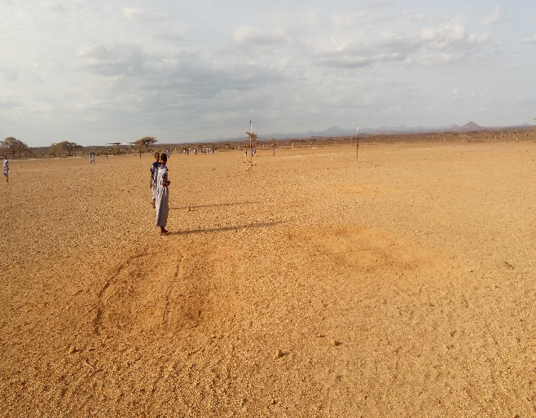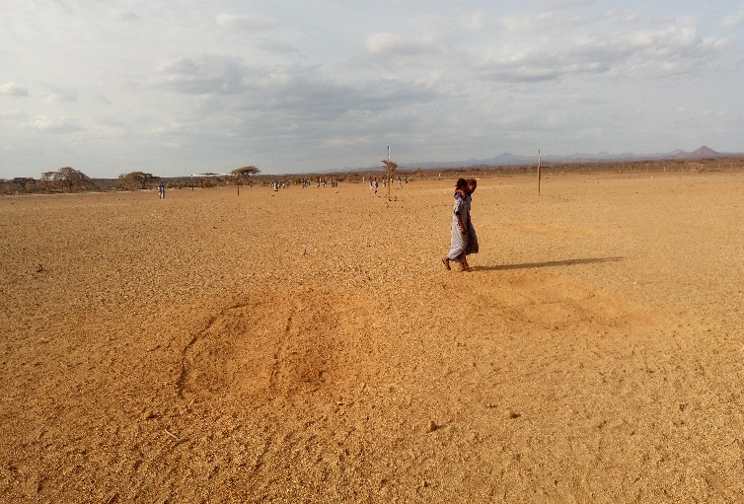

Playground Kalacha Nomadic Girls Boarding Primary School North Horr

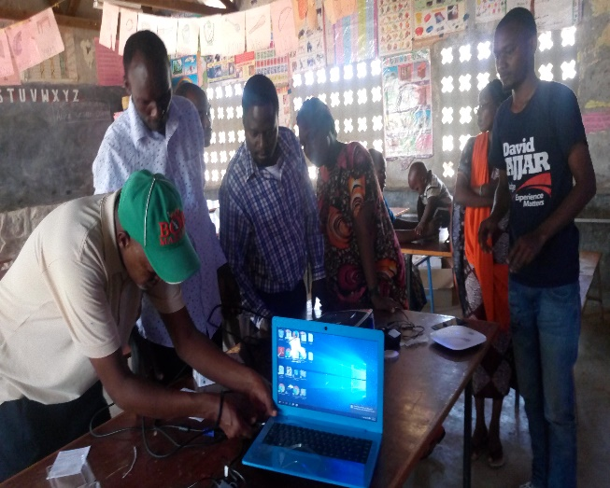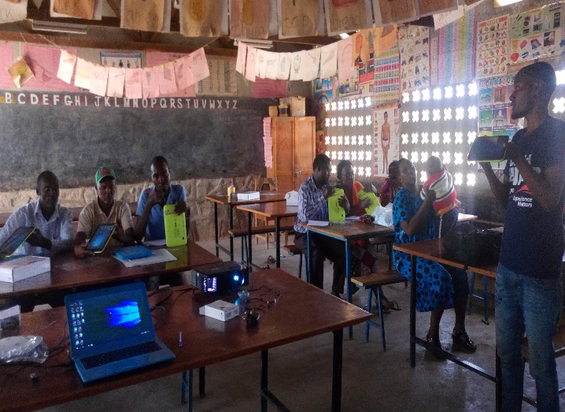

During Knowledge Transfer Practical by Nelson Ndeto at Kalacha Nomadic for teacheers from Kalacha Primary,Rage Primary and Kalacha Nomadic Girls.

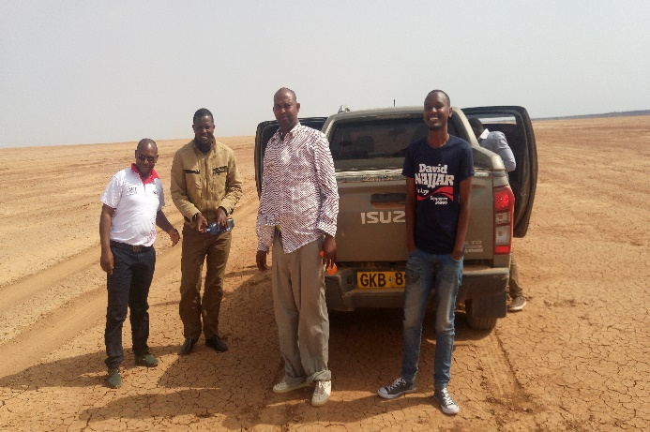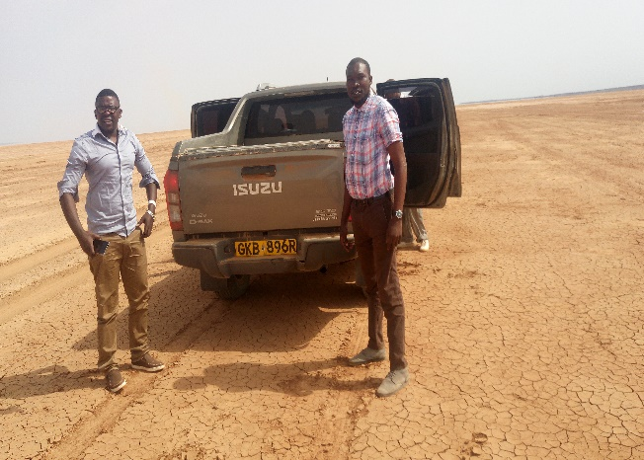

At Chalbi desert on our way to north horr with us is Mr.Ali North Horr Education director and our able pilot Mr.Galgalo.

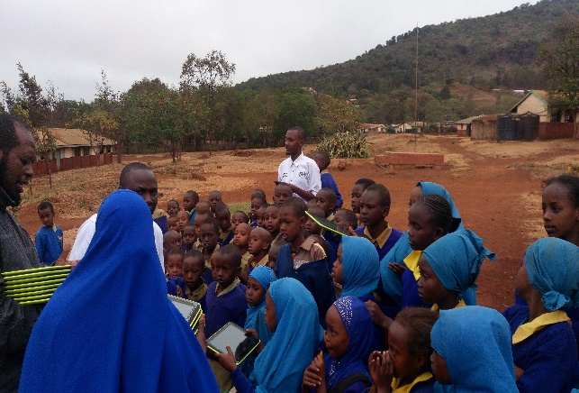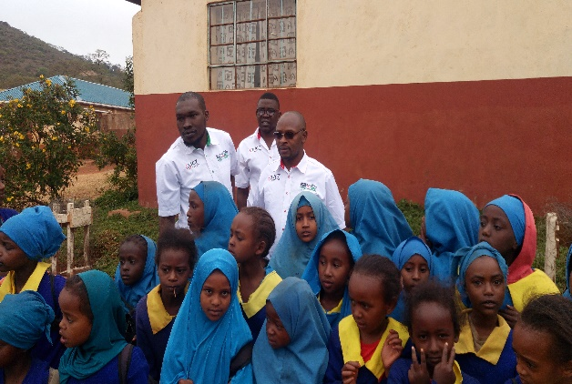

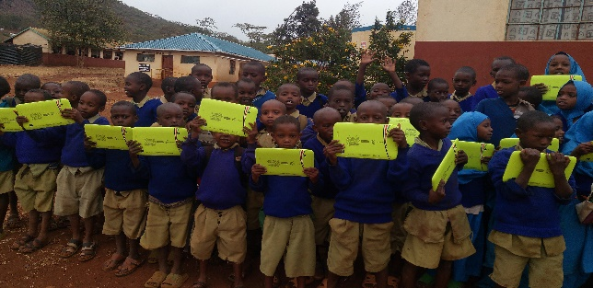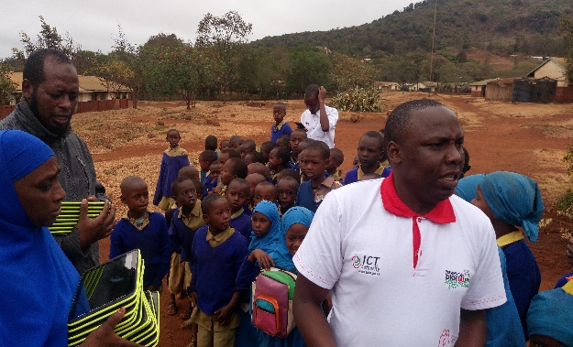

During DLP launch at Marsabit Primary

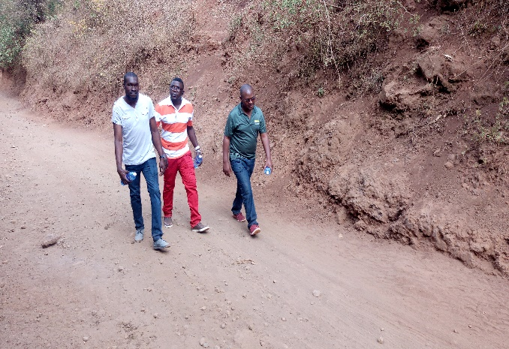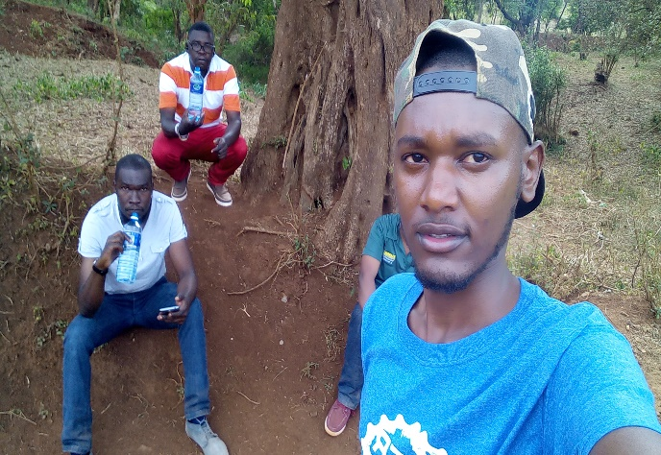

At the Middle of Marsabit National Park Forest as we walk to our next school for DLP

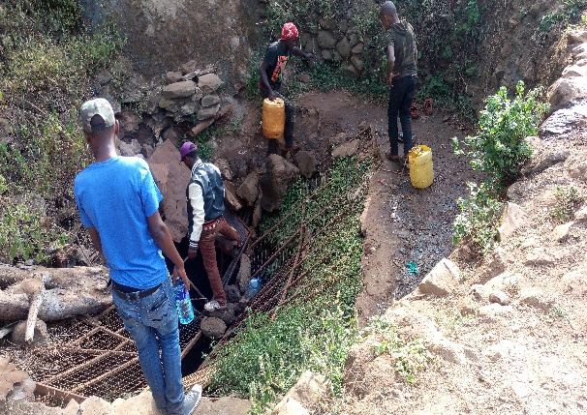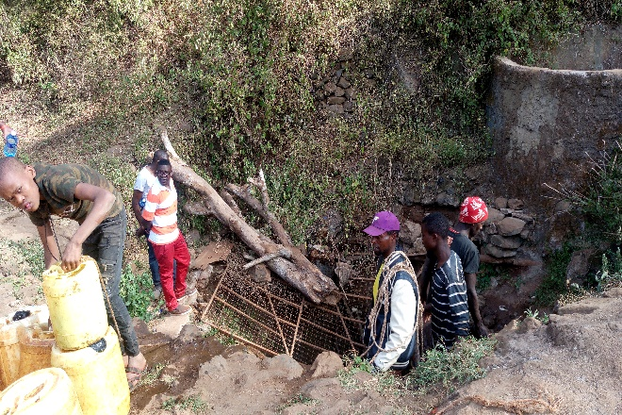

At the water source at Marsabit Forest. With our ICTO Jabir Omar.

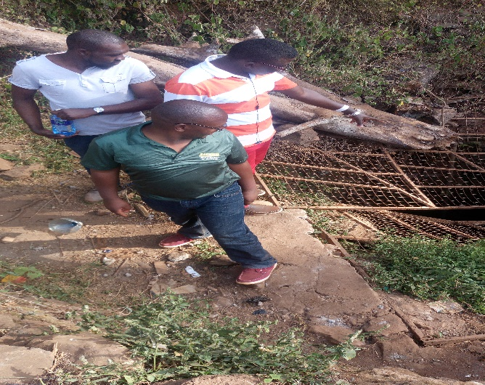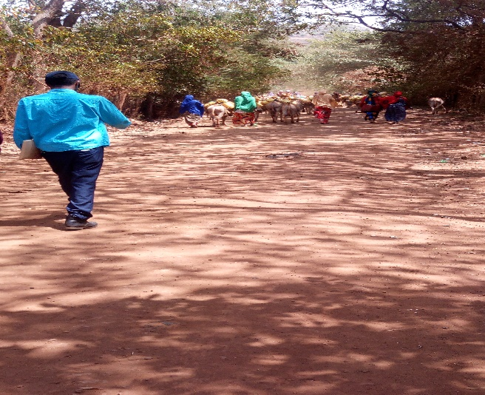

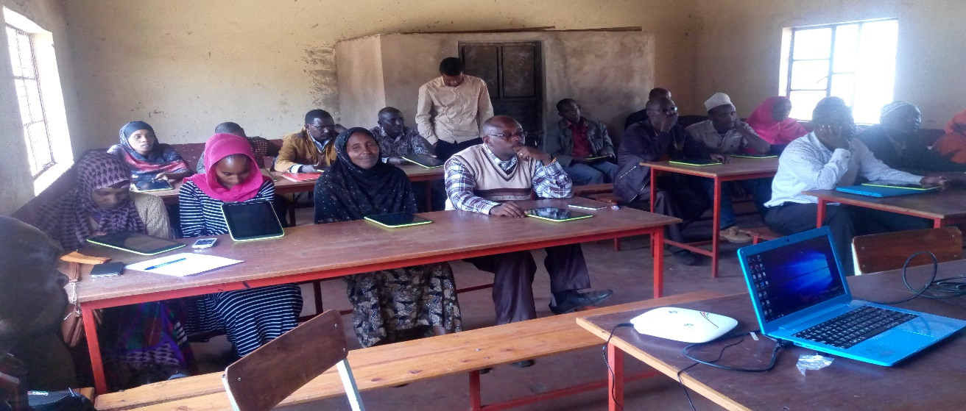

During Knowledge Transfer/Training for teachers from St. Johns Primary school,segel,comboni,

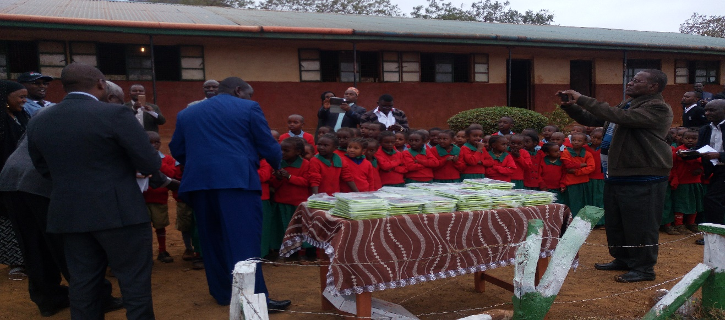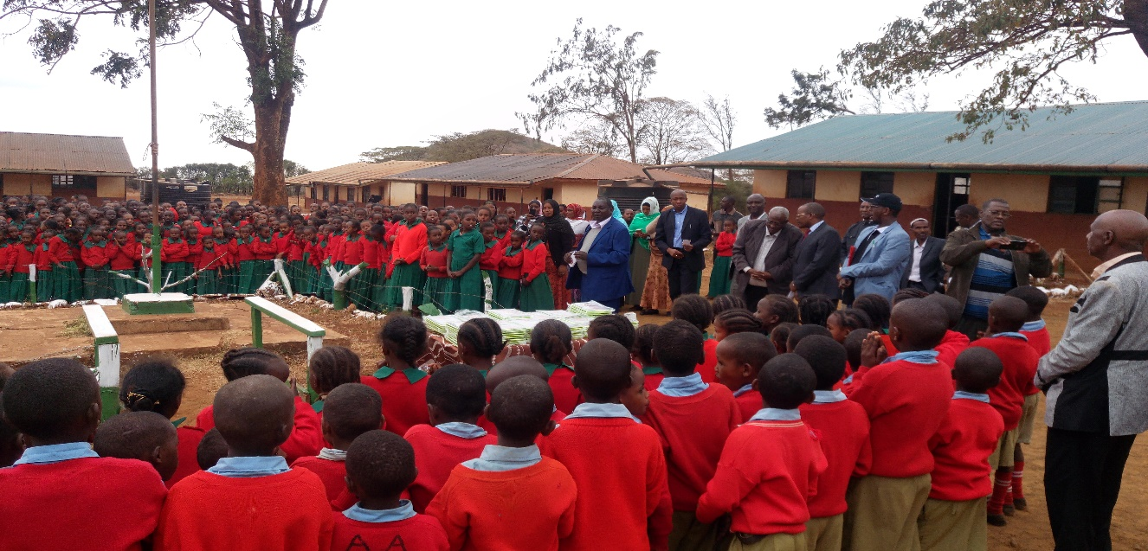

Above the Marsabit county commissioner during the grand launch of DLP at SKM primary, below Mr.Idris of ICTA addressing the gathering.

