DEPLOYMENT AND REDEPLOYMENT TO DIGITAL LITERACY PROGRAM MERU COUNTY

* Report Contents
  + Overview of Digital Literacy Program
  + Key stakeholders
  + Scope of the Digital Literacy Program in Meru County
  + Digital Literacy Program milestones
  + Experiences
  + Achievements
  + Challenges
  + Recommendations
  + Conclusion
* Overview of Digital Literacy Program

Digital Literacy Program is a program which is aimed at integrating the use of digital technologies in learning. ICT authority had the 2016 Presidential Digital Talent Program cohorts trained on Digital Literacy Program and deployed to the counties as quality inspectors to ensure successful implementation of the project.

The quality inspectors were required to conduct e-readiness assessment in all public primary schools; provide technical support where necessary; inspect and verify all Digital Literacy Program installations in schools as directed by the Assistant Ict Officer, Meru county; work together with ICT Authority to build capacity in teachers on Digital Literacy Program solutions, provide better workable solutions for the program and recommend to ICT Authority; report and record all Digital Literacy Program inquiries and technical as well as any other official duty that may be delegated from time to time by the supervisor.

The daily work routine involved inspection of public primary schools in the county, writing and submitting reports on the same. There were two launches carried out in Meru county at Ankamia Primary school, Tigania East and Luciuti Primary School, Igembe North sub counties. During the launch, we helped in preparations, installation of the DLP devices as well as giving technical support to pupils and teachers. After carrying out the inspection, we helped JKUAT in training of teachers, an excessing that took place from 14th December 2016 to 16th December 2016.

This report gives a general overview of Digital Literacy Program, Key stakeholders, Digital Literacy Program milestones, experiences, achievements, challenges and recommendations for Meru County and ICT Authority. A precise and informative conclusion is given at the end.

* Meru County Quality Inspectors

We were a totaL of 9 quality inspectors in Meru county namely:

* + Evan Murangiri Miriti
  + Jane Kathambi Igoki
  + Moindi Duke
  + Dickson Mutuma
  + Boniface Kimathi
  + Mukaria Elias
  + Earnest Ndumba Mugambi
  + Titus Kiambi
  + Michael Muketha
* Scope of the Digital Literacy Program in Meru County

Meru County is one of the 47 counties of Kenya, located in the former Eastern Province. The county headquarters are at Meru town. The county is further subdivided into 9 sub counties which include:

* + Igembe South Sub County
  + Igembe Central Sub County
  + Igembe North Sub County
  + Tigania West Sub County
  + Tigania East Sub County
  + North Imenti Sub County
  + Buuri Sub County
  + Central Imenti Sub County
  + South Imenti Sub County
* Key Stakeholders
  + ICT Authority
    - Assistant ICT Officer, Martin Mwirigi Kathurima
    - Quality Inspectors
  + Kenya National News
    - County Information Officer, Margaret Makaa
    - Information Officer, Richard Muhambe
  + Ministry of Education
    - County Director of Education, Mr Machocho
    - Sub County Directors of Education
    - Curriculum Support Officers
    - School Headteachers
    - Teachers Service Commission
  + Jomo Kenyatta University of Science and Technology Positivo
* Total Number of Schools in Meru County

Meru County has a total of 730 public primary schools of which 16 were newly registered schools that were discovered by the quality inspectors. Approximately, each quality inspector inspected 80 schools.

* Digital Literacy Program Milestones
  + Total Number Of Proof Of Concept Schools

There were 3 Proof of Concept Schools as shown in the table below.

|  |  |
| --- | --- |
| **Name Of School** | **Sub County** |
| Kaaga Primary School | Imenti North |
| Kigane Primary School | Imenti South |
| Amwamba Primary School | Igembe South |

* + Total Number Of Schools Inspected

There were a total of 702 public primary schools inspected inclusive of all new schools. Twenty eight schools were not inspected due to inaccessibility especially during rainy seasons. Other schools were located in security prone zones.

* + Total Number of Schools READY

Out of the inspected 702 schools, 583 schools are READY , 119 schools are NOT READY. Amongst schools that are not ready for the program; in 7 schools there is no transformer installed within the environs, 11 have not been supplied with meters while 111 are not connected to the national grid at all.

* + Total Number of Schools With Devices Installed

There were a total of 12 schools with DLP equipment installed as at 8/11/2016 as shown in the table below.

|  |  |
| --- | --- |
| **Name Of School** | **Sub-County** |
| Kaaga Primary School | Imenti North |
| Amwamba Primary School | Igembe South |
| Kigane Primary School | Imenti South |
| Ankamia Primary School | Tigania East |
| Luciuti Primary School | Igembe North |
| D.E.B Ncoroiboro Primary School | Buuri |
| Tiira Primary School | Igembe South |
| ST. Jude K.K Primary School | Imenti South |
| KK Lumbi Primary School | Tigania West |
| MCS Mariene Primary School | Meru Central |
| Mwirine Primary School | Imenti North |
| Mulathankari Primary School | Imenti North |

* + Total Number of Schools Trained

There was a total of 251 schools which were trained. The table below gives a breakdown of trained schools per sub county.

|  |  |
| --- | --- |
| **Name of Sub County** | **Number of Trained Schools** |
| Igembe South, Central and North | 55 |
| Igembe North and South | 55 |
| Tigania West | 33 |
| Tigania East | 29 |
| North Imenti | 24 |
| Buuri | 28 |
| Central Imenti | 33 |
| South Imenti | 49 |

* + Distribution Of Training Centers Per County

The table below lists distribution of training centers in Meru County.

|  |  |  |  |
| --- | --- | --- | --- |
| **Name Of Training Center/Bidder** | **Description of Item** | **No. of Participants** | **Sub County/Counties Trained** |
| Meru National Polytechnic | Conference Facilities | * 186 teachers * 93 schools | * Imenti North * Meru Central * Buuri |
| Mitunguu Technical Training Institute | Conference Facilities | * 98 teachers * 49 schools | * Imenti South |
| Karumo Technical Training Institute | Conference Facilities | * 148 teachers * 74 schools | * Tigania East * Tigania West |
| C.C.M. Amwamba Primary School | Conference Facilities | * 156 teachers * 78 schools | * Igembe North * Igembe South |

* + Total Number Of Schools Not Included In The Digital Literacy Program

There was a total of 16 schools not included in the list of schools provided by the ministry of education. These are listed in the table below.

|  |  |
| --- | --- |
| **Name Of School** | **Sub County** |
| Kaura Primary School | Imenti South |
| AMUGAA ADVENTIST PRIMARY SCHOOL | TIGANIA EAST |
| KIRUMONE PRIMARY SCHOOL | TIGANIA EAST |
| EAPC MURICHIA PRIMARY SCHOOL | TIGANIA EAST |
| MAKARIOS PRIMARY SCHOOL | TIGANIA EAST |
| KAMARUKI PRIMARY SCHOOL | TIGANIA WEST |
| MCK MWERONDU | TIGANIA WEST |
| MCK NTUALE | TIGANIA WEST |
| GITAUGA PRIMARY SCHOOL | MERU CENTRAL |
| MITARATU PRIMARY SCHOOL | MERU CENTRAL |
| GITUGU PRIMARY SCHOOL | MERU CENTRAL |
| KARAENE PRIMARY SCHOOL | MERU CENTRAL |
| KAUMONE DAY & BOARDING PRIMARY SCHOOL | IGEMBE NORTH |
| NAC NTONYIRI MIXED DAY & BOARDING PRIMARY SCHOOL | IGEMBE NORTH |
| NKANDONE NAC PRIMARY SCHOOL | IGEMBE NORTH |
| INONO NAC PRIMARY SCHOOL | IGEMBE NORTH |

* Digital Literacy Program Experiences

We had diverse experiences throughout the duration of our assignment. The experiences varied across various domains; settling down in Meru County, carrying out DLP sensitization for education officials, undertaking the DLP launches, public primary schools inspection and teachers’ training on DLP.

* + Settling Down At Meru County

Three quality inspectors reported at the Kenya National News Agency, Meru County between 26th September 2016 and 10th October 2016. This was a great experience as we got to network with officials from the Kenya National News Agency, Ministry of Education and other officials who were involved with the program in one way or another. However, the initial reception at the Kenya National News Agency wasn’t smooth. This was so due to lack of timely communication to the county information officer before our arrival. The immediate consequence was lack of office space to house us, but the issue was resolved after the official communication was relayed. The office is installed with internet connection, but the bandwidth could only comfortably support 3 computers.

Our Assistant Ict Officer introduced us to the county director of education who supplied us with official introductory letters to help access the schools with ease.

* + Digital Literacy Program Sensitization to County Education Officials

A Digital Literacy Program sensitization workshop for county education officials was carried out at Kaaga Girls’ Secondary School. The education officials were in full support of the Digital Literacy Program considering the fact that they turned up in large numbers. Besides, the vigor with which they participated in the sensitization illustrated their enthusiasm with the program. However, of major concern, was the fact that funds for the facilitation of their work had not yet been released.

* + Digital Literacy Program Launch

Two Digital Literacy Program launches were done in Meru County. They were done at Ankamia Primary school, Tigania East and Luciuti Primary School, Igembe North. During these Launches We:

* + - Supported devices installation in both schools.
    - Gave technical support to teachers and pupils..

It was impressive to note that most of the pupils were able to operate the Learner Digital Devices. For instance, they were able to sign and register for lessons with minimal assistance. However, a few were unable to perform such tasks but we moved in with the appropriate assistance. In one instance, the teacher re-sent the registration form to all pupils instead of the few who could not register in the first trial. This is indicative of the need to enroll the teachers for more practice and training.

Below are some of the images taken during the launches in Meru.

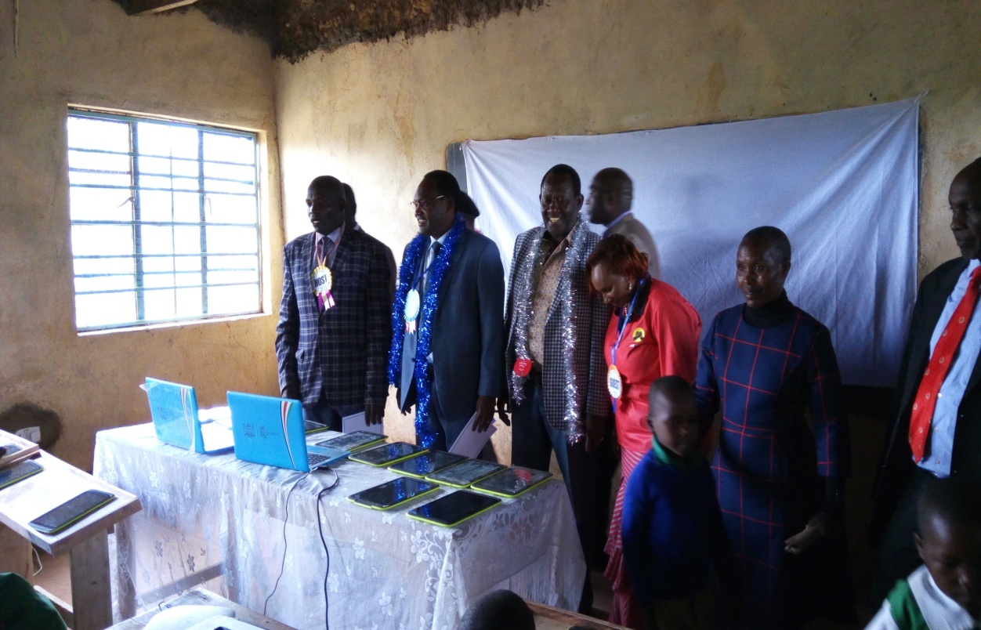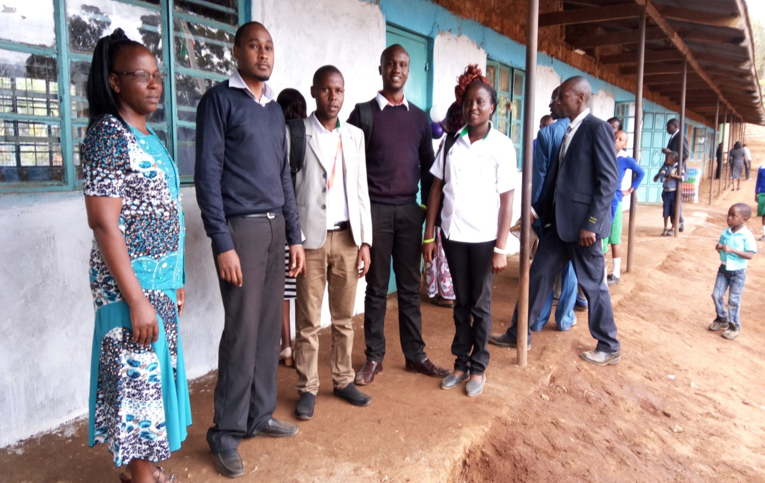

* + Digital Literacy Program Inspection

We carried out e-readiness inspection of 702 public primary schools inclusive of all new schools, 28 were not inspected because some are located in places with inaccessible roads during rainy seasons. Others schools could not be inspected due to the security threat visiting those location posed.

The means of transport used for inspection was boda boda which were fairly expensive and prone to accidents and theft of laptops.

During this exercise the following were some of the experiences we encountered.

* + - There are cases where we found out that laptops and tablets had been delivered to schools which had not yet been inspected at all. This is a clear proof that there was communication breakdown between JKUAT and ICT Authority.
    - The commitment towards the program differed across the schools in the county. While some schools were eagerly anticipating the roll out of the program, some had barely made any preparation. In several instances, the school heads had squandered the money they were allocated for preparing the strong room and the storage cabinet. This acted as a big hindrance for the program to be rolled out in these schools, because in most cases they were unable to raise funds to supplement the little that was remaining. In some other schools parents were asked to foot the costs.

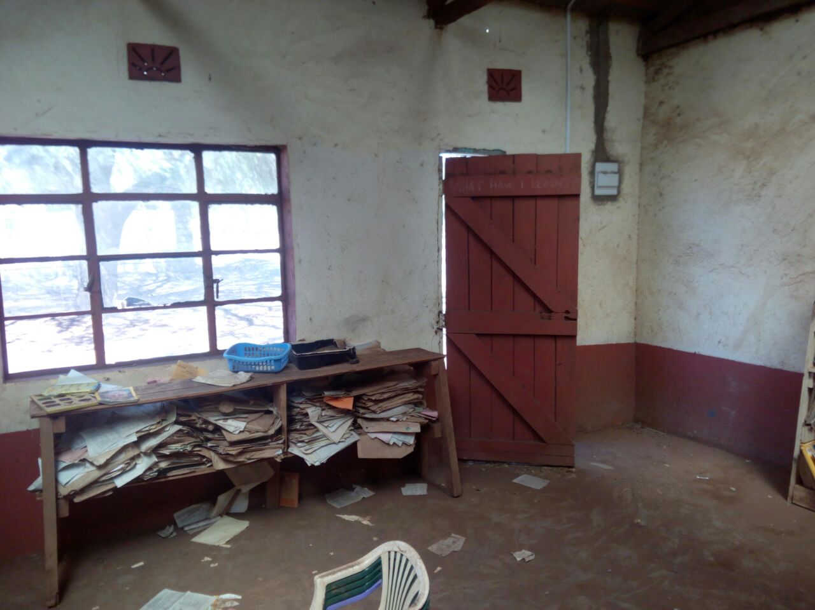

* + - In several cases the head teachers claimed the money allocated for Digital Literacy Program was inadequate.
    - In almost all the cases the deputy head teachers had little or no information on what progress the headteacher was making with the Digital Literacy Program work.
    - Most Board of Management Members were in support of the roll out of the program in the schools, though in a few cases, they revolted against it. One instance is Murara Primary School in Igembe North.
    - The number of schools connected to national grid is impressive yet those not, still remains significant. There are schools that are solar powered, which offers easier management. However the challenge with this type of connection is that once the systems stall, the schools can hardly find a technician to restore or repair and in most cases, contacting the firms that installed them are futile.
    - It was noted that security in most schools is of major concern. This is because of poor fencing and insecure gates.
    - In most schools pupils’ desks were inadequate, shaky and rough.
    - In cases where we were asked to talk to the pupils we found out that the term ‘tablet’ was new to them. Instead what they were conversant with were the terms ‘laptop’ and ‘computer’.
    - Some schools had class one and two classroom separated by plywood. There was a lot of interference during learning.
    - We inspected the training centers prior to the JKUAT training. The training centers were well prepared for the training considering the fact that they had reliable internet, adequate computers, projectors and desks.
  + Digital Literacy Program Training

We assisted JKUAT in carrying out training of teachers from Wednesday 14th December 2016 to Friday 16th December 2016. We noted the following:

* + - The number of schools with untrained teachers was high especially in Igembe North and South sub counties.
    - Newly promoted head teachers were not trained on ICTs.
    - All trained teachers claimed they had forgotten what they trained on since training was short, fast and they were not given devices to go practise with.
    - Several Learner's Digital Devices and a few Teacher's Digital Devices kept on hanging. This was a concern to teachers and they started requesting that technicians be stationed at every school after installation.
    - The rate of understanding the contnet taught was low. The teachers requested for prolonged trainings. They also highlighted that residential trainings are better than having to commute daily as it would allow more time for group discussions.

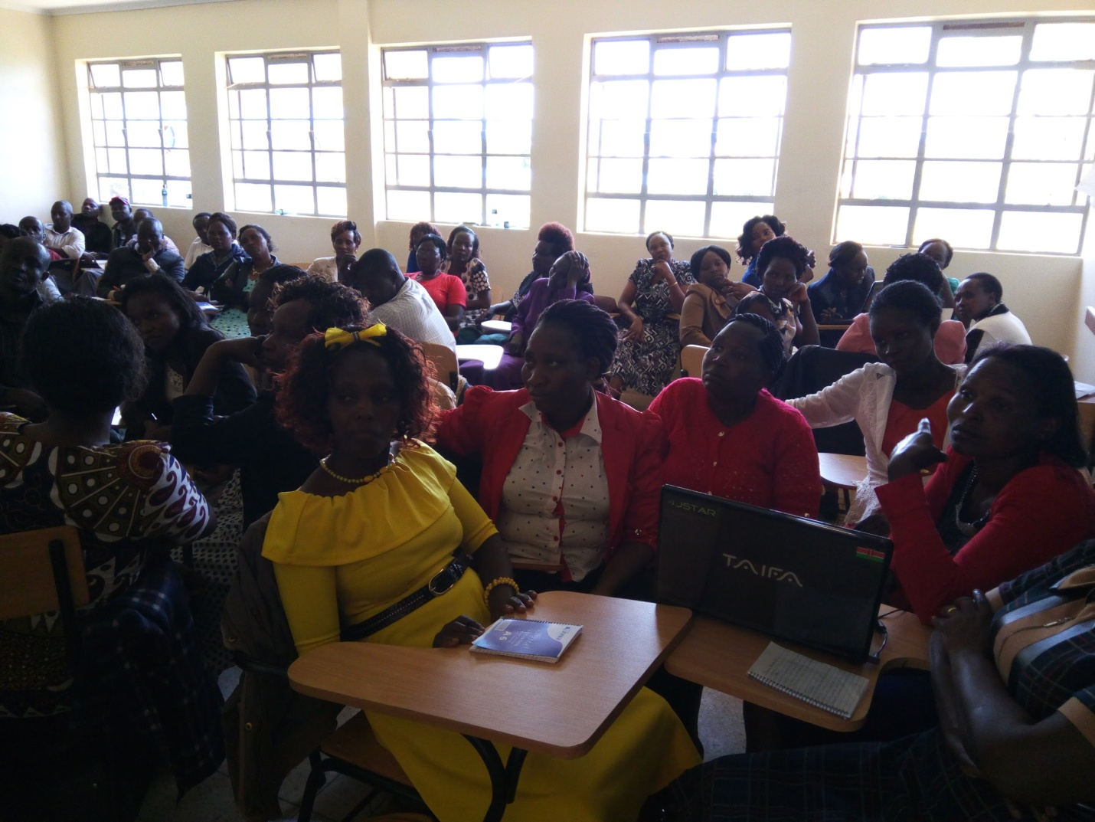

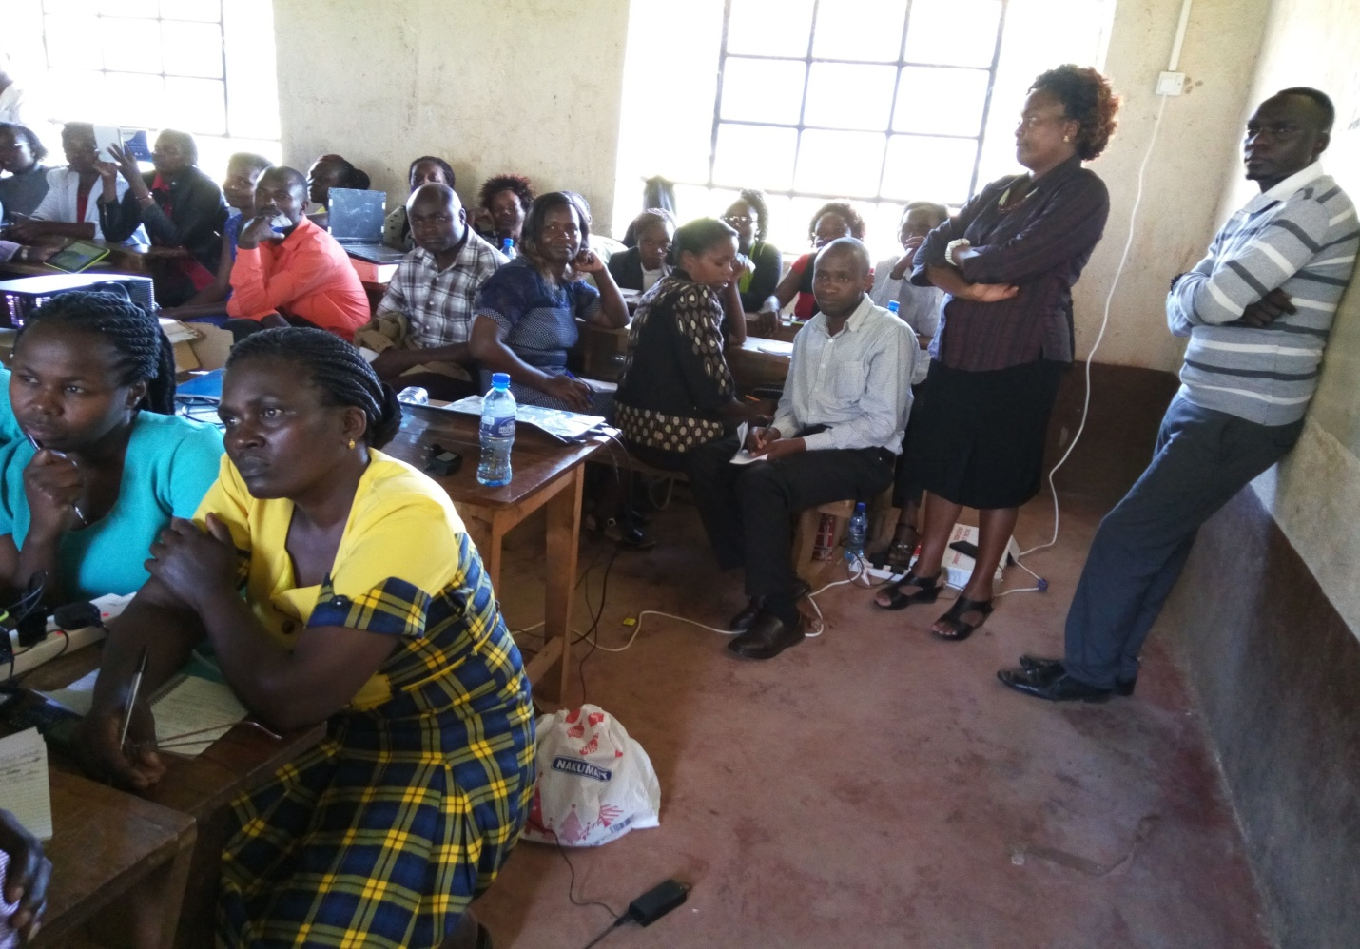

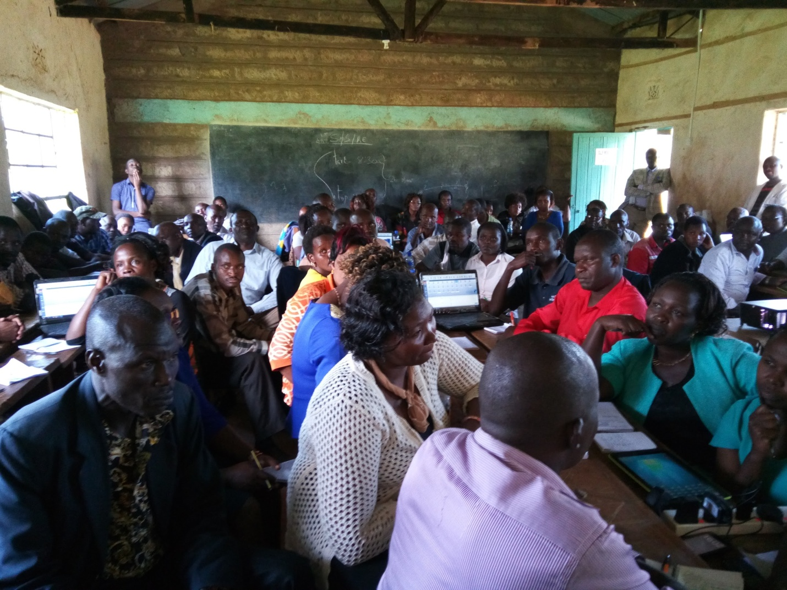

* Digital Literacy Program Achievements.

We made various achievements during the DLP launch, Schools Inspection and Teachers’ Training.

* + Digital Literacy Program Launch

The following are some of the achievements that we made during Digital Literacy Program launch:

* + - We supported devices installation in Digital Literacy Program launch in Meru County e.g. Ankamia Primary.
    - We gave technical support to teachers and pupils during Digital Literacy Program launch.
  + Digital Literacy Program Inspection

The following are the achievements that were made during Digital Literacy Program inspection:

* + - We managed to inspect 702 out of 730 schools. This was a great achievement.
    - We managed to mobilize the schools which had not built cabinets and strong rooms to do so.
    - Our inspection was a big hope for the schools that Digital Literacy Program is a reality.
    - We gave technical support to Digital Literacy Program proof of concept schools.
  + Digital Literacy Program Training

The following are some of the achievements that we made during Digital Literacy Program training:

* + - We gave JKUAT support during training of teachers by giving technical support to teachers.
* Digital Literacy Program Key Challenges
  + Settling Down In Meru County

The following are the challenges that we encountered at the Kenya National News Agency:

* + - The reception at Kenya National News Agency, Meru wasn’t good. This is because, there was no communication done to the head of the department by the time we arrived.
    - The internet bandwidth could only support 3 computers. This made working from the office difficult.
  + Digital Literacy Program Launch

The following are the challenges that we encountered during the Digital Literacy Program launch:

* + - There was no transport and lunch allowance provided.
  + Digital Literacy Program Inspection

The following are the challenges that we encountered during Digital Literacy Program inspection:

* + - Communication breakdown.

Some schools which had not been inspected received devices yet they were not ready. This demotivated the neighboring schools in e-readiness preparations.

* + - Poor roads.

Some areas had poor road networks lendering access of some schools difficult.

* + - Insecurity.

Some schools are in security prone zones making it a challenge to access them. E.g. Kachiuru Primary School which is located on the border of Meru County and Isiolo County.

* + - Harsh environment

Some areas were almost inaccessible due to the nature of their locations e.g. a school called Mukunga in Tigania East is located on a very steep rocky mountain.

* + - Uncooperative School Heads

Some school heads did not leave the relevant keys and information with their deputies when they were absent forcing the quality inspectors to revisit the schools for information.

* + - Inadequate funding.

The travel allowance was inadequate considering the number of schools we had to cover. Besides boda boda riders charged high fares.

* + - Inadequate personnel per school ratio.

This made revisits difficult. To try beat the deadline, for follow-ups we made calls to the schools to remind them of what they are supposed to achieve.

* + - Exposure to motorbike accidents.

Two quality inspectors fell off their motorbikes, one got a burn from the exhaust pipe.

* + - Power connectivity.

Not all schools are connected to power.

* + - Low ICT literacy.

Some schools had teachers not trained on ICTS. Teachers who were trained in other schools had forgotten what was taught.

* + Digital Literacy Program Training

The following are some of the challenges that we encountered during the Digital Literacy Program Training:

* + - Several Learner's Digital Devices and a few Teacher's Digital Device kept on hanging. This slowed down the training process.
    - Some teachers had no knowledge of ICTs at all and this slowed down the pace of training.
* Recommendations about Digital Literacy Program

Based on the challenges and experiences of the Digital Literacy Program the following are the recommendations that were arrived at:

* + We recommend that ICT Authority establish county offices with adequate capacity to support the processes and services, the ministry will be offering to the county. The need for a well furnished and fully resourced office is overwhelming in Meru county. This need will increase especially after the roll out of Digital Literacy Program and all the other program the ministry is undertaking in the counties.
  + It is necessary for ICT authority to deploy all Presidential Digital Talent Program Interns to the Digital Literacy Program since it requires a lot of technical support.
  + It is necessary for ICT Authority to ensure that the communications department does its work well to avoid communication breakdown between the various stakeholders supporting the program.
  + It is important that more funds are made available to the schools in building secure structures suitable for the Digital Literacy Program to be a success. The is a major concern of security in schools with no permanent structured buildings.
  + It is very important that community sensitization be done in order to ensure they protect the devices from theft.
  + It is necessary to prepare a standard specification of the storage cabinet and send it to all the head teachers through their education officers to avoid confusion.
  + If frequent trainings for the teachers are done it will help them grasp and remember what they are taught and hence propel the program to more success.
  + It is very important if appealing promotional packages are offered to teachers who undertake own ICT related courses. This will encourage teachers to do the ICT courses and will enhance their skills hence propelling the Digital Literacy Program.
* Conclusion

The Digital Literacy Program is one of the greatest programs the country has ever had. If well implemented it will also be one of the most successful projects in Kenya. This is because every public primary school and household will be connected to electricity. Electricity improves the quality of life of kenyans by providing clean lighting, enabling them to power computers and phones in order to access information that helps them in making informed decisions. Besides, many business which rely on electricity will come up, creating more income to Kenyans. Furthermore, if pupils begin using computers at an early age, we envision smart future leaders who will aid in propelling the economy of Kenya to new heights.

However, for these great things to be achieved, the project needs proper planning, more personnel, adequate financing and proper coordinated communication among stakeholders. Otherwise, we, the Meru County Quality Inspectors thank ICT Authority for offering us this opportunity to serve our country and we are more than willing to continue with our service both at the county level and national level.