# NETWORK REPORT

## Team Members:

|  |  |
| --- | --- |
| **Name** | **Email** |
| Joseph Kimani | josefkimani@gmail.com |
| Gladys Masaku | glads.macha@yahoo.com |
| Elizabeth Gitange | lizziegeta@gmail.com |
| Kennedy Koech | kkoech27@gmail.com |

# Objective of the learning as per the curriculum

Develop a critical mass of local high-end ICT skills  
Develop ICT ready workforce  
Increase digital literacy of citizens  
Strengthen the leadership and ICT human capacity of ICTA

# ICT structure

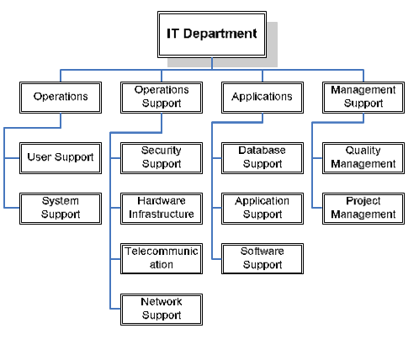

# Skills Learnt

|  |  |
| --- | --- |
| Category | Skills |
| Technical | * Knowledge of LAN technologies, Switches, Cables, Bridges * Routing Protocol Configurations * IP addressing, administrating subnets and various routing models * Installation and set up of routers and switches * Implementation of DHCP, DNS, FTP |
| Organizational | **Physical Organization**  **Planning**  **Teamwork**  **Collaboration**  Identifying Problems and Resources |
| Training Attended  Information security | Next Generation Fire walls  Web an Email Security  Policy and Access  Advanced Threat |

# Learning: What Can Be Applied To The Government

|  |  |
| --- | --- |
|  |  |
| Technology solution | Modern day collaboration tools should be used to facilitate faster and secure communication  New security technologies such as firewalls ,Web Authentication to be used to ensure the security of the government data |
| People | Senior People to be urged to embrace technology in a positive way. |
| Process | The Chain of command should be reduced in order to reduce the time taken to make decisions. |

# Challenges/issues/ Observations

There were no major challenges during the internship.

# Recommendations

To extend the duration of Private sector to at least four months to facilitate smooth and ample learning.

Look for more private sector partner companies to avoid attaching more than 5 interns in one private company.