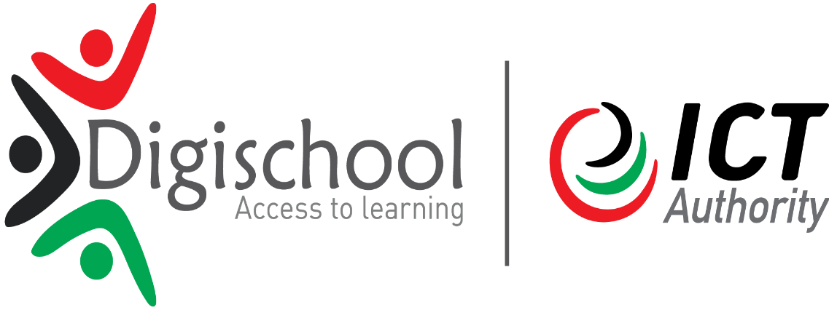

|  |  |  |  |  |  |  |  |  |  |
| --- | --- | --- | --- | --- | --- | --- | --- | --- | --- |
| **DIGITAL LITERACY PROGRAMME (DLP)** | | | | | | | | | |
| **Work plan for DLP QUALITY INSPECTOR** | | | | | | | | | |
| **Goal of the activities** | **To ensure successful implementation of DLP Programme in the Counties** | | | | | | | | |
| **Duration of activity** | **6 weeks from 19th June to 31st July 2017** | | | | | | | | |
| **Areas** | **Objective(s)** | **Activities (list the all the tasks)** | **Out put** | **Indicators /KPI** | **Duration** | | **Input** | **Status(use colors)** |  |
|  |  |  |  |  | **Start Date** | **Due date** |  |  |  |
| 1. Launching of schools | Coordinate and facilitate DLP launches in schools for awareness creation | Brief the head teacher on the launch programme and the requirements.  Set a date for the launch with the head teacher.  Follow up to ensure the schools scheduled for launched during the week are completed.  Attend some launches where appropriate and assist in the exercise. | Successful launches | No. of schools launched | 26th June | 31th July 2017 | AICTOs Approval | Completed.  Launches are 95% done in all the Sub counties in Migori County with exception of Uriri as a Sub-County. |  |
| 1. Teacher training | Facilitate digital knowledge transfer to teachers and offer technical support where needed. | Visit the school and conduct brief training to teachers on the setup and use of devices and provide technical support where necessary | Optimal utilization of DLP solutions in schools  Trained teachers | No. of schools using devices  No. of Teachers trained | 26th June | 31st July | AICTO and County Director of Education Approval | Completed.  Teacher training at the county and zonal level is at 95% with few zones yet to schedule training dates. |  |
| 1. School commissioning | Inspection and Acceptance of devices for commissioning | Assist AICTOs in verification of devices during Inspection and Acceptance process | Devices delivered as per specifications | No. of Schools Commissioned | 26th June | 31th July | AICTO approval | Completed.  School commissioning is completed in the County. |  |
| 1. E-Readiness assessment | Complete e-Readiness Assessment | Gather and provide information to enable implementation of the programme. | Information availed for successful implementation | No. of schools assessed | 26th June | 31th July | AICTO approval | Completed.  Quality inspection and E-readiness assessment in completed in Migori county. |  |

Note/Key

|  |  |
| --- | --- |
| Key | Remark |
|  | Complete |
|  | In progress |
|  | Delayed |

**DLP Quality Inspector’s Name: VICTOR OTIENO OWINO Signature: ………………………………… Date 31st July, 2017**

**AICTOs Name: ALEX GEOFFREY ODHIAMBO Signature ………………………………… Date 31st July, 2017**

**Note:** Inspection and Acceptance(I &A) of Devices **STRICTLY** remains the role of AICTOs and DLP Quality Inspector **SHOULD NOT** sign any I&A certificate but can assists in verifications of devices.