**CROPTIMIZE**

Design Specifications

STYLE GUIDE

**Font**

Lato - <https://fonts.google.com/specimen/Lato>

**Colors**

Content Colors:

Dark Blue #11566f – *Headings, Dynamic numbers*

*Teal Blue #118ba0* – Labels

Green #4e9c4a – Links, Buttons

Red – #f94444 – alerts, (high usage)

Background: gradient - (top) #ffffff - (middle) #b5dbdb - (bottom) #b7d7b9

**Graph Colors**

Extend through spectrum from

low usage: Blue #5da5bd

mid usage: Dark red #991a3d

High usage: Red #f94444

**Icons**

Light bulb 

Clock 

Battery 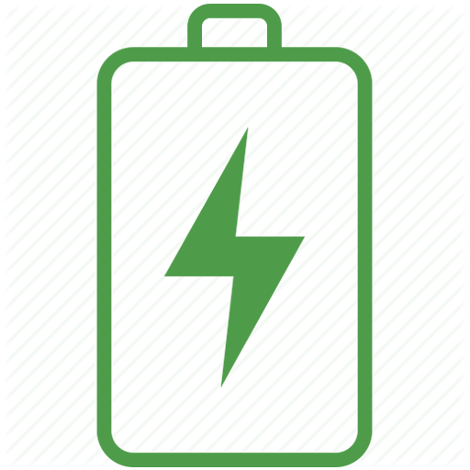

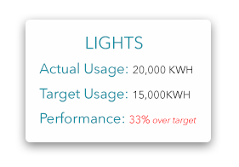Alert 

**Hover**

Rounded corners: 5px

Drop shadow

Transparent background: #ffffff, 90% opacity

**Graphs**

Peak demand chart: <https://www.highcharts.com/demo/combo-dual-axes>

Usage by category: <https://www.highcharts.com/demo/bar-stacked>

Performance Rose chart: <https://www.highcharts.com/demo/polar-wind-rose>

(this might work as well): <https://www.highcharts.com/demo/gauge-activity>

**User Onboarding**

Activation will begin with installing CURB hubs, creating Location configuration, and a user profile. Croptimize will own all locations they create in CURB system, and have a fleet-view of all profiles/locations through master credentials. Croptimize can then grant access to location owners, to that they can view their data, user profile, and configuration.

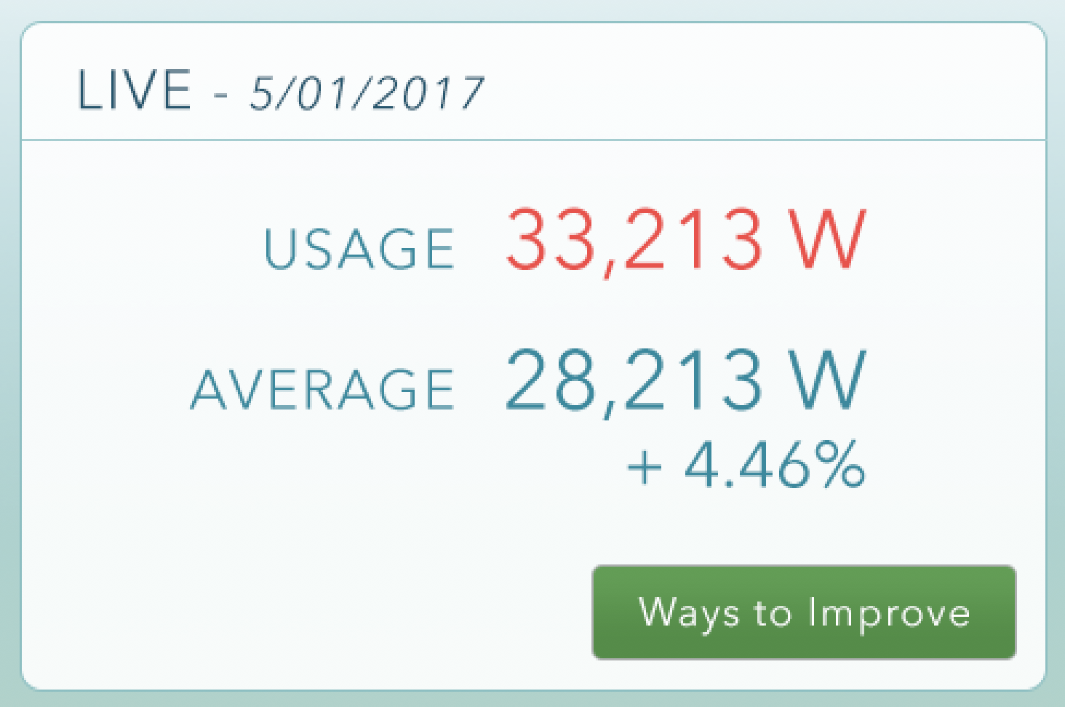

LIVE USAGE BOX

The live usage box will display the current live usage of the location in red.

The average usage for the day will be displayed underneath in blue. The Average % will display under the day’s average usage, and will dynamically change based on the current live usage. “Ways to Improve” button links to the Optimization modal window.

ALERTS

Alerts are comprised of notifications based on thresholds set by Croptimize on pre-determined categories or circuits. These will trigger when (other than average) activity is indicated on a circuit or category. Alerts will be listed on the Alerts page, from most current to least. Once the Alerts page has been viewed, the red alert notification will dismiss.

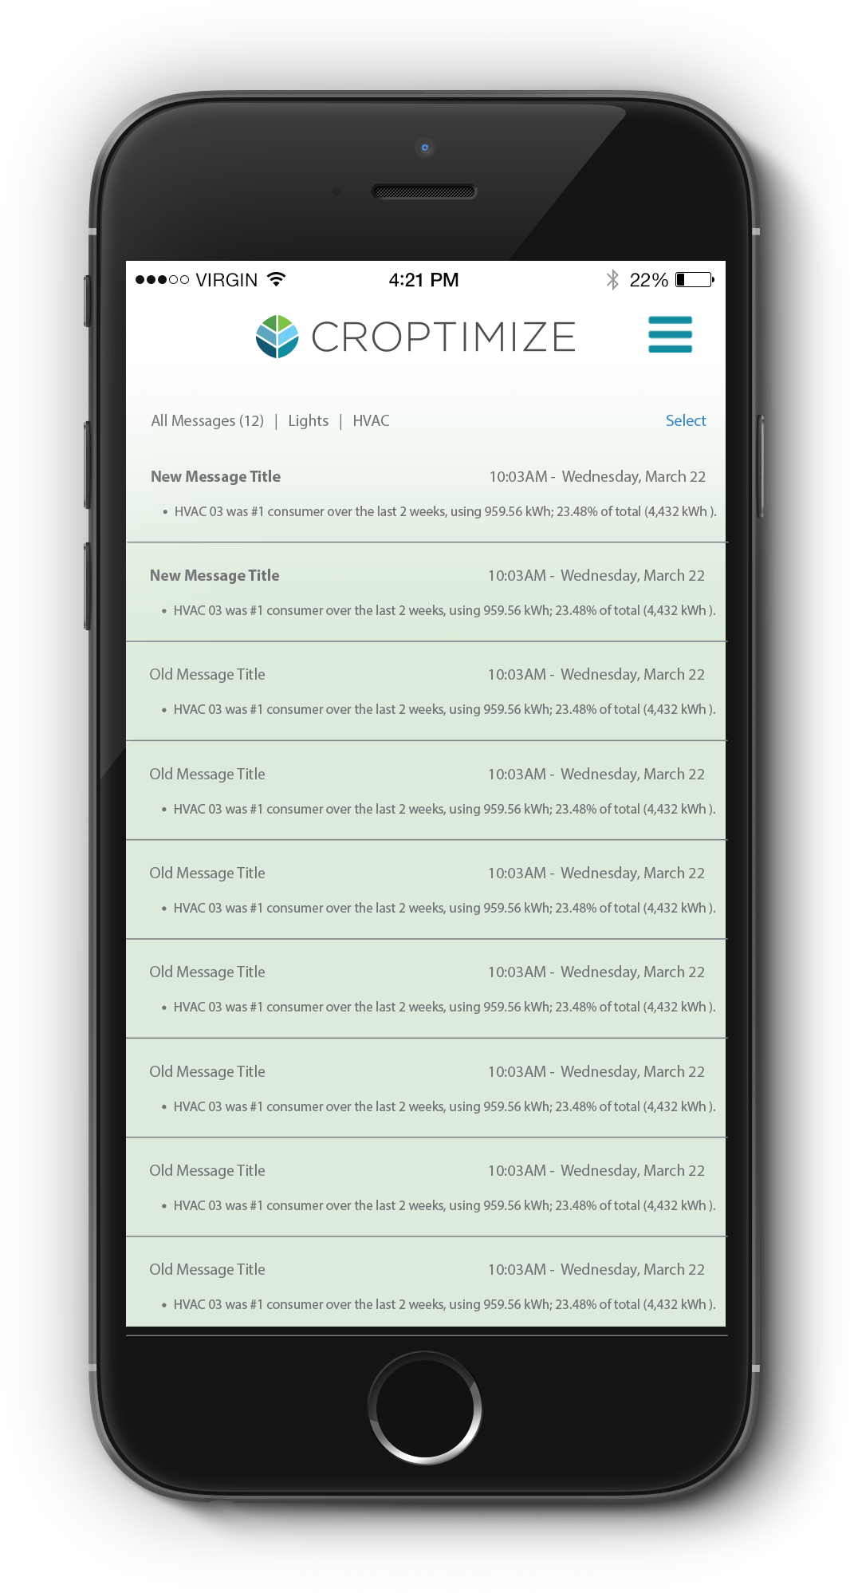

PERFORMANCE

This graph is displays a rose graph of the top categories within a location. If a user selects a part of the graph (or taps on it with mobile), that graph piece becomes highlighted, and a hover appears over it. The hover will display the “Actual Usage”, the “Target Usage”, and the “Performance” of the category. “Performance” is a calculated percentage by from the category being above or below its Target Usage.

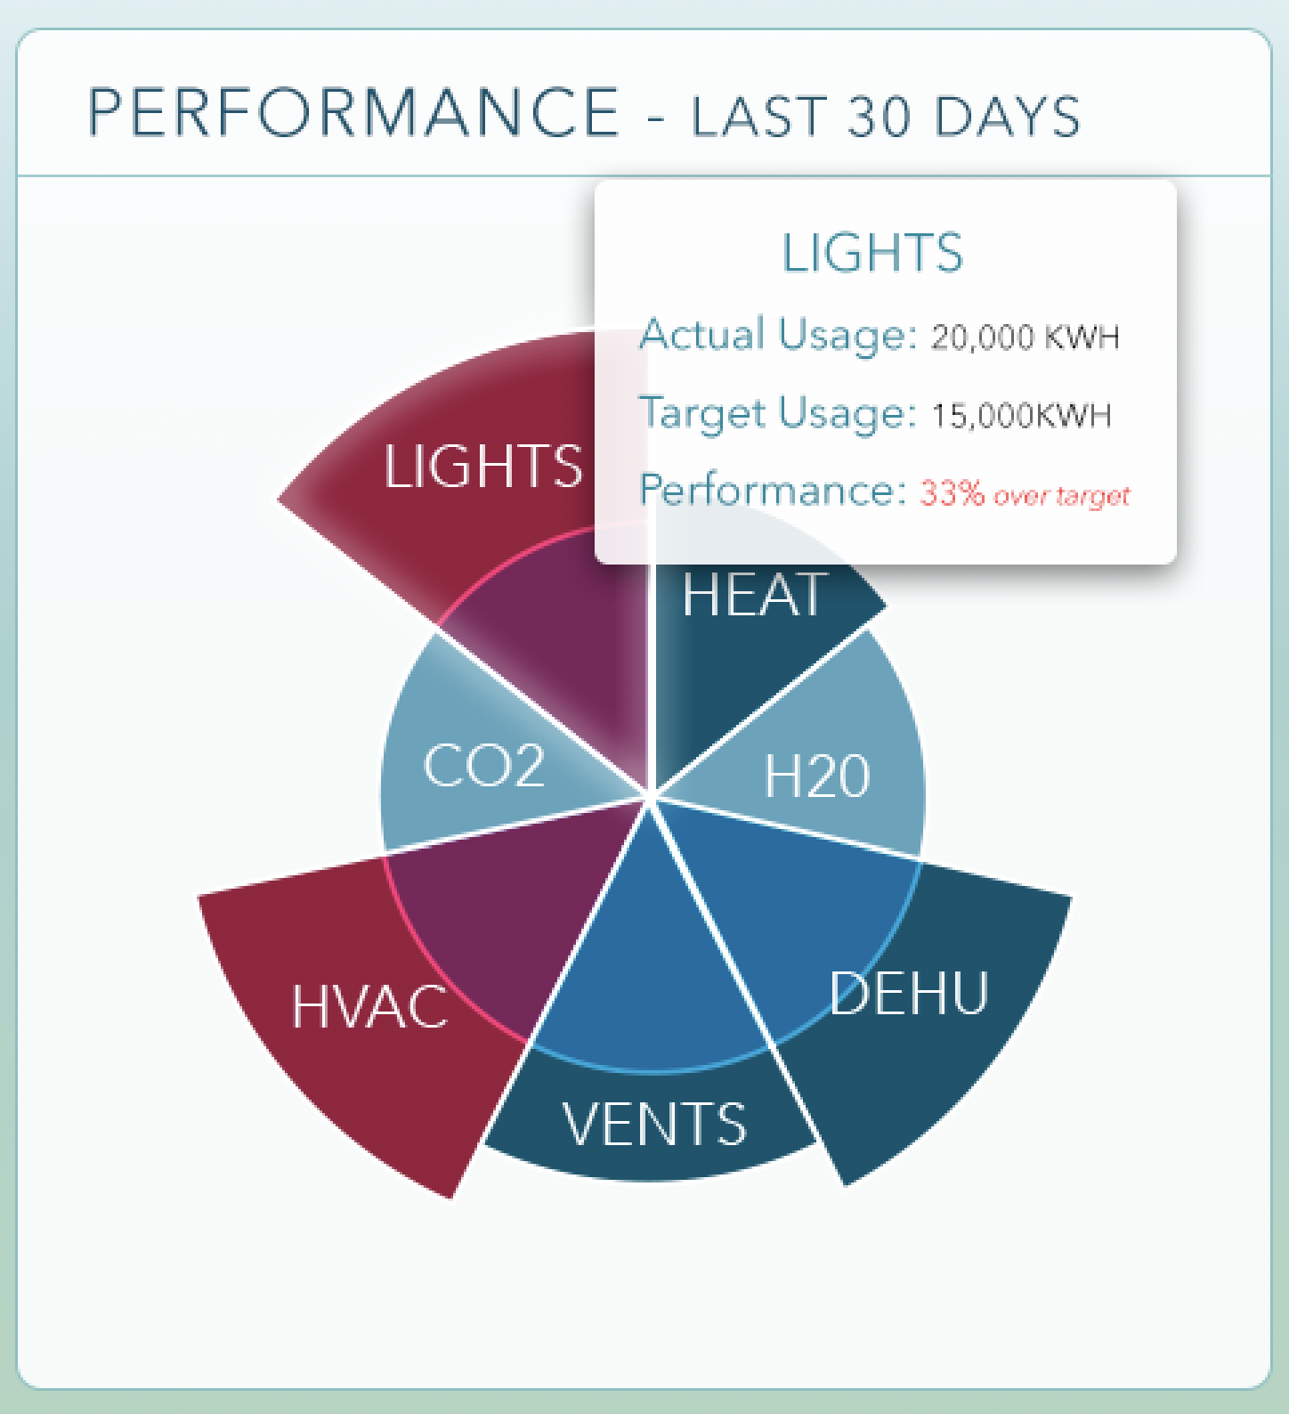

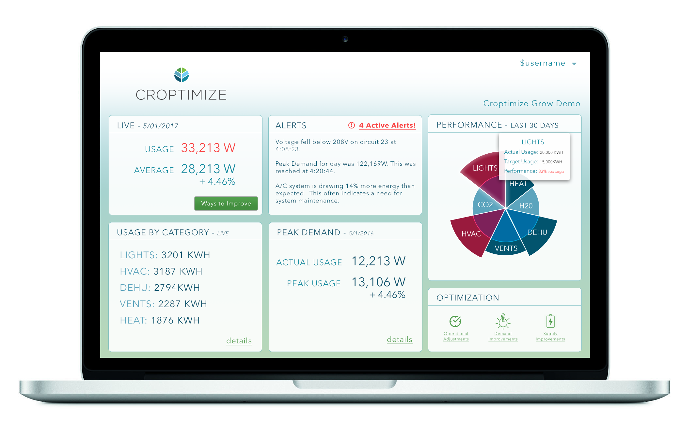

USAGE BY CATEGORY

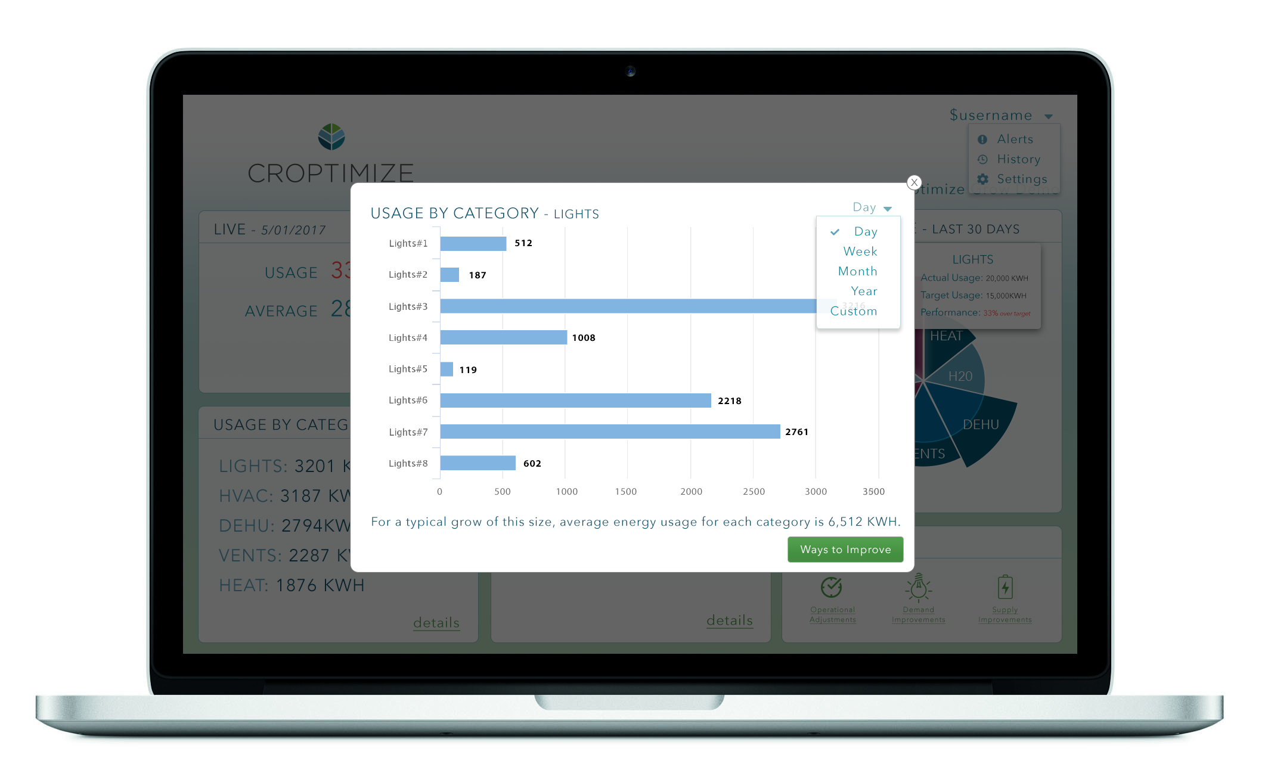This box shows data of the top 5 consumers by category within a location. If a user selects “details”, a modal window overlays the screen to give a horizontal bar chart perspective of the categories. If a user selects the category name (LIGHTS), it will then display a more detailed bar chart of the clamped circuits which make up that category name. Selecting the “X” in the right corner, or clicking off the window will dismiss the window.

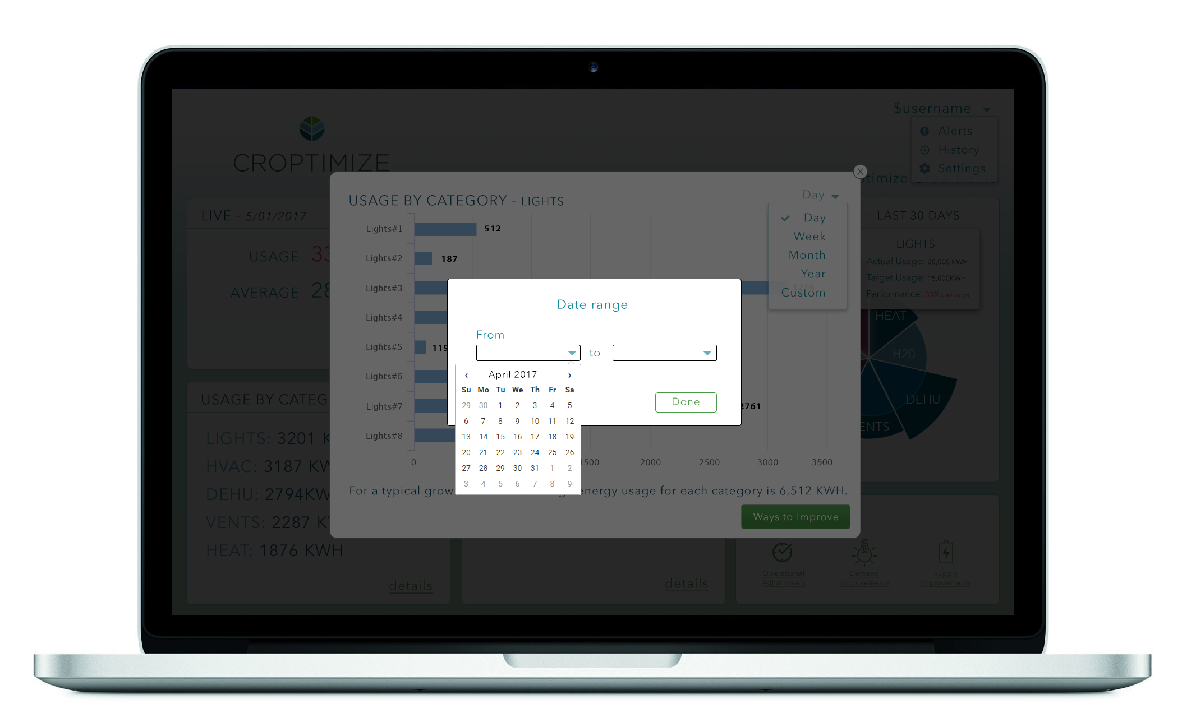Users can select to see data for the current day, week, month, year, or set a custom range.

PEAK DEMAND

The Peak Demand box shows the “Actual Usage” and “Peak Usage” for the current day. If the user selects the “details” link, a modal window overlays the screen and shows a bar chart of usage and peak usage (see screenshot). The user can determine the time range of data displayed in the chart. The “Ways to Improve” button directs users to the “Optimization” window.

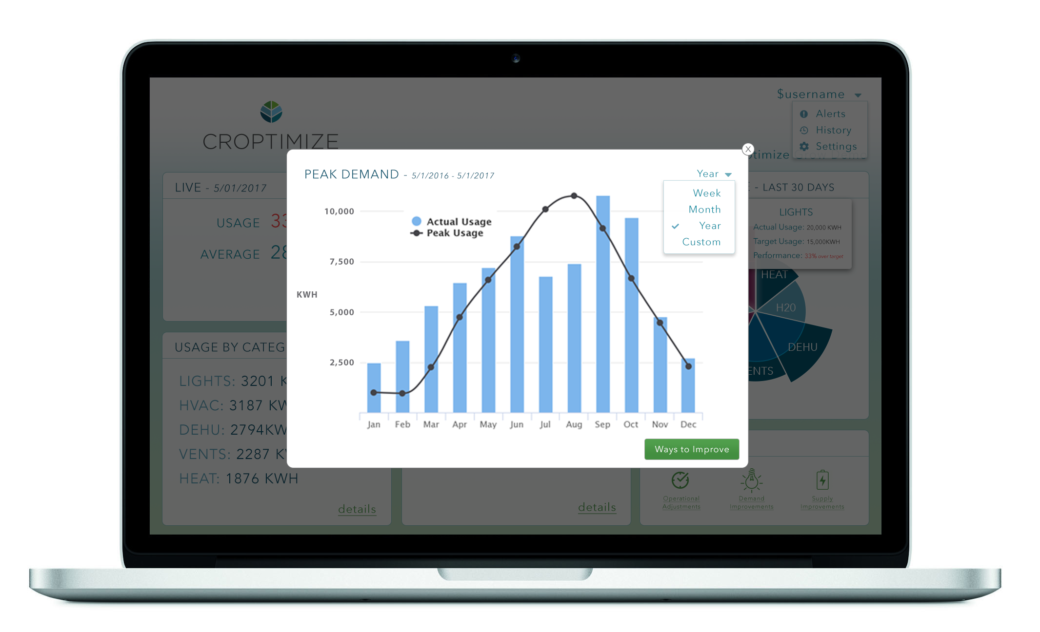

**OPTIMIZATION**

Each icon and associated text will link to the Optimization Modal window. This window will display the latest optimizations generated. These optimizations will be categorized by the main categories of the location (Lights, HVAC, etc).

**USER PROFILE**

Alerts – Alerts will display a list of all alerts, with unread alerts featuring red bold text in the title. Read alerts will have black text. All alerts will display in order of history.

History – History will give a list of optimization recommendations by date.

Settings – this will link to the CURB configuration screen – there is no branding on these pages (other than the title CURB Hub). The user will be able to change clamp configurations, polarity, add hubs, change location name, and edit the panel labels. This can be locked out or available only to Croptimize, based on preference.