Frontend Inspirations

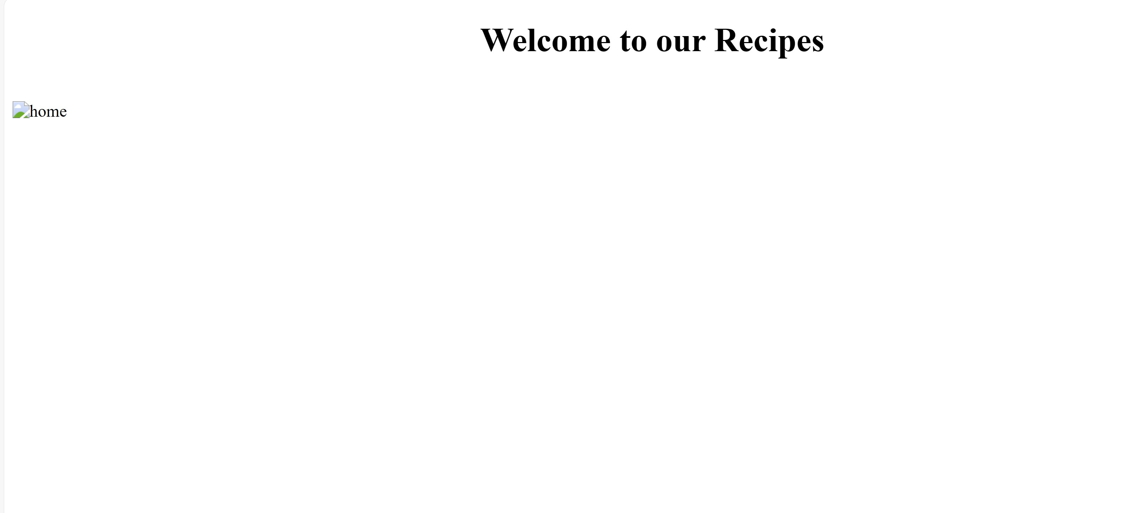

Some nice recipe applications:

[Recipe Guides – FRESHFARM](https://www.freshfarm.org/foodprints/foodprints-anywhere/recipe-guides?gclid=EAIaIQobChMImMelxb3YggMVKUZHAR3wqgPfEAAYAyAAEgJMQvD_BwE)

[Epicurious – Recipes, Menu Ideas, Videos & Cooking Tips](https://www.epicurious.com/)

[Allrecipes | Recipes, How-Tos, Videos and More](https://www.allrecipes.com/)

They are nice because they have usable and pleasant user interfaces. They have nicely fitting landing pages. They have many recipes and can scale at large. They have styled their images and text so they are readable.