BANK IT OPERATIONS

Multi-Agent Monitoring System

Technical Architecture & Solution Design Document

Version: | 1.0
Date: | April 2026
AI Engine: | Claude Opus 4.6 (Anthropic)
Platforms: | Dynatrace, Azure Monitor, Kibana/ELK
Classification: | Internal / Confidential

Table of Contents

1. Executive Summary
This document describes the architecture and design of the Bank IT Operations Multi-Agent Monitoring System — an AI-powered platform that provides unified, real-time visibility across the bank’s entire IT infrastructure.
The system employs seven specialist AI agents, each powered by Claude Opus 4.6 with adaptive thinking, to independently investigate Dynatrace APM, Azure Monitor cloud telemetry, Kibana/ELK log analytics, audit trails, PCI-DSS compliance, and Azure cost management. An orchestrator agent synthesizes their findings into a single, prioritized incident report for the CTO and on-call engineering teams.
Key capabilities of the system include:
- Concurrent multi-platform investigation across Dynatrace, Azure Monitor, and Kibana/ELK
- 36 specialized monitoring tools with mock-to-production swap capability
- Z-score anomaly detection against 7-day rolling baselines per service/metric
- Incident memory with TF-IDF cosine similarity for recurrence pattern matching
- Automated runbook execution with approval workflows
- PagerDuty escalation, Slack alerting, and threat intelligence enrichment
- Dark-themed live operations dashboard with 30-second auto-refresh
- PCI-DSS, SOX, and GDPR compliance monitoring with scorecard reporting

2. System Architecture

2.1 High-Level Architecture
The system follows a hub-and-spoke architecture where a central Orchestrator Agent coordinates six specialist agents operating in parallel. Each agent is a fully autonomous AI loop that independently investigates its platform, calls tools, evaluates results, and produces a structured report.
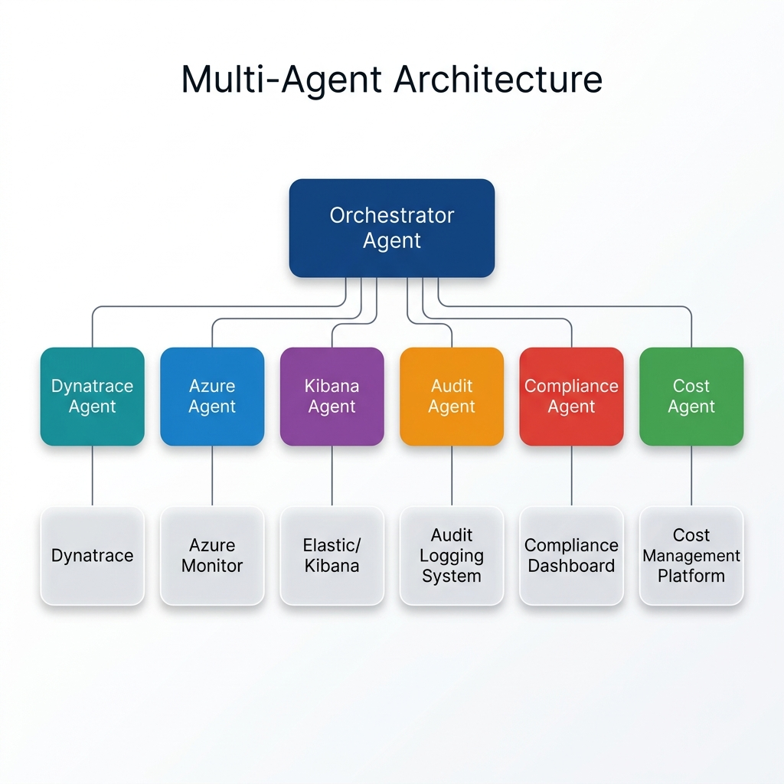
Figure 1 — Multi-Agent Architecture Overview

2.2 Component Summary
Component | Type | Responsibility
Orchestrator Agent | AI Agent (Claude) | Coordinates all agents, synthesizes unified incident report, determines escalation
Dynatrace Agent | AI Agent (Claude) | APM metrics, SLO compliance, synthetic monitors, database health, infrastructure
Azure Agent | AI Agent (Claude) | Cloud alerts, AKS health, KQL log queries, Defender for Cloud security
Kibana Agent | AI Agent (Claude) | Log analytics, SIEM events, APM traces, transaction analytics, alert rules
Audit Agent | AI Agent (Claude) | Privileged access monitoring, compliance violations, configuration drift
Compliance Agent | AI Agent (Claude) | PCI-DSS scorecard across 12 requirements, regulatory posture assessment
Cost Agent | AI Agent (Claude) | Azure spend anomalies, budget forecast, idle resources, RI coverage gaps
PostMortem Agent | AI Agent (Claude) | On-demand blameless post-mortem generation for resolved incidents
Analytics Engine | Python Module | Anomaly detection, alert correlation, metric forecasting, SRE burn rate
Incident Memory | JSON + TF-IDF | File-backed store with cosine similarity search for recurrence detection
Dashboard | Flask + Chart.js | 11 API endpoints, dark ops UI, 30s auto-refresh with ±8% jitter

3. Monitoring Workflow

3.1 End-to-End Flow
The monitoring cycle executes in four sequential phases:
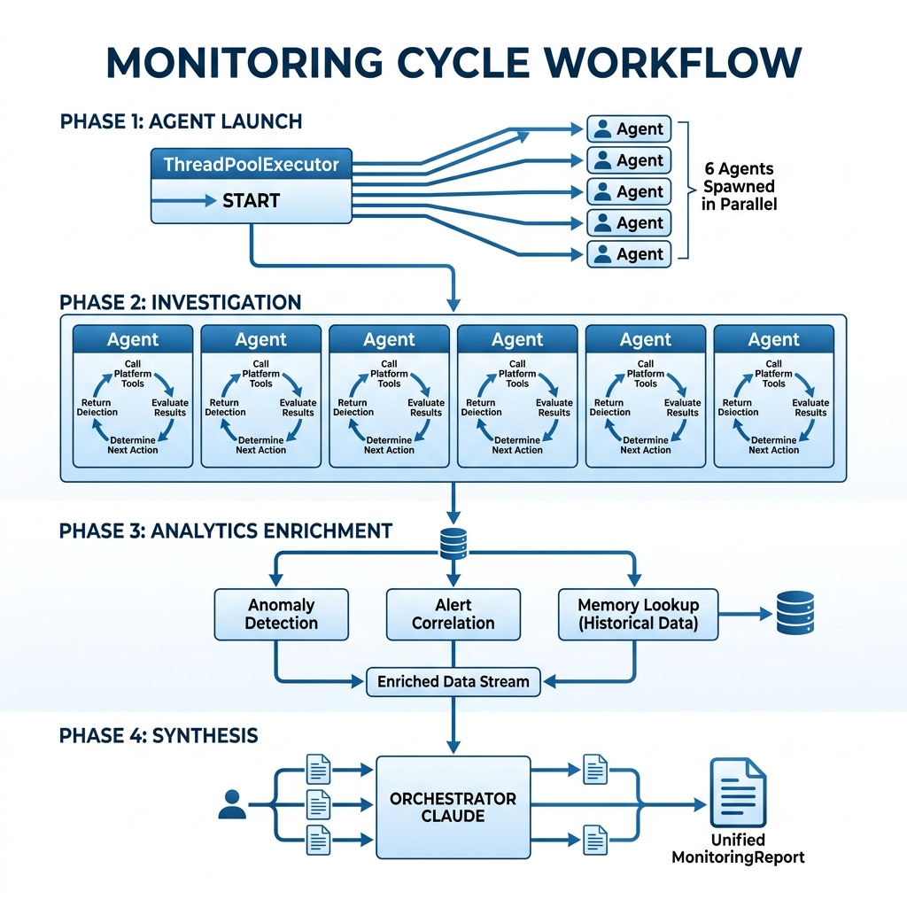
Figure 2 — End-to-End Monitoring Workflow

Phase 1 — Concurrent Agent Launch
The orchestrator spawns all six specialist agents simultaneously using Python’s ThreadPoolExecutor with max_workers=6. Each agent runs independently in its own thread, ensuring maximum parallelism and minimal wall-clock time.

Phase 2 — Autonomous Investigation
Each agent enters an agentic loop: it sends its system prompt and investigation context to Claude, receives tool call requests, executes them against mock (or real) platform APIs, appends results to the conversation, and repeats until Claude signals end_turn. The agent has full autonomy over its investigation strategy.

Phase 3 — Analytics Enrichment
Before synthesis, the orchestrator enriches the context with: z-score anomaly detection (baselines module), alert correlation (clustering by temporal/service similarity), incident memory search (TF-IDF against historical incidents), and a confidence score based on agent success rate and cross-platform agreement.

Phase 4 — Unified Synthesis
The orchestrator Claude instance receives all six AgentReport objects plus analytics context. It cross-correlates findings, identifies shared root causes, ranks incidents by business impact, and produces a structured report with executive summary, active incidents, immediate actions, and escalation recommendation.

4. Agentic Loop Pattern
Every agent in the system follows the same core loop pattern. Claude autonomously decides which tools to call, evaluates intermediate results, and determines when it has sufficient information to produce its final report.
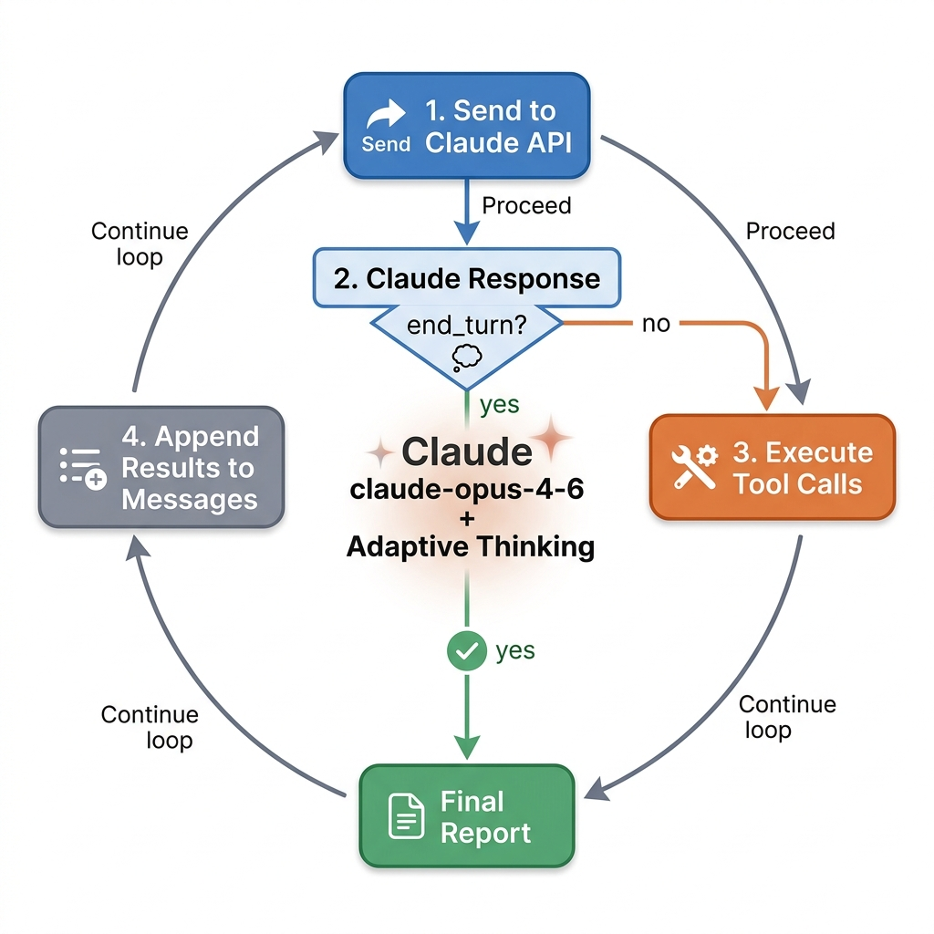
Figure 3 — Agentic Loop: Claude Autonomous Tool Execution

4.1 Loop Mechanics
- The agent sends its system prompt, conversation history, and available tools to the Claude API.
- Claude responds with either tool_use blocks (requesting to call tools) or end_turn (investigation complete).
- If tool_use: the system executes each requested tool and appends the results as tool_result messages.
- If end_turn: the final text content is extracted as the agent’s findings report.
- The loop continues until Claude naturally concludes its investigation (no hard iteration limit).

4.2 Adaptive Thinking
All agents use Claude’s adaptive thinking mode (thinking: {type: "adaptive"}), which allows Claude to allocate internal reasoning effort proportional to problem complexity. For routine checks, Claude thinks briefly; for complex correlation tasks or ambiguous findings, it engages deeper reasoning chains.

5. Data Flow Architecture
Data flows from monitoring platforms through tool layers, into AI agents, through the orchestrator for synthesis, and out to multiple delivery channels.
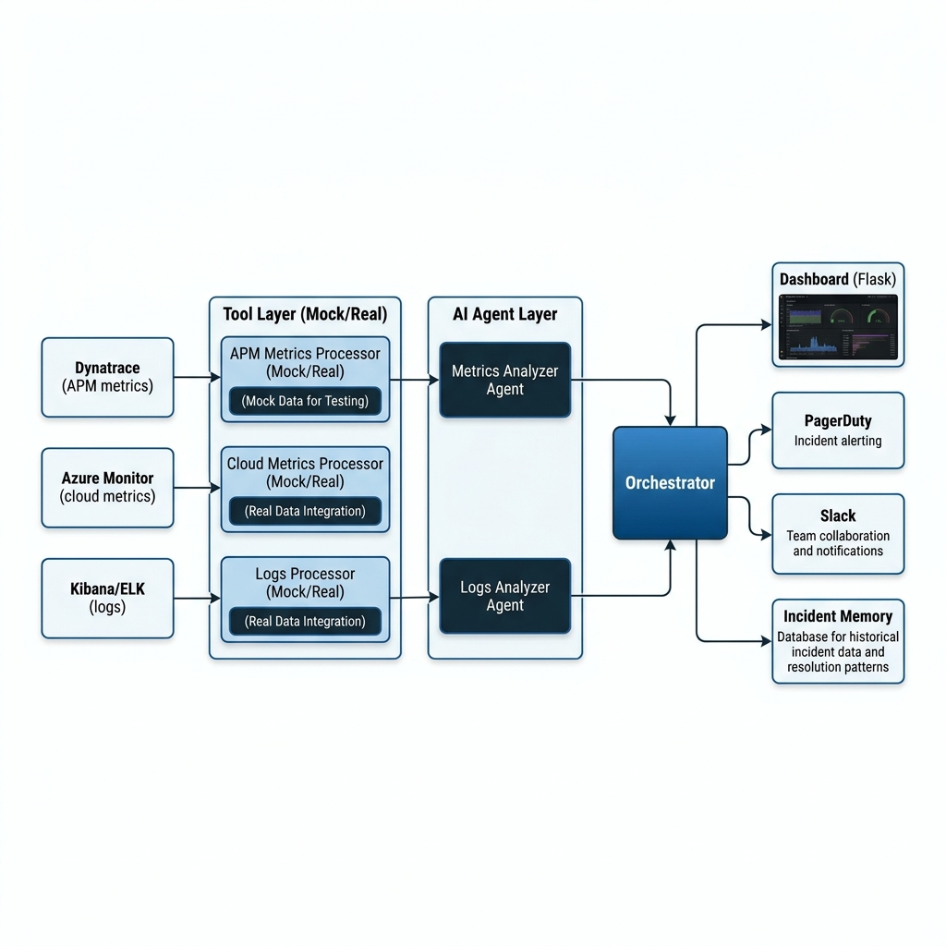
Figure 4 — Data Flow from Platforms to Delivery

5.1 Tool Layer (Mock → Production)
Each platform has 6 tool definitions (JSON schemas) and corresponding mock executor functions. The swap strategy is simple: replace the private _get_* function body with real API calls while keeping the tool schema and dispatcher unchanged. Agents never call tool executors directly — they only see JSON schemas.

5.2 36 Tools Across 6 Platforms
Platform | Tools (6 each)
Dynatrace | get_problems, get_service_metrics, get_infrastructure_health, get_slo_status, get_synthetic_monitors, get_database_metrics
Azure Monitor | get_active_alerts, get_resource_metrics, query_logs (KQL), get_aks_cluster_health, get_security_alerts, get_service_health
Kibana/ELK | search_logs, get_error_rate_aggregation, get_security_events, get_transaction_analytics, get_alert_rules_status, get_apm_traces
Audit | get_compliance_violations, get_privileged_access_log, get_data_access_log, get_config_changes, get_failed_auth_summary, get_key_vault_access
Compliance | get_pci_scorecard, get_encryption_status, get_access_control_review, get_vulnerability_scan, get_network_segmentation, get_pen_test_status
Cost/FinOps | get_daily_spend, get_anomalies, get_top_resources, get_budget_status, get_idle_resources, get_reserved_instance_coverage

6. Banking Services Monitored
The system monitors 8 core banking services. Each has a defined priority, SLO target, and current mock health profile used consistently across all tools and the dashboard.

Service | Priority | Error Rate | p90 SLA | SLO Target | Mock Status
payment-gateway | CRITICAL | 4.70% | 500ms | 99.9% | CRITICAL — SLO violated
core-banking-api | CRITICAL | 0.85% | 1000ms | p95 < 2s | WARNING — p90=1850ms
fraud-detection | HIGH | 0.05% | 100ms | p99 < 500ms | Healthy (CPU issue)
auth-service | HIGH | 0.01% | 100ms | 99.99% | Healthy
transaction-proc | HIGH | 1.20% | 500ms | — | WARNING — 1.2% errors
swift-connector | HIGH | 0.10% | 2000ms | — | Healthy
account-mgmt | MEDIUM | 0.10% | 500ms | — | Healthy
atm-network | MEDIUM | 2.10% | 1500ms | 99.5% | HIGH — SLO violated

7. Analytics Engine
The analytics layer provides four capabilities that enrich the orchestrator’s synthesis with quantitative context.

7.1 Anomaly Detection (baselines.py)
Computes 7-day rolling P95 baselines per service/metric. Detects anomalies using z-score deviation with a configurable threshold (default: 2.5σ). Context-aware: a 4.7% error rate on payment-gateway is 36.2σ above baseline (critical), while the same rate on a batch service might be normal.
Service | Metric | Current | Baseline | Z-Score | Severity
payment-gateway | error_rate | 4.70% | 0.35% | 36.2σ | CRITICAL
atm-network | error_rate | 2.10% | 0.55% | 12.9σ | CRITICAL
core-banking-api | p90_ms | 1850ms | 820ms | 17.2σ | CRITICAL
fraud-detection | cpu_pct | 94.2% | 71% | 2.6σ | MEDIUM

7.2 Alert Correlation (correlation.py)
Groups related alerts into incident clusters using temporal proximity (alerts within 15-minute windows) and service dependency analysis. Reduces alert noise by identifying that multiple alerts across Dynatrace, Azure, and Kibana often have a single root cause.

7.3 Metric Forecasting (forecasting.py)
Projects metric trends using linear regression over recent data points. Used to predict SLO breaches before they occur (e.g., if error_rate is trending up at 0.5%/hour, forecast when it will breach the 5% critical threshold).

7.4 SRE Burn Rate (burn_rate.py)
Implements Google SRE’s multi-window burn rate alerting. Measures how fast error budget is being consumed across 1h (fast, threshold: 14x) and 6h (slow, threshold: 3x) windows. If both windows breach simultaneously, immediate escalation is triggered.

8. Incident Memory & Runbooks

8.1 Incident Memory Store
The system maintains a file-backed incident memory store (JSON) that persists all monitoring reports. When a new incident occurs, the system searches for similar past incidents using TF-IDF cosine similarity — no external vector database required.
The store is seeded with 6 realistic historical incidents covering common banking failure modes:
- INC-00001: Payment gateway certificate expiry (clearing-house TLS rotation failure)
- INC-00002: Core banking DB degradation (missing index after schema migration)
- INC-00003: Credential stuffing attack from Tor exit nodes
- INC-00004: ATM network availability drop (disk I/O saturation during log rotation)
- INC-00005: PCI-DSS violation — PAN data in application logs + ML CPU saturation
- INC-00006: SWIFT connector SLA breach (SWIFTNet congestion)

8.2 Automated Runbooks
The system includes 6 pre-defined runbooks for safe automated remediation. Each specifies trigger conditions, the action command, risk level, required approvals, estimated downtime, and rollback procedure.
ID | Runbook | Risk | Approval | Downtime | Target
RB-001 | Restart Redis Session Cache | Low | No | ~30s | redis-session
RB-002 | Scale AKS Node Pool | Medium | Yes | 0s | payment-gateway-aks
RB-003 | Block IP at WAF | Low | Yes (SOC) | 0s | authentication-service
RB-004 | Flush Oracle Connection Pool | Medium | Yes (DBA) | ~120s | core-banking-api
RB-005 | Rotate Log Level (DEBUG→INFO) | Low | No | ~30s | payment-gateway
RB-006 | Terminate ML Training Job | Low | No | 0s | fraud-detection

9. External Integrations
The system integrates with three external services for incident management, team communication, and threat intelligence enrichment. All integrations have mock fallbacks and can be enabled/disabled via environment variables.

9.1 PagerDuty (pagerduty.py)
Triggers incidents via the PagerDuty Events API v2. Supports incident creation with severity levels, dedup keys for preventing duplicate pages, and programmatic resolution. Active incident listing and on-call schedule retrieval are also supported.

9.2 Slack (slack.py)
Posts structured alert messages to designated ops channels (#it-ops-alerts, #runbook-approvals). Messages include severity badges, affected services, and deep links to the dashboard and relevant runbooks.

9.3 Threat Intelligence (threat_intel.py)
Enriches suspicious IP addresses and file hashes using AbuseIPDB and VirusTotal APIs. When the Kibana agent detects credential stuffing or brute-force attacks, the threat intelligence module provides reputation scores, geographic origin, and known malware associations.

10. Operations Dashboard
The dashboard provides real-time visibility into the bank’s IT operations through a dark-themed, auto-refreshing web interface built with Flask and Chart.js.
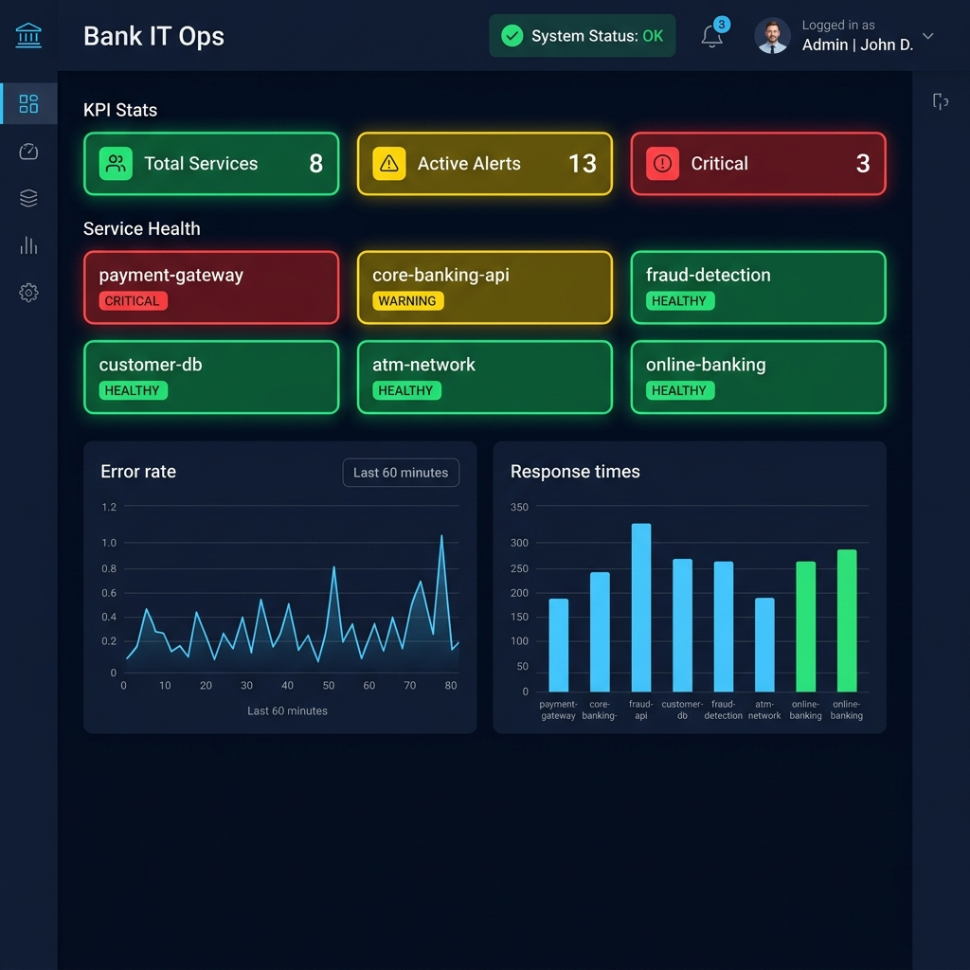
Figure 5 — Dark Ops Dashboard Screenshot

10.1 Dashboard Components
Section | Data Source | Behavior
Top Bar | — | Last refresh time + 30s countdown bar
Agent Status Row | /api/dynatrace, /api/azure, /api/kibana | Agent name, status badge, alert counts
KPI Stats Bar | /api/services, /api/alerts | Total services, active alerts by severity
Service Health Grid | /api/services | 8 cards with error rate, p90, availability, SLO badge
Error Rate Chart | /api/charts/error-rates | Line chart, 60-min history, 5 services
Alert Feed | /api/alerts | Scrollable list with severity and source tags
Response Time Chart | /api/charts/response-times | Grouped bar: p50/p90/p99 per service
SLO Compliance | /api/slos | Table with progress bars, burn rate, status
Transaction Volume | /api/charts/transaction-volume | Line chart, 4 transaction types
Infrastructure Heatmap | /api/charts/infrastructure | 6 hosts, CPU/memory bars with color coding
Orchestrator Panel | /api/orchestrator | 6 ranked incidents + immediate actions table

10.2 API Endpoints
The Flask backend exposes 11 JSON API endpoints. All numeric metrics are passed through a jitter function (±8% random variation) on each request, making the dashboard feel live without requiring real data changes.

11. Data Models
All agents return typed Python dataclasses. No raw dictionaries are used in inter-component communication.

11.1 Core Data Structures
Model | Key Fields | Purpose
Severity | CRITICAL > HIGH > MEDIUM > LOW > INFO | Alert severity classification enum
AlertStatus | OPEN | ACKNOWLEDGED | RESOLVED | Alert lifecycle status enum
Alert | id, source, severity, title, service, timestamp | Individual alert from any platform (Dynatrace, Azure, Kibana)
ServiceHealth | name, status, error_rate, response_time_ms, availability | Per-service health snapshot with active alert count
AgentReport | agent_name, platform, alerts[], raw_findings | Output from each specialist agent (typed, not raw dict)
MonitoringReport | overall_status, *_report, incident_summary, escalation | Orchestrator output aggregating all agent reports

12. Configuration & Deployment

12.1 Environment Variables
All secrets and configuration are loaded from environment variables via .env file and the config.py dataclass hierarchy. The system never hardcodes credentials.
Variable | Example | Used By
ANTHROPIC_API_KEY | sk-ant-api03-... | All agents
DYNATRACE_BASE_URL | https://tenant.live.dynatrace.com | Dynatrace tools
AZURE_TENANT_ID | xxxxxxxx-xxxx-xxxx-xxxx-xxxx | Azure Monitor tools
KIBANA_BASE_URL | https://kibana.bank.internal:5601 | Kibana tools
PAGERDUTY_API_KEY | (routing key) | PagerDuty integration
SLACK_BOT_TOKEN | xoxb-... | Slack integration
CRITICAL_ERROR_RATE | 5.0 | Threshold config
BURN_RATE_FAST | 14.0 | SRE burn rate alerting

12.2 Running the System
Command | API Key? | Description
python dashboard/app.py | No | Launch live dashboard at http://localhost:5000
python demo.py | No | Print all mock tool data to console (no AI)
python main.py | Yes | Full 6-agent + orchestrator AI cycle
python main.py --agent dynatrace | Yes | Run single agent only
python main.py --output report.txt | Yes | Save full report to file

13. Extending the System

13.1 Adding a New Monitoring Platform
The architecture is designed for easy extension. To add a new monitoring platform:
- Create tools/newplatform_tools.py with 6 tool JSON schemas and mock executors
- Create agents/newplatform_agent.py with a system prompt and the standard agentic loop
- Add the agent to the orchestrator’s ORCHESTRATOR_TOOLS list and _run_all_agents_concurrently()
- Add a Flask endpoint in dashboard/app.py for the new platform

13.2 Adding a New Tool to an Existing Platform
Even simpler — no agent code changes needed:
- Add the tool schema to the relevant *_TOOLS list
- Add a handler entry in the execute_*_tool() dispatcher
- Implement the mock function — agents will automatically discover and use the new tool

13.3 Replacing Mock Data with Real APIs
Each tool file contains clearly marked _get_* private functions returning mock data. The swap strategy: replace the function body with real API calls while keeping the tool schema and dispatcher unchanged. Example for Dynatrace:
Replace the mock _get_problems() body with a real requests.get() call to the Dynatrace Problems API v2.

14. Security & Compliance Considerations
- All credentials stored in .env (never committed to git via .gitignore)
- PCI-DSS compliance agent monitors all 12 requirements with scorecard reporting
- Audit agent tracks privileged access, key vault reads, and configuration changes
- Runbooks with approval workflows prevent unauthorized automated actions
- Post-mortem agent generates audit-ready RCA documents for SOX/PCI review
- Threat intelligence enrichment for IP reputation scoring on detected attacks

— End of Document —

