**Collective Data Science for Connected and Autonomous Vehicles**

**Berkeley Deep Drive Seminar  
University of California, Berkeley**

**Wednesday, February 12, 2020**

Berkeley Way West 8019  
1:00 - 2:00 pm

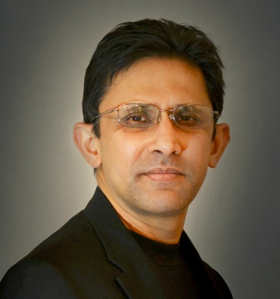

**Hillol Kargupta**

President and Chairman of the Board  
Agnik Group

**Abstract:**

Data science is playing an increasingly important role in connected and autonomous vehicle technology. Vehicle health modeling, driver scoring, fuel cost optimization, and autonomous navigation are just some of the many areas where data-driven technology is disrupting the market, impacting not only our experience with vehicles, but almost all aspects of our life. This talk will focus on the technology for the next generation of connected and autonomous vehicles that are driven by the collective interdependent activities of vehicles, powered by distributed data science algorithms and applications running in a collection of vehicles. It will start by identifying a few applications in the areas of vehicle parts inventory management, insurance claims processing, health-care and location-based services where distributed edge analytics onboard the vehicle and in-cloud may make more sense compared to their centralized counterparts. Next, it will offer a perspective on how these applications can be addressed by adapting the current generation of connected vehicle products that are scaling rapidly worldwide. The talk will also discuss analytical foundations for developing a new generation of collective data science algorithms geared towards such distributed applications. It will end with a historical perspective of the speaker’s commercial and academic experience in building connected vehicle products and some of the related research areas that are emerging in the horizon.

**Biography**

Hillol Kargupta is a co-founder and the President of Agnik Group, a distributed data science business for connected cars and devices. Agnik is the owner of popular consumer brands like Vyncs (https://vyncs.com). Dr. Kargupta is an IEEE Fellow. He has more than 25 years of experience in computing and business leadership. He received his Ph.D. in Computer Science from University of Illinois at Urbana-Champaign in 1996. He was a Professor of Computer Science at the University of Maryland, Baltimore County until 2014 before cofounding and joining Agnik. He published more than 100 peer-reviewed articles and several edited volumes. His team received many awards such as the 2010 Frost & Sullivan Enabling Technology of Year Award, 2016 Fleet Logistics Tech Outlook Top-10 Fleet Management Solution Provider for smartphone-based telematics product, CIO Review 2015 20 Most Promising Automotive Technology Solution Providers, IEEE Top-10 Data Mining Case Studies Award. Dr. Kargupta won the IEEE ICDM 10-year Highest Impact Paper Award in the field of Privacy Preserving Data Mining, IBM Innovation Award in 2008 and the National Science Foundation CAREER award in 2001 for his research on ubiquitous and distributed data mining. His other awards include the 2003 IEEE International Conference on Data Mining for a paper on privacy-preserving data mining, Best of 2008 SIAM Data Mining Conference (SDM'08) and Most Interesting Paper of WebKDD'06. He also won the 2000 TRW Foundation Award, 1997 Los Alamos Award for Outstanding Technical Achievement, and 1996 SIAM annual best student paper award. He served as the associate editors for IEEE Transactions for Knowledge and Data Engineering, IEEE Transactions on Systems, Man, and Cybernetics. and conference chairs for many leading conferences such as the SIAM Data Mining Conference, IEEE Conference on Data Mining, ACM SIGKDD among many others.