Setting up the Build Path to Compile and Run Selenium Applications in Eclipse (Kepler release)
The procedure described below works for me in getting programs that make calls to Selenium WebDriver to compile, execute, and sometimes return expected results in the Eclipse IDE environment. I am working in the Kepler release of Eclipse.
On the need to keep Selenium current
Applications that make calls to Selenium appear to be sensitive to the version of Selenium that is being invoked. If the version of Selenium is not “correct”, that is, if there is what I believe to be a mismatch between the version of Selenium and that of the browser of interest, the application may not run right. The symptoms may be that the browser of interest cannot be brought up or the browser may not be able to connect to the URL of interest. To make a long story not quite as long, the current version of Selenium needs to be present on the build machine and its libraries included in the application build path. As of this writing, the current Selenium version is 2.48.2. If the machine on which Eclipse is running does not have this version of Selenium present, here is how to download and set it up to be used in Eclipse.
Downloading Selenium
- Bring up a browser and go to http://docs.seleniumhq.org/download/
- Click on the Download link for Java as shown in the picture.
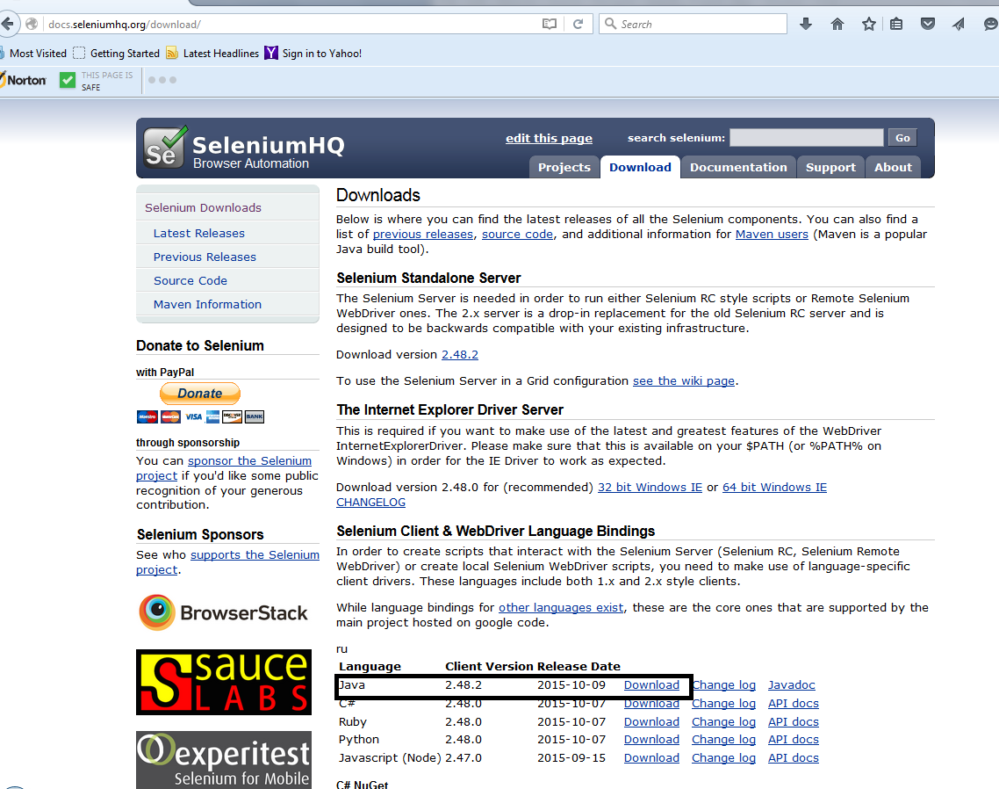
Figure 1 - Selenium download page

This will download a file called selenium-java-2.48.2.zip .
- Place this file in a directory where you will want your Selenium libraries to reside. This location is based strictly on what is convenient to you. For example, I have used a directory called C:\Users\Paul\Documents\SeleniumStuff\SeleniumWebDriver , where SeleniumStuff is where I put everything I do that is related to Selenium, and SeleniumWebDriver is where I put the Selenium releases I have accumulated over the years.
- Extract the contents of the ZIP file. I accept the default values for the extraction and end up with a directory called selenium-java-2.48.2 which resides in the same directory as the ZIP file. This directory has a subordinate directory called selenium-2.48.2. Directory selenium-2.48.2 has a subordinate directory called libs and some files. To the best of my knowledge, the most important of these files is selenium-java-2.48.2.jar.
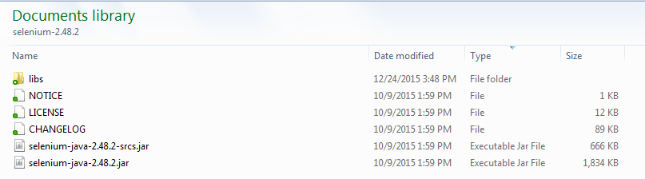
Figure 2 - The selenium-2.48.2 directory

Adding Selenium Libraries to an Eclipse IDE Project
Selenium libraries need to be added to the Java project that will be making Selenium WebDriver calls. As I am working in the Eclipse IDE (Kepler release), this is the procedure I use to accomplish this. I do not know if this is optimal, but it works for me.
- In the Eclipse IDE, bring up the Package Explorer. Right-click on the project of interest. From the context menu that appears, select Build Path . From the context menu that appears, select Configure Build Path … The Properties window shown in Figure 3 should appear.
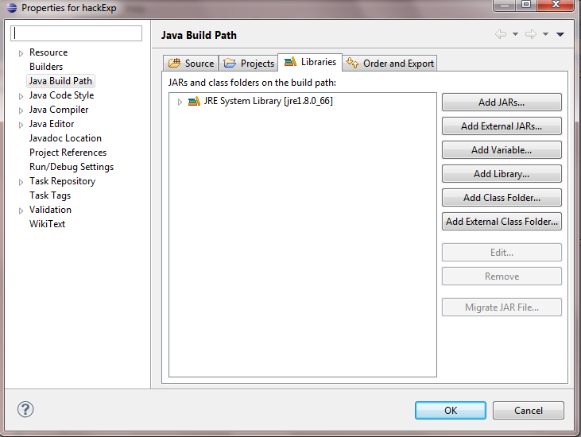
Figure 3 – Properties window with Build Path selected
- Verify that Java Build Path is selected from the left-hand pane of this window. Verify that the Libraries tab is on top in the right-hand pane. If there are .jar files shown in the Libraries tab, you can get the full path for any of them by hovering the cursor over any of the files of interest as shown in Figure 4. If there are Selenium-related .jar files present that are not of the desired version (usually the current version) they will have to be removed. Select the files to be removed (click on file at the top of the list of those to be removed, then Shift + click on the file at the bottom of the list for a range of files, or Ctrl + Click to select multiple files from within the list), then click on the Remove button.
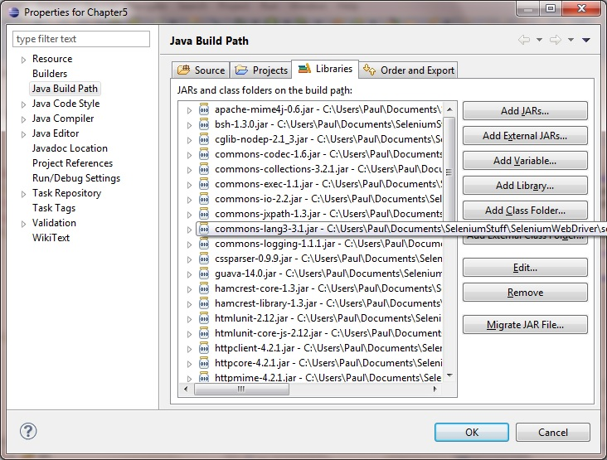
Figure 4 - Build Path window with existing JAR files
- Click on the Add External JARs … button. Navigate to the selenium-2.48.2 directory shown in Figure 2, above. Click on the selenium-java-2.48.2-jar file to add it as an external .jar, then click on the OK button.
- Click on the Add External JARs … button again. Navigate to the selenium-2.48.2 directory shown in Figure 2, above, then double-click on the libs directory shown to open it. When you open it, there should be a number of .jar files listed. Select them all (click on the top file in the list, then go to the bottom file in the list, hold down the left shift key and click on the bottom file to select them all). Click on the OK button to add these files to the build path.
I do not know if all these .jar files are needed but I do not know which ones are not at this point so I just add them all.

