**Please follow the following steps to Activate or Deactivate the Process Builder**

Setup🡪Process Builder🡪Select the process Builder which one you want to activate/Deactivate

**Step by step screen shots are given below.**

**Lightning Screen**

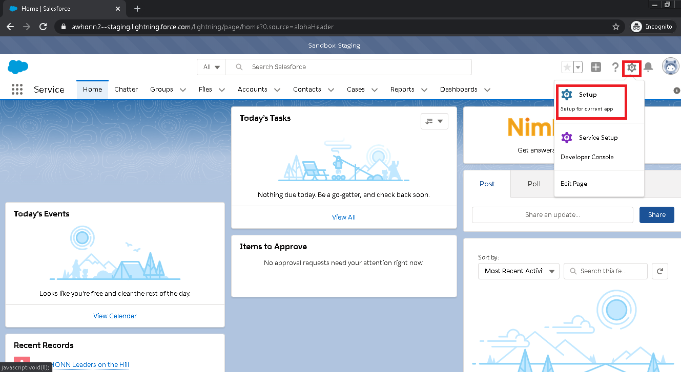

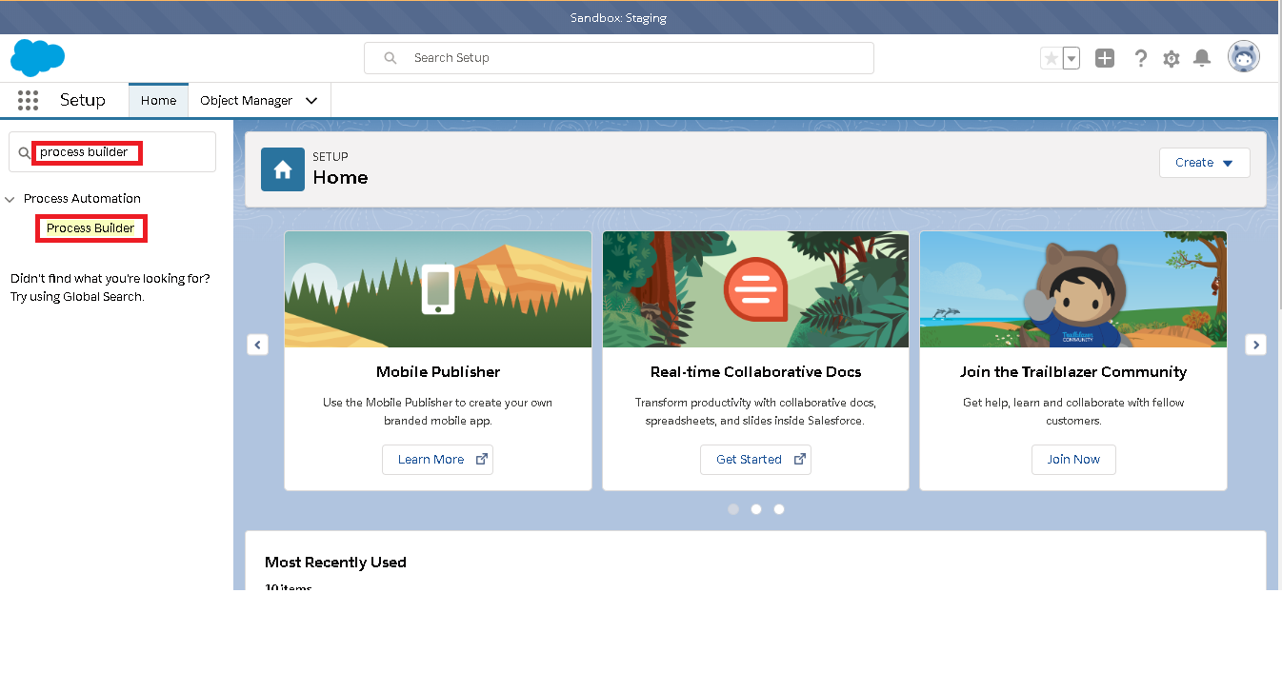

**Classic Screen**

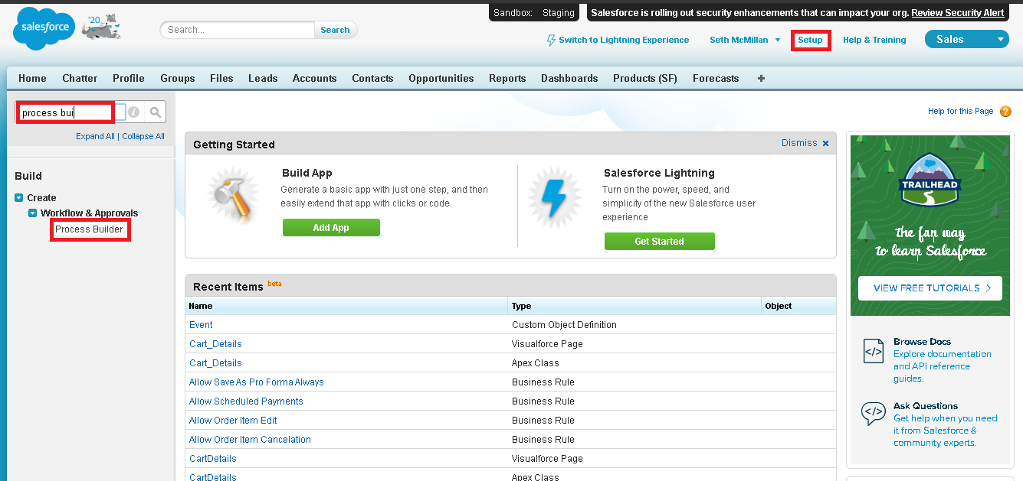

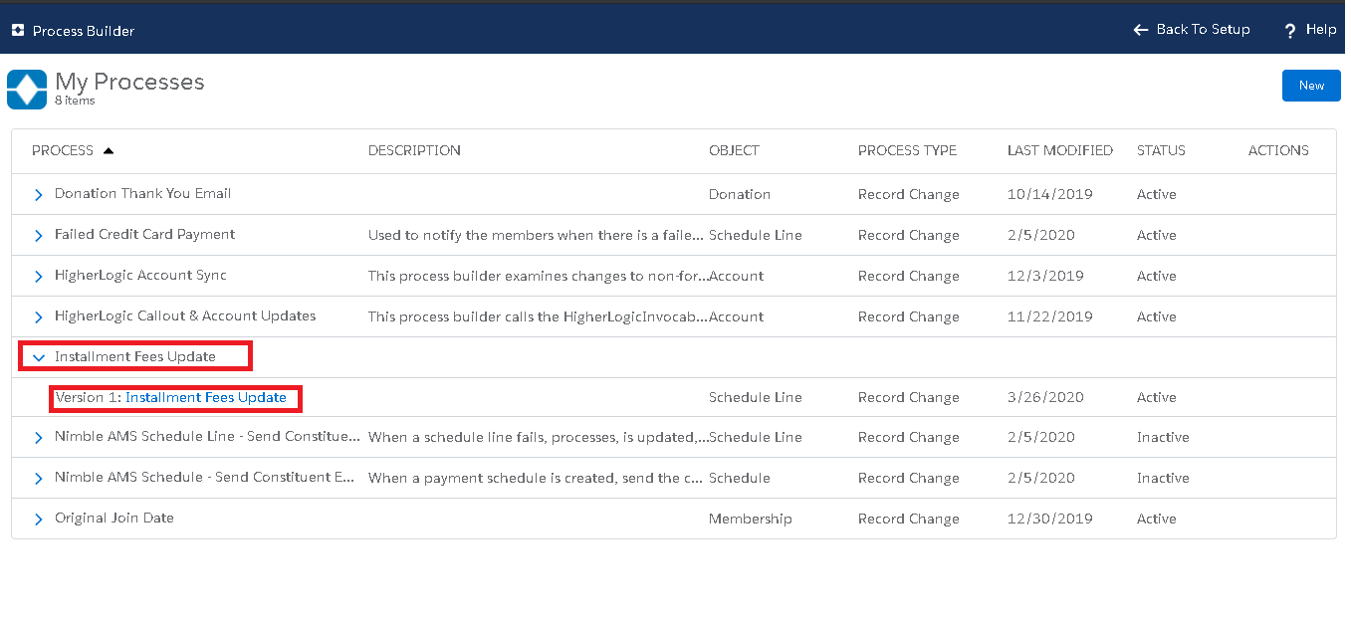

Now process is in activate state so Deactive button is showing. If process is in deactive state Activate button will be display.