MAJOR ASSIGMENT
GROUP PROJECT
MEMBER NAMES: PARKHA KASHAF ZEB(14745)
SABA GUL(15277)

Pakistan Football Tournament Manager
Project Documentation

1. PROJECT OVERVIEW
The Pakistan Football Tournament Manager is a web-based application developed to manage football tournaments digitally. The system helps tournament organizers manage teams, players, matches, scores, and tournament results in an efficient way. It provides digital tools for scheduling matches, recording scores, generating standings, and managing user roles. The system reduces manual work, minimizes errors, and ensures smooth, professional, and real-time management of local and national football tournaments.

2. Objectives
- Provide a professional platform for football tournament management.
- Reduce manual work and paperwork.
- Manage teams, players, matches, and results digitally.
- Generate tournament standings and match schedules.
- Improve transparency and accuracy in tournament management.

3. Technologies Used
- Frontend: HTML, CSS, JavaScript
- Backend: PHP
- Database: MySQL
- Server: XAMPP

4. Main Features
- Admin Login System
- Dashboard Management
- Add / Delete Teams
- Add / Delete Players
- Match Scheduling
- Tournament Management
- Responsive User Interface

5. System Modules

Login Module
Allows admin users to securely log into the system.

Team Management
Admins can add, update, and remove football teams.

Player Management
Stores and manages player details.

Match Management
Schedules football matches and stores match results.

Tournament Management
Handles tournament information and standings.

Dashboard
Provides a summary of tournament activities and statistics.

6. Database Design
The project uses a MySQL database to store tournament information. The database contains tables such as:
- users
- teams
- players
- matches
- tournaments
- venues

7. WEBSITE OVERVIEW

Login Page


Dashboard


Dashboard Statistics
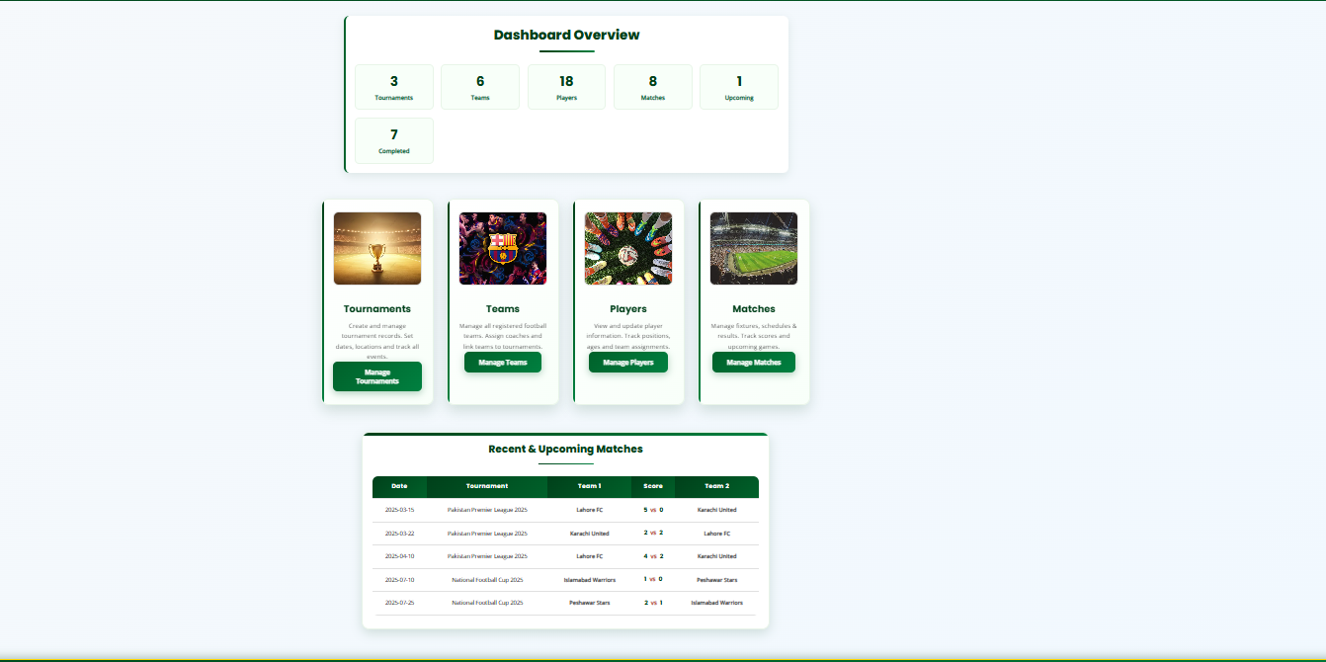

Team Management
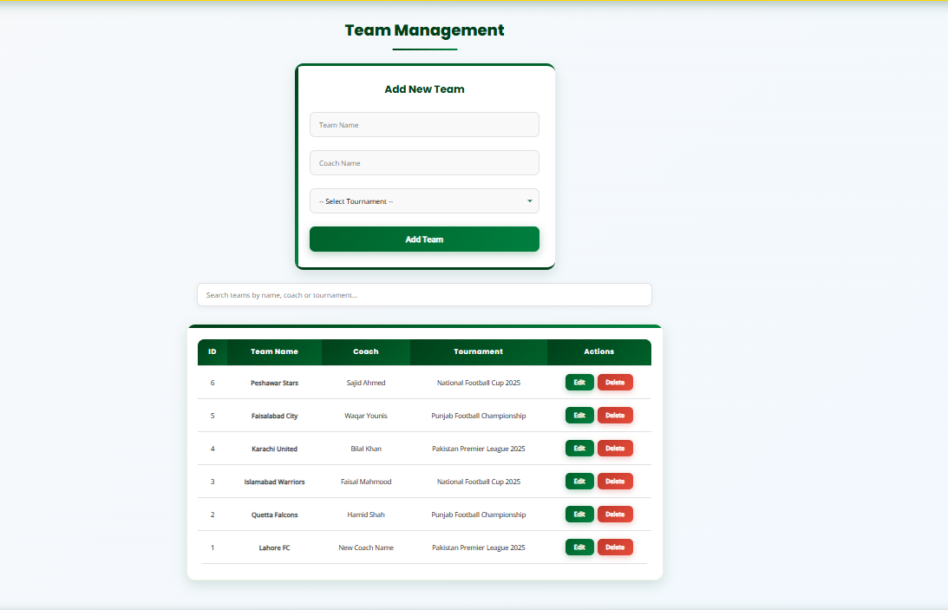

Add Team Form
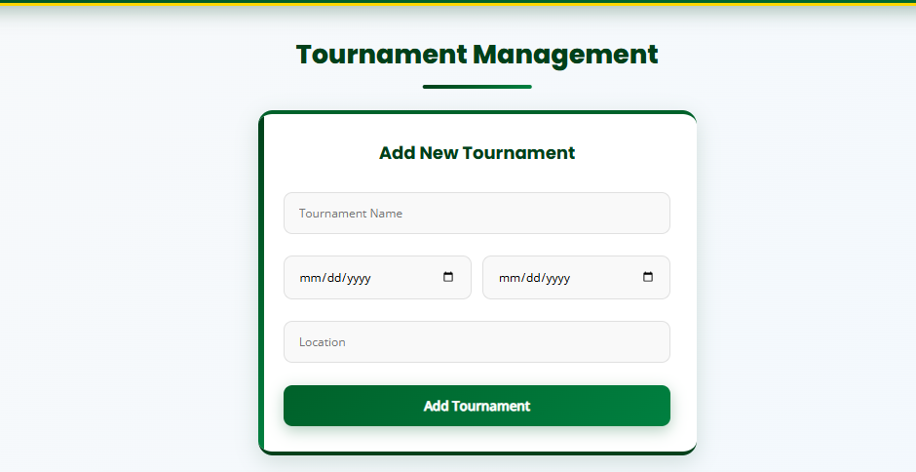
Add Team Form

Players Management
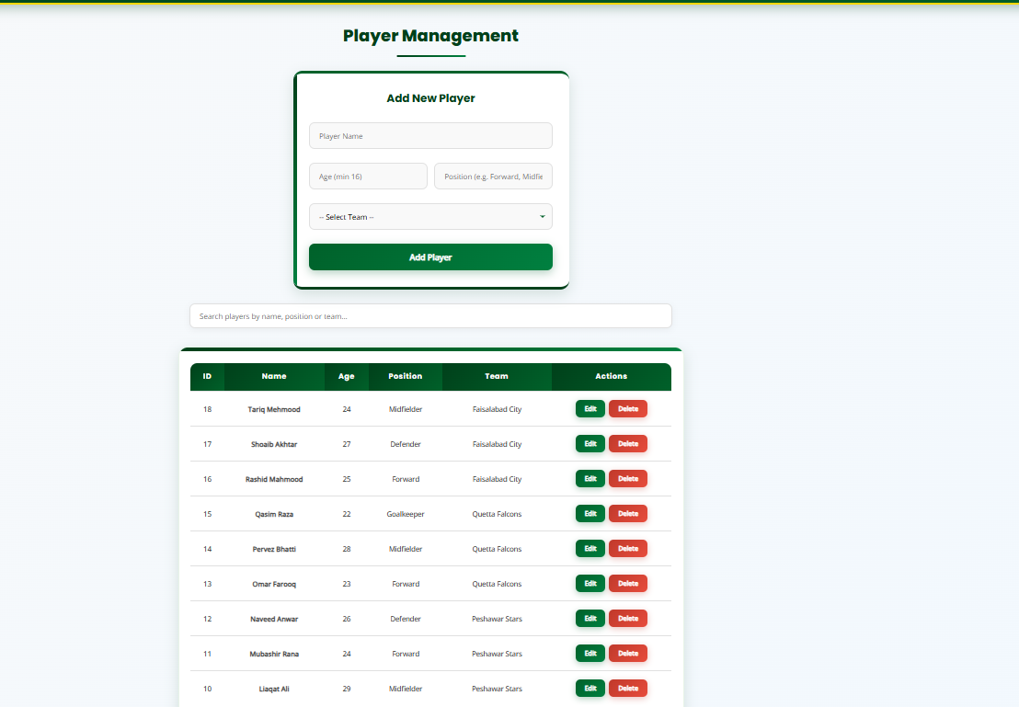

Add Player Form
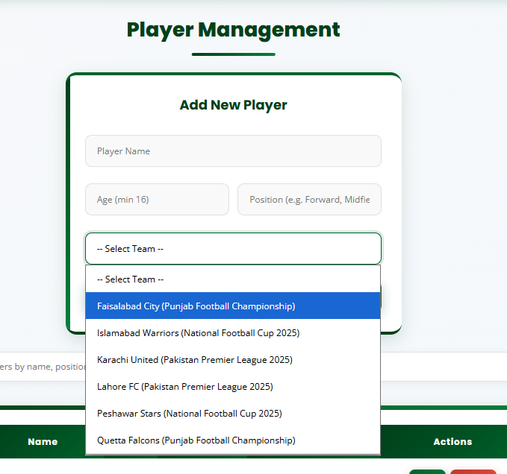

Match Management
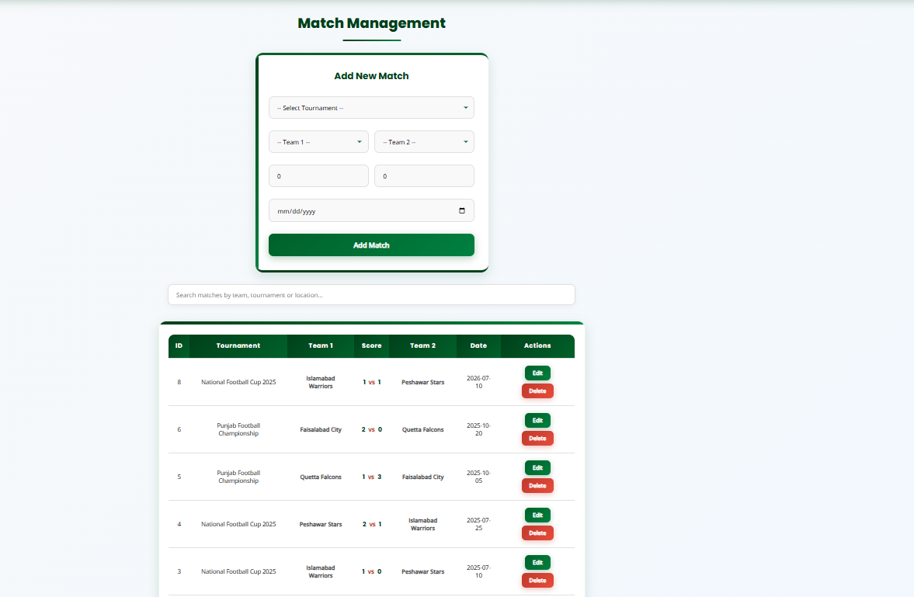

Add Match Form
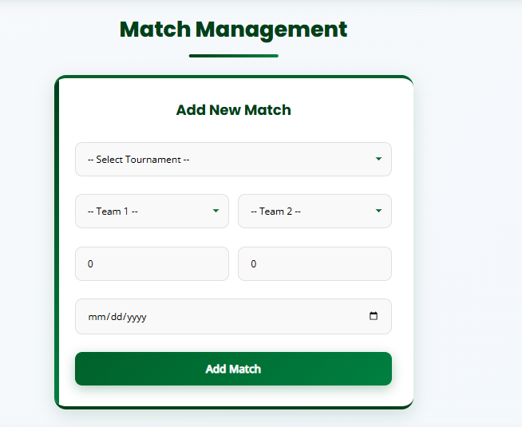

Tournament Page
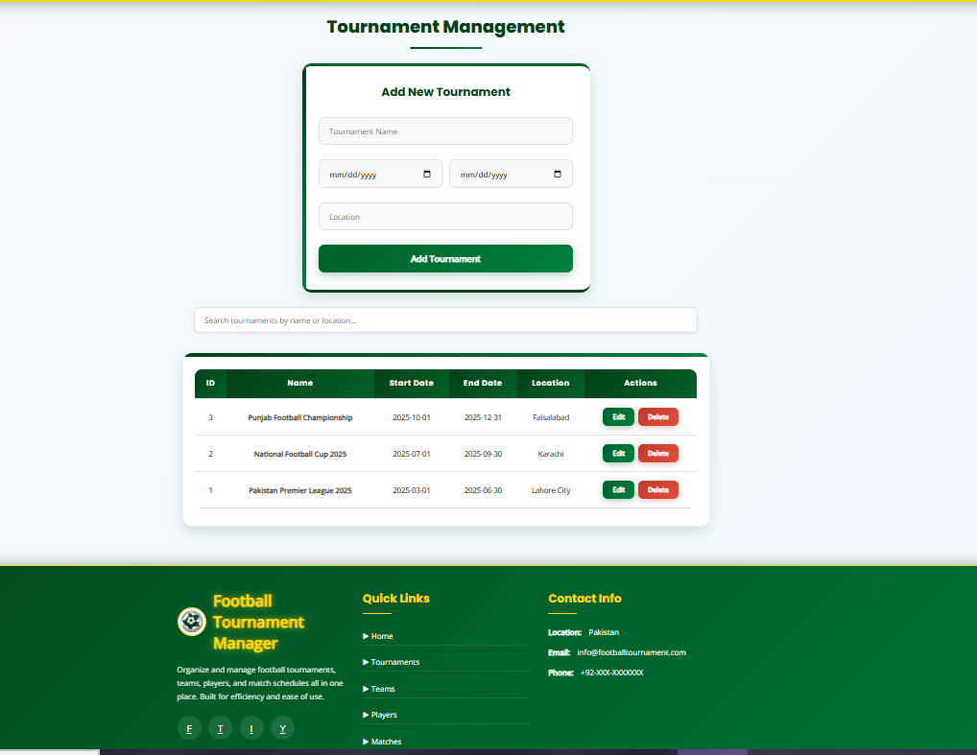

8. Advantages of the System
- Easy tournament management
- Saves time and reduces errors
- Centralized data storage
- Professional and responsive interface
- Improves organization and communication

9. Future Enhancements
- Online player registration
- Live score updates
- Email notifications
- Mobile application version
- Advanced analytics and reports

10. Conclusion
The Pakistan Football Tournament Manager provides an efficient and modern solution for organizing football tournaments in Pakistan. The project demonstrates the use of web technologies and database management concepts to solve real-world problems.

