Cody Onishi

Week of April 13, 2020

What have I accomplished recently:

* Verified that Pin PC13 can be used as a GPIO for a button input despite already being connected to a user button on-board the microcontroller
* Adjusted design of my PCB push button design according to Oscar Jia Jun Yu’s feedback:

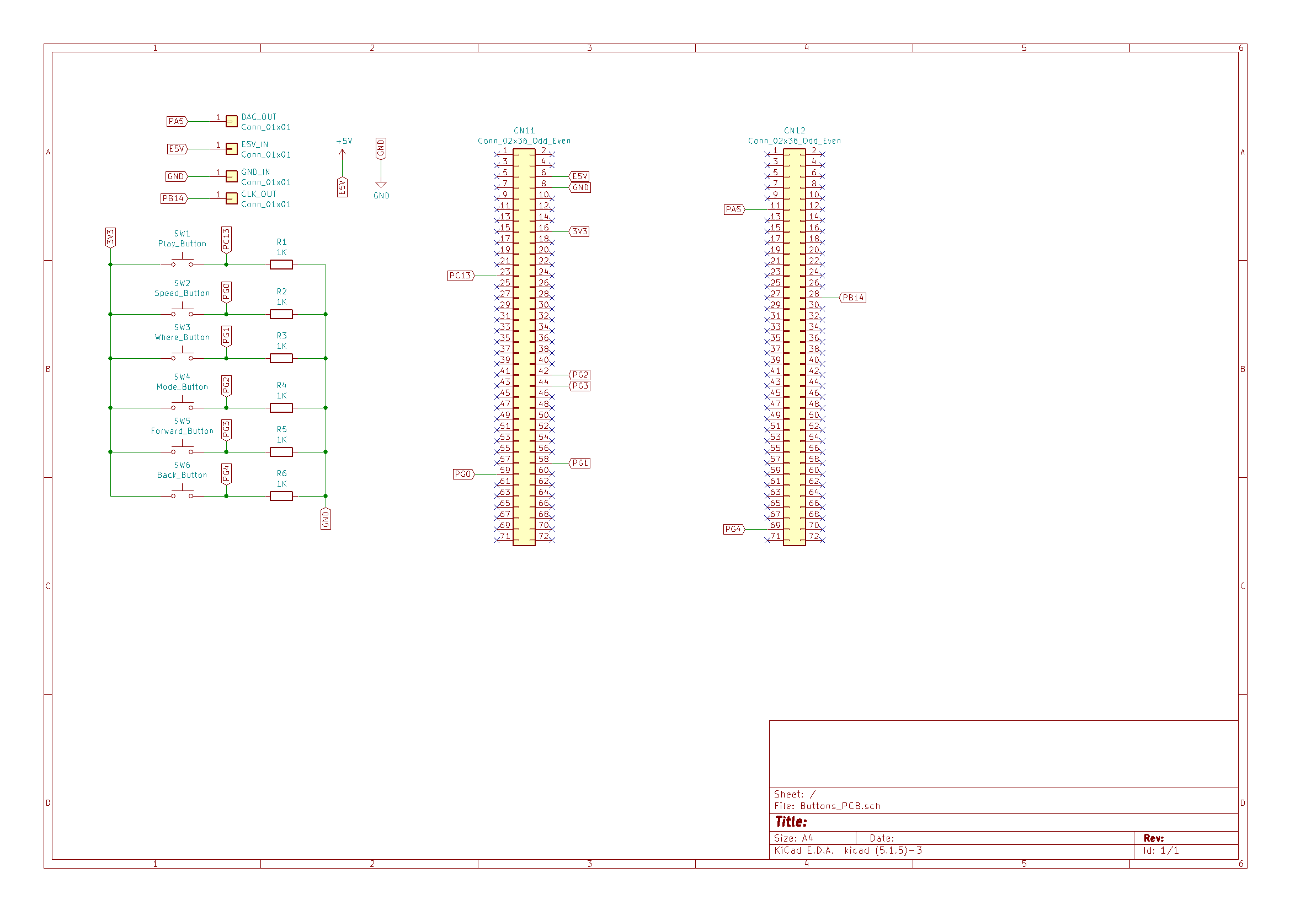

What am I working on now:

* Integrating my PCB circuit schematic with Nicholas Birmingam’s current design
* Creating the PCB_new footprint design with Nicholas
* Filling out the PCB Review Rubric specifications chart
* Completing all other tasks specified on the PCB Review Rubric

What needs to be done next:

* Finalizing code that reads the sample WAV audio files from Qi Dai and outputs all their sound data through the DAC.