**Flight Search Application**

Flight Search Application is created using React js,Redux.

---> The application is responsive on ipad, iphone, android.

---> There is also `Refine Flight Search` as per price. Flights will be displayed based on the price selected by user.

---> `Validations` are also applied on the form.

-🡪 Initially, all the available flights will be displayed to the user.

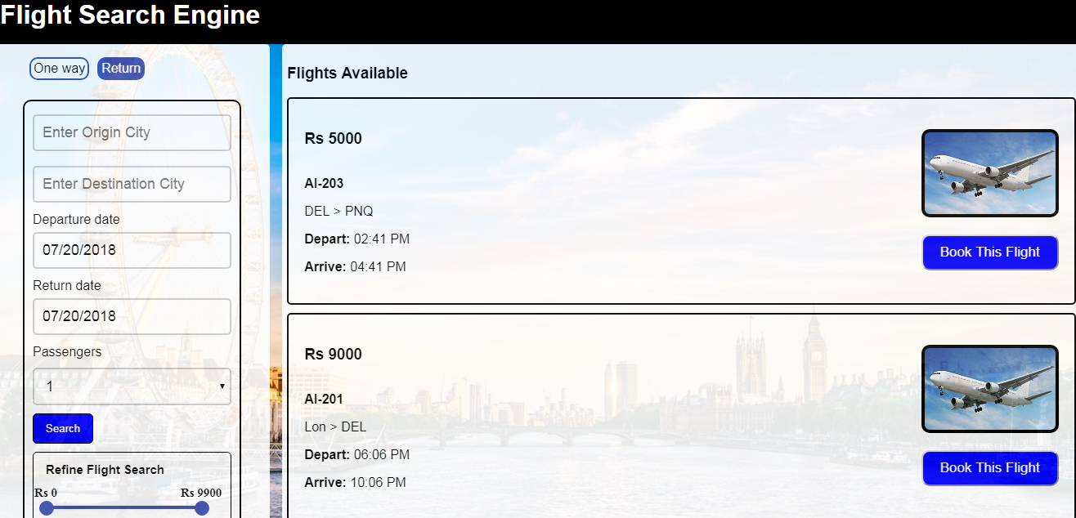

**Return Tab**

When clicked on Return Tab, Enter the following details in the form :

**Origin City ->** Pune

**Destination City**-> Delhi

**Departure Date** -> 08/02/2018 ( 2nd August 2018)

**Return Date** -> 08/05/2018 (5th August 2018)

User can also refine search based on price range

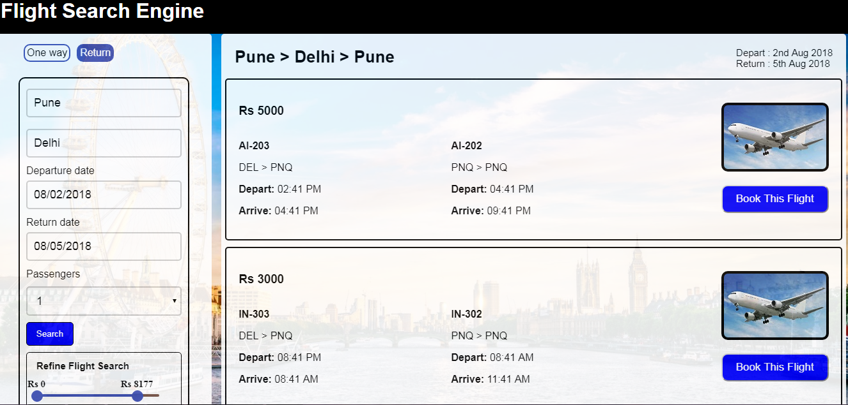

**Validations**

If search form contains invalid result, then error will be displayed below search button.

**1. Origin city is blank** --> If Origin City is blank, `Please Enter Origin City` error will be displayed below search button.

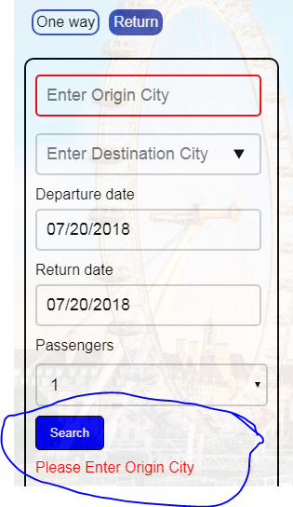

2.  **Destination city is blank --**> if Destination City is blank, `Please Enter Destination City` error will be displayed below search button.

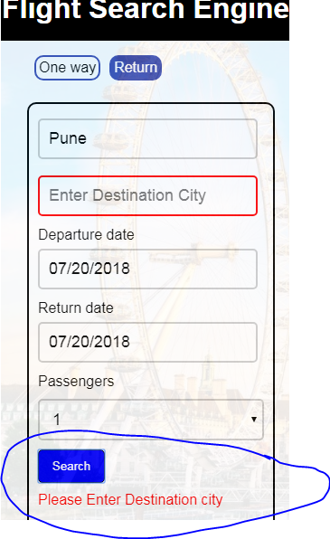

**3. Origin and Destination City are same**

**-->** If Origin and Destination city is same, `The Origin and Destination city cannot be same. Please re-type` error will be displayed below search button.

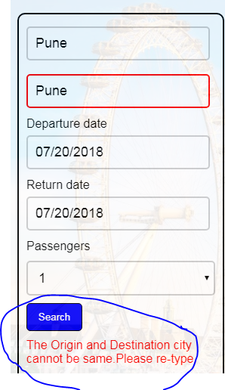

**4. Departure Date is greater than return date -->** If Departure date is greater than return date, `Return date should be greater than destination Date` error will be displayed below search button.

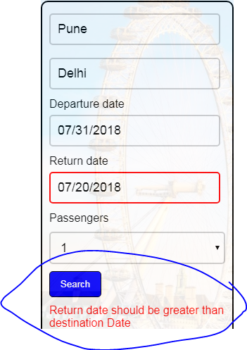

**No Match Found**

If no match is found as per search data entered in search form, then user will see

`Sorry, there are no flights available. Please try again with different search!!!`

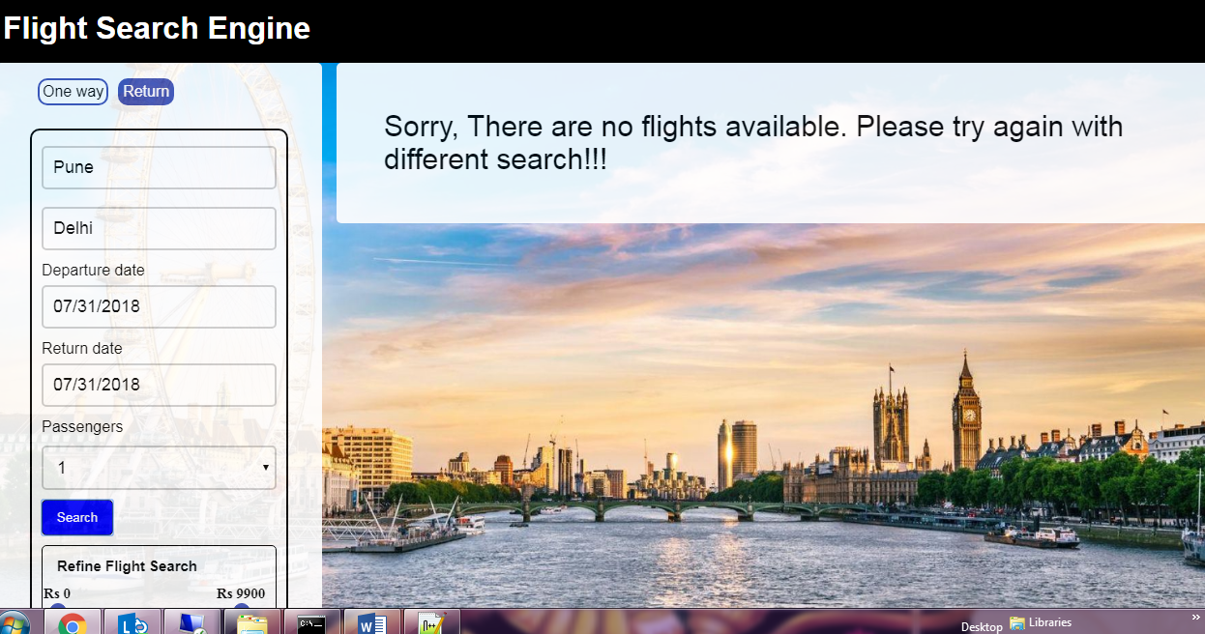

**Refine Flight Search**

User can also refine search as per price range. Flight list will be displayed as per the price range selected by the user.