OPENOCCAS
Open Platform for Business occasion execution
Process documentation

A Concept of Savant Brain Consulting (SBC) GMBH Lyss, Schweiz
under GNU General Public License version 3

Table of contents
1 Introduction 3
2 Architecture 4
3 Appendix 5
3.1 References 5
3.2 Terms 5

Introduction
The “Open Platform for Business occasion execution” has the objective to define standards for the following areas:
- A controller, which manages any external interfaces of the platform. External also means a UI for the platform itself. The controller manages also the access to the platform in means of security and quality.
- A Business Process unit, which executes the business processes modeled with BPMN
- An integration unit, which assures proper service integration for functional components and legacy applications. The integration unit must provide at least messaging services, Web-Services, Database Access Services and REST services. Other integration services are optional but allowed.
- A component to manage the occasions, include fine grain human/machine interface control and process integration routing and management.
The human/machine interface control and the process integration routing and management are key features of the platform. If one is missing, the platform is not complete. The following chapters explain the two concepts further.

Routing Process

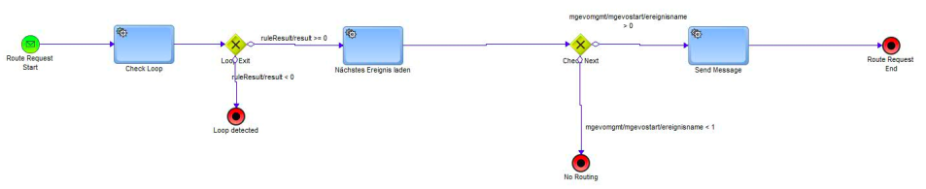

OPENOCCASrouting Process description

 | OPENOCCASSrouting
Process Objective | The process makes a decision if a next process can run or if the chain shall be set to wait for user action
Description | The main purpose of the process is to manage and control process chains based on work item state and last process end state (contained in input message). The process then checks out what the current workevent (a configuration entry) is for the last process and creates the next workevent. If the chain shall be set to wait state the process ends (as the work item was already updated by the OPENOCCASmanagement process (second invocation in last process).
Entry conditions | workitem state set by last business process executed and correct input parameters set in the start event message queue
Exit conditions | There are three exit conditions:  - A loop was detected (wrong settings in start event message or work item state)  - A wait state reason was detected an no follower process shall be started  - A start event message was sent for the follower process to be executed
Input / Output services | Input:  OPENOCCASION  workitem  workevent | Output:  OPENOCCASION  workitem  new workevent
Business objects | OPENOCCASION  workitem  workevent  businessprocedure (configuration information) (businesstransaction)  workeventname (configuration information)
Ratios  (optional) | <process ratios>
Target measurement values  (optional) | <target measurement values>
Process roles

Activities of OPENOCCASrouting
Activity name | purpose | Business rules
Check loop | The activity verifies if the workevent was already previously processed. If yes, it sets an abort indicator. If no, it marks the workevent as processed | See use case OPENOCCAS checkloop
create next workevent | The activity loads the current workevent object and creates a new one, based on start event message state, work item state, businessprocedures information | See use case OPENOCCAS createnexworkevent
Invoke next selected process | Identifikation und Bewertung möglicher Schwachstellen | See use case OPENOCCAS invokenexprocess

Use cases

OPENOCCAS checkloop

Use Case | UC0001
Description | The use case describes the steps to check if a workevent was already processed and stops the process in such a case.
Actor | OPENOCCASrouting
Context | The use case will every time being executed when a start event message receives the routing process.
Precondition | - The starte event message must contain the correct state information
Postcondition | - No loop was detected, last workitem set to processed  - Loop was detected, ruleresult set to -1
Trigger | - Execution of OPENOCCASrouting activity check loop
Main scenario
Alternate scenarios | A1  B1  C1
References | Zu 2.: UC Kompetenzstufe prüfen  Zu 4, A4.: [1] Business Service „Auftrag bewirtschaften“, Operation „Auftrag anlegen“  Zu a): [3] GOM
Extions | none
Comment | none

OPENOCCAS createnextworkevent

OPENOCCAS invokenextprocess

Appendix

References
Nr | References
[1]
[2]
[3]
[4]
[5]
[6]
[7]
[8]

Terms
Term | Explanation
Documents | The Documents used in this concept mean structured information that contains semantic information (means it is known what an entry in the structure means).

