OPENOCCAS
Open Platform for Business occasion execution

A Concept of Savant Brain Consulting (SBC) GMBH Lyss, Schweiz
under GNU General Public License version 3

Table of contents
1 Introduction 3
2 Architecture 4
3 Appendix 5
3.1 References 5
3.2 Terms 5

Introduction
The “Open Platform for Business occasion execution” has the objective to define standards for the following areas:
- A controller, which manages any external interfaces of the platform. External also means a UI for the platform itself. The controller manages also the access to the platform in means of security and quality.
- A Business Process unit, which executes the business processes modeled with BPMN
- An integration unit, which assures proper service integration for functional components and legacy applications. The integration unit must provide at least messaging services, Web-Services, Database Access Services and REST services. Other integration services are optional but allowed.
- A component to manage the occasions, include fine grain human/machine interface control and process integration routing and management.
The human/machine interface control and the process integration routing and management are key features of the platform. If one is missing, the platform is not complete. The following chapters explain the two concepts further.

Process integration routing and management
Today’s business process engines, which execute BPMN 2.0 and higher models, have a lot of capabilities implemented to run processes in complex environments. But what all of them are missing is a dynamic routing of process flows and integration patterns for processes. In addition it is necessary to have a full history control of what was running and in what state it is.
A second problem with the available platforms is the task list. If users have to deal with multiple running processes in different states it is almost impossible for them to overview what a certain task is for and what the best answer would be in focus of customer needs and wishes. At the end of the day the users are just assembly line workers without any choice to help the customer.
The above drawbacks are a huger problem when customers should be part of business processes, as the so called “digitalization” would demand. On the other hand, employees of enterprises providing electronic channels for clients do not become the necessary information and control to optimal support the customers on there requests.
The process integration routing and management provides a feature to manage work items in a different way than simple task lists. Occasions (named these way to distinguish from case management, which is a different approach) will organize work items, which can be sorted and filtered. But if one is selected, the user will be guided through all the processes necessary to complete the work item. If the work item cannot be completed for any reason, the currently running process instance will be terminated, the work item will be updated with the actual state, so if the user restarts the work, the platform will know where it terminated. The feature allows at the same time the fine grain human/machine interface control and automation of processes, which is further explained in chapter 3.

Process principles
To make the platform work, some process principles must be followed:
- The processes are organized in a three layer model, from layer 1 to layer 3. Layer 1-2 are the organizational layers, while 3 is the operational layer.
- Processes are structured in process chains. Process chains should contain between 2 and 7 processes. A process chain itself is a conceptual structure to organize processes and will never be executed directly. But the platform has configuration data about the chains and will assure that the the sequences are followed. If more processes are needed to complete a business request, the chain should be split. More than 7 processes are allowed if there are reasonable justifications. Within the chain, the processes may be hard wired (means connected via a line) or soft wired (means no connecting line). Hard wired means, the processes are executed in a sequence, while soft wired means, the processes are independent usable, but the sequence in the chain cannot be random.
- Process contain 2 to 7 business activities. If more business activities are necessary, the process should be split. More than 7 activities are allowed if there are reasonable justifications. In addition, each process will contain activities and subprocesses for the platform control, which do not count as business activities.
- Process flow control is managed via business rules.
- The business values to be delivered are called business procedure. A business procedure can pass multiple process chains and therefore multiple processes. The platform routing process uses the business procedure information to decide next process to call.
- Process invocation occurs always through the platform routing process which will decide the next action to be performed depending an delivered information (e.g. “business procedure”, processing state of the work item, etc.
- Processes, either within a chain or cross chain are integrated via standardized document structures. These structures are interface descriptions containing information about what has to be done and with the information it should be done, always with an input and a separate output structure. The interface description is based on business objects containing attributes and values of these attributes. The are predefined in an business object model.

Examples for the process principles

The level 1 Process chains are actually value chains. Value chains in this concept are always an end-to-end view, partner-partner. Partner can be a customer (B2C or C2B) or a business partner (B2B). To be able to process different request types from partners, the values to be delivered must be categorized. A category can for example be a “customer contact management”. Each category must be modeled as a value chain on level 1. A value chain must be able to handle several types of value deliveries, as long as the belong to the same category. To identify a specific value deliver, the “business procedure” structure is used.
TODO: Insert example for level 1 value chain

Level 2 process chains represent a detailed overview of the L3-process chains composed to support certain “business procedures”. An L3 process chain within the L2 chain can be reused in other L2 chains as long as this chain belongs to the same category. L3-Process chains outside the L2 chain will be integrated via the interface document, the routing process will assure that the right process gets instantiated. This means, a chain can support different “business procedures”, but they must belong to the same category. A level 2 process chain can only support one category.
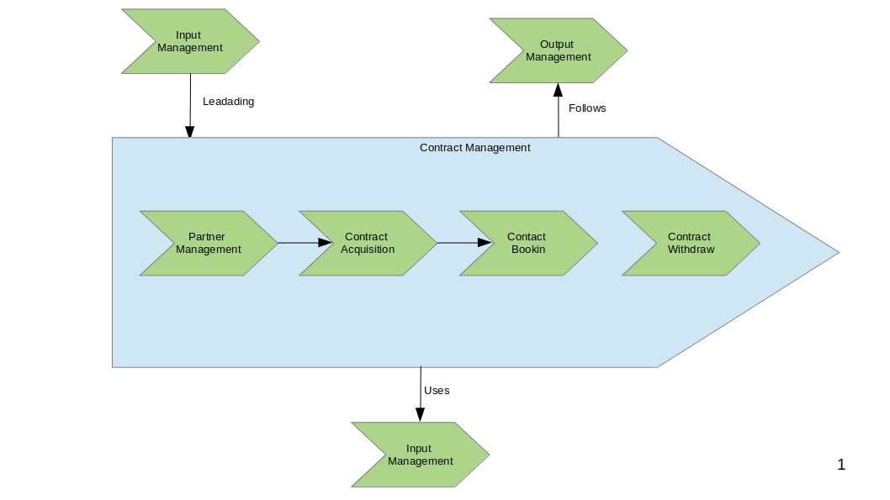
L3-process chains give an in-site view to the next level of processing. For L3-Process-chain, different interfaces can be specified, whereas a single process can only have one entry and one exit interface defined. In opposite of BPMN, a process which run has only one start and an end BPMN event. All oder end events are seen as exit events and must terminate the process. The routing process of the platform takes care that no further process is executed if a business error occurred in a process (state of work item of completed process).
As an example, there may be an interface definition A to run process “person management” and “address management”, where the input interface description for “person management” will be reused for an interface definition B which runs all processes in the chain from “person management” to “Correlation management”. In this case only the interface output description defers from the interface definition A. But base on OO rules the interfaces are of different types so they can easily be distinguished.
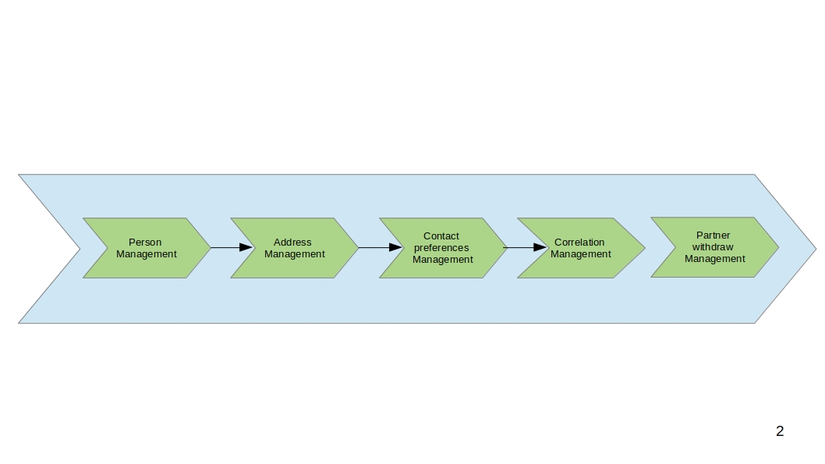
Data Model example
<Partner>
<id>1</id>
<Surname>alpha</Surname>
<Firsntame>alpha</Firstname>
<DateofBirth>12.03.1979</DateofBirth>>
</ Partner>
<Address>
<id>15</id>
<Street>Mc Kinsey Road</Street>
<StrNr>125</StrNr>
<zip>12345</zip>
<city>best known</city>
</Address>
<Contactpreference>
<id>20</id>
<address_id>15</address_id>
<partner_id>1</partner_id>
<priority>1</priority>
<contacttype>Homeaddress</contacttype>
</Contactpreference>
<Correlation>
<partner_id>1</partner_id>
<businessobject>125</businessobject>
<businessobjecttype>Contract</businessobjecttype>
</Correlation>
Example of interface A description
Interface A:
Input: Partner / Address
Output: Partner / Address

Interface B:
Input: Partner / Address / Contactpreference / Correlation
Output: Partner / Address / Contactpreference / Correlation

The first process has the capability to identify a partner. If a partner could be identified, the partner data would be updated by the process. If the partner was not identified, with the usage of the first interface, the process returns a business error, while with interface two a new partner will be created, if there is enough information delivered (attributes filled), they are valid and no similar partner, which was not unique identifiable by the business rules, exist.
This way processes can serve many different services without knowing too much about there internal implementation. Only the possible behaviors of the different interfaces need to be specified.

Human/Machine interface control

Appendix

References
Nr | References
[1]
[2]
[3]
[4]
[5]
[6]
[7]
[8]

Terms
Term | Explanation
Documents | The Documents used in this concept mean structured information that contains semantic information (means it is known what an entry in the structure means).

