**Project 1**

**Documentation Page**

**Pari Brown**

The visualization below represents Dr. John Snow’s map of the London Cholera Epidemic of 1854. In addition to the London streets map, it includes location of 13 nearby pumps (red) and location of the deaths (pink and blue). Legend shows the pump circle color. The gender of victim can be identified by different color coding for male and female, also included a legend for further clarification. Victims age group can be identified by added tooltip functionality on the map. The map also shows some of the major street names. Also added was the location of the brewery and workhouse on the map as bar and work. Colors were applied to show the locations. I have drawn the streets by path function, and pumps and death locations by using SVG “circle”. I grouped the streets, pumps, and deaths location in order to make the map stable. I got the data for the map below from “streets.json”, “pumps.csv”, and “death_age_sex.csv” files.

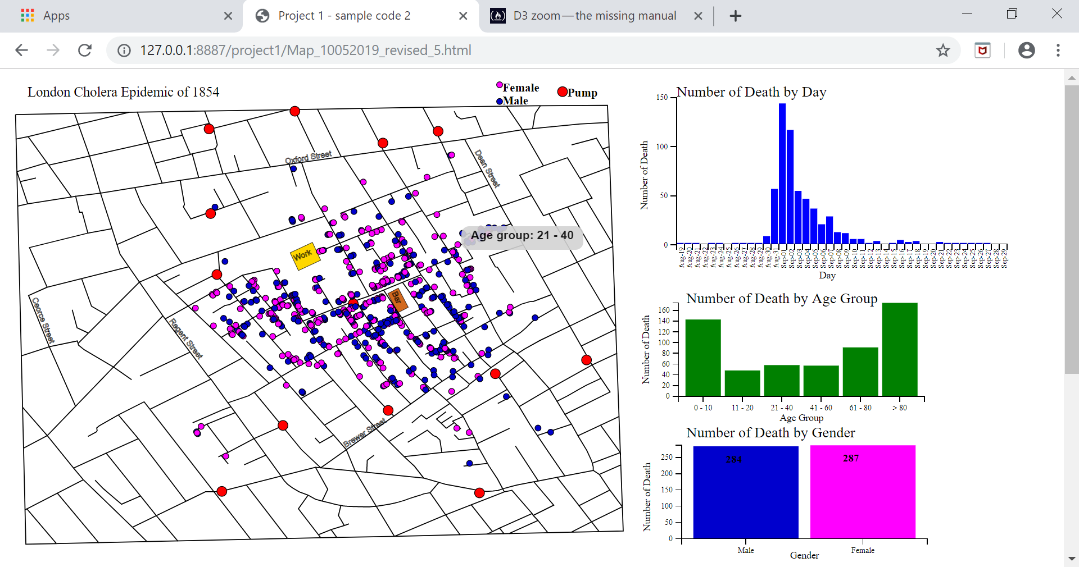

Number of Deaths by Day graph is a timeline bar graph shown below. The data for the graph came from “deathdays.csv” file. I have added a graph title, x-axis and y-axis labels. I have drawn the bars using SVG “rect” and axis by “line”.

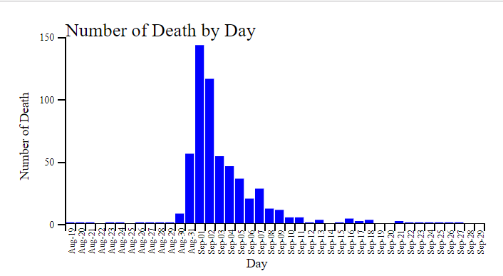

I also added mouseover functionality on the death timeline graph above in order to choose the desired day to be visualized as shows below (colored orange). Also added mouseover charts interactivity, as a user mouseover a bar on the Number of Deaths by Day graph, the location of the victims is showed on the map. I also changed opacity of the death circles that are not associated with the selected day in order to make them less transparent.

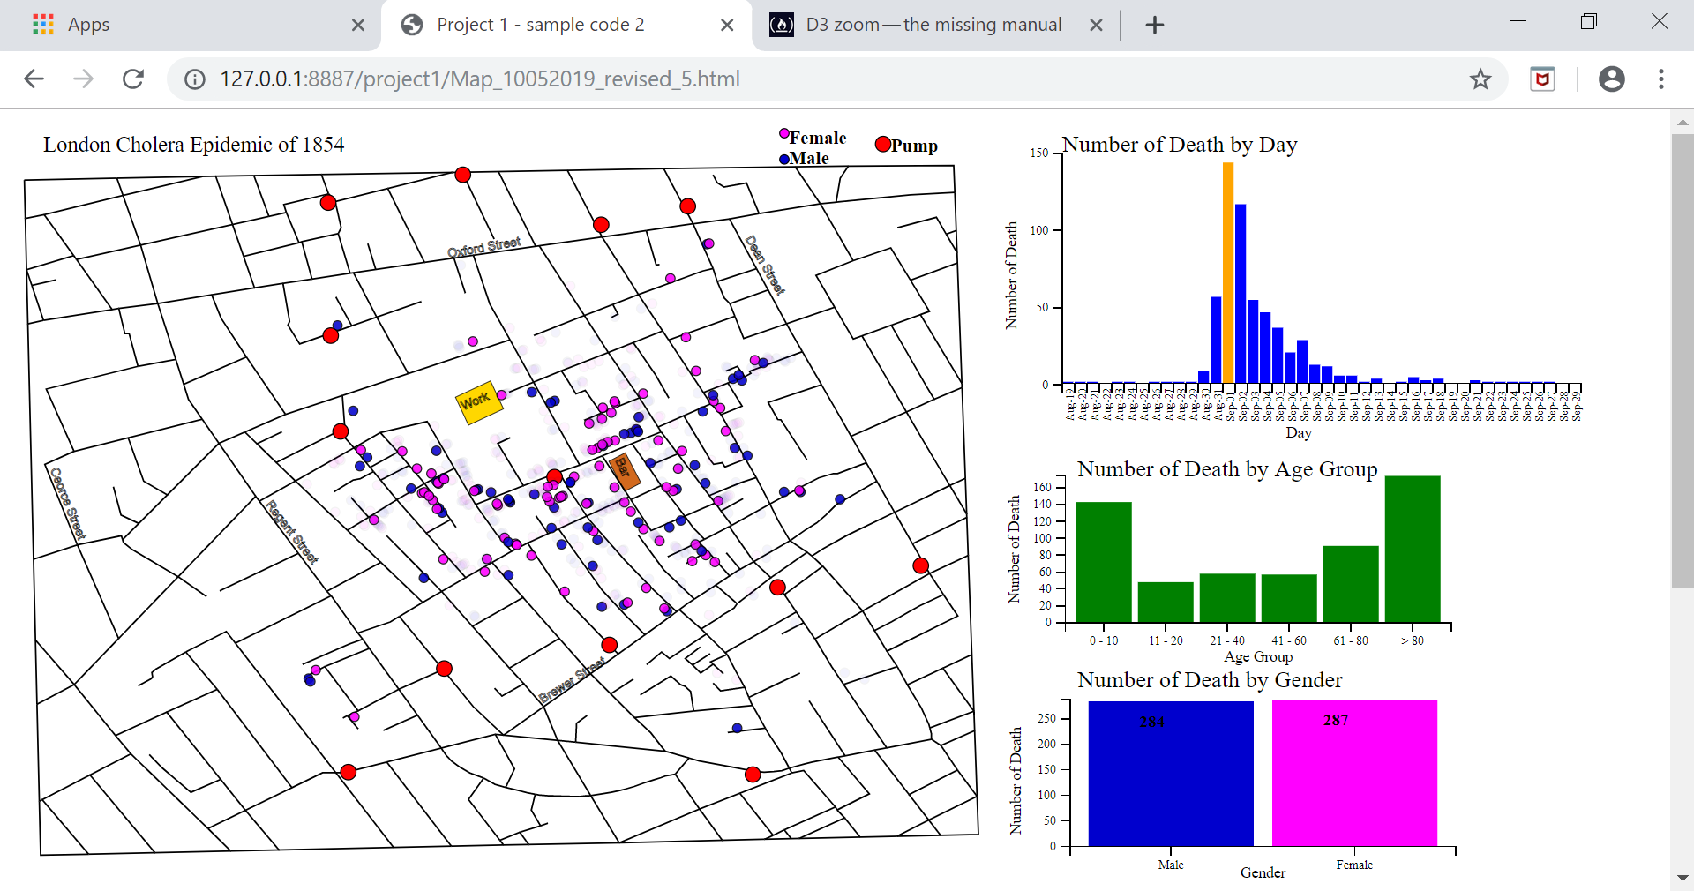

I added Number of Deaths by Age Group bar graph to show number of deaths by age group. I added age grouping rather than age 0 through 5 as contained in the “deaths_age_sex.csv” file, in order to make the age group of the victims clearer. The age grouping information was provided in project specification that was provided in class. I also added title for the graph and axis labels. I created an array to get total number of deaths for each age group.

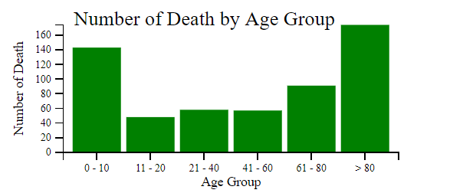

The visualization below shows number of deaths by gender during the Cholera Epidemic. As we can see the distribution of deaths between the male and female were close. I used color blue to show male and magenta to show female, the same color coding that I used to locate victims on the London Cholera Epidemic of 1854. I added total number of deaths to each bar. I defined sex 0 as male and 1 as female according to the information that was provided in class.

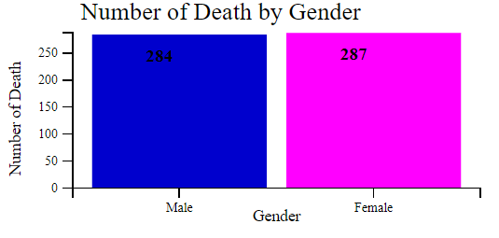

Link to GitHub visualization of the project: <https://pkavoosi1341.github.io/Project1_CholeraMap_PKB.html>

Link to the YouTube video: <https://youtu.be/CJ8oWbzyU7M>