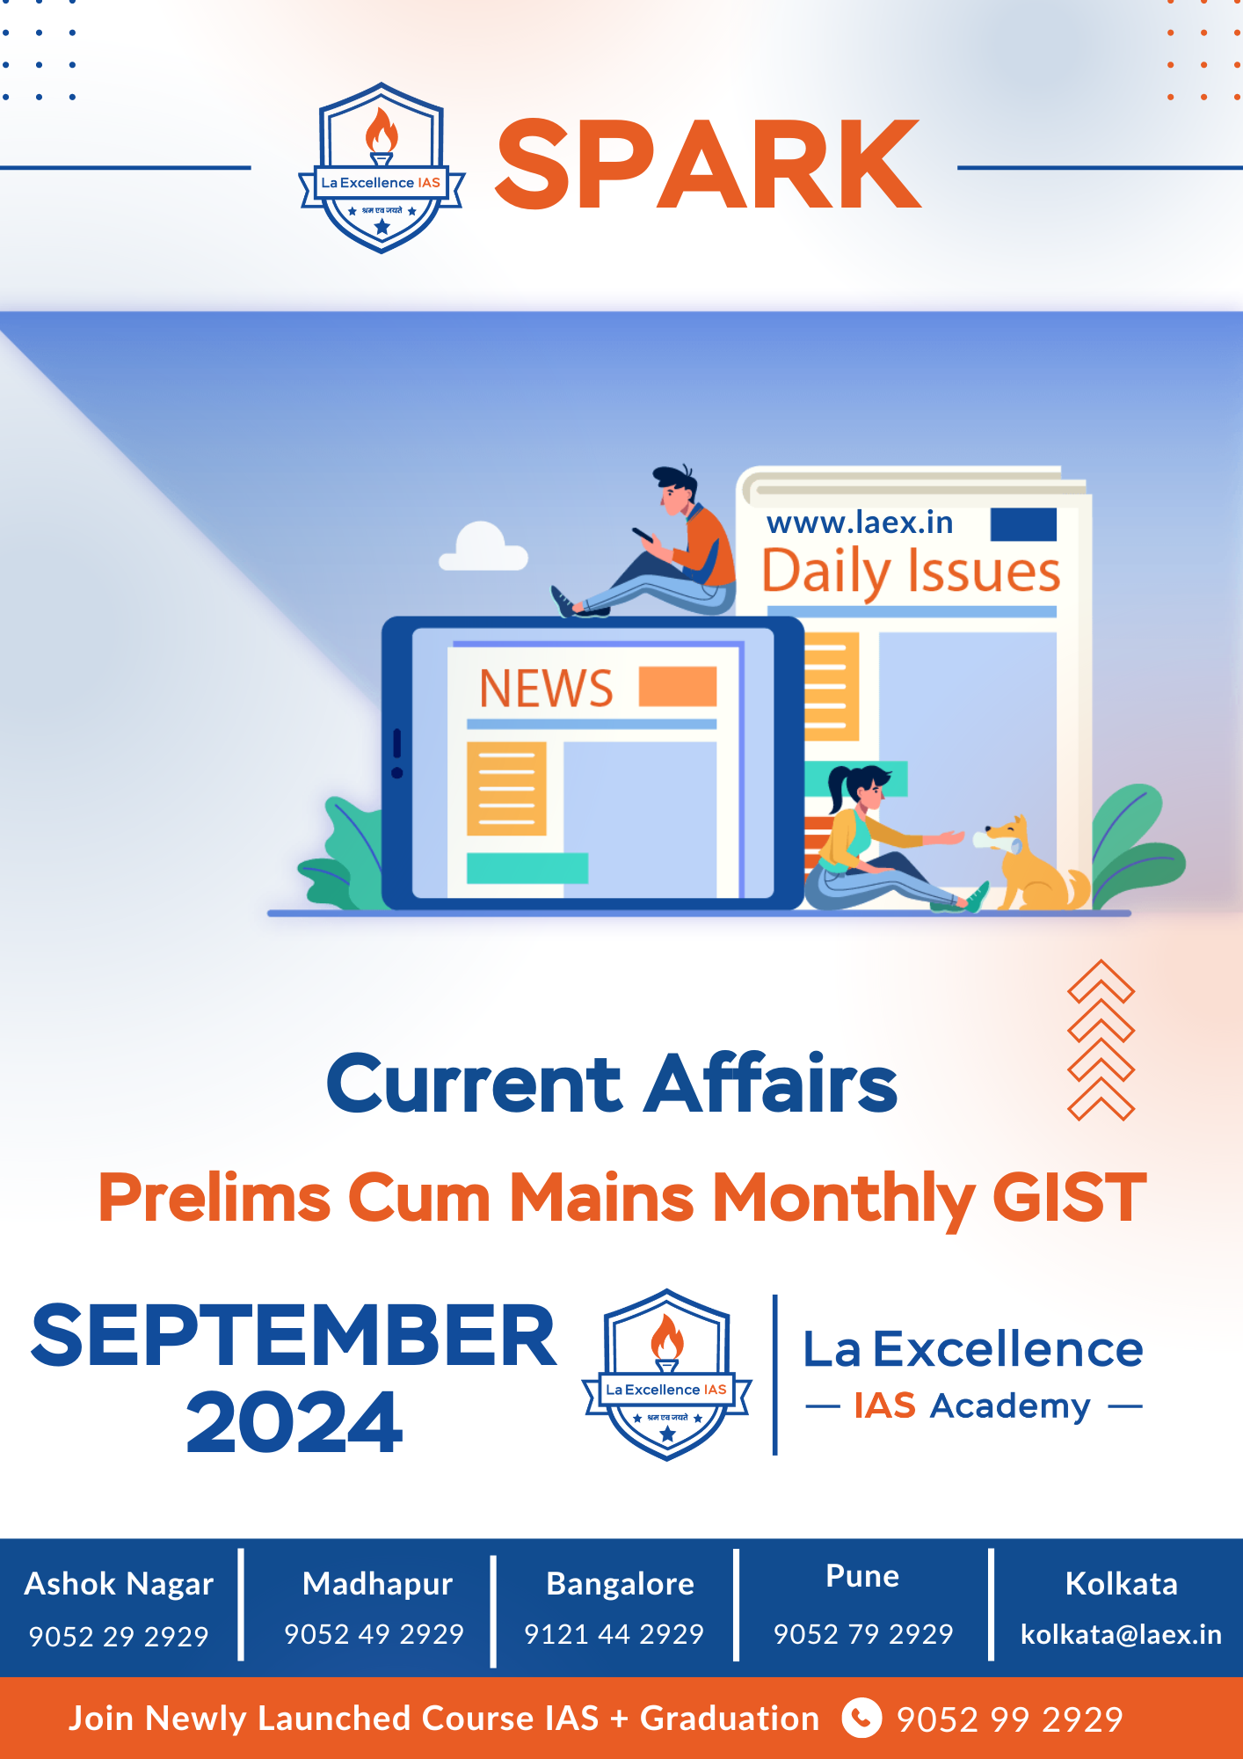

Dear Aspirants

Join our official La Excellence IAS telegram channel
https://t.me/CivilsPrepLaEx

To get all value-added materials, RRP notes, workbook, slides, and Daily current affairs handout.

PREFACE

Current Affairs {{Month}} 2024

Current Affairs-Sine QuaNon of Upsc Preparation
Proficiency in Current affairs is sine non qua for UPSC preparation. It is the basic foundation of any aspirant‘s preparation. Knowledge and skill to relate current news with UPSC syllabus is quintessential part of the preparation.

Our new initiative - Monthly magazine
What if we told you we have panacea for all the problems related to preparation of current affairs!? A one stop solution for revising all current affairs material in a style where mains answer writing becomes very easy.

What is the Usp of Current Affairs Magazine
- Systematic segregation of monthly news in tandem with syllabus
- Contextual relation of topic in news with UPSC news.
- Brief and crisp explanation
- Extremely precise information which will make revision easy
- Video QR code for better understanding
- Practice mains questions
INDEX
MONTHLY MAGAZINE

Sl.  No. | Topic | Page No.
1. | Monthly Mains GIST
2. | Monthly Prelims GIST

Monthly Mains GIST

{% for subject, topic_issues in mains_data.items() %}

{{ letters[loop.index0] }}. {{ subject }}

{% for data in topic_issues %}

{{ loop.index }}. {{ data.topic }}

{{ data.issue.name }}
Context: {{ data.issue.context }}
{{ data.issue.issueDetails }}
Mains Practice Questions:
{% for qs in data.issue.questions %}
{{ qs.question }}
{% endfor %}

{% endfor %}
{% endfor %}

MONTHLY PRELIMS GIST
{{Month}} {{Year}}
INDEX

{% for subject, topic_issues in prelims_data.items() %}

{{ letters[loop.index0] }}. {{ subject }}

{% for data in topic_issues %}

{{ loop.index }}. {{ data.topic }}

{{ loop.index }} {{ data.issue.name }}
Why in news ?
{{ data.issue.context }}
Description:
{{ data.issue.issueDetails }}
{% endfor %}
{% endfor %}

