CIVIL SERVICES (MAIN) EXAM – PRACTICE TEST
BY
LA EXCELLENCE

UPSC Mains Paper I
Test ID: 3596
Time Allowed: 0.75 Hours
Maximum Marks: 80.0

Instructions
(Please read each of the following instructions carefully before attempting questions)
There are 5 questions printed in English.
All questions are compulsory.
The number of marks carried by a question is indicated against it.
Answers must be written in English (except for language subjects).
Space for answers is provided below each question. Answers must be written in the provided space only.
This is a test meant for practice and preparation.

To take test, the following steps should be followed.
- Download this PDF (or share this PDF to your email ID) from UPSC.PRO app.
- Print the PDF.
- Take the test on the printed paper (write answer in allocated space only).
- Scan the paper into a single PDF file.
- Upload the answered scan (PDF) on UPSC.PRO app (on same test).
- Submit your test on UPSC.PRO app.
After you submit your answer on the app, our evaluator will check the answers and the result will be available on the app itself. It will take few days for us to complete evaluation and publish result on the app.
Go to the next page to start taking test.

1.
(Marks: 15.0)
Answer:

2.
(Marks: 15.0)
Answer:

3.
(Marks: 15.0)
Answer:

4.
(Marks: 15.0)
Answer:

5. 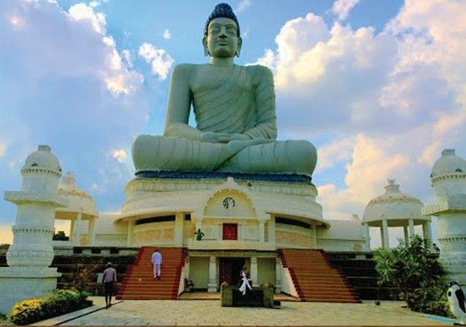
(Marks: 20.0)
Answer:

