

Technical Report

Design 2 - MA2

Priscila Kuhn Derlam

Word count
Summary: 103 | Main text: 837

Table of Contents

1. Summary 3

2. Body 4
2.1. Introduction 4
2.2. Main section of report 4
2.3. Conclusion 4

3. References 5

4. Acknowledgements 6

5. Appendices 7

1. Summary

It’s not by a chance that design is a fundamental for UX: the enhanced experience backed up by good design can be seeing both as the pillar of the good communication and as a tide-shifting towards a more pleasant user experience.
The user experience comprises the web site structure itself combined with the selected images – whenever this is the case. In the end, from the UX design perspective, we want to achieve an overall harmony.
None of that is possible without combining photographic techniques and editing tools with the knowledge accumulated so far. That’s what I want to report in the current work.

2. Body

2.1. Introduction
For this module assignment, I used the same color scheme and logo from module assignment 1. I have kept the Latin text for the content, the buttons, and the navigation bar.
I took the pictures/photos for the product images for the page, to do this I used a camera phone (iPhone 8). I have optimized some of these pictures, but I have chosen only two to represent the products.
I designed and created, also, two icons for use on the page, and I have included them in the webpage code. These icons were created in artboards with measures 64px x 64px, as recommended in the video from James Williamson.

2.2. Main section of report
This module assignment was pretty fun. I was very glad with this purpose because, first, I like to take photos and, in addition, I have a personal on-going project about learning Photoshop.
When something is not really necessary, liking is not enough to learn – I will call it necessity-driven learning. Finally it is my turn to explore the Photoshop, and take some Pro photos of products.
I do not have plenty of resources that allow for taking professional pictures, then it was necessary to improvise: I put a white paper inside a semi-transparent white box, and I used some lamps to achieve a better illumination.
The weather in Norway did not help me this week: the winter Trondheim is dark, cloudy, snowy and even rainy due to a storm. My husband took a photo of the thing I dare to call a studio set (appendix 1).
I took more than three pictures for the website (appendix 2): I thought of replacing the old ones by the new ones.
I invested way too much time on learning simple Photoshop features and, because of that, I could only optimise three pictures, however only two were good enough in my evaluation:
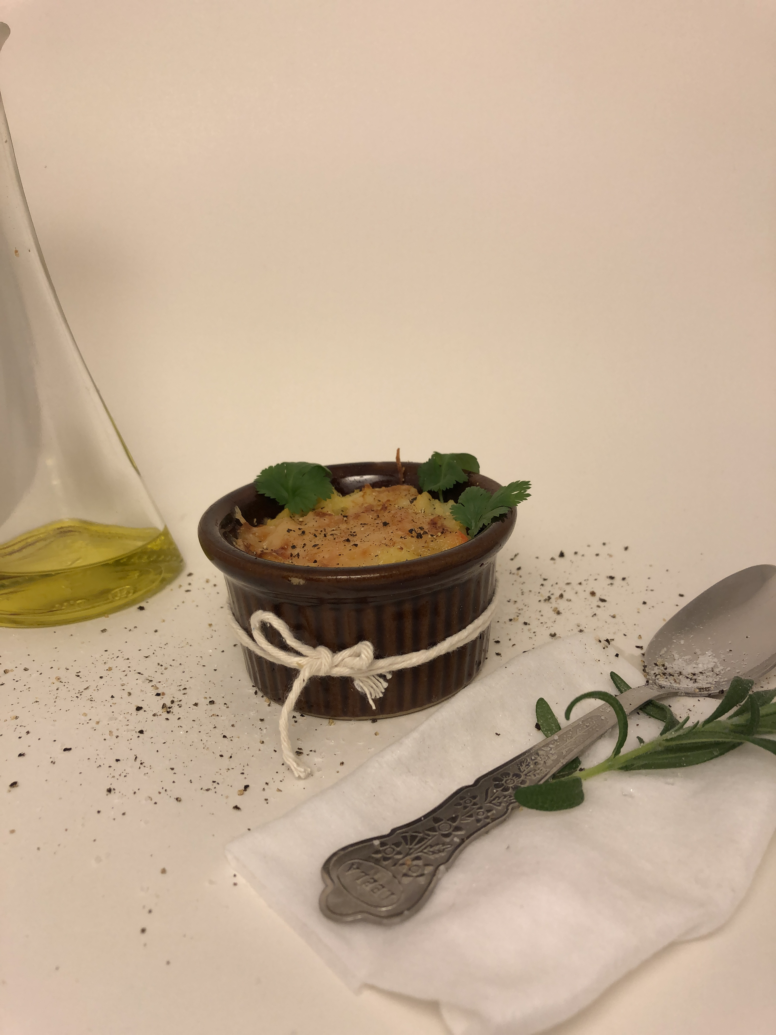Figure 1: The original photo, before optimised
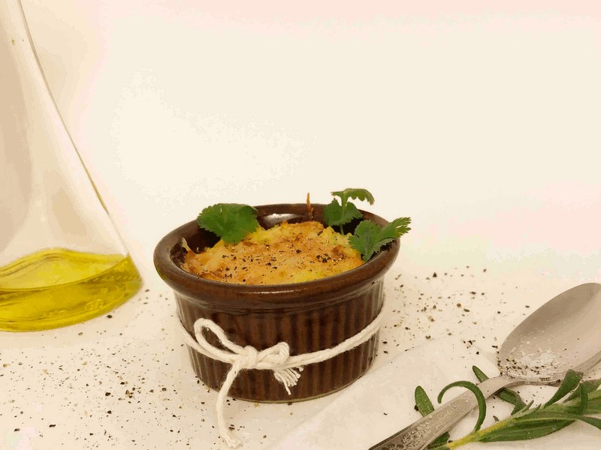Figure 2: Optimised photo by Photoshop

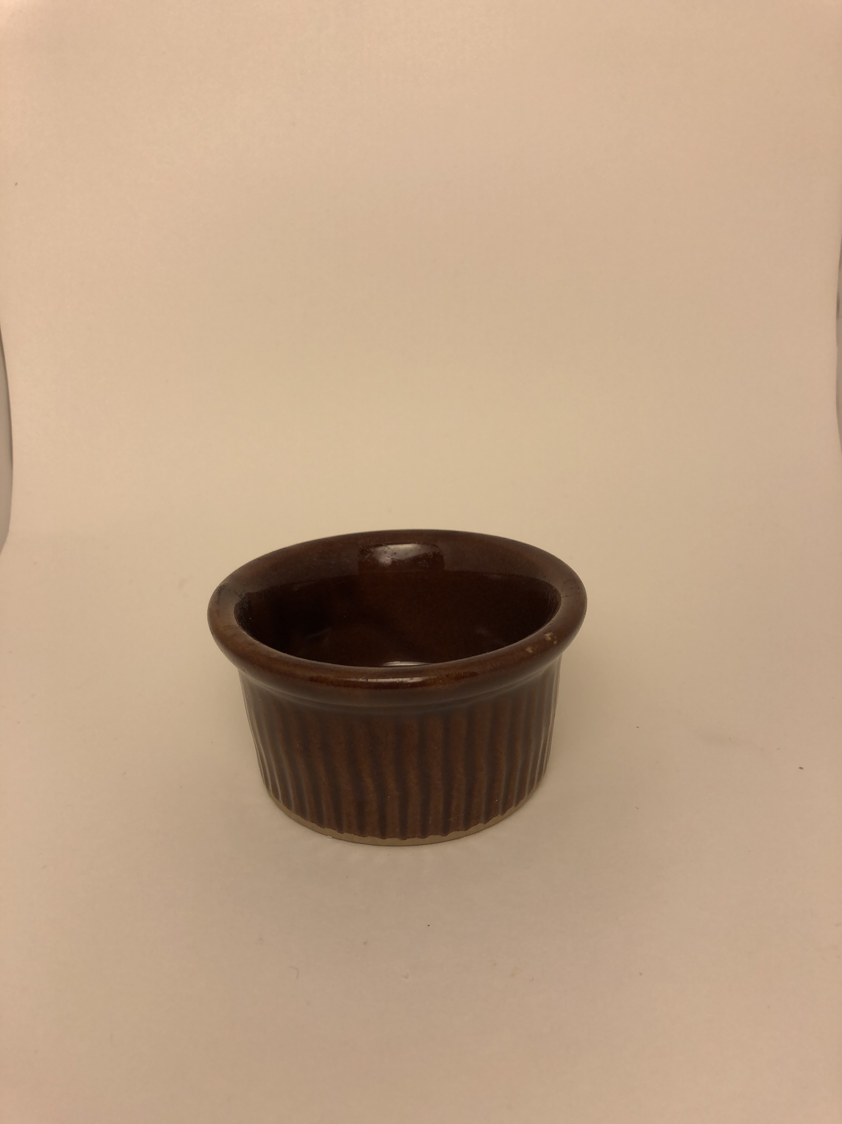Figure 3: The original photo, before optimised by Photoshop
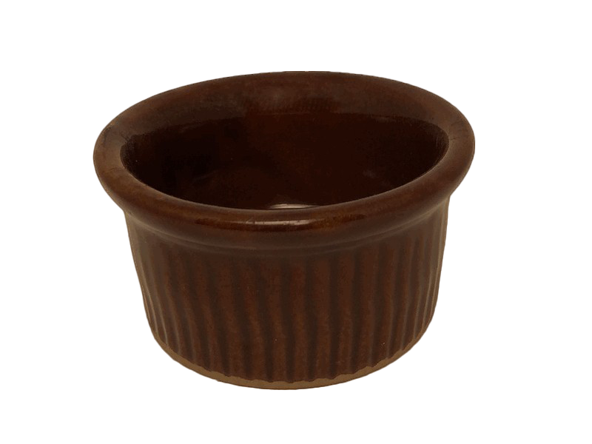Figure 4: Optimised photo by Photoshop
These photos were used in the website. I’ve chosen specifically this rustic brown ceramic baking dish because it is brown, and because I thought it could be a good combination of food colours with the melted cheese, the olive oil, the rosemary, the cilantro and the pepper.
In order to take these pictures, I followed the tips in the material, and in the base articles . In the figure 1, I chose the lyfestile/context type of image. Afterwards, a studio photo seemed important to me. Clearly, I needed to repair some usage marks and the reflex of the lamp.
In the CSS, I added the filter drop-shadow to the images. In the homepage, the image has a pseudo-class hover, so when the user access the website on the desktop screen it can see the difference between the shadows under the image. In the products page, the same filter was applied, except the pseudo-class hover. Before applying this filter, I tested another ones, like contrast and sepia, which I have not used before, so it was important to learn this feature as part of the CSS drills.
The icons handling was very fun experience: I enjoyed it very much. I am comfortable with working with Adobe XD, but, for this lesson, I decided to explore Adobe Illustrator. I liked it better because it seems to be between Photoshop and XD, so it was easier to explore.
I created, then, two icons: one to favourite the products and another one to the search in the page. The searching icon is not that authentic, but, at least, I built it using a new tool, with added transparency, so it’s.

Figure 7: The flower icon checked like favorite product
Figure 6: The flower icon to favorite the products
Figure 5: The transparent background search icon
In order to create these icons, I’ve used a shade colour from the #72858c, the #344c55. Regarding filling the image in figure 7, I chose the #72858c one. The reasoning here is that #72858c was already in my palette, while #344c55 was used both in the text of the buttons and in the text of the navigation bar.

2.3. Conclusion

I could simply say that it’s possible to be resourceful when you put together fundamental knowledge and good tools, but I want to elaborate a bit more.
First, since taking pictures and edition is something I do like, I wish I had at least three months in order to present some good results here. I’d like to use some more time in order to command the editing tools features and in order to build a more advanced studio set, which includes buying lamps, reflective surfaces, painting a room, etc – yes, I really mean it: I’d like to build my own, from scratch, read about it, study about it, test it.
In addition, I totally understand the connection between each picture, the website purpose and the other design fundamentals, but also this topic deserves some more time invested, more testing, more study, etc.
Finally, I’d say I’m in peace with my results although I’m very confident i can do way much better that what I’ve presented here. I believe I was able to put the design concepts together and to exercise tools usage, but it’s far from being as good as the best I can deliver.

3. References

BRISCOE, Jason. Digital photograph. Retrieved January 2022, from: https://unsplash.com/photos/AQl-J19ocWE

canva.com(2022). Retrieved January 2022, from: https://www.canva.com/

GRIEBHAMMER, Frank. Source Serif 4 font. Retrieved January 2022, from: https://fonts.google.com/specimen/Source+Serif+4?category=Sans+Serif

Jonathan Signature Font. Retrieved January 2022, from: https://ifonts.xyz/jonathan-signature-font.html

KADAVY, David. Design for hackers. Wiley, 2011.

KIWIHUG. Digital photograph. Retrieved January 2022, from: https://unsplash.com/photos/y_2GC4EhOP4

ninefivebrand.com(2022). Modern day Wellness. Retrieved January 2022, from: https://ninefivebrand.com/modern-day-wellness/

pixel77.com(2022). Color psychology web design color schemes big websites. May 25, 2011. Retrieved January, 2022, from: https://pixel77.com/color-psychology-web-design-color-schemes-big-websites/

PRLJIC, Marko. The web designers’ guide to photo selection. July 16, 2014. Retrieved January, 2022, from: https://webdesign.tutsplus.com/tutorials/the-web-designers-guide-to-photo-selection--cms-21592

SILANTEV, Daniil. Digital photograph. Retrieved January 2022, from: https://unsplash.com/photos/nBuiLbz_j4A

SIMMONS, Katie-jay. Easy DIY guide to high-quality product photography. July 2, 2021. Reviewed by Meaghan Brophy. Retrieved January, 2022, from: https://fitsmallbusiness.com/product-photography/

TOSOLINI, Francesca. Digital photograph. Retrieved January 2022, from: https://unsplash.com/photos/tHkJAMcO3QE

ULANOVSKY, Julieta et al. Montserrat Font. Retrieved January 2022, from: https://fonts.google.com/specimen/Montserrat?category=Sans+Serif

unsplash.com (2022). Retrieved January 2022, from: http://www.unsplash.com

stackoverflow.com (2022). Retrieved January 2022, from:
https://stackoverflow.com/questions/12362256/addeventlistener-on-nodelist

WILLIAMSON, James. Design Icons for the web. Designing for smaller sizes. Aug 27, 2015. Retrieved January, 2022, from: https://www.linkedin.com/learning/designing-icons-for-the-web/designing-for-smaller-sizes?autoAdvance=true&autoSkip=false&autoplay=true&resume=true&u=43268076

5. Appendices

Appendix 1
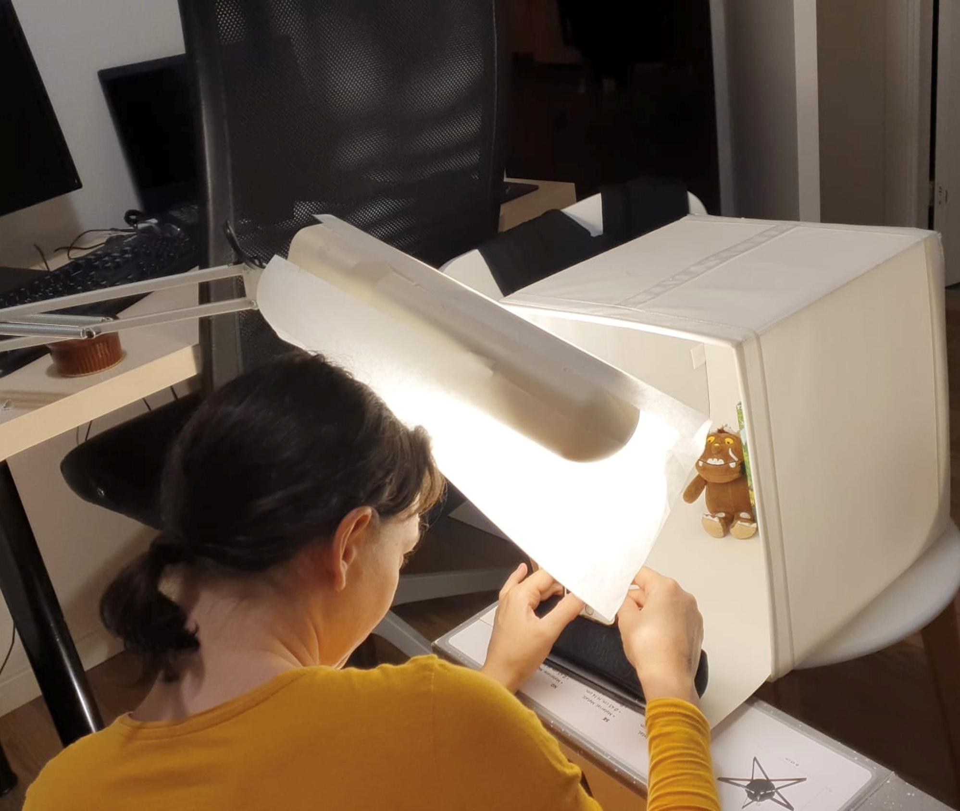Figure 8: My improvised studio set

Appendix 2
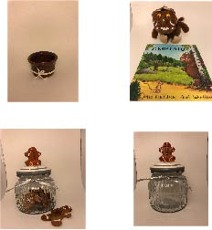Figure 9: Some pictures that I took but did not use at this time.

WILLIAMSON, James. Design Icons for the web. Designing for smaller sizes. Aug 27, 2015. Retrieved January, 2022, from: https://www.linkedin.com/learning/designing-icons-for-the-web/designing-for-smaller-sizes?autoAdvance=true&autoSkip=false&autoplay=true&resume=true&u=43268076
PRLJIC, Marko. The web designers’ guide to photo selection. July 16, 2014. Retrieved January, 2022, from: https://webdesign.tutsplus.com/tutorials/the-web-designers-guide-to-photo-selection--cms-21592
SIMMONS, Katie-jay. Easy DIY guide to high-quality product photography. July 2, 2021. Reviewed by Meaghan Brophy. Retrieved January, 2022, from: https://fitsmallbusiness.com/product-photography/

