

Technical Report

Title of report

Student Name

Word count
Summary: 250 | Main text:500

Table of Contents

1. Summary 3

2. Body 4
2.1. Introduction 4
2.2. Main section of report 4
2.3. Conclusion 4

3. References 5

4. Acknowledgements 6

5. Appendices 7

1. Summary

Start writing here

2. Body

2.1. Introduction

Decorating a house is not a simple task. So, based on my experiences with home decoration, I like the pastels colours. They can be combined with whatever colour do I want and they have an elegant association.
I based my palette colours on the “modern day wellness”, but I preferred to add tint. Because I like the light colour to the background and the contrast with dark colour to the fonts. My palette is that:

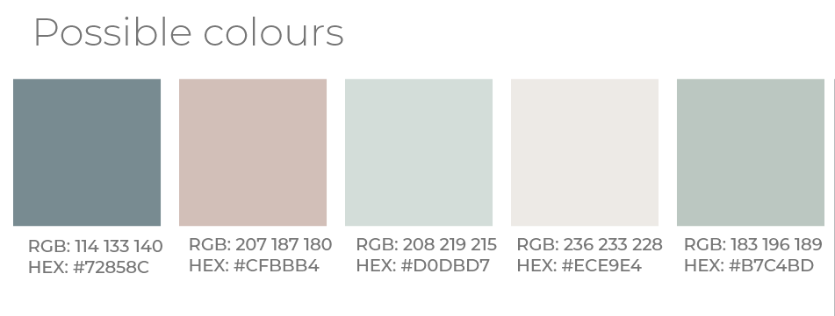Figure 1: My palette used to this Module Assignment

The blue suggest calmness and peacefulness, the exact sensation I would like to feel when I am at home. This colour is perfect to cushions, an armchair or a curtain.
The orange “is most commonly associated with comfort, warmth, creativity, fun, youth, enthusiasm, celebration and in website designs, this color is also associated with affordability.” I would like to celebrate with my family and my friends a good meal, an expected reunion or a simple breakfast. This colour is special to the kitchen and dinning room. To this website, this colour is essential, because the propose is home decoration and everyone can be that, so affordability is very important to this task.
The green is very important to home decoration. A plant in a corner of the house is harmonic and inspiring. To bring the nature to home is freshness and calmness too. I like so much this colour and all my projects have this colour in the palette, for me is difficult to think some project without green.
To the buttons uses blue and orange, in other words, complementary colours. I made that choice because this elements expected some action of the user, like suggests in the lesson 3. The same colours is used to explain the temperature and tint in the book Design for hackers, on the figure 9-12. For the author this contrast “is so great that there is a sense of vibration where they meet”.

2.2. Main section of report
For this website I create only the index page to represent all the elements necessary to demonstrate what I understand about colours, shapes and textures.

2.3. Conclusion

3. References

https://ninefivebrand.com/modern-day-wellness/

Photo by Daniil Silantev on Unsplash

https://unsplash.com/photos/AQl-J19ocWE

https://unsplash.com/photos/y_2GC4EhOP4

4. Acknowledgements

Start writing here

5. Appendices

Start writing here

https://ninefivebrand.com/modern-day-wellness/
https://pixel77.com/color-psychology-web-design-color-schemes-big-websites/
Design for hackers p. 258
Design for hackers p. 258

