

Technical Report

Design 2 - MA3

Priscila Kuhn Derlam

Word count
Summary: | Main text:

Table of Contents

1. Summary 3

2. Body 4
2.1. Introduction 4
2.2. Main section of report 4
2.3. Conclusion 4

3. References 5

4. Acknowledgements 6

5. Appendices 7

1. Summary

Reading some text on different devices can be difficult if the typefaces, fonts, colors, and sizes do not match. A sans serif font in paragraphs is essential, a good contrast to be able to read easily and an adequate size that allows you to see characters and icons on small screens is fundamental.
A font can reflect brand adjectives, as well as colors, photos, logo, and text. The correct choices are as important as the photos selection. However, this choice is based on the user and the target audience.
None of that is possible without combining background information about different fonts and their compositions. That is what I want to report in the current module assignment.

2. Body

2.1. Introduction

I was encouraged by this new proposal for choosing fonts. My first choice was simple: in the logo – Jonathan font; in the call to action and navigation bar – Source Serif 4; in the text and headings – Montserrat. It seemed pretty easy and fast to choose. But, I did not have the knowledge that I have now after vast readings.
I change some of my choices, like the texts/ paragraphs font and the headings font. I needed to see what I could improve, so I did. Because different fonts can "help develop a sense of consistency and hierarchy throughout your web pages."
So, in the end, I have chosen: the headings - Embury Text font; the body (paragraphs) - Source Sans 3 font; the slogan - Source Sans Pro font. I have kept my first choices on the logo, the call to action, and the navigation bar.

2.2. Main section of report

Historically, the web fonts would like to see as the printer version. Kadavy said in his book: "promise to one day bring web typography to the resolution of paper." It is not a dream that technology is evolving in this way. He complements:
“The only way for a designer or developer to ensure that she’s making the right font choice is for her to develop an understanding of the font’s intentions and the limitations of the screen technology – or whatever medium in which the design will finally be conveyed.”

I am not 100% sure of my choices: if I am making the right font choice. However, I searched a lot and learned how to do that. The material was rich in articles and knowledge. I tried to follow the steps and improve the website.
The first concept I learned is the difference between typeface and font: “a typeface is the underlying visual design that can exist in different typography technologies, and a font is one of these implementations, in the form of a digital file. In other words, a type is what you see and a font is what you use.”
In the beginning, I had some fonts chosen, but I did not know the variable fonts and what this type of fonts could do.
“Variable fonts deal with these challenges by grouping multiple styles into a single file. This works by starting from a central or 'default' style, usually the 'Regular' - a vertical Roman design with more typical weight and width that is best suited for regular text. This is then connected to other styles in a continuous range, called the 'axis'. The most common axis is Weight, which can connect the default style to a Bold style. Any individual style can be located along an axis and is called an 'instance' of the variable font.”
After figuring the variables fonts out, I decided to explore these kinds of fonts. I decided to keep the Source Serif 4 because it is variable, and I searched for another variable font for the body.
This font “continues Adobe’s line of high-quality open source typefaces. Designed for a digital environment, the letter shapes are simplified and highly readable. Its historical roots, combined with expert guidance give the typeface a strong character of its own that will shine when used for extended text on paper or screen”, accordingly Google fonts website.
Source serif has been chosen for the calls to actions buttons and the navigation bar. As much as it could be a font for paragraphs. However, I preferred to keep this font only to these specific contexts.
This font is commonly used with Source Code and Source Sans. They was created by Paul D. Hunt, and, accordantly Adobe “Source Serif has been conceived as a friendly companion to Paul D. Hunt’s Source Sans”.
For the body, I would like a sans-serif font. Previously, the paragraphs were written with Montserrat. Though, Source Sans seemed more compatible with the font in the CTA's and Navigation bar. This font was created by the same author, and it is different, but can be combined with Source Serif.
As stated by the material "the content text for your website should be clean and legible with good spacing between letters and lines. Sans serif fonts are a good choice as they are quite legible and simple fonts.”
Also, the Source Sans 3 font is a variable font, as Source Serif 4 font. I have chosen these fonts because I can control the weight by CSS font-weight. I liked this option after all these fonts allow me for a more granular level of control, for example, the body font has a value 370. This value only is possible because the font is variable.
The headings could be decoratives, and I could explore this with handwritten fonts or serifs. I selected the simple one to be more readable without ceasing to be decorative. For this piece of text, I have chosen the Embury Text font.
According to the article Introduction to variable fonts on the web, "for titles, exploring different axes to create great artistic designs is exciting.” I did not make different axes or create great artistic designs, but I enjoyed seeing the results. I have chosen this font because I liked a lot of the contours of this font. It is a serif font with personality and elegance.
The material says: “serif fonts are usually used for headings as have small lines on the letters giving the font character. They stand out more and are a good choice for headings.” I followed the suggestion of the material: "often sans serif fonts are used for the content text of the page, and serif fonts used for the headings. Contrast is good."
So that is the result:

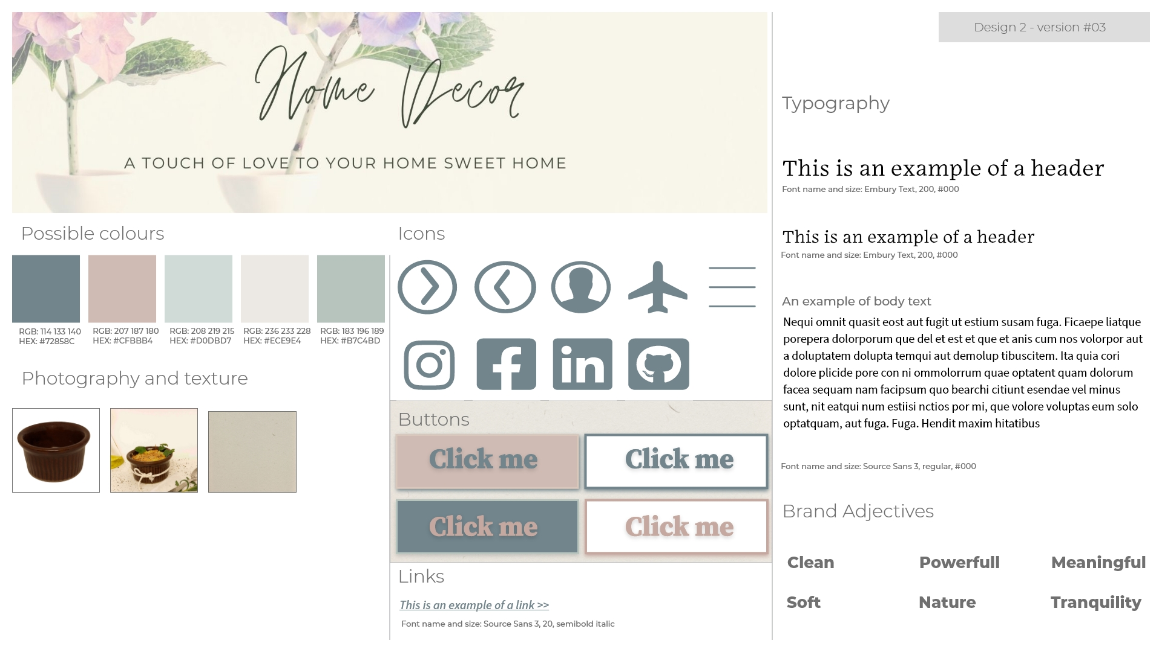Figure 1: The new fonts: Embury Text, Source Sans and Source Serif 4
The logo of Home Decor reflects the personality of the brand. It writes in a handwriting font (Jonathan) because the brand would like to seem handmade with love, but at the same time sophisticated to be shared and shown. As the author of the article Find the perfect Google Font pairing for your website says: “these font ‘personalities’ should reflect the personality of your brand.”
The slogan has written in Source Sans Pro, it is a variation of Source Sans 4, and I have chosen this font because it is similar to the paragraph's text.
About the texts, I applied the hanging indent on my project, in paragraphs. However, I did not like the results. Maybe it will fit in another project or for another purpose. For now, I will not apply this style.
The material says that “studies show that the optimal line length should be 50 – 60 characters for a good user experience on a normal laptop or PC screen. For smaller screen sizes, i.e. mobile, this number would obviously be less. Too narrow can also make the website text uncomfortable to read.”
Thereby, I used only 28 words to describe the concept of the kitchen and dining room product. I did not justify the text instead it aligned left. These texts are only displayed on the desktop version. And the icons replace the complete information about the contact in the mobile version.

2.3. Conclusion

“Using 2-3 fonts is best with a primary font for the headings, a secondary font for the main body text, and an accent font used in specific places on the web page like calls to actions and quotes.” (material)

3. References

BLOGGER, Guest. Find the perfect Google Font pairing for your website. Retrieved January, 2022, from: https://99designs.no/blog/tips/find-perfect-google-font-combinations-website/

BRISCOE, Jason. Digital photograph. Retrieved January 2022, from: https://unsplash.com/photos/AQl-J19ocWE

canva.com(2022). Retrieved January 2022, from: https://www.canva.com/

developer.mozilla.org(2022). Change event. Retrieved January, 2022, from:https://developer.mozilla.org/en-US/docs/Web/API/HTMLElement/change_event

fontinuse.com (2022). Source Serif. Retrieved January, 2022, from: https://fontsinuse.com/typefaces/32500/source-serif

fonts.google.com (2022). Source Serif. Retrieved January, 2022, from: https://fonts.google.com/specimen/Source+Serif+4#about

GRIEBHAMMER, Frank. Source Serif 4 font. Retrieved January 2022, from: https://fonts.google.com/specimen/Source+Serif+4?category=Sans+Serif

HUNT, Paul D. Source Sans Pro. Retrieved January, 2022, from: https://fonts.adobe.com/fonts/source-code-pro

HUNT, Paul D. Source Sans 3. Retrieved January, 2022, from: https://fonts.adobe.com/fonts/source-code-pro

Jonathan Signature Font. Retrieved January 2022, from: https://ifonts.xyz/jonathan-signature-font.html

KADAVY, David. Design for hackers. Wiley, 2011.

KIWIHUG. Digital photograph. Retrieved January 2022, from: https://unsplash.com/photos/y_2GC4EhOP4

KURTULDU, Mustafa, et al. Introduction to variable fonts on the web. Feb 19, 2018. Updated Aug 17, 2020. Retrieved January 2022, from: https://web.dev/variable-fonts/

ninefivebrand.com(2022). Modern day Wellness. Retrieved January 2022, from: https://ninefivebrand.com/modern-day-wellness/

pixel77.com(2022). Color psychology web design color schemes big websites. May 25, 2011. Retrieved January, 2022, from: https://pixel77.com/color-psychology-web-design-color-schemes-big-websites/

PRLJIC, Marko. The web designers’ guide to photo selection. July 16, 2014. Retrieved January, 2022, from: https://webdesign.tutsplus.com/tutorials/the-web-designers-guide-to-photo-selection--cms-21592
RUSHTON, Victoria. Embury Text. Retrieved January, 2022, from: https://fonts.adobe.com/fonts/embury-text#recommendations-section

SILANTEV, Daniil. Digital photograph. Retrieved January 2022, from: https://unsplash.com/photos/nBuiLbz_j4A

SIMMONS, Katie-jay. Easy DIY guide to high-quality product photography. July 2, 2021. Reviewed by Meaghan Brophy. Retrieved January, 2022, from: https://fitsmallbusiness.com/product-photography/

STOREY, Dudley. Classic typography effects in CSS: Hanging indent. Retrieved January, 2022, from: http://thenewcode.com/50/Classic-Typography-Effects-in-CSS-Hanging-Indent

TOSOLINI, Francesca. Digital photograph. Retrieved January 2022, from: https://unsplash.com/photos/tHkJAMcO3QE

ULANOVSKY, Julieta et al. Montserrat Font. Retrieved January 2022, from: https://fonts.google.com/specimen/Montserrat?category=Sans+Serif

unsplash.com (2022). Retrieved January 2022, from: http://www.unsplash.com

stackoverflow.com (2022). Retrieved January 2022, from:
https://stackoverflow.com/questions/12362256/addeventlistener-on-nodelist

WILLIAMS, Ollie. One file, many options: using variable fonts on the web. Jan 29, 2018. Retrieved January, 2022, from: https://css-tricks.com/one-file-many-options-using-variable-fonts-web/

WILLIAMSON, James. Design Icons for the web. Designing for smaller sizes. Aug 27, 2015. Retrieved January, 2022, from: https://www.linkedin.com/learning/designing-icons-for-the-web/designing-for-smaller-sizes?autoAdvance=true&autoSkip=false&autoplay=true&resume=true&u=43268076

5. Appendices

Jonathan Signature Font. Retrieved January 2022, from: https://ifonts.xyz/jonathan-signature-font.html
HUNT, Paul D. Source Sans 3. Retrieved January, 2022, from: https://fonts.adobe.com/fonts/source-code-pro
BLOGGER, Guest. Find the perfect Google Font pairing for your website. Retrieved January, 2022, from: https://99designs.no/blog/tips/find-perfect-google-font-combinations-website/
RUSHTON, Victoria. Embury Text. Retrieved January, 2022, from: https://fonts.adobe.com/fonts/embury-text#recommendations-section
HUNT, Paul D. Source Sans 3. Retrieved January, 2022, from: https://fonts.adobe.com/fonts/source-code-pro
HUNT, Paul D. Source Sans Pro. Retrieved January, 2022, from: https://fonts.adobe.com/fonts/source-code-pro
KADAVY, David. Design for hackers. Wiley, 2011. p. 72.
KADAVY, David. Design for hackers. Wiley, 2011. p. 72.
KURTULDU, Mustafa, et al. Introduction to variable fonts on the web. Feb 19, 2018. Updated Aug 17, 2020. Retrieved January 2022, from: https://web.dev/variable-fonts/
KURTULDU, Mustafa, et al. Introduction to variable fonts on the web. Feb 19, 2018. Updated Aug 17, 2020. Retrieved January 2022, from: https://web.dev/variable-fonts/
HUNT, Paul D. Source Sans 3. Retrieved January, 2022, from: https://fonts.adobe.com/fonts/source-code-pro
fonts.google.com (2022). Source Serif. Retrieved January, 2022, from: https://fonts.google.com/specimen/Source+Serif+4#about
HUNT, Paul D. Source Sans 3. Retrieved January, 2022, from: https://fonts.adobe.com/fonts/source-code-pro
fontinuse.com (2022). Source Serif. Retrieved January, 2022, from: https://fontsinuse.com/typefaces/32500/source-serif
fontinuse.com (2022). Source Serif. Retrieved January, 2022, from: https://fontsinuse.com/typefaces/32500/source-serif
WILLIAMS, Ollie. One file, many options: using variable fonts on the web. Jan 29, 2018. Retrieved January, 2022, from: https://css-tricks.com/one-file-many-options-using-variable-fonts-web/
WILLIAMS, Ollie. One file, many options: using variable fonts on the web. Jan 29, 2018. Retrieved January, 2022, from: https://css-tricks.com/one-file-many-options-using-variable-fonts-web/
RUSHTON, Victoria. Embury Text. Retrieved January, 2022, from: https://fonts.adobe.com/fonts/embury-text#recommendations-section
KURTULDU, Mustafa, et al. Introduction to variable fonts on the web. Feb 19, 2018. Updated Aug 17, 2020. Retrieved January 2022, from: https://web.dev/variable-fonts/
Jonathan Signature Font. Retrieved January 2022, from: https://ifonts.xyz/jonathan-signature-font.html
BLOGGER, Guest. Find the perfect Google Font pairing for your website. Retrieved January, 2022, from: https://99designs.no/blog/tips/find-perfect-google-font-combinations-website/
HUNT, Paul D. Source Sans Pro. Retrieved January, 2022, from: https://fonts.adobe.com/fonts/source-code-pro
STOREY, Dudley. Classic typography effects in CSS: Hanging indent. Retrieved January, 2022, from: http://thenewcode.com/50/Classic-Typography-Effects-in-CSS-Hanging-Indent

