**LockedMe.com Specification Document**

**Project Detail**

Project Name: LockedMe.com

**Project Version: 1.0**

**GitHub repository link:**

**Project Details:** Prototype of file management system. This application has the feature to add delete and search files from specific directory

**Objective**: Application Need to be presented to relevant stack holder for the budget approval

**Developer Detail**

Name: Pradeep Kumar Dubey

Simplilearn user ID: [pkdubay2021@gmail.com](mailto:pkdubay2021@gmail.com)

Batch: MS FSD June 2022 Cohort 1

**Functionality Detail of the Application:**

**Main Screen:**

This screen heaving the welcome screen and the user interface detail where user need to select any of one options

“

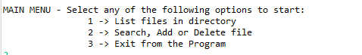

**“**

**List files in the directory:** These option provide the list of files in current directory

**Search, Add Delete file:** This option takes the user to secondary menu. (More details are provided in the secondary menu section of this document).

**Exit from the programme**: Close the Application

**Secondary Menu:**

This Section has the options for the file operation and one option for the going back to main screen. By selecting the file operation a, b, or c user can perform specific Task.

“

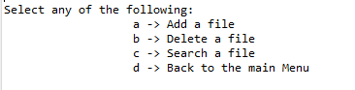

“

**Add file**: when user select this options it ask for the file name first. When user enters the file name it adds the file in the directory.

**Delete file**: when user select this options it ask for the file name first. When user enters the file name it Delete the file in the directory

**Search file**: when users select these options it searches the files in the directory and shows the search result.

**Back to the main menu**: it takes bake the user to main menu option.

**Flow Chart:**

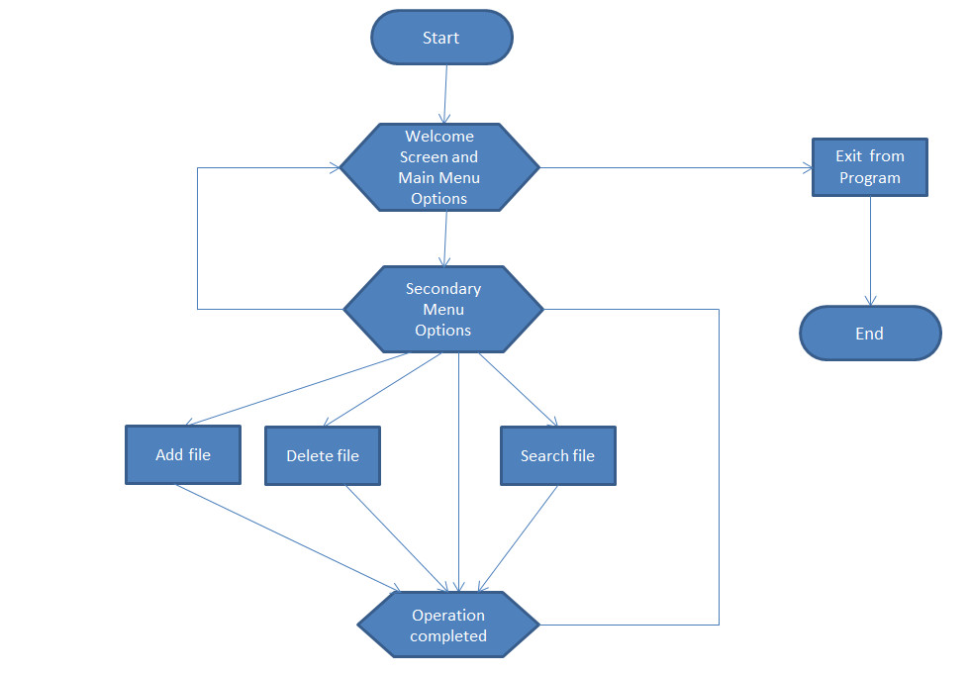

**Sprint Plan:**

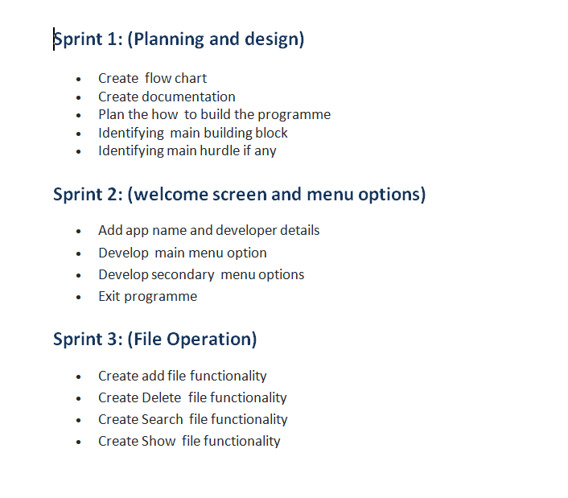

**Classes and functions used in the programme:**

|  |  |  |  |
| --- | --- | --- | --- |
| Sr. No. | Name | Class/functions | Remarks |
| 1 | LockedMeDotCom | Class | Class for the file operations |
| 2 | showPrimaryMenu | Function | For showing primary menu |
| 3 | showFiles | Function | For listing and sorting the files |
| 4 | showSecondaryMenu | Function | For showing secondary menu |
| 5 | addFile | Function | For adding files |
| 6 | deleteFile | Function | For deleting file |
| 7 | searchFile | Function | For searching files |
|  |  |  |  |

**Concept used in this programme:**

1. Classes
2. Objects
3. Constructor
4. Encapsulation
5. Inheritance
6. Exception Handling
7. File handling
8. Flow control
9. Methods
10. Variable
11. Access Modifier
12. List
13. String
14. Array
15. Searching and Sorting

**Conclusion:**

There is a lot of scope to improve this programme. The code can be improved a lot we can make it by using any specific pattern or using the abstract class.

The functionality like editing file can also be added.

The USP of this project is that once it is fully developed it can be a complete file management system. And this programme can be run on any operating system.