**Step 1: Create a Folder Pair**

LEFT side = c:\FolderA

RIGHT side = c:\FolderB

**Step 2: Create two subfolders under the LEFT side and place 1 file in each subfolder.**

C:\FolderA\subfolder 1

C:\Folder A\subfolder 2

**Step 3: Run Sync. After the sync, the Tree will look like this picture:**

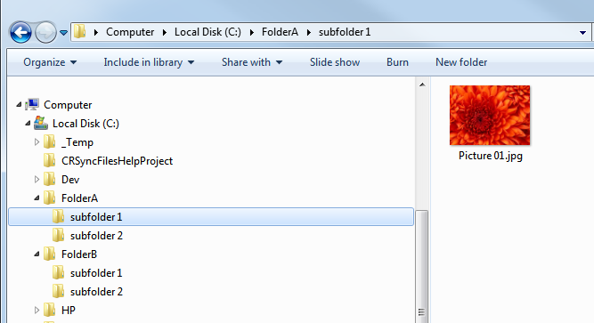

**Step 4: On the LEFT side, CUT subfolder1 and PASTE it into subfolder2**

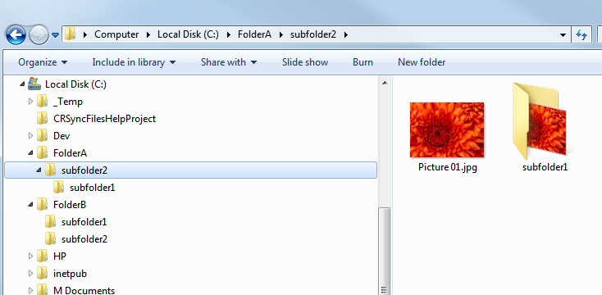

**Step 5: Go to the Options of the Folder Pair, then click the “Select Subfolder” link and Exclude subfolder2**

**That is, Uncheck subfolder2 on the LEFT side, to Exclude subfolder2**

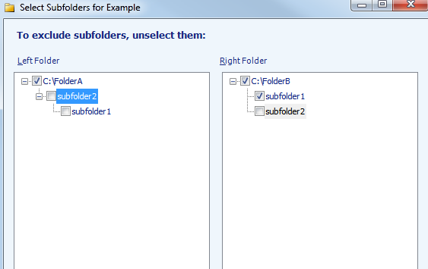

**Step 6: Click Preview. SyncToy will show the correct operations.**

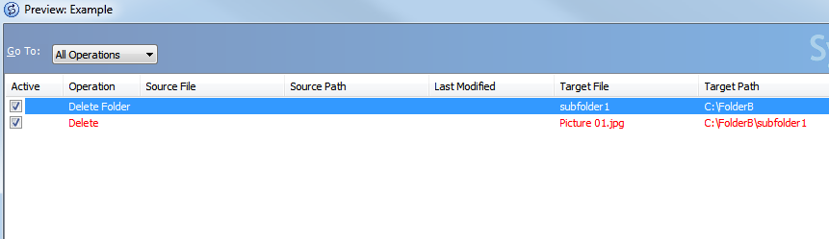

**Step 7: Run Sync again with SyncToy. SyncToy will correctly handle it.**

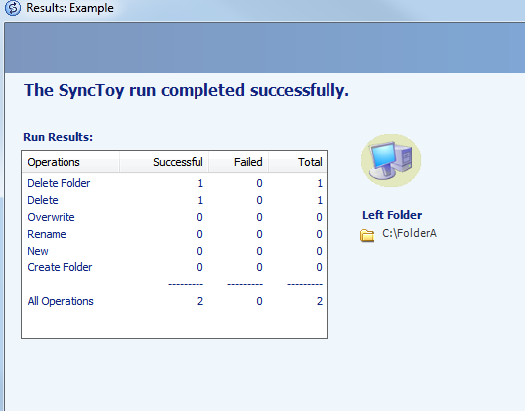

If you follow the same steps in the console version attached as follows, you will get the following error:

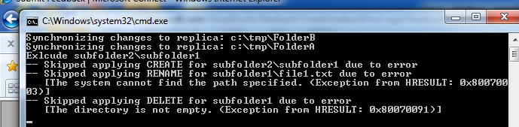

The steps are first load up just FolderA with two subdirectories and a file in each subdirectory (as above)

Then, make (FolderB empty and run sync with the excludes commented out (see picture below)

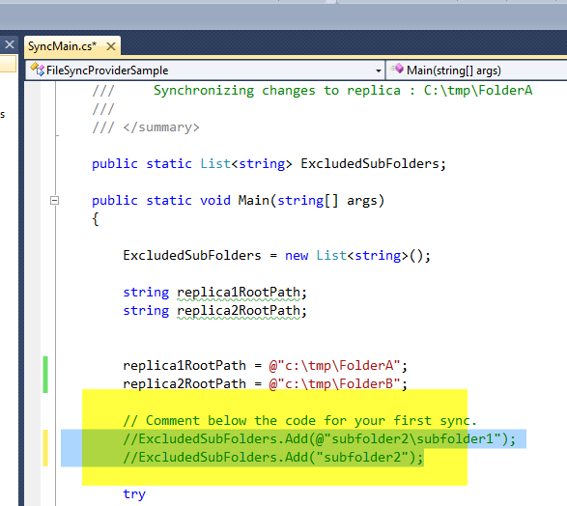

That gives you this:

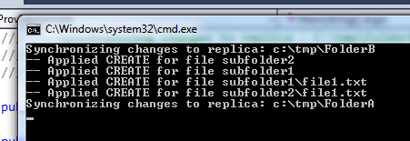

Now, cut from FolderA\subfolder1 to FolderA\subfolder2 so you get this:

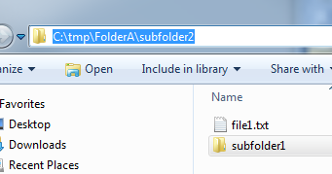

Now, enable the excludes (same as what would happen inside synctoy 2.1)

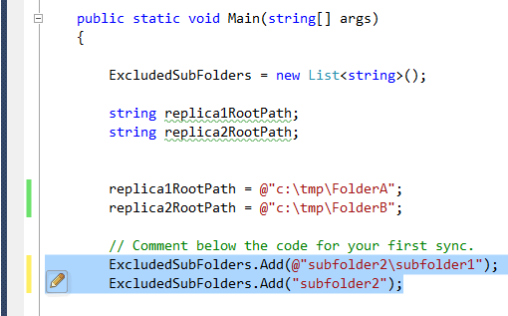

Run the console app again and you get this error (which you don’t get in synctoy from above example which is file provider 2.0)

