Plotted vectors of FA profiles on top of PCA, also tried water quality predictors. Only statistically significant (p<0.05) vectors were plotted. Water quality vectors in red where available.

Seston – red lines are VSS and chlorophyll

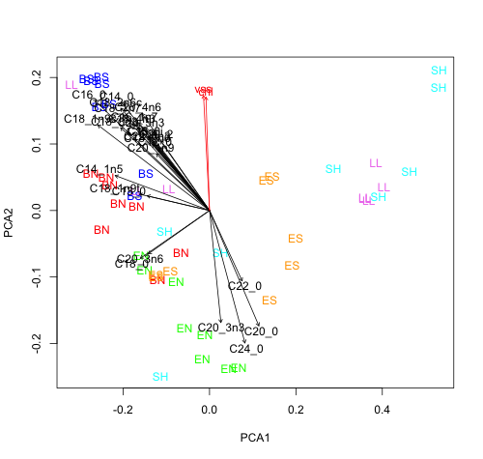

TS nestlings

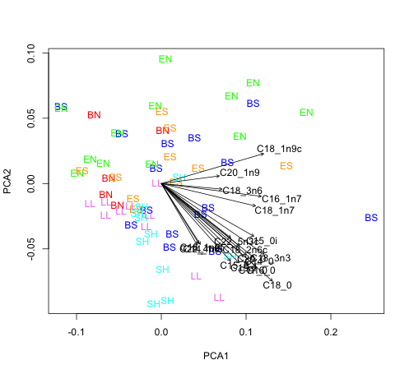

Bolus

