Analysis

**The dependence of the execution time of the program on the matrix size n**

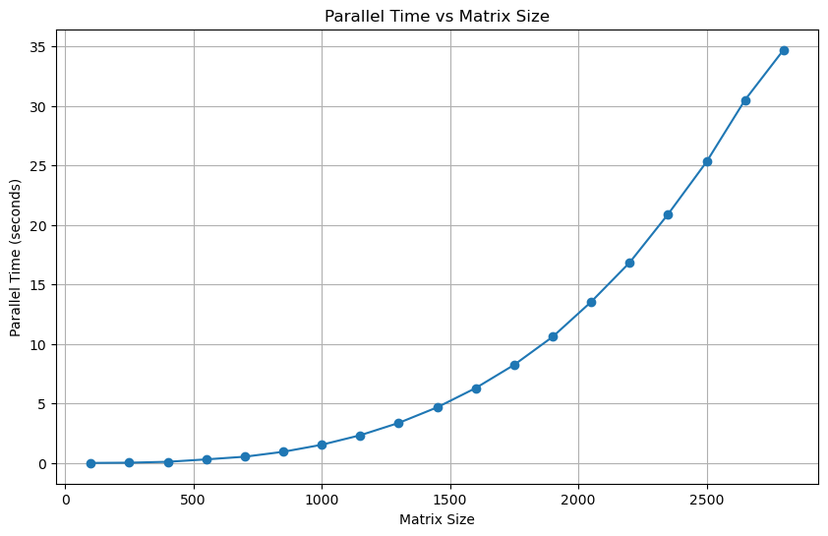

Examining the graph, we can easily see that as the matrix size *n*, grows, so does the time required for computation. This trend is expected since larger matrices demand more processing power. We can also see that the increase in time is non-linear, resembling a curve, possibly polynomial or exponential, as *n* increases linearly.

However, the graph does not provide a comprehensive view of the efficiency of the parallel method. To explore of the performance further, I will discuss the efficiency in relation to the serial method.

Note:

The number of processors p is dynamically calculated at runtime using the MPI function <MPI_Comm_size(MPI_COMM_WORLD, &p)> , which queries the MPI environment to determine the number of processors available in the current execution context.

As a result, the exact number of processors utilised varies depending on the specific configuration and availability of resources in the MPI environment during each run of the program. This approach ensures that our program adapts to the available parallel computing resource.

For my particular experiments I set p as 4 using the openMPI command

<mpirun -np 4 ./main>.

**The speedup over a serial counterpart of the program**

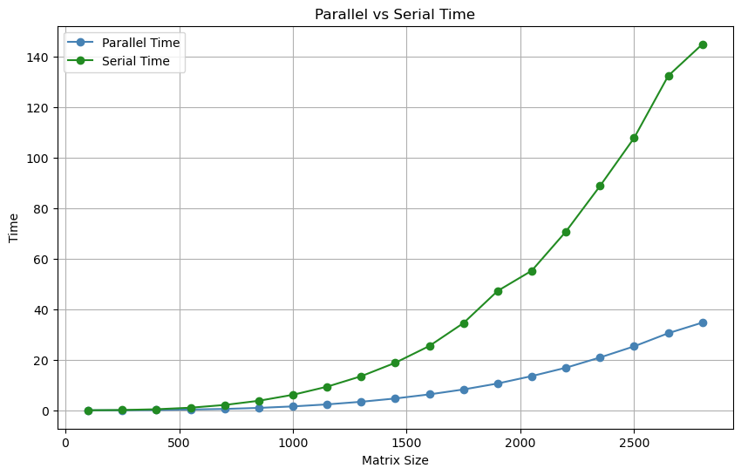

Looking at the graph, we can clearly see that parallel computation has a substantial advantage, particularly when it comes to larger matrices. As the size of the matrix increases, the line for serial computation begins to rise steeply, in contrast to the more gradual ascent of the parallel computation line. This marked difference demonstrates the superior efficiency of parallel processing for handling complex tasks involving large datasets. We especially see how they begin to diverge around matrix size=500.

The reason for the parallel method having a more consistent increase in time lies in its approach to splitting the matrix into smaller sections, which are then processed concurrently. This effectively utilises the multi-core design of contemporary processors, distributing the computational load across several threads. In contrast, the serial method, which handles the entire matrix in a singular sequence, finds itself increasingly challenged by larger matrices, leading to a much sharper increase in computation time. However, when I ran this programme on a different machine, the speedup (caused by increased serial times) appeared to improve, suggesting that my machine potentially optimises the serial multiplication somewhat.

It is worth noting from the values in the experiment2.csv that the speedup consistently floated around 4, suggesting there is a limit with the hardware of my processor. That being said 4 is still a great improvement with the parallel method and shows that the parallelisation of my code scales with the increase in matrix size.

This graph provides a good illustration of the strengths of parallel computing, especially for demanding computational tasks. It demonstrates that as the size of the data grows, parallel processing can significantly mitigate the impact on computation time, making it a more efficient choice for intensive calculations.

**The effect of the number of processors *p* on speedup**

**p = 8**

|  |  |  |  |
| --- | --- | --- | --- |
| Matrix Size | Serial Time | Parallel Time | Speedup |
| **100** | 0.005959 | 0.001465 | 4.067577 |
| 250 | 0.107519 | 0.023596 | 4.556662 |
| 400 | 0.416174 | 0.099836 | 4.168576 |
| 550 | 1.01971 | 0.25379 | 4.017928 |
| 700 | 2.126491 | 0.525188 | 4.049009 |
| 850 | 3.798794 | 0.941076 | 4.03665 |
| 1000 | 6.244625 | 1.53312 | 4.073148 |
| 1150 | 9.368154 | 2.385435 | 3.927231 |
| 1300 | 13.517019 | 3.36799 | 4.013379 |
| 1450 | 18.707884 | 4.662332 | 4.012559 |
| 1600 | 25.33802 | 6.282582 | 4.033058 |
| 1750 | 33.558891 | 8.233952 | 4.075672 |
| 1900 | 43.444675 | 10.51504 | 4.13167 |
| 2050 | 55.169559 | 13.292317 | 4.150485 |
| 2200 | 74.032608 | 16.474596 | 4.493743 |
| 2350 | 89.583397 | 20.166518 | 4.442185 |
| 2500 | 111.700485 | 24.615526 | 4.537806 |

**p = 4**

|  |  |  |  |
| --- | --- | --- | --- |
| Matrix Size | Serial Time | Parallel Time | Speedup |
| **100** | 0.005926 | 0.001455 | 4.072852 |
| 250 | 0.096426 | 0.023473 | 4.107954 |
| 400 | 0.404436 | 0.097861 | 4.13276 |
| 550 | 1.021478 | 0.301946 | 3.382983 |
| 700 | 2.099202 | 0.525511 | 3.994592 |
| 850 | 3.758721 | 0.938134 | 4.006593 |
| 1000 | 6.124197 | 1.528601 | 4.006407 |
| 1150 | 9.323936 | 2.327 | 4.006849 |
| 1300 | 13.471663 | 3.362487 | 4.006458 |
| 1450 | 18.798637 | 4.672137 | 4.023563 |
| 1600 | 25.456583 | 6.290354 | 4.046924 |
| 1750 | 34.532238 | 8.240396 | 4.190604 |
| 1900 | 47.244839 | 10.597695 | 4.45803 |
| 2050 | 55.255627 | 13.533082 | 4.083004 |
| 2200 | 70.73085 | 16.83509 | 4.201394 |
| 2350 | 88.780075 | 20.901503 | 4.247545 |
| 2500 | 107.815544 | 25.305041 | 4.260635 |
| 2650 | 132.40921 | 30.506183 | 4.340406 |
| 2800 | 144.925415 | 34.706657 | 4.175724 |

**p = 2**

|  |  |  |  |
| --- | --- | --- | --- |
| Matrix Size | Serial Time | Parallel Time | Speedup |
| 100 | 0.006345 | 0.006471 | 0.980529 |
| 250 | 0.094939 | 0.095457 | 0.994573 |
| 400 | 0.391468 | 0.388569 | 1.007461 |
| 550 | 1.037346 | 1.016708 | 1.020299 |
| 700 | 2.099198 | 2.09066 | 1.004084 |
| 850 | 3.774193 | 3.752295 | 1.005836 |
| 1000 | 6.129642 | 6.116769 | 1.002105 |
| 1150 | 9.346747 | 9.335935 | 1.001158 |
| 1300 | 13.461467 | 13.537216 | 0.994404 |
| 1450 | 18.724487 | 18.765273 | 0.997827 |
| 1600 | 26.548019 | 25.258235 | 1.051064 |
| 1750 | 34.716187 | 34.99048 | 0.992161 |
| 1900 | 46.852364 | 46.022775 | 1.018026 |
| 2050 | 55.178143 | 58.58279 | 0.941883 |
| 2200 | 69.513199 | 70.090242 | 0.991767 |
| 2350 | 86.792877 | 85.898994 | 1.010406 |
| 2500 | 105.928238 | 102.850194 | 1.029927 |
| 2650 | 124.464691 | 124.406422 | 1.000468 |
| 2800 | 143.566803 | 142.07013 | 1.010535 |

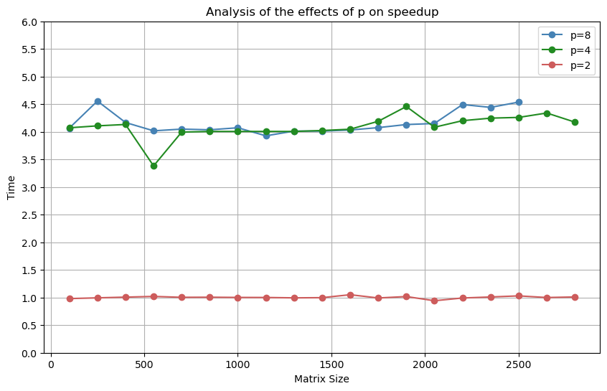

As we can see from the tables and graph above, p=4 is the best number for my hardware as it balances well the additional memory required for parallelisation and the speedup from parallelisation. P=2 showed no obvious improvements in performance over the serial computation and p=8 was largely equal to p=4 in terms of performance, meaning the increase in memory use had diminishing returns. In fact, on my computer, I was unable to go over n=2500 as numbers above this caused segmentation errors.

We can see that the parallelisation offers a speedup of around 4, with larger matrices showing more consistently over 4, suggesting even larger matrices could see greater improvements in calculation if the memory was available, and vice versa for smaller matrices.