***File Beat:-***

Filebeat is a lightweight shipper for forwarding and centralizing log data. Installed as an agent on your servers, Filebeat monitors the log files or locations that you specify, collects log events, and forwards them to either to Elasticsearch or Logstash for indexing.

1. Use to collect the application logs.(provide logs location in configuration file)
2. Stored into a elastic search for indexing
3. Using kibana to search the logs.

**Filebeat.yml:-**

filebeat.inputs:

- type: log

enabled: true

paths:

- /var/log/*.log

output.elasticsearch:

hosts: ["myEShost:9200"]

<https://www.elastic.co/guide/en/beats/filebeat/current/filebeat-configuration.html>

**how to start filebeat:-**

./filebeat –e –c filebeat.yml

***Metric Beat:-***

1. Metricbeat is a lightweight shipper that you can install on your servers to periodically collect metrics from the operating system and from services running on the server.
2. Metricbeat takes the metrics and statistics that it collects and ships them to the output that you specify, such as Elasticsearch or Logstash.
3. Here we are using metric beat for system metrics(aws machine metrics)
4. Enable System module for collecting system metrics.

<https://www.elastic.co/guide/en/beats/metricbeat/current/metricbeat-module-system.html>

1. The default metricsets are cpu, load, memory, network, process, and process_summary.

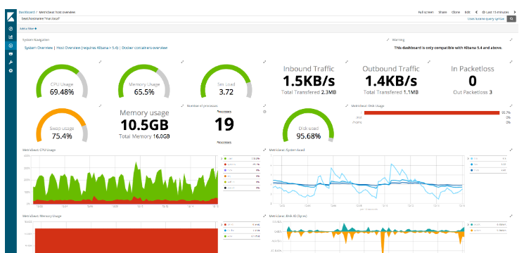

1. Enable the modules that you want to run. If you accept the default configuration without enabling additional modules, Metricbeat collects system metrics only.

./metricbeat modules enable apache mysql

**metricbeat.yml:-**

Elasticsearch configuration

output.elasticsearch:

hosts: ["myEShost:9200"]

<https://www.elastic.co/guide/en/beats/metricbeat/current/metricbeat-configuration.html>

**To Start metricbeat:-**

./metricbeat -e -c metricbeat.yml

***Hearbeat:-***

1. Heartbeat is a lightweight shipping agent used to monitor the health of services running on the host.
2. The results can then be shipped to one or more destinations, including Logstash.
3. Use of this hearbeat is mainly check the service is up or not .When I configured elastic and kibana ports into configuration file it will check that give ports are in active or not.

Configuration:-

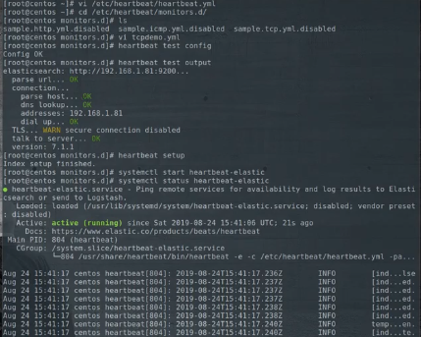

Creating monitor.yml file:-

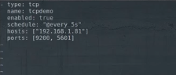

Monitor services :-

