Agent-based Simulation of Infectious Diseases on Cruise Ships: Modeling Pathogen Spread and Public Health Interventions
Authors
Akane B. Fujimoto
H. Milton Stewart School of Industrial & Systems Engineering, Georgia Institute of Technology, Atlanta, Georgia
Sarah Bowden
Division of Global Migration Health, National Center for Emerging and Zoonotic Infectious Diseases, Centers for Disease Control and Prevention, Atlanta, Georgia
Kara Tardivel
Division of Global Migration Health, National Center for Emerging and Zoonotic Infectious Diseases, Atlanta, Georgia
Centers for Disease Control and Prevention; Commissioned Corps, United States Public Health Service, Rockville, Maryland
Stefanie White
Vessel Sanitation Program, National Center for Environmental Health, Centers for Disease Control and Prevention, Atlanta, Georgia
Pinar Keskinocak (Corresponding author)
H. Milton Stewart School of Industrial & Systems Engineering, Georgia Institute of Technology, Atlanta, Georgia
pinar@isye.gatech.edu
404-894-2325
755 Ferst Dr NW, Atlanta, GA 30332

Disclaimer: The findings and conclusions in this report are those of the author(s) and do not necessarily represent the official position of the Centers for Disease Control and Prevention
Abstract

Cruise ships are semi-enclosed, high-density environments where passengers and crew interact repeatedly across shared spaces, creating conditions that can facilitate infectious disease transmission and complicate outbreak control. These environments have unique contact network structures and operational features that require setting-specific models to evaluate infectious disease spread and interventions.

We developed a disease-agnostic agent-based simulation framework to model human-to-human infectious disease transmission onboard cruise ships and assess public health interventions across different cruise configurations and outbreak scenarios. The model represents individual passengers and crew, captures variation in demographics and disease progression, and simulates contact networks shaped by travel groups, cabin assignments, activity participation, employment groups, and passenger–crew interactions.

We demonstrate the model’s utility through COVID-19 and norovirus case studies calibrated with field data. The COVID-19 case study evaluated vaccination, testing, isolation, and masking strategies, while the norovirus case study examined isolation and sanitation interventions. Results highlight how the model can help evaluate the value of interventions under different outbreak conditions, such as varying pathogen transmissibility and population immunity levels. For example, in the COVID-19 case study, expanding testing to include travel-group members of symptomatic cases provided limited additional benefit for onboard case detection, suggesting implications for resource allocation during outbreaks.

This work provides a flexible decision-support tool that captures the social and operational structure of cruise ships, helping cruise operators and public health officials evaluate intervention strategies, inform resource allocation, and strengthen outbreak preparedness and response across a range of infectious disease threats.

Keywords: agent-based simulation; infectious disease modeling; cruise ships; contact networks; intervention evaluation; outbreak response

Introduction
Cruise ships are congregate environments where travelers from diverse geographic and demographic backgrounds gather in close proximity within semi-enclosed, shared spaces for extended periods of time (Centers for Disease Control and Prevention et al., 2024). These high-density settings, combined with frequent and repeated interactions in shared living quarters, dining areas, entertainment venues, and recreational facilities, can facilitate infectious disease outbreaks, particularly gastrointestinal (GI) and respiratory illnesses (Centers for Disease Control and Prevention et al., 2024). Major cruise-associated events, including the SARS-CoV-2 outbreak on the Diamond Princess in 2020 and the 2026 hantavirus pulmonary syndrome (HPS) cluster linked to Andes virus aboard the M/V Hondius, illustrate how outbreaks in cruise ships can create complex public health challenges involving onboard transmission, severe morbidity and mortality, passenger and crew monitoring, and coordination across jurisdictions (Mizumoto & Chowell, 2020; World Health Organization (WHO), 2026). Outbreaks on cruise ships not only endanger the health and well-being of passengers and crew members but also pose risks to the communities where passengers disembark during and after voyages, potentially facilitating onward transmission to the broader population (Arino et al., 2021; Russell et al., 2021).
Given the elevated risk of pathogen transmission on cruise ships, effective public health interventions and policies are essential to prevent and control outbreaks onboard. While most public health responses have traditionally focused on modeling interventions for larger populations, such as countries and states (Keskinocak, Oruc, et al., 2020; Perra, 2021; Xiang et al., 2021), there remains an opportunity to further examine intervention strategies in cruise ship environments, where populations are smaller but denser and contact patterns are frequent and repeated (Jenness et al., 2021; Wen et al., 2022; Zhao et al., 2022). These characteristics create unique challenges for understanding pathogen transmission and intervention effectiveness, making the modeling of such dynamics important for effective outbreak control (Centers for Disease Control and Prevention, 2022).
In this study, we present an agent-based simulation model designed to capture the spread of infectious pathogens under different public health interventions on cruise ships. We apply this model in two case studies, evaluating the spread of SARS-CoV-2, the virus that causes COVID-19, and norovirus. These pathogens are of particular concern for the cruise ship industry due to their high transmissibility, modes of transmission, and documented outbreak history. We quantify the effectiveness of both pharmaceutical and non-pharmaceutical interventions. These findings can inform evidence-based guidance to control pathogen spread, ensuring the safety of travelers, crew members, and the communities potentially affected by cruise ship–associated outbreaks.

Materials and Methods
We developed an agent-based model to simulate the spread of infectious pathogens on cruise ships and to evaluate the impact of public health interventions. The model is flexible and can be adapted to represent infectious diseases with human-to-human transmission by adjusting disease-specific parameters.

Data

Cruise ship characteristics
The cruise industry offers various types of cruise ships depending on the populations they serve. We modeled three cruise ship types: standard, family, and senior. These types represent the most popular cruise ship segments and exhibit contrasting demographic characteristics (Pietschmann, 2022).
- Standard: Budget-friendly cruise ships that cater to a broad demographic, including multi-generational groups, young adults, children, and seniors.
- Family: Cruise ships designed for families with children. These cruises typically have larger travel group sizes than a standard cruise ship.
- Senior: More luxurious cruise ships with smaller travel group sizes, catering primarily to couples and older adults.
We used data from the cruise industry to capture cruise ship passengers' demographics and travel group size patterns. Average passenger age and travel group size distributions were obtained from the Cruise Lines International Association (CLIA) (Appendix A). We adjusted these data to match the age groups selected for the model (0-12, 13-17, 18-64, and 65+ years) and to reflect differences across cruise ship types (Table 1). Family cruise ships cater to larger groups, often comprising families and multi-generational travel groups. Conversely, senior cruises tend to attract couples rather than larger family groups, with many excluding children altogether. An extreme demographic scenario in which children are excluded was represented by excluding children in the senior cruise ship type, allowing assessment of the impact of this setting on simulation outcomes. Additional details on age and group distribution generation are provided in Appendix A.
The proportion of solo travelers has increased in recent years, with estimates ranging from approximately 1% to 10% (Cruise Lines International Association (CLIA), 2015, 2018). We conducted a sensitivity analysis to evaluate the impact of increasing the proportion of solo travelers; results are presented in Appendix B.
Table 1: Generated passenger age and travel group size distributions by cruise ship type.
 |  | Cruise ship type
 |  | Standard | Family | Senior
Passenger age group in years | 0-12 | 0.07 | 0.30 | 0.00
Passenger age group in years | 13-17 | 0.04 | 0.20 | 0.00
Passenger age group in years | 18-64 | 0.65 | 0.25 | 0.35
Passenger age group in years | 65+ | 0.24 | 0.25 | 0.65
Travel group size | 1 | 0.01 | 0.01 | 0.01
Travel group size | 2 | 0.40 | 0.15 | 0.75
Travel group size | 3 | 0.15 | 0.14 | 0.09
Travel group size | 4 | 0.19 | 0.35 | 0.10
Travel group size | 5 | 0.25 | 0.35 | 0.05

Disease-specific data
Disease-specific data include parameters describing the natural history of the disease, such as the latent and infectious periods, the proportion of individuals who develop symptoms, and the probability of hospitalization.

Model
The model was implemented in R (R Core Team, 2022).

Agents
The agents in the model represent the individuals aboard the cruise ship, categorized as either passengers or crew members. Each agent is assigned to an age group (0–12, 13–17, 18–64, 65+ years). The age distribution of passengers reflects typical cruise ship demographics (Table 1). All crew members are assigned to the 18-64 years age group, as they must be of working age. While the Maritime Labour Convention (MLC) sets the minimum age for shipboard employment at 16 years, most cruise lines require employees to be at least 18 years old, with certain positions imposing stricter age requirements (International Labour Organization (ILO), 2006).

Natural history of infection
Each agent can be in one of the following disease states: susceptible, exposed, pre-symptomatic, symptomatic, asymptomatic, isolated infected, isolated not infected, hospitalized, recovered/immune, or dead. At the start of the simulation, each agent begins in the susceptible state unless assigned to a different state (e.g., exposed, asymptomatic, symptomatic, or recovered/immune) to reflect infections occurring before embarkation or prior immunity.
Susceptible agents who become infected transition to the exposed state and remain there for a duration $T_{e}$ before becoming infectious. Agents in the exposed state have been infected but do not show symptoms and cannot transmit the pathogen; infections in this stage are not detectable through testing. After the latent period, agents enter either the asymptomatic or pre-symptomatic state according to the probability of developing symptoms ($P_{sym}$).
Asymptomatic agents remain infectious for $T_{recov-asym}$days and then transition to the recovered/immune state. Agents who develop symptoms first enter the pre-symptomatic stage for $T_{pre-sym}$ days, during which they are infectious but do not show symptoms. They then transition to the symptomatic state and may either recover or progress to severe disease requiring hospitalization with probability $P_{hosp}$. Symptomatic agents who recover remain infectious for $T_{recov-symp}$ days before entering the recovered/immune state.
Hospitalized agents may recover or die, with probability $P_{dead}$. The duration of hospitalization depends on the outcome: $T_{\text{recov-hosp}}$ for agents who recover and $T_{\text{dead-hosp}}$ for those who die. Because cruise ship voyages are short in duration, we assume that only infected agents can transition to the dead state and that recovered agents remain in the recovered/immune state for the remainder of the simulation.
Testing can be performed to detect infection. Agents who receive a positive result transition to either the isolated infected or isolated not infected state, depending on their infection status at the time of testing. Isolated infected agents no longer interact with others but continue to progress through their disease course. Agents placed in the isolated not infected state return to the susceptible state once their isolation period ends.
All state durations follow log-normal distributions with disease-specific means and standard deviations, allowing for individual variability. Figure 1 illustrates state transitions, and Table 2 summarizes the associated model parameters.
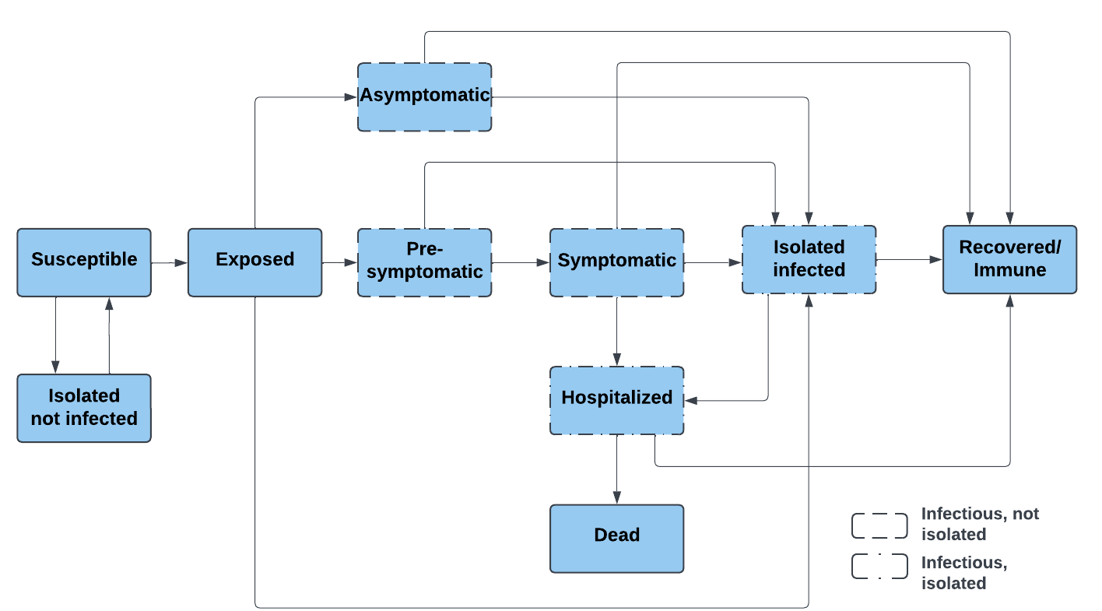
Figure 1: Transition diagram of the disease states.
Table 2: Disease-specific model parameters. All $T$ parameters represent durations in days.
Parameter | Description | Parameter | Description
$$T_{e}$$ | Duration in the exposed state before becoming infectious (i.e., latent period) | $$T_{recov-hosp}$$ | Time in hospitalized state until recovered
$$T_{recov-asym}$$ | Duration in the infected state for asymptomatic cases (i.e., time to recover) | $$T_{dead-hosp}$$ | Time in hospitalized state before transitioning to dead state
$$T_{p,asym}$$ | Duration of virus proliferation phase for asymptomatic cases (time from infection onset to peak viral load) | $$V_{peak,asym}$$ | Peak viral load (in Ct) for asymptomatic individuals
$$T_{pre-sym}$$ | Duration in the pre-symptomatic state for symptomatic cases | $$V_{peak,sym}$$ | Peak viral load (in Ct) for symptomatic individuals
$$T_{p,sym}$$ | Duration of virus proliferation phase for symptomatic cases | $$P_{sym}$$ | Probability of infected individuals developing symptoms
$$T_{recov-symp}$$ | Duration in symptomatic state before transitioning to recovered state | $$P_{hosp}$$ | Probability of symptomatic individuals being hospitalized
$$T_{hosp-symp}$$ | Duration in the symptomatic state before transitioning to hospitalized stated | $$P_{dead}$$ | Probability of hospitalized individuals dying

Pathogen transmission
Pathogen transmission occurs within networks, where agents in the same network group interact with each other. Transmission takes place during each pairwise interaction between an infectious, not isolated agent (i.e., asymptomatic, pre-symptomatic, or symptomatic) and a susceptible agent, with a baseline transmission probability denoted $π_{n}$, where n depends on the network. For diseases with infectious periods lasting several days, such as COVID-19 and other respiratory diseases, viral loads change over time and influence the probability of transmission. To account for this, we adjust the baseline parameter $π_{n}$ according to an individual’s viral load.
Passengers and crew differ in their length of stay onboard: passengers remain for a single voyage (an average of 7 days), whereas crew members stay for several months. This difference affects transmission pathways, as passengers contribute primarily to within-voyage spread, while crew may accumulate exposure across voyages and facilitate transmission between passenger cohorts.
    - Individual viral loads
We explicitly model individual viral loads for pathogens whose infectiousness varies substantially over the course of the infection, building on a framework introduced by Kerr et al. (2021) in their agent-based model of SARS-CoV-2 transmission. Viral load profiles for respiratory infections typically exhibit a rapid increase followed by a slower decline (Puhach et al., 2023). In Appendix C, we describe how individual viral loads are modeled and how they modify the baseline transmission probability $π_{n}$. The resulting adjusted probability of infection, $π_{i,d,n}^{adj}$, varies by individual i, day d, and network n.

Transmission Probabilities
Agents belong to groups in multiple networks based on the agent’s type (passenger or crew) and age (child or adult). These networks determine the set of interactions in which transmission may occur. The baseline transmission $π_{n}$ represents the average probability of infection when a susceptible agent interacts with an infectious agent within network n. The value of $π_{n}$ depends on both the pathogen transmissibility and the network characteristics. There are three types of networks: passenger, crew, and passenger-crew networks. Figure 2 shows a summary diagram of the networks.
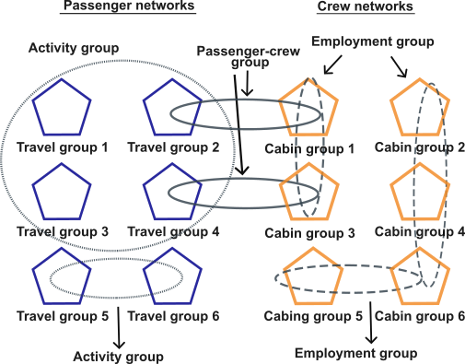
Figure 2: Diagram of networks in the agent-based model.
Passenger networks
We considered three types of transmission probabilities within passenger networks: $π_{\text{main}}$, $π_{\text{act}}$, and $π_{\text{kids}}$.
$π_{\text{main}}$ represents transmission among passengers who travel together. Each passenger is assigned to a travel group of 1–5 passengers, with the distribution depending on the cruise ship type (Table 1). Travel groups spend substantial time together and share cabins, leading to the highest transmission probability.
$π_{\text{act}}$ represents transmission occurring in activity-based networks, including dining, entertainment, nightlife, and kids' playgroups (Cruise Lines International Association (CLIA), 2018). Dining and entertainment networks capture interactions during meals and various onboard entertainment activities such as plays, concerts, movie screenings, comedy shows, etc. We assume that 100% of travel groups participate in dining and 70% in entertainment activities daily (Cruise Lines International Association (CLIA), 2018). Passengers stay with their travel groups, and each group mixes with 1–4 other travel groups daily. Nightlife networks include passengers frequenting bars and nightclubs; 35% of adult passengers are included in this network (Cruise Lines International Association (CLIA), 2018). We assume that passengers interact with people from different travel groups throughout the night. Each night, participating passengers mix with 2–5 other passengers of the same age group (e.g., passengers aged 18-64 years mix with passengers in the same age group).
$π_{\text{kids}}$ represents transmission in kids’ playgroup networks, which include programs and babysitting services for children aged 0-12 and 13-17 years. Participation in these networks includes 30% of travel groups with children (Cruise Lines International Association (CLIA), 2018). Kids of the same age group remain in their travel groups and interact with 1–4 groups of children in the same age category. Close physical play and shared toys contribute to the second-highest transmission probability among the passenger networks behind transmission within travel groups (Havumaki et al., 2021; Tseng et al., 2023).
Crew networks
We considered two types of transmission probabilities within crew networks: $π_{main}$ and $π_{emp}$.
$π_{main}$ represents the transmission probability among crew members who share sleeping quarters. Each crew member is assigned to a cabin group of 1–4 crew members, reflecting typical crew room occupancy on cruise ships (Lilley, n.d). Cabin groups involve prolonged close contact, similar to passenger travel groups, and therefore carry the highest transmission probability among crew networks. We assume that $π_{main}$ has the same value as the passenger travel group transmission probability.
$π_{emp}$ represents transmission occurring in employment-based networks, which are organized into groups of 10 crew members who regularly work together. Each crew member is assigned an employment role aligned with common operational divisions and consistent with modeled passenger activities (The Florida-Caribbean Cruise Association, n.d). These roles include front-facing dining (15% of the crew) , back-facing dining (20%), entertainment (15%), housekeeping (25%), and other operational roles (25%) (Pung et al., 2022). Front-facing dining crew interact directly with passengers during mealtimes, while back-facing dining crew are responsible for food preparation without passenger contact. Entertainment crew participate in activities such as performances, hosting, and technical and facility operations, while housekeeping crew clean and maintain cabins, public areas, and open decks. The remaining crew members fall into the “other” category, covering all roles not listed above. Each group in the employment-based network consists of 10 crew members who regularly work together. Table 3 summarizes the passenger and crew networks and their characteristics.
Table 3: Passenger and crew networks characteristics.
Type | Network | Inclusion | Group size (probability) | Baseline probability of transmission
Passenger | Travel group | All passengers | 1–5 passengers  (prob. depends on cruise ship type) | $$π_{main}$$
Passenger | Dining | All travel groups | 1 (0.375), 2 (0.375), 3 (0.125), 4 (0.125) travel groups, changes daily | $$π_{act}$$
Passenger | Entertainment | 70% of travel groups | 1 (0.375), 2 (0.375), 3 (0.125), 4 (0.125) travel groups, changes daily | $$π_{act}$$
Passenger | Nightlife | 35% of adults | No groups, but agents interact with 2-5 agents, changes daily | $$π_{act}$$
Passenger | Kids’ playgroups | 30% of travel groups with children | 1 (0.375), 2 (0.375), 3 (0.125), 4 (0.125) travel groups, changes daily | $$π_{kids}$$
Crew | Cabin group | All crew members | 1 (0.02), 2 (0.58), 3 (0.2), 4 (0.2) crew members | $$π_{main}$$
Crew | Front-facing dining | 15% of crew members | 10 crew members | $$π_{emp}$$
Crew | Back-facing dining | 20% of crew members | 10 crew members | $$π_{emp}$$
Crew | Entertainment | 15% of crew members | 10 crew members | $$π_{emp}$$
Crew | Housekeeping | 25% of crew members | 10 crew members | $$π_{emp}$$
Crew | Other | 25% of crew members | 10 crew members | $$π_{emp}$$

Passenger-crew networks
The transmission probability in passenger-crew networks is labeled $π_{pc}.$ These networks capture interactions between passengers and crew members arising from passenger activity networks and the passenger-facing crew employment networks. Front-facing dining and entertainment crew members each interact with eight passengers randomly throughout the day, reflecting the average number of crew-passenger contacts reported in the literature (Jenness et al., 2021). Housekeeping staff are organized into pairs, with each pair responsible for a defined number of travel groups corresponding to the cabins they service. Each housekeeping pair interacts with eight passengers per day drawn from their assigned travel groups, rather than mixing randomly across the entire ship population. Table 4 summarizes the characteristics of these networks.
Table 4: Passenger-crew network characteristics
Type | Network | Interactions | Baseline probability of transmission
Passenger-crew networks | Front-facing dining | Each member interacts with 8 random passengers daily. | $$π_{pc}$$
Passenger-crew networks | Entertainment | Each member interacts with 8 random passengers daily. | $$π_{pc}$$
Passenger-crew networks | Housekeeping | Each housekeeping pair interacts with 8 random passengers from their voyage-assigned travel groups daily. | $$π_{pc}$$

Interventions
We implemented commonly used public health interventions, including non-pharmaceutical and pharmaceutical measures, to prevent and control infectious diseases transmission on cruise ships.

Non-pharmaceutical interventions
- Increased sanitation: This intervention captures a range of non-pharmaceutical measures that reduce transmission risk, including enhanced sanitation practices (e.g., more frequent cleaning of shared spaces) and other environmental or behavioral interventions. When increased sanitation is activated, the probability of transmission $π_{n}$ is reduced by a factor, $S_{decr}$. The intervention is triggered when the number of positive cases (or another specified outcome) reaches a predefined threshold.
- Limited operations: Under limited operations, selected activity networks (e.g., nightlife, dining) are temporarily suspended. When a network is suspended, all interactions associated with that network are removed, and no transmission can occur through it. As with increased sanitation, this intervention is triggered when predefined threshold is reached.
- Isolation: Individuals who meet certain criteria (e.g., are symptomatic or have tested positive) are moved into isolation. Isolated individuals do not interact with others and cannot transmit the pathogen. We assume isolation is 100% effective.
- Masking: Mask-wearing reduces infectious individuals’ adjusted probability of transmission, $π_{i,d,n}^{adj}$, by a factor $M_{decr}$. The proportion of agents who wear masks is denoted ${MC}_{t}$, where t represents the agent type.
- Testing: Infections can be detected through molecular testing (e.g., PCR), antigen tests, or other diagnostic methods. Agents who receive a positive test result move into the isolation state and no longer contribute to pathogen transmission. Infections in the pre-symptomatic, symptomatic, or asymptomatic states are detected given the test’s true positive rate ($TPR)$. Agents in the susceptible state (not infected) or in the exposed state (infected but not yet detectable) may still return a positive result depending on the test’s false positives rate (FPR). These agents also transition to isolation, consistent with isolation protocols

Pharmaceutical interventions
- Vaccination: If vaccination is available for the disease being modeled, a proportion of vaccinated individuals is fully protected from infection using an all-or-nothing mechanism, based on the vaccine's effectiveness ${VE}_{g}$, where g denotes the age group. Agents who are effectively vaccinated are assumed to acquire sterilizing immunity against infection and, at the start of the simulation, are moved from the susceptible state to the recovered/immune state. The proportion of agents who are up to date with their vaccinations is represented by ${VC}_{t,g}$, where t indicates the agent type and g the age group.
Table 5 summarizes the intervention parameters used. Not all interventions are applicable to every disease, and some intervention parameters are disease-specific.
Table 5: Parameters used to model public health interventions.
Intervention | Parameter | Description
Increased sanitation | $$S_{decr}$$ | Decrease in the probability of transmission due to increased sanitation.
Increased sanitation | $$S_{trig}$$ | Number (or percentage) of passengers or crew members in a state (e.g., isolation) to activate intervention.
Limited operations | $$Q_{trig}$$ | Number (or percentage) of passengers or crew members in a state (e.g., isolation) to activate intervention.
Masking | $$M_{decr}$$ | Decrease in probability of transmission due to mask use.
Masking | $${MC}_{t}$$ | Percentage of agents of type t that wear masks
Testing | $$TPR$$  $$FPR$$ | Test’s true positive rate  Test’s false positive rate
Vaccination | $${VE}_{g}$$ | Vaccine effectiveness at protecting from disease for age group g.
Vaccination | $${VC}_{t, g}$$ | Percentage of agents of type t and age group g that are vaccinated.

Calibration
Model parameters describing the natural history of the disease (Table 2) are obtained from the literature. The network-specific transmission probability, $π_{n}$, for each network n is calibrated against observed case data. In general, the calibrated parameter set, C, includes $π_{main}$, $π_{act}$, $π_{kids}$, $π_{emp}$, and $π_{pc}$.
The calibration procedure uses daily observed case counts to identify the values of C that minimize the root sum of squared errors (RSSE) between the observed and simulated number of cases over the cruise duration. The error function is given in Equation 1.
 |  | $$RSSE= \sqrt{\sum_{d ∈D}{{(y_{d}-x_{d})}^{2}}}$$ | (1)
 | where: | $y_{d}$: the observed number of cases on day d;  $x_{d}$: the simulated number of cases on day d;  $D$: the set of days included in the calibration.
We use a two-step calibration procedure to estimate the optimal values of the parameters in C. First, we use Latin hypercube sampling to generate a set of plausible initial values. We then use those initial parameter values to run local optimization using the Nelder-Mead algorithm (Singer & Nelder, 2009). This approach has been previously applied in the calibration of agent-based models for infectious pathogen transmission (Perini et al., 2020). Additional details on the calibration steps are provided in Appendix D.

Scenario Analysis and Case Studies
We used the agent-based model to conduct scenario analysis evaluating how different intervention strategies influence pathogen transmission on cruise ships. For each scenario, outcomes were summarized across simulation replications using the mean and 95% confidence intervals. We used t-tests to assess whether differences between scenarios were statistically significant; assumptions underlying the t-test were examined and deemed appropriate. We additionally computed percent differences in outcome counts relative to a reference scenario to quantify relative differences between scenarios.
We applied this approach to two infectious diseases of particular relevance to cruise ship settings: COVID-19 and norovirus infection. Both have historically caused frequent and well-documented outbreaks on cruise ships due to high transmissibility and the semi-closed, high-density nature of onboard environments.
COVID-19 outbreaks from January–April 2020 resulted in 89 reported incidents among cruise ships sailing in U.S. jurisdiction or carrying U.S. residents, leading to 1,669 confirmed cases and 29 deaths (Guagliardo et al., 2022). These outbreaks prompted the Centers for Disease Control and Prevention (CDC) to issue the No Sail Order and later the Conditional Sailing Order, which established phased requirements—such as crew testing and onboard laboratory capacity—to support the safe resumption of cruise operations (Centers for Disease Control and Prevention, 2020a, 2020b). CDC released updated guidance throughout the pandemic as pharmaceutical interventions, including vaccination, became widely available (Centers for Disease Control and Prevention, 2021, 2022).
Norovirus, one of the leading causes of acute gastroenteritis (AGE) in the United States, spreads readily through direct contact, contaminated surfaces, and foodborne routes (Wikswo et al., 2011). During November 2022–January 2023, 410 norovirus cases were reported on commercial cruise ships in the United States, underscoring its continued public health relevance and making it an important pathogen for evaluating sanitation and operational interventions (Bert et al., 2014; Crisp, 2023). Recent model-based work on cruise ship norovirus outbreaks has further highlighted the importance of timely diagnosis and isolation for outbreak containment (De Bellis, Bizzotto, Anagnostopoulos, et al., 2025; De Bellis, Bizzotto, Anagnostopoulou, et al., 2025).

Case Study 1: COVID-19

Data
Table 6 summarizes the disease-specific parameters capturing the natural history of SARS-CoV-2 infection. We used the parameters associated with the original strain circulating in January and February 2020, consistent with the strain represented in the calibration data.
Table 6: COVID-19-specific disease parameters.
Parameter | Estimates (mean, SD) | Source | Parameter | Estimates (mean, SD) | Source
$T_{e}$  (days) | Log-normal (5.5, 1.52) | (Kerr et al., 2021) | $$T_{recov-hosp}$$  (days) | Log-normal (18.1, 6.3) | (Kerr et al., 2021)
$$T_{recov-asym}$$  (days) | Log-normal (8, 2) | (Kerr et al., 2021) | $$T_{dead-hosp}$$  (days) | Log-normal (10.7, 4.8) | (Kerr et al., 2021)
$$T_{p,asym}$$  (days) | Log-normal (3.6, 3.2) | (Kissler et al., 2021) | $$V_{peak,asym}$$  (Ct) | Normal (22.4, 4.71) | (Kissler et al., 2021)
$$T_{pre-sym}$$  (days) | Log-normal (1.1, 0.9)  Gamma (scale 1.8 and rate 0.6.) | (Kerr et al., 2021)  (Kissler et al., 2021) | $$V_{peak,sym}$$  (Ct) | Normal (22.3, 3.6) | (Kissler et al., 2021)
$$T_{p,sym}$$  (days) | One day less, same duration, or one day more than pre-symptomatic duration with equal probabilities. | (He et al., 2020; Karita et al., 2022) | $$P_{sym}$$ | Overall: 0.821  By age. 0-17: 0.525 18-64: 0.675. 65+: 0.863 | (Mizumoto et al., 2020)  (Kerr et al., 2021)
$$T_{recov-symp}$$  (days) | Log-normal (8, 2) | (Kerr et al., 2021) | $$P_{hosp}$$ | 0-17: 0.016 18-64: 0.18 65+: 0.3 | (CDC COVID-19 Response Team, 2020; Keskinocak, Oruc Aglar, et al., 2020; Verity et al., 2020)
$$T_{hosp-symp}$$  (days) | Log-normal (6.6, 4.9) | (Kerr et al., 2021) | $$P_{dead}$$ | 0-17: 0 18-64: 0.0515. 65+: 0.3512 | (CDC COVID-19 Response Team, 2020; Keskinocak, Oruc Aglar, et al., 2020)
The calibration data were collected during the Diamond Princess (DP) outbreak in early 2020 (Mizumoto et al., 2020). The cruise ship carried 2,666 passengers and 1,045 crew members onboard. The DP was on a scheduled 16-day voyage (January 20–February 4, 2020); however, after a COVID-19 case was identified in a passenger who had disembarked earlier, the ship was quarantined upon returning to Yokohama on February 3. Passengers and crew remained quarantined onboard until disembarkation was permitted beginning on February 19 (Nakazawa et al., 2020). For calibration, we used data spanning February 5–20, 2020, which included the daily number of positive cases and the number of tests administered.
Table 7 summarizes the COVID-19-specific intervention parameters. The effectiveness of masks in reducing transmission ($M_{decr}$) is based on the performance of cloth masks (Brooks, 2021; Lindsley et al., 2021). Vaccination effectiveness (${VE}_{g}$) was obtained from studies evaluating vaccine effectiveness against infection with the Delta variant (Bruxvoort et al., 2021; Fowlkes, 2022; Khan et al., 2022).
Table 7: COVID-19-specific intervention parameters.
Intervention | Parameter | Description | Source
Masking | $$M_{decr}$$ | 0.44 | (Brooks, 2021; Lindsley et al., 2021) based on cloth masks
Masking | $${MC}_{t}$$ | Depends on scenario
Testing | $$TPR$$  $$FPR$$ | 99%  1% | (Kissler et al., 2021)
Vaccination | $${VE}_{g}$$ | 0-12: 85%  13-17: 87%  18-64: 87.9%  65+: 75.2% | (Bruxvoort et al., 2021; Fowlkes, 2022; Khan et al., 2022) based on Delta variant.
Vaccination | $${VC}_{t, g}$$ | Based on scenario

Calibration
We modified the model for the calibration process against the DP data to reflect conditions present at the time the data were collected, as allowed by the available information. This calibration was performed assuming a standard cruise ship, which best reflects the demographic and operational characteristics of the ship considered.
We calibrated the transmission probability in the travel groups and crew cabins ($π_{main}$), activity networks ($π_{act }$), and kids’ playgroups ($π_{kids}$). We assumed that the probability of transmission in the employment networks ($π_{emp}$) and passenger-crew networks ($π_{cp}$) was equal to $π_{act }$.
Quarantine and testing were initiated on day 17 and implemented in accordance with the reported protocol (Lanz & Feltault, 2020). During quarantine, all passenger activities were suspended, and passengers remained in their cabins except for a scheduled daily time period. Crew members continued working in their assigned roles. Dining services continued, with meals delivered directly to passenger cabins.
We modeled quarantine by deactivating all passenger activity networks (dining, entertainment, nightlife, and kids’ playgroups), while travel group networks remained active, as individuals within the same travel group continued interacting in shared cabins. Crew employment networks also remained active. Transmission probabilities within travel group and crew cabin networks were unchanged from pre-quarantine levels; however, mask use among crew members was activated, assuming 80% coverage to reflect high but imperfect compliance in a structured workplace setting under mandated masking policies.
Routine testing was conducted daily. We administered the reported daily number of tests following the observed prioritization protocol: symptomatic individuals were tested first (initially those aged 65+, then all age groups), followed by asymptomatic individuals within travel groups of symptomatic cases, and finally the remaining population, subject to daily testing capacity. Additional details on the calibration-specific model modifications are provided in Appendix E.

Scenario analysis
We ran scenarios to evaluate the spread of SARS-CoV-2 on cruise ships under various conditions and interventions. To account for the stochasticity of the model, we ran 500 replications per scenario. Stochasticity arises from probabilistic transmission and disease progression, random generation of contact groups and networks for each replication, and random assignment of initial infections. All scenarios involved a 7-day cruise ship with 2,000 passengers and 800 crew members. We evaluated scenarios by comparing the cumulative number of infected passengers and crew, and the corresponding percentages of the total passenger and crew populations, respectively, who entered the exposed state by the end of the simulation, capturing the overall extent of transmission.
We used the number and percentage of agents in the exposed state as the primary outcome because cruise voyages are relatively short. Agents infected during the trip may not progress to detectable pre-symptomatic, symptomatic or asymptomatic states before disembarkation, making exposure a more accurate measure of onboard transmission.
We first examined how cruise ship demographics influenced pathogen transmission by simulating the standard, family, and senior cruise ship configurations. For each configuration, we ran scenarios both without interventions and with baseline interventions in place (low vaccination coverage, symptomatic testing, and no masking; Table 8). Simulations were initialized with one, three, and five infected passengers to assess the sensitivity to the number of initial infections.
We then evaluated scenarios combining different levels of vaccination coverage, testing strategies, and mask usage. Vaccination coverage included three levels (none, low, and high), reflecting up-to-date COVID-19 vaccination rates at two time points: May 2021 (lower coverage) and December 2021 (higher coverage). Crew vaccination coverage was assumed to be 90%, reflecting requirements for crew vaccination while allowing for limited exemptions (National Academies of Sciences, 2022). Testing strategies included no testing, testing symptomatic individuals only, and testing symptomatic individuals along with their travel groups. Agents who tested positive were isolated and no longer contributed to transmission. Mask usage included four levels (none, low, medium, and high); when masking was active, crew masking compliance was set at 80%, while passenger masking ranged from 15% to 75%, depending on the scenario. Masks were randomly assigned to agents. The combination of intervention levels resulted in 36 scenarios, each initialized with three symptomatic infected passengers. Table 8 summarizes the intervention levels and associated parameter values.
Table 8: Intervention parameters for the COVID-10 case study.
Intervention | Levels | Passengers | Crew | Source
Vaccination Coverage | None | $${VC}_{pass}=0\%$$ | ${VC}_{crew}$ = 0%
Vaccination Coverage | Low | ${VC}_{pass,kids}$= 13%  ${VC}_{pass,teens}$= 18%  ${VC}_{pass,adults}$= 20%  ${VC}_{pass,seniors}$= 40.6% | ${VC}_{crew}$ = 90% | (Centers for Disease Control and Prevention, n.d., n.d. ) based on U.S vaccine coverage on Dec. 2021
Vaccination Coverage | High | ${VC}_{pass,kids}$= 20%  ${VC}_{pass,teens}$= 57%  ${VC}_{pass,adults}$= 73.5%  ${VC}_{pass,seniors}$=94.4% | ${VC}_{crew}$ = 90% | (Centers for Disease Control and Prevention, n.d., n.d. ) based on U.S coverage on May 2021
Mask usage | None | ${MC}_{pass }$= 0% | ${MC}_{crew}$= 0% | Assumption
Mask usage | Low | ${MC}_{pass }$= 15% | ${MC}_{crew}$= 80% | Assumption
Mask usage | Medium | ${MC}_{pass }$= 45% | ${MC}_{crew}$= 80% | Assumption
Mask usage | High | ${MC}_{pass }$= 75% | ${MC}_{crew}$= 80% | Assumption
Testing | None | No parameters
Testing | Symptomatic
Testing | Symptomatic + Travel group

Case Study 2: Norovirus

Data
The disease-specific parameters that capture the natural history of norovirus infection are summarized in Table 9. In the norovirus simulation, individuals transition directly from exposed to infected symptomatic or asymptomatic. We did not model a pre-symptomatic state, as we did for the COVID-19 case study, since the time between exposure and experiencing symptoms is relatively short (12–48 hours, Centers for Disease Control and Prevention (2024a)). Additionally, we assumed that the individual viral load is constant across time. We did this to simplify the model and calibration and to demonstrate that the model is adaptable when epidemiologic data are limited.
Although norovirus can spread through person-to-person contact, contaminated surfaces, and foodborne routes, the current implementation explicitly models human-to-human transmission only. The aggregate effects of non-human-to-human transmission pathways may be reflected indirectly through calibrated transmission parameters, but these pathways are not modeled as separate mechanisms.
Table 9: Norovirus-specific disease parameters.
Parameter | Estimates (mean, SD) | Source | Parameter | Estimates (mean) | Source
$T_{e}$  (days) | Uniform (1,2) | (Centers for Disease Control and Prevention, 2024a) | $T_{recov-symp}$ (days) | Log-normal (15.5, 1.5) | (Kirby et al., 2014)
$$T_{recov-asym}$$  (days) | Log-normal (18, 1.5) | (Kirby et al., 2014) | $$P_{sym}$$ | 0.7 | (Miura et al., 2018)
The data used for calibration was obtained from a previous norovirus outbreak study (Wikswo et al., 2011). The cruise ship sailed from January 3, 2009–January 15, 2009, with 1,842 passengers and 859 crew members. The dataset contains the number of acute gastroenteritis cases by day.

Calibration
Similar to the COVID-19 case study, we adjusted the model to run parameter calibration using the norovirus outbreak data (Wikswo et al., 2011). We calibrated $π_{main}$, $π_{act}$, $π_{kids}$ and $S_{decr}$. See Appendix F for details.

Scenario Analysis
We ran scenarios to evaluate the spread of norovirus on cruise ships, with 500 replications per scenario. Each scenario simulated a 7-day cruise with 2,000 passengers and 800 crew members, consistent with the configuration used in the COVID-19 case study. We evaluated the scenarios by comparing the cumulative number of passengers and crew, and their corresponding percentages, who exhibited GI symptoms by the end of simulation.
Unlike SARS-CoV-2 infection, for which some infected individuals may develop symptoms after disembarkation due to a longer incubation period, norovirus has a short incubation period (1–2 days). Individuals infected during the voyage are therefore more likely to develop symptoms before disembarkation, making symptomatic cases an appropriate measure of outbreak size.
We evaluated scenarios combining various levels of isolation protocols, isolation compliance, and sanitation triggers. Isolation protocols included three levels: no isolation, isolating symptomatic individuals only (Sym), and isolating symptomatic individuals and their travel groups (Sym + TG). Isolation compliance had two levels (low and high) and represented the proportion of symptomatic passengers who reported their symptoms and isolated; crew compliance was assumed to be 100%. Sanitation triggers determined when increased sanitation procedures were activated and included four levels: none, and activation at low, medium, or high symptom-reporting thresholds. These combinations resulted in 20 intervention scenarios, each initialized with one symptomatic infected passenger. Table 10 summarizes the intervention levels and parameter values.
Table 10: Intervention parameters for the norovirus case study.
Intervention | Levels | Passengers | Crew | Source
Isolation compliance | Low | 30% | 100% | (Neri et al., 2008)
Isolation compliance | High | 60% | 100% | (Neri et al., 2008)
Increased sanitation trigger | Low | 0.5% of passengers report symptoms |  | (Centers for Disease Control and Prevention, 2024b)
Increased sanitation trigger | Medium | 1.5% of passengers report symptoms |  | (Centers for Disease Control and Prevention, 2024b)
Increased sanitation trigger | High | 3% of passengers report symptoms |  | (Centers for Disease Control and Prevention, 2024b)

Results

Calibration
The calibrated parameter values are summarized in Table 11. Although the calibrated baseline transmission probability for norovirus is relatively high, this value represents transmission in the absence of increased sanitation and may reflect, in aggregate, transmission pathways not explicitly modelled separately. In scenarios where increased sanitation is activated, transmission probabilities are reduced by 80%; for example, $π_{main}$ is reduced from 0.5 to 0.1.
Table 11: Parameter calibration results for the case studies.
Parameter | COVID-19 | Norovirus
$$π_{main}$$ | 0.24 | 0.5
$$π_{act}$$ | 0.11 | 0.12
$$π_{kids}$$ | 0.14 | 0.16
$$S_{decr}$$ |  | 0.8
Figure 3 compares the calibration data with the corresponding simulation outputs. In the COVID-19 case study, the observed data fall within the range of the simulated outcomes under the calibration conditions described in the Methods, including time-varying network behavior due to quarantining and testing. In the norovirus case study, the number of symptomatic passengers is slightly underestimated due to constraints in the calibrated parameters; however, the simulation was able to capture the overall transmission trajectory.
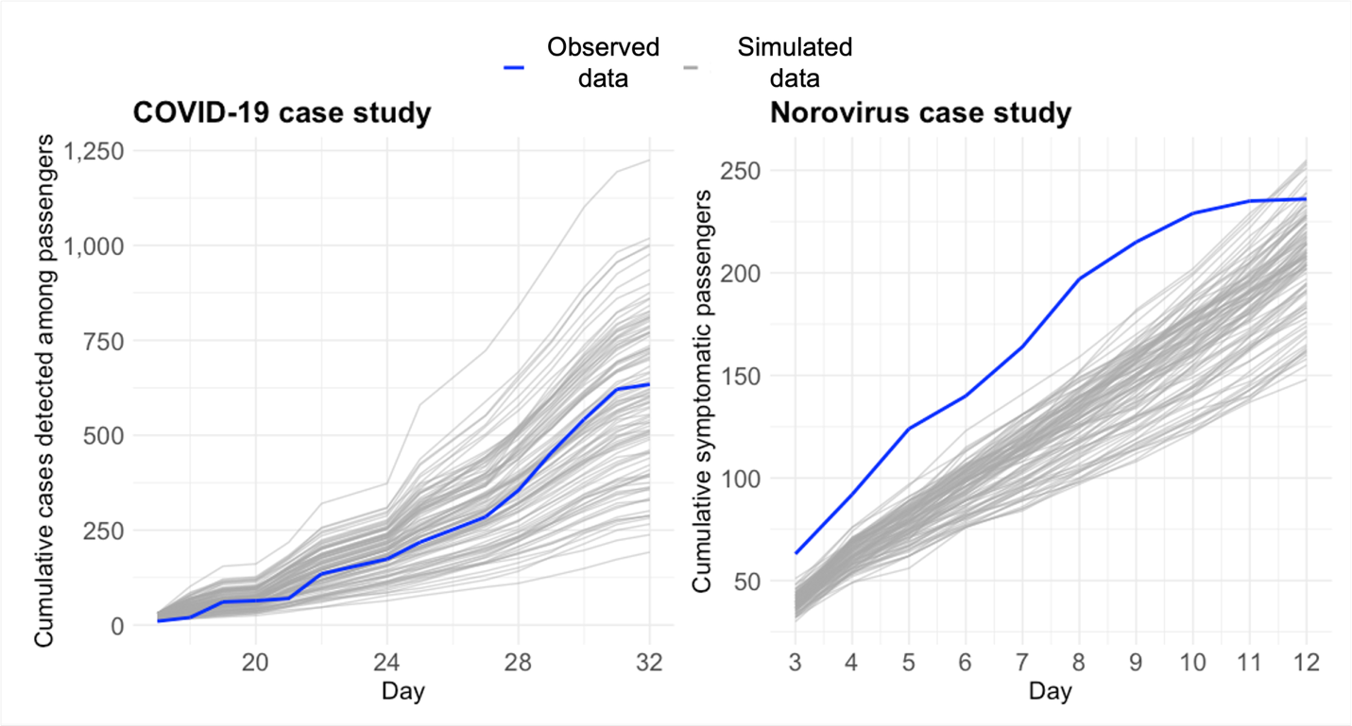
Figure 3: Simulated cases using calibrated parameters and observed data (100 replications).

COVID-19 case study

The results of simulation scenarios comparing the number of infected passengers in the standard, senior, and family cruise ships are displayed in Figure 4. Across all scenario combinations, the senior cruise ship consistently had the lowest number of infected passengers by the end of the cruise, followed by the standard cruise ship. The number of infected passengers on senior cruise ships was 17%–35.6% lower than on standard cruise ships. In contrast, family cruise ships had the highest number of infected passengers, 17.2%–57.1% higher than standard cruise ships. These ranges were calculated by computing the percent difference in total infected passengers between cruise ship types (standard vs. senior and standard vs. family) within each scenario, with the reported ranges reflecting the minimum and maximum values across all scenarios. This approach is applied consistently throughout the Results section for other outcomes.

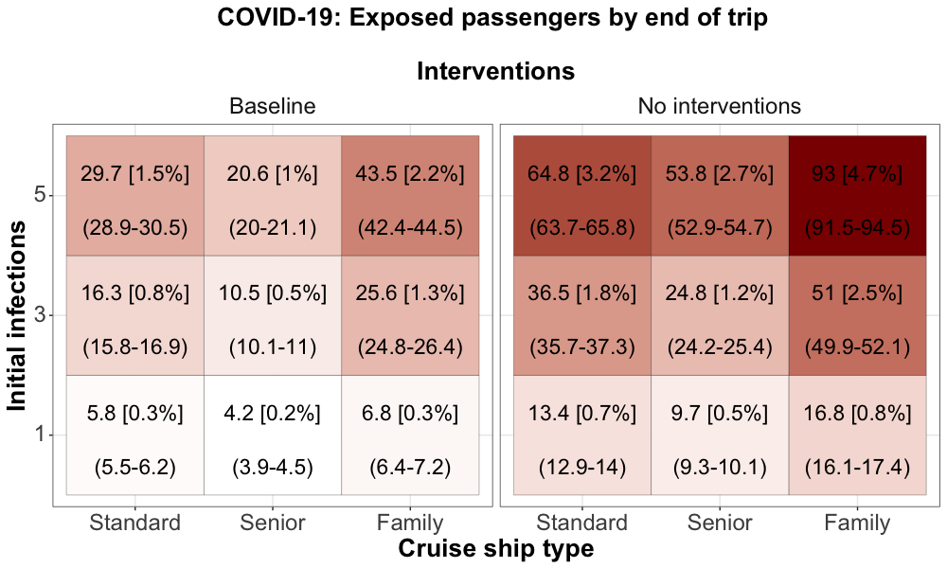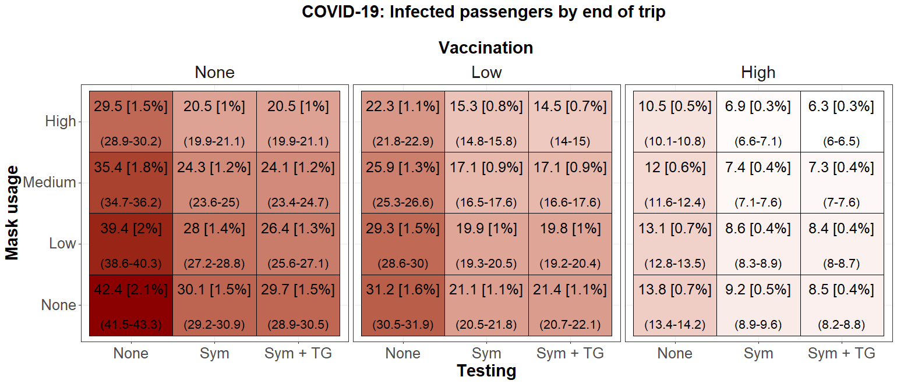
Figure 4: COVID-19 case study - Number of infected passengers [% of passengers] (95% CI) by the end of the cruise (day 7) by cruise ship type and number of initial infections. The baseline intervention represents low vaccination coverage, symptomatic testing, and no masking. The darker red represents more infected passengers.

The simulation results comparing the impact of interventions on the number of infected passengers are displayed in Figure 5. The results showed that vaccination was the most effective intervention in reducing pathogen spread. Scenarios where the vaccination coverage was low, as opposed to none, resulted in 5.2–11.2 fewer exposed passengers (a 24.4–29.9% decrease), while a high vaccination coverage resulted in 13.6–28.6 fewer exposed passengers (a 64.4-71.4% decrease), on average, depending on the testing protocol and mask usage levels.

Testing and isolating individuals based on symptoms was effective. Testing symptomatic individuals reduced the number of exposed individuals by 3.6–12.3 (28.9–38.3% decrease) on average. Expanding testing to include members of the travel group of a symptomatic individual did not reduce the number of exposed passengers.

Mask usage reduced the spread of pathogen and was most effective when vaccination coverage was none or low. When there was no vaccination, the scenarios with mask usage resulted in as many as 12.9 fewer exposed passengers (a 30.4% decrease). Under low vaccination coverage, exposure was reduced by up to 8.9 passengers (a 32.2% decrease). In contrast, when vaccination coverage was high, the reduction was smaller, up to 3.3 passengers (a 25.9% decrease).
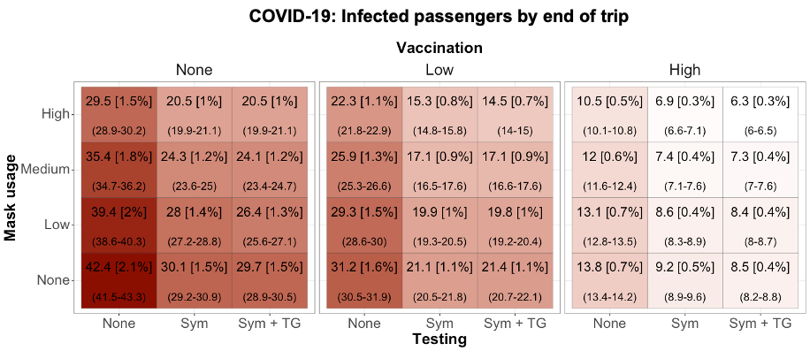
Figure 5: COVID-19 case study - Number of infected passengers [% of passengers] (95% CI) by the end of the cruise (day 7) by intervention scenario with three initial passenger infections. The darker red represents more exposed passengers.

3.3. Norovirus case study

The scenario analysis results for the norovirus case study are shown in Figure 6. Isolating passengers who displayed symptoms was the most effective intervention. When isolation was not in place, 135.1-139.2 passengers, on average, were exposed and showed GI symptoms by the end of the voyage, compared to 12–94.6 when isolation was in place (up to a 91.1% decrease). Isolating symptomatic individuals along with their travel group, compared to only isolating symptomatic individuals, reduced the number of symptomatic individuals by 25.4–52.3 cases (a 52.3–67.9% decrease). Isolation compliance also significantly impacted the spread of norovirus onboard. Increasing compliance from 30 (low) to 60% (high), reduced the number of symptomatic individuals from 6.3–19.7 cases (a 17.3–42.6% decrease).
While activating the increased sanitation protocol reduced the probability of transmission, sanitation alone was not sufficient to limit pathogen spread when isolation was not in place. Even with lower transmission probabilities, the high number of interactions allowed norovirus to continue spreading. When sanitation and isolation were both in place, the sanitation trigger determined the magnitude of the reduction in cases. When the sanitation trigger was low (i.e., the intervention was activated early), the number of passengers showing GI symptoms was reduced by 17.8–39.4 cases (a 43.6–59.7% decrease) compared with no sanitation intervention. When the activation trigger was medium, the effect was smaller, with reductions of 4.2–8.1 symptomatic passengers (a 4.7–26.8% decrease). When the sanitation trigger was high, there were no significant differences compared with scenarios without increased sanitation because the trigger threshold was reached too late, or not reached at all, for the intervention to take effect.

Discussion
In this study, we presented an agent-based model that simulates infectious pathogen spread on cruise ships. The model is disease-agnostic and can be adapted to simulate infectious pathogens that heavily rely on person-to-person transmission. We used the model in two case studies examining the spread of SARS-CoV-2 and norovirus in a 7-day cruise ship voyage. These case studies serve to validate the modeling framework by demonstrating that it can reproduce outbreak patterns, generate realistic transmission dynamics in cruise ship settings, and support the evaluation of diverse public health interventions.

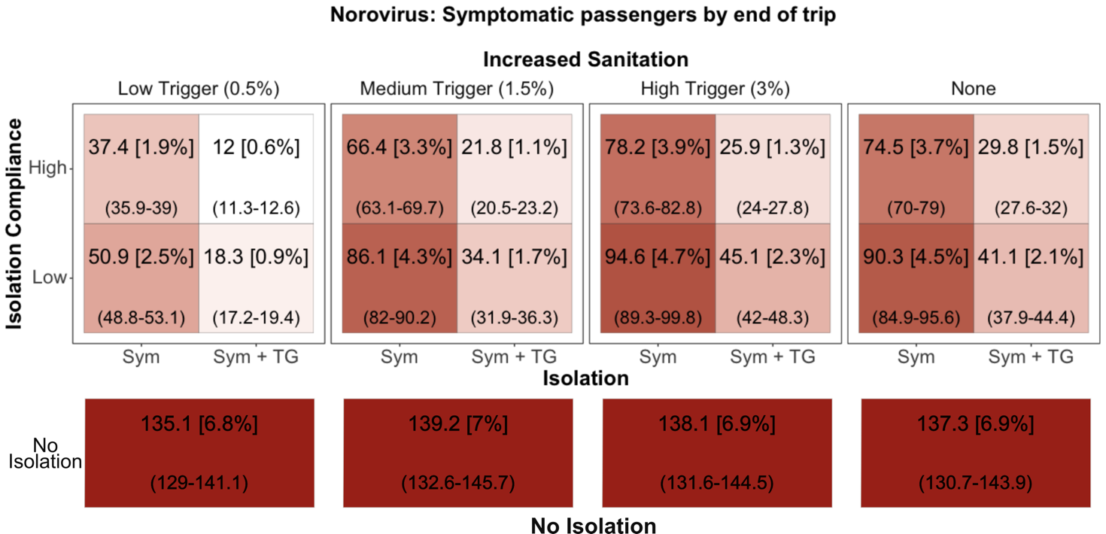
Figure 6: Norovirus case study - Number of passengers experienced symptoms [% of passengers] (95% CI) by the end of the cruise (day 7) by intervention scenario with three initial passenger infections. The darker red represents more symptomatic passengers.
Agent-based models are preferred over compartment models to simulate pathogen spread in congregate settings with highly structured and repeated contacts between the same or overlapping groups of people over time, such as cruise ships (Jenness et al., 2021). Compartment models assume that all individuals in the same compartment are homogenous in their behavior, interactions, and risk profiles (Tolles & Luong, 2020). The homogeneity assumption can be overlooked in high-density, high-transmission environments—such as large communities—in exchange for less data-intensive and computationally expensive models. However, this assumption is less appropriate in settings like cruise ships, where individuals repeatedly interact with the same groups.
Our model builds upon the dynamic network strategies proposed by Jenness et al. (2021), which demonstrated the importance of interventions that reduce contact networks to control SARS-CoV-2 transmission on cruise ships. We extend this approach by incorporating passenger demographics, activity and employment-based networks, individual viral load dynamics, and additional interventions. These additions provide a more granular representation of diverse cruise ship configurations and support more adaptive and responsive planning.
Our model uses contact networks to determine how passengers and crew members interact with each other, including the frequency and intensity of interactions that potentially lead to pathogen transmission. This network-based approach allows us to more accurately represent how passengers travel and stay together in groups during activities, as well as how crew members work and interact with passengers. Additionally, our agent-based framework models individual viral loads, accounting for the variability in infection dynamics over time and between individuals.
The case studies demonstrated the flexibility and adaptability of our model to simulate different pathogens and evaluate interventions during a cruise voyage. We quantified how pathogen spread varied based on the demographics of the cruise ship and the structure of the passenger travel groups. Cruise ships with larger travel groups, such as family-oriented cruises, experienced a larger number of passengers exposed.
The scenario analyses provided quantitative insights into which interventions and combinations were the most impactful and what their trade-offs were. For example, while the relative impact of mask usage on SARS-CoV-2 transmission was smaller in populations with high vaccination coverage compared to those with low or no vaccination, the absolute impact, measured as the total number of infections averted, was greatest when masking was combined with high vaccination coverage.
The model can support decision-makers in evaluating interventions tailored to the specific demographics and characteristics of their target cruise population, enabling evidence-based strategies to mitigate pathogen spread. Beyond cruise ships, the framework could be adapted to other high-density, structured environments with repeated interactions, such as schools, nursing homes, and resorts.
Limitations
Our agent-based model is subject to some limitations. As with other mathematical models, the model is constrained by the availability of data to characterize networks and interactions. We relied on surveys describing cruise ship demographics and activities that travelers most frequently participate in to extrapolate the network configurations and interaction patterns. While our approximations simplified the real-world contact patterns on a cruise ship, they provide a reasonable approximation of how people interact and behave onboard.
The model relies on literature-based estimates for the natural history of the disease, including the duration of time agents spend in each disease state. While we conducted an extensive review to obtain appropriate parameters, these parameters are approximations, and there is uncertainty about their applicability when used in other contexts (e.g., different populations of interest).
The model represents transmission through direct human-to-human interactions only and does not explicitly model environmental, surface-mediated, or foodborne routes as separate mechanisms. This limitation is most relevant for pathogens, such as norovirus, for which contaminated surfaces and foodborne routes can contribute meaningfully to outbreak dynamics. In such cases, the aggregate effects of these non-human-to-human routes may be partially reflected through the calibrated transmission parameters.
Furthermore, the model adopts a simplified representation of vaccine-derived protection against infection. Vaccination is modeled using an all-or-nothing mechanism, in which vaccination is assumed to confer sterilizing immunity against infection. In practice, however, vaccine-derived protection against SARS-CoV-2 infection is leaky, such that no individual is fully protected and vaccinated individuals may still become infected and transmit the virus (Lee et al., 2025; Lind et al., 2023).
In the COVID-19 case study, we indirectly mitigated the impact of this limitation by using data on up-to-date vaccination coverage, defined as the proportion of individuals who had received the recommended number of doses at the time the data were collected, rather than coverage based on having received any dose. This approach reduces effective coverage and partially accounts for heterogeneity in protection due to factors such as time elapsed since vaccination (Centers for Disease Control and Prevention, 2024c). Nonetheless, this simplifying assumption may overestimate the impact of vaccination on infection outcomes, particularly in high-transmission, congregate settings; therefore, infection reductions attributable to vaccination should be interpreted as an upper bound. Future work should extend the framework to explicitly model vaccine effectiveness against severe outcomes, as vaccination is currently modeled only as protection against infection.
Additionally, immunity can arise not only through vaccination but also through previous infection (i.e., natural immunity). Since the case study focused on early outbreak scenarios, we did not include individuals with natural immunity. However, in settings where natural immunity is relevant, it can be incorporated by reclassifying the estimated number of immune individuals from the susceptible to the recovered state at the start of the simulation.
Isolation was modeled as fully effective in preventing transmission, such that isolated individuals did not engage in contact with others. Future extensions of the framework could represent isolation as reducing, rather than eliminating, transmission risk, while still allowing limited interactions (e.g., between passengers and crew members) with a lower probability of transmission. Such extensions would enable evaluation of isolation compliance and the effectiveness of additional precautionary measures.
In the case studies, infections were seeded only among passengers. However, crew members typically remain onboard for extended periods and could introduce or carry infections between voyages. While this was not incorporated in the current analysis, the model can be configured to simulate sequential voyages with persistent crew cohorts, which would allow exploration of transmission dynamics across voyages.
We calibrated the networks’ transmission probabilities for each network ($π_{n}$) and sanitation reduction factor (S_{dec}) using observed data from the Diamond Princess COVID-19 outbreak in 2020 and a norovirus outbreak in 2009, reflecting the epidemiologic context at the time of those events. Subsequent viral evolution and changes in population immunity can alter transmissibility and effective contact-level transmission probabilities; therefore, recalibration with updated data would be necessary to reflect later conditions.
The calibration process is sensitive to the other model parameters. We made assumptions regarding demographics of the passengers and network compositions, as this information was not fully available. While the assumptions may have impacted the calibration outcomes, we performed validity checks and consulted the literature and subject-matter experts throughout the process.
During calibration, we assumed that transmission probabilities within travel groups and crew cabins ($π_{main}$) remained constant throughout the voyage, including during the quarantine period, and did not introduce a separate quarantine transmission parameter. This choice was made to limit the number of free parameters during calibration. However, this simplifying assumption may lead to higher estimated pre-quarantine transmission probabilities to compensate for not explicitly modeling increased close-quarters transmission during quarantine. Because the model is designed to support scenario analysis rather than strict forecasting, these limitations do not undermine its utility for evaluating relative intervention effects within the case study setting.

Conclusions
We developed an agent-based simulation framework to model human-to-human pathogen transmission on cruise ships by capturing network-based interactions among passengers and crew. The framework supports the evaluation of pharmaceutical and non-pharmaceutical interventions and can guide operational decision-making by identifying strategies that enhance passenger and crew safety while accounting for population characteristics and evolving outbreak conditions, such as disease prevalence, pathogen transmissibility, and vaccination coverage. Although demonstrated through COVID-19 and norovirus case studies, the framework is disease-agnostic and can be adapted to additional pathogens and other high-density, structured environments with similar network-based transmission dynamics. By supporting scenario analysis, preparedness planning, and policy evaluation, this work provides a practical tool to strengthen outbreak prevention and response on cruise ship settings.

Declarations
Ethics approval and consent to participate
The study used de-identified data. Ethics approval and consent to participate were waived.

Consent for publication

Not applicable.

Competing interests

The authors declare that they have no competing interests.

Funding

This research was supported by National Science Foundation (NSF) grant #2246678, the Center for Health and Humanitarian Systems, and the following Georgia Tech benefactors: William W. George, Andrea Laliberte, Richard “Rick” E. and Charlene Zalesky, and Claudia and Paul Raines. This work is solely the responsibility of the research team and does not necessarily represent the official views of NSF.

Disclaimer
The findings and conclusions in this report are those of the author(s) and do not necessarily represent the official position of the Centers for Disease Control and Prevention.

Authors’ contributions
Akane B. Fujimoto: Conceptualization, Data curation, Formal analysis, Investigation, Methodology, Software, Validation, Visualization, Writing – original draft, Writing – review & editing.
Sarah Bowden: Validation, Writing – review & editing.
Kara Tardivel: Validation, Writing – review & editing.
Stefanie White: Validation, Writing – review & editing.
Pinar Keskinocak: Conceptualization, Methodology, Supervision, Funding acquisition, Writing – review & editing.
All authors reviewed and approved the final manuscript.

Acknowledgments
The authors thank Lucy Boswell, undergraduate research assistant at the H. Milton Stewart School of Industrial and Systems Engineering at Georgia Tech, for her contributions to the literature review, data collection, data processing, and the generation of data and scenarios. The authors also thank the CDC reviewers involved in the internal clearance process for their feedback and suggestions, which significantly improved the manuscript.
REFERENCES
Arino, J., Boëlle, P.-Y., Milliken, E., & Portet, S. (2021). Risk of COVID-19 variant importation–How useful are travel control measures? Infectious Disease Modelling, 6, 875-897.
Bert, F., Scaioli, G., Gualano, M. R., Passi, S., Specchia, M. L., Cadeddu, C., Viglianchino, C., & Siliquini, R. (2014). Norovirus outbreaks on commercial cruise ships: a systematic review and new targets for the public health agenda. Food and environmental virology, 6, 67-74.
Brooks, J. T. (2021). Maximizing fit for cloth and medical procedure masks to improve performance and reduce SARS-CoV-2 transmission and exposure, 2021. MMWR. Morbidity and Mortality Weekly Report, 70.
Bruxvoort, K. J., Sy, L. S., Qian, L., Ackerson, B. K., Luo, Y., Lee, G. S., Tian, Y., Florea, A., Aragones, M., & Tubert, J. E. (2021). Effectiveness of mRNA-1273 against delta, mu, and other emerging variants of SARS-CoV-2: test negative case-control study. BMJ, 375.
CDC COVID-19 Response Team. (2020). Severe outcomes among patients with coronavirus disease 2019 (COVID-19)—United States, February 12–March 16, 2020. Morbidity and Mortality Weekly Report, 69(12), 343-346.
Centers for Disease Control and Prevention. (2020a). Framework for Conditional Sailing and Initial Phase COVID-19 Testing Requirements for Protection of Crew. Federal Register Retrieved from https://www.federalregister.gov/documents/2020/11/04/2020-24477/framework-for-conditional-sailing-and-initial-phase-covid-19-testing-requirements-for-protection-of
Centers for Disease Control and Prevention. (2020b). No Sail Order and Suspension of Further Embarkation. Federal Register Retrieved from https://www.federalregister.gov/documents/2020/03/24/2020-06166/no-sail-order-and-suspension-of-further-embarkation
Centers for Disease Control and Prevention. (2024a). About Norovirus. Retrieved July 24, 2024 from https://www.cdc.gov/norovirus/about/index.html
Centers for Disease Control and Prevention. (2024b). Earlier Outbreaks on Cruise Ships in VSP's Jurisdiction. Retrieved July 10, 2024 from https://www.cdc.gov/vessel-sanitation/cruise-ship-outbreaks/earlier-outbreaks.html
Centers for Disease Control and Prevention. (2024c). Vaccine Effectiveness Studies. Retrieved June 1 from https://www.cdc.gov/covid/php/surveillance/vaccine-effectiveness-studies.html?
Centers for Disease Control and Prevention. (n.d.). Weekly COVID-19 Vaccination Dashboard. Retrieved Feb 12, 2024 from https://www.cdc.gov/covidvaxview/weekly-dashboard/?CDC_AAref_Val=https://www.cdc.gov/vaccines/imz-managers/coverage/covidvaxview/interactive/vaccination-dashboard.html
Centers for Disease Control and Prevention. (n.d. ). COVID-19 Vaccination Coverage and Vaccine Confidence Among Children. Retrieved Feb 12, 2024 from https://www.cdc.gov/covidvaxview/interactive/children.html?CDC_AAref_Val=https://www.cdc.gov/vaccines/imz-managers/coverage/covidvaxview/interactive/children.html
Centers for Disease Control and Prevention, National Center for Emerging and Zoonotic Infectious Diseases (NCEZID), Division of Global Migration and Quarantine (DGMQ). (2021). CDC COVID-19 Orders for Cruise Ships. Retrieved September 8, 2022 from https://web.archive.org/web/20211103125446/https:/www.cdc.gov/quarantine/cruise/covid19-cruiseships.html
Centers for Disease Control and Prevention, National Center for Emerging and Zoonotic Infectious Diseases (NCEZID), Division of Global Migration and Quarantine (DGMQ). (2022). Cruise Ship Guidance. Retrieved September 7, 2022 from https://www.cdc.gov/quarantine/cruise/index.html
Centers for Disease Control and Prevention, Tardivel, K. M., White, S., Treffiletti, A., & Freeland, A. (2024). Travel by Air, Land & Sea. In CDC Yellow Book 2024. Oxford University Press.
Crisp, C. A. (2023). Notes from the Field: Cruise Ship Norovirus Outbreak Associated with Person-to-Person Transmission—United States Jurisdiction, January 2023. MMWR. Morbidity and Mortality Weekly Report, 72.
Cruise Lines International Association (CLIA). (2015). 2014 North American Cruise Market Profile. Cruise Lines International Association, Inc. Retrieved July 1, 2024 from https://cruising.org/-/media/research-updates/research/consumer-research/2014-north-american-cruise-market-profile.pdf
Cruise Lines International Association (CLIA). (2018). Cruise Travel Report - January 2018. Cruise Lines International Association, Inc. Retrieved July 1, 2024 from https://cruising.org/-/media/research-updates/research/consumer-research/2018-clia-travel-report.pdf
De Bellis, A., Bizzotto, A., Anagnostopoulos, L., Kourentis, L., Marziano, V., Mouchtouri, V., Merler, S., & Guzzetta, G. (2025). Mitigating norovirus spread on cruise ships: a model-based assessment of diagnostic timing and isolation. Journal of Travel Medicine, 32(7), taaf059.
De Bellis, A., Bizzotto, A., Anagnostopoulou, L., Kourentis, L., Marziano, V., Mouchtouri, V., Merler, S., & Guzzetta, G. (2025). Reducing diagnostic delays is key for norovirus control on cruise ships. Population Medicine, 7(1).
Fowlkes, A. L. (2022). Effectiveness of 2-dose BNT162b2 (Pfizer BioNTech) mRNA vaccine in preventing SARS-CoV-2 infection among children aged 5–11 years and adolescents aged 12–15 years—PROTECT cohort, July 2021–February 2022. MMWR. Morbidity and Mortality Weekly Report, 71.
Guagliardo, S. A. J., Prasad, P. V., Rodriguez, A., Fukunaga, R., Novak, R. T., Ahart, L., Reynolds, J., Griffin, I., Wiegand, R., & Quilter, L. A. (2022). Cruise ship travel in the era of coronavirus disease 2019 (COVID-19): a summary of outbreaks and a model of public health interventions. Clinical Infectious Diseases, 74(3), 490-497.
Havumaki, J., Eisenberg, J. N., Mattison, C. P., Lopman, B. A., Ortega-Sanchez, I. R., Hall, A. J., Hutton, D. W., & Eisenberg, M. C. (2021). Immunologic and epidemiologic drivers of norovirus transmission in daycare and school outbreaks. Epidemiology, 32(3), 351-359.
He, X., Lau, E. H., Wu, P., Deng, X., Wang, J., Hao, X., Lau, Y. C., Wong, J. Y., Guan, Y., & Tan, X. (2020). Temporal dynamics in viral shedding and transmissibility of COVID-19. Nature Medicine, 26(5), 672-675.
International Labour Organization (ILO). (2006). Maritime Labour Convention (MLC), 2006 (as amended). International Labour Organization. Retrieved April 24, 2024 from https://normlex.ilo.org/dyn/nrmlx_en/f?p=NORMLEXPUB:91:0::::P91_SECTION:MLCA_AMEND_A1
Jenness, S. M., Willebrand, K. S., Malik, A. A., Lopman, B. A., & Omer, S. B. (2021). Dynamic network strategies for SARS-CoV-2 control on a cruise ship. Epidemics, 37, 100488.
Karita, H. C. S., Dong, T. Q., Johnston, C., Neuzil, K. M., Paasche-Orlow, M. K., Kissinger, P. J., Bershteyn, A., Thorpe, L. E., Deming, M., & Kottkamp, A. (2022). Trajectory of viral RNA load among persons with incident SARS-CoV-2 G614 infection (Wuhan strain) in association with COVID-19 symptom onset and severity. JAMA network open, 5(1), e2142796-e2142796.
Kerr, C. C., Stuart, R. M., Mistry, D., Abeysuriya, R. G., Rosenfeld, K., Hart, G. R., Núñez, R. C., Cohen, J. A., Selvaraj, P., & Hagedorn, B. (2021). Covasim: an agent-based model of COVID-19 dynamics and interventions. PLOS Computational Biology, 17(7), e1009149.
Keskinocak, P., Oruc Aglar, B. E., Baxter, A., Asplund, J., & Serban, N. (2020). The Impact of Social Distancing on COVID19 Spread: State of Georgia Case Study. https://doi.org/10.1101/2020.04.29.20084764
Keskinocak, P., Oruc, B. E., Baxter, A., Asplund, J., & Serban, N. (2020). The impact of social distancing on COVID19 spread: State of Georgia case study. PLoS One, 15(10), e0239798.
Khan, F. L., Nguyen, J. L., Singh, T. G., Puzniak, L. A., Wiemken, T. L., Schrecker, J. P., Taitel, M. S., Zamparo, J. M., Jodar, L., & McLaughlin, J. M. (2022). Estimated BNT162b2 vaccine effectiveness against infection with delta and omicron variants among US children 5 to 11 years of age. JAMA network open, 5(12), e2246915-e2246915.
Kirby, A., Shi, J., Montes, J., Lichtenstein, M., & Moe, C. (2014). Disease course and viral shedding in experimental Norwalk virus and Snow Mountain virus infection. Journal of Medical Virology, 86(12), 2055-2064.
Kissler, S. M., Fauver, J. R., Mack, C., Olesen, S. W., Tai, C., Shiue, K. Y., Kalinich, C. C., Jednak, S., Ott, I. M., & Vogels, C. B. (2021). Viral dynamics of acute SARS-CoV-2 infection and applications to diagnostic and public health strategies. PLoS biology, 19(7), e3001333.
Lanz, L., & Feltault, M. (2020). The Case of the Diamond Princess: Stranded at Sea in a Pandemic (Part 1). Boston Hospitality Review. Retrieved January 15, 2023 from https://www.bu.edu/bhr/files/2020/07/The-Case-of-the-Diamond-Princess-Stranded-at-Sea-in-a-Pandemic-Part-1.pdf
Lee, D. I., Nande, A., Anderson, T. L., Levy, M. Z., & Hill, A. L. (2025). Vaccine failure mode determines population-level impact of vaccination campaigns during epidemics. Journal of the Royal Society Interface, 22(223), 20240689.
Lilley, R. (n.d). What Are Crew Cabins Like on Cruise Ships? Retrieved June 9, 2024 from https://workingoncruiseships.com/what-are-crew-cabins-like-on-cruise-ships/
Lind, M. L., Dorion, M., Houde, A. J., Lansing, M., Lapidus, S., Thomas, R., Yildirim, I., Omer, S. B., Schulz, W. L., & Andrews, J. R. (2023). Evidence of leaky protection following COVID-19 vaccination and SARS-CoV-2 infection in an incarcerated population. Nature communications, 14(1), 5055.
Lindsley, W. G., Blachere, F. M., Law, B. F., Beezhold, D. H., & Noti, J. D. (2021). Efficacy of face masks, neck gaiters and face shields for reducing the expulsion of simulated cough-generated aerosols. Aerosol Science and Technology, 55(4), 449-457.
Miura, F., Matsuyama, R., & Nishiura, H. (2018). Estimating the asymptomatic ratio of norovirus infection during foodborne outbreaks with laboratory testing in Japan. Journal of epidemiology, 28(9), 382-387.
Mizumoto, K., & Chowell, G. (2020). Transmission potential of the novel coronavirus (COVID-19) onboard the diamond Princess Cruises Ship, 2020. Infectious Disease Modelling, 5, 264-270.
Mizumoto, K., Kagaya, K., Zarebski, A., & Chowell, G. (2020). Estimating the asymptomatic proportion of coronavirus disease 2019 (COVID-19) cases on board the Diamond Princess cruise ship, Yokohama, Japan, 2020. Eurosurveillance, 25(10), 2000180.
Nakazawa, E., Ino, H., & Akabayashi, A. (2020). Chronology of COVID-19 cases on the Diamond Princess cruise ship and ethical considerations: a report from Japan. Disaster medicine and public health preparedness, 14(4), 506-513.
National Academies of Sciences, Engineering, and Medicine. (2022). Improving the CDC Quarantine Station Network's response to emerging threats.
Neri, A. J., Cramer, E. H., Vaughan, G. H., Vinjé, J., & Mainzer, H. M. (2008). Passenger behaviors during norovirus outbreaks on cruise ships. Journal of Travel Medicine, 15(3), 172-176.
Perini, T., Keskinocak, P., Li, Z., Ruiz-Tiben, E., Swann, J., & Weiss, A. (2020). Agent-Based Simulation for Seasonal Guinea Worm Disease in Chad Dogs. The American journal of tropical medicine and hygiene, 103(5), 1942-1950.
Perra, N. (2021). Non-pharmaceutical interventions during the COVID-19 pandemic: A review. Physics Reports, 913, 1-52.
Pietschmann. (2022). Guide to passengers you'll find on each cruise line. Retrieved June 9, 2024 from https://cruiseable.com/guide-to-passenger-types-on-cruise-lines
Puhach, O., Meyer, B., & Eckerle, I. (2023). SARS-CoV-2 viral load and shedding kinetics. Nature Reviews Microbiology, 21(3), 147-161.
Pung, R., Firth, J. A., Spurgin, L. G., Singapore CruiseSafe working group, CMMID COVID-19 working group, Lee, V. J., & Kucharski, A. J. (2022). Using high-resolution contact networks to evaluate SARS-CoV-2 transmission and control in large-scale multi-day events. Nature communications, 13(1), 1956.
R Core Team. (2022). R: A language and environment for statistical computing. In R Foundation for Statistical Computing. https://www.R-project.org/
Russell, T. W., Wu, J. T., Clifford, S., Edmunds, W. J., Kucharski, A. J., & Jit, M. (2021). Effect of internationally imported cases on internal spread of COVID-19: a mathematical modelling study. The Lancet Public Health, 6(1), e12-e20.
Singer, S., & Nelder, J. (2009). Nelder-mead algorithm. Scholarpedia, 4(7), 2928.
The Florida-Caribbean Cruise Association. (n.d). Cruise Industry Onboard Employment Overview. Retrieved May 15 2024 from https://www.f-cca.com/downloads/Cruise-Line-Employee-Overview.pdf
Tolles, J., & Luong, T. (2020). Modeling epidemics with compartmental models. JAMA, 323(24), 2515-2516.
Tseng, Y.-J., Olson, K. L., Bloch, D., & Mandl, K. D. (2023). Smart thermometer–based participatory surveillance to discern the role of children in household viral transmission during the COVID-19 pandemic. JAMA network open, 6(6), e2316190-e2316190.
Verity, R., Okell, L. C., Dorigatti, I., Winskill, P., Whittaker, C., Imai, N., Cuomo-Dannenburg, G., Thompson, H., Walker, P. G., & Fu, H. (2020). Estimates of the severity of coronavirus disease 2019: a model-based analysis. The Lancet Infectious Diseases, 20(6), 669-677.
Wen, C., Wei, J., Ma, Z. F., He, M., Zhao, S., Ji, J., & He, D. (2022). Heterogeneous epidemic modelling within an enclosed space and corresponding Bayesian estimation. Infectious Disease Modelling, 7(2), 1-24.
Wikswo, M. E., Cortes, J., Hall, A. J., Vaughan, G., Howard, C., Gregoricus, N., & Cramer, E. H. (2011). Disease transmission and passenger behaviors during a high morbidity Norovirus outbreak on a cruise ship, January 2009. Clinical Infectious Diseases, 52(9), 1116-1122.
World Health Organization (WHO). (2026). Hantavirus cluster linked to cruise ship travel, Multi-country. Retrieved May 20, 2026 from https://www.who.int/emergencies/disease-outbreak-news/item/2026-DON600
Xiang, Y., Jia, Y., Chen, L., Guo, L., Shu, B., & Long, E. (2021). COVID-19 epidemic prediction and the impact of public health interventions: A review of COVID-19 epidemic models. Infectious Disease Modelling, 6, 324-342.
Zhao, S., Cao, P., Gao, D., Zhuang, Z., Wang, W., Ran, J., Wang, K., Yang, L., Einollahi, M. R., & Lou, Y. (2022). Modelling COVID-19 outbreak on the Diamond Princess ship using the public surveillance data. Infectious Disease Modelling, 7(2), 189-195.

