COIT20258
Software Engineering
Assignment 3 - Part 1: Group Report

DRS-Enhanced
(Disaster Response System — Enhanced Prototype)

Team Details:
Team Name | DRS-Enhanced Development Team
Team Leader Name & ID | Ketul Pareshbhai Patel - 12262547
Other Team Members & IDs | Preetkumar Navinbhai Patel – 12277687  Parth Lalajibhai Patel – 12281818  Takshil Manishkumar SANGHVI – 12299739  Jay Niteshbhai Dobariya — 12278730

Table of Contents
1. Requirement Specification 4
1.1 Overview 4
1.2 Functional Requirements 4
1.3 Non-Functional Requirements 5
1.4 System Requirements 5
1.5 User Requirements 5
1.6 Two Additional Features 6
Feature 1: Team Coordination 6
Feature 2: Resource Management 6
2. Design Specifications 7
2.1 System Architecture 7
2.2 Use Case Diagram 7
2.3 Class Diagram 8
2.4 Sequence Diagrams 9
2.5 Entity Relationship Diagram 10
3. Test Plan 11
4. Evidence of Automated Testing 13
5. Application Screenshots 14
5.1 Authentication 14
5.2 Main Dashboard and Disaster Management 15
5.3 Feature 1: Team Coordination 18
5.4 Feature 2: Resource Management 19
5.5 Administration 20
5.6 NetBeans Project Structure 21
6. Conclusion 21
7. References 23

1. Requirement Specification

1.1 Overview
The Disaster Response System Enhanced (DRS-Enhanced) is a three-tier distributed Java application. It adds team coordination and resource management, two new domain-specific features, to DRS-Initial, which is extended by a multi-threaded server, a MySQL database. The system is based on the Model-View-Controller (MVC) pattern and uses JavaFX for the client GUI which communicates through TCP sockets over port 9090, to which a persistent storage system based on MySQL is connected (Bass et al., 2021).

1.2 Functional Requirements
- FR1 — User Authentication: Users register and log in. Passwords are hashed with SHA-256 via SecurityUtil before storage.
- FR2 — Role-Based Access Control: Four roles enforced (ADMIN, COORDINATOR, RESPONDER, PUBLIC). Tab visibility is restricted per role.
- FR3 — Disaster Reporting: All users report disasters with type, title, description, location, severity, and affected count.
- FR4 — Disaster Management: Coordinators update disaster status and details. Priority sort using getPriorityScore().
- FR5 — Team Coordination (Feature 1): Create teams, assign to disasters (DEPLOYED), complete to release (AVAILABLE).
- FR6 — Resource Management (Feature 2): Add resources, allocate with auto-deduction, return to restore quantity.
- FR7 — User Management: Administrators view and update all users including roles and active status.
- FR8 — Audit Logging: All actions recorded with timestamp, user, action, table, record ID for non-repudiation (Stallings, 2022).
- FR9 — Multi-Threaded Server: ExecutorService pool of 20 threads on port 9090 for concurrent connections.
- FR10 — Programmatic DB Init: All seven tables created via CREATE TABLE IF NOT EXISTS on first startup.

1.3 Non-Functional Requirements
- NFR1 — Security: SHA-256 password hashing, AES-128 encryption, non-repudiation through audit log (Stallings, 2022).
- NFR2 — Performance: Thread pool of 20 handles concurrent clients. PreparedStatements improve safety and speed.
- NFR3 — Usability: Colour-coded severity and status. Role-based tab disabling provides clear access feedback (Oracle, 2023).
- NFR4 — Reliability: INSERT IGNORE prevents duplicate seed data. Singleton DatabaseConnection auto-reconnects.
- NFR5 — Maintainability: MVC with dedicated DAO, model, controller, view layers (Fowler, 2018).
- NFR6 — Portability: Runs on any platform with JDK 17+ and JavaFX 21+.

1.4 System Requirements
- Java Development Kit (JDK) 17 or later — OpenJDK Temurin recommended
- JavaFX SDK 21 LTS or later — Gluon distribution
- MySQL Server 8.0 or later with drs_enhanced schema
- MySQL Connector/J 8.x or 9.x JDBC driver JAR
- Apache NetBeans IDE 18+ with Ant build system
- Minimum 4 GB RAM, 500 MB disk space

1.5 User Requirements
Four user groups interact with DRS-Enhanced:
- Public Users — report disasters and view current incident status. Access: Login and Disasters tab only.
- Responders — view all disasters and priority-sorted list to determine urgency.
- Coordinators — assign teams, manage resources, update disaster status, monitor deployment.
- Administrators — full access including user management and audit trail review.

1.6 Two Additional Features

Feature 1: Team Coordination
Coordinators coordinate the response teams and allocate them to disasters. Teams have department, leader, contact, capacity, and status (AVAILABLE, DEPLOYED, STANDBY, UNAVAILABLE). The status automatically switches to DEPLOYED and completion to AVAILABLE and the record is marked as COMPLETED. That is to say, it addresses the need for multi-department coordination needs (Coppola, 2020; Haddow et al., 2021).

Feature 2: Resource Management
Physical resources (vehicles, medical supplies, food, equipment, shelters, personnel) are tracked by Coordinators. Quantity is automatically decreased when allocated and increased when returned. Colour coding indicates no stock (red) and low stock (less than 5 units) (orange). The states tracked by AllocationStatus are ACTIVE, RETURNED, and LOST (Haddow et al., 2021).

2. Design Specifications

2.1 System Architecture
DRS-Enhanced uses a three-tier architecture (Bass et al., 2021):
- Presentation Tier — JavaFX client with eight FXML views and eight MVC controllers over TCP on port 9090.
- Business Logic Tier — Multi-threaded server using ExecutorService (pool 20). ClientHandler implements Runnable.
- Data Tier — MySQL 8 via JDBC. Singleton DatabaseConnection and five DAO classes.
Protocol: "|" separates command from data; "~~" separates fields; ";;" separates list items.

2.2 Use Case Diagram
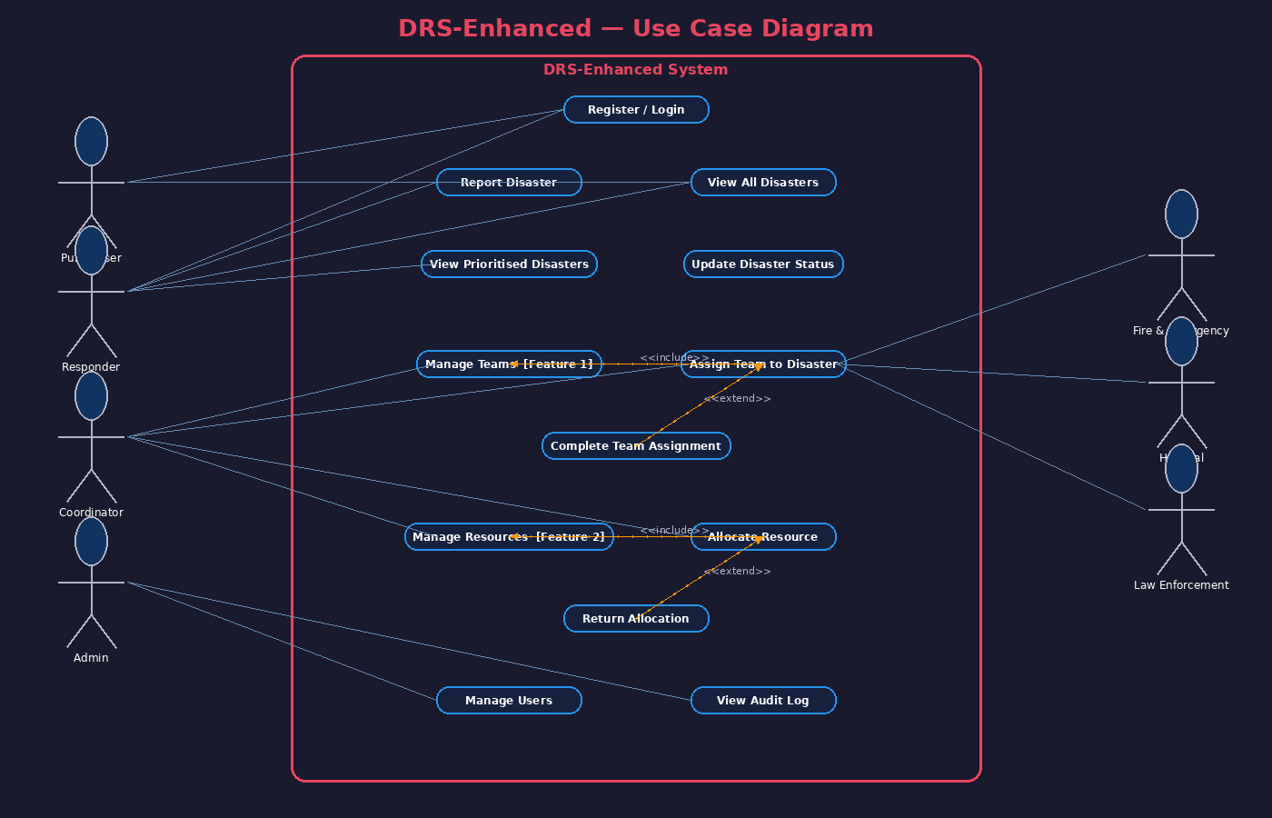
Figure 1: DRS-Enhanced Use Case Diagram — Actors, Use Cases, Include/Extend Relationships
There are four main actors (Public, Responder, Coordinator, Admin) working with the system and three external departments. Assign Team includes Manage Teams (Feature 1) for allocating teams and Allocate Resource includes Manage Resources (Feature 2) for allocating resources. The optional extensions (Complete Assignment and Return Allocation) are indicated by extending the arrows (Gamma et al., 2019).

2.3 Class Diagram
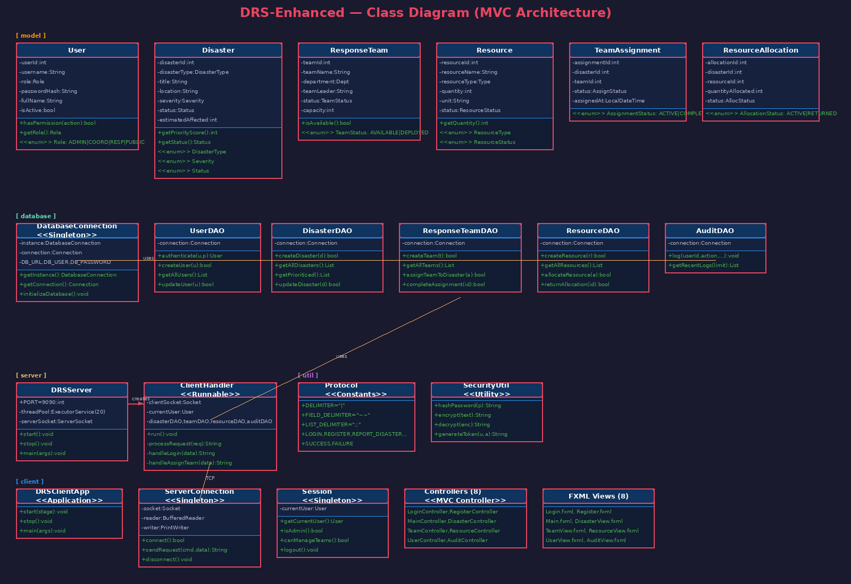
Figure 2: DRS-Enhanced Class Diagram — MVC Architecture Across Five Packages
Five packages: model (six domain classes; getPriorityScore() and isAvailable()), database (five DAOs plus Singleton DatabaseConnection), server (DRSServer and ClientHandler Runnable), util (Protocol and SecurityUtil), and client (DRSClientApp, Singleton ServerConnection, Singleton Session, eight controllers, eight FXML views). This layered separation is recommended by Fowler (2018) in order to achieve maximum maintainability.

2.4 Sequence Diagrams
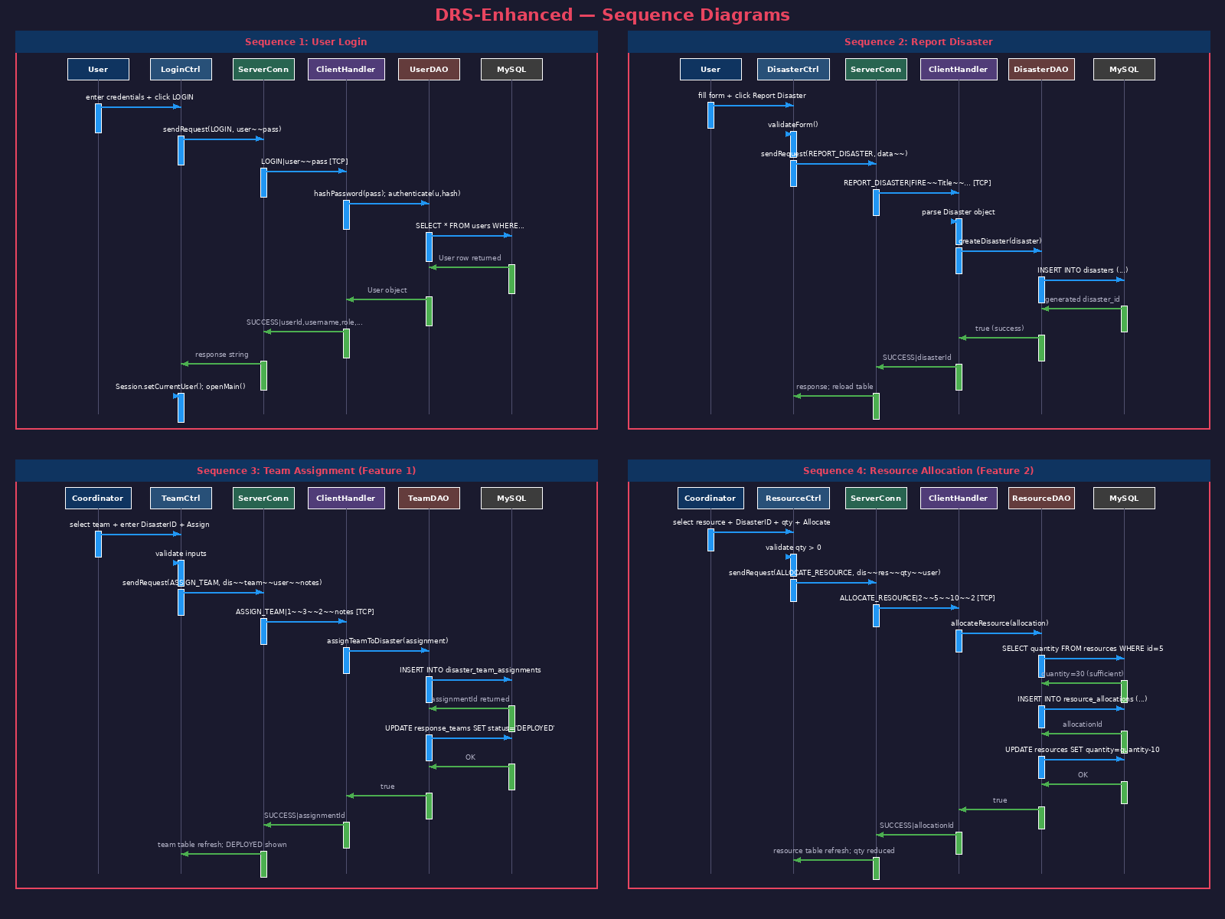
Figure 3: Sequence Diagrams — Login, Report Disaster, Team Assignment, Resource Allocation
Sequence 1 (Login): Generate the SHA-256 hash, UserDAO authenticates, Set a session, Audit logged. Sequence 2 (Report Disaster): form validation, DisasterDAO insert, table refresh. The sequence of the assignment is to be inserted atomically, along with the team status being set to DEPLOYED. The Sequence 4 (Resource Allocation — Feature 2) validates the stock, adds an allocation and automatically deducts the quantity, and then restores the quantity when returning.

2.5 Entity Relationship Diagram
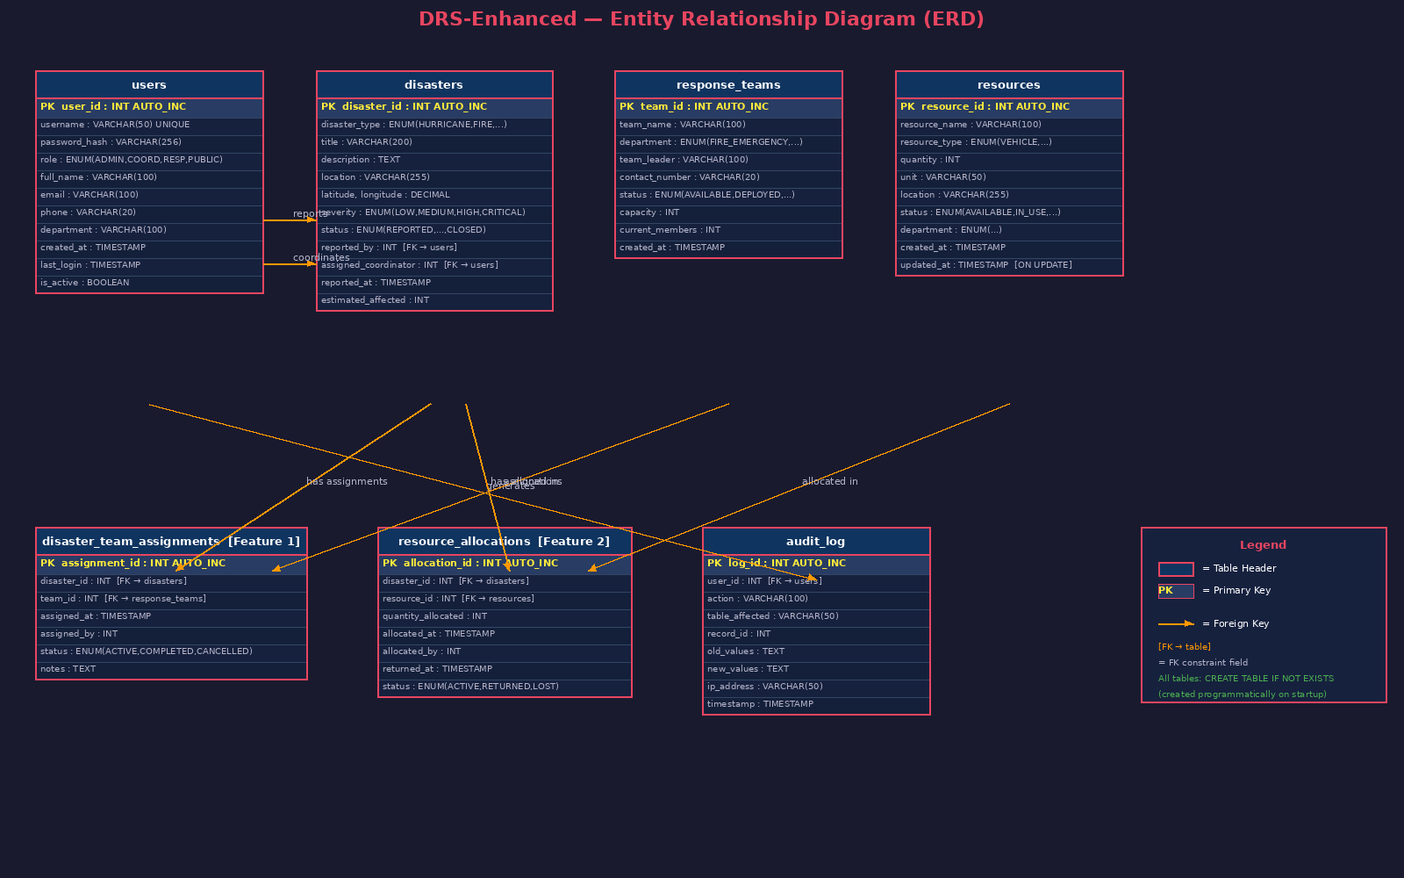
Figure 4: ERD — Seven Tables with Primary Keys and Foreign Key Constraints
The following tables: users (central), disaster, response_teams, disaster_team_assignments (Feature 1 join), resources, resource_allocations (Feature 2 join), audit_log. These are all ultimately created by DatabaseConnection.Create a table if it does not exist (Oracle, 2024) to initialize the database. Database-constrained FKs.

3. Test Plan
The test plan is based on the Test-Driven Principles (Beck, 2022). Automated unit testing using DRSTest.java (15 methods with 81 assertions) and manual functional testing. 23 test cases passed.
ID | Test Case | Input | Expected | Result
T01 | Priority Critical | CRITICAL+EARTHQUAKE+15000 | Score=100 | PASS
T02 | Priority Low | LOW+OTHER+50 | Score=20 | PASS
T03 | Priority High | HIGH+HURRICANE+500 | Score=65 | PASS
T04 | Status Transitions | REPORTED→...→CLOSED | All 5 persist | PASS
T05 | Perms Admin | ADMIN, MANAGE_USERS | true | PASS
T06 | Perms Coord | COORD, MANAGE_USERS | false | PASS
T07 | SHA-256 | password="admin123" | 64-char, deterministic | PASS
T08 | AES Round-trip | Encrypt then decrypt | Original restored | PASS
T09 | Token Gen | user=admin, LOGIN | 16-char uppercase | PASS
T10 | Team Available | Status=AVAILABLE | isAvailable()=true | PASS
T11 | Team Deployed | Status=DEPLOYED | isAvailable()=false | PASS
T12 | Resource Depleted | qty=0, DEPLETED | Both fields correct | PASS
T13 | Protocol Delim | LOGIN|user~~pass | Split correct | PASS
T14 | DisasterType Enum | 7 enum values | All parse OK | PASS
T15 | All Enums | 13 Severity+Status+Role | All 13 parse | PASS
T16 | Login Valid | admin/admin123 | Dashboard opens | PASS
T17 | Login Invalid | admin/wrongpass | Error shown | PASS
T18 | Report Disaster | EARTHQUAKE,Brisbane,HIGH | Record+ID created | PASS
T19 | Priority Sort | Click toggle | EARTHQUAKE row 1 | PASS
T20 | Assign Team | Alpha Fire, Disaster#1 | Status=DEPLOYED | PASS
T21 | Complete Assign | Active assignment | Team AVAILABLE | PASS
T22 | Allocate Resource | Medical Kits,qty=50 | 500→450 | PASS
T23 | Audit Log | Login+report actions | Entries recorded | PASS
Table 1: DRS-Enhanced Test Plan — 23 Test Cases

4. Evidence of Automated Testing
DRSTest.java — 15 test methods, 81 assertions, no external framework. Run from project root (Beck, 2022):
javac -cp build\classes -d build\classes test\DRSTest.java
java -cp build\classes DRSTest

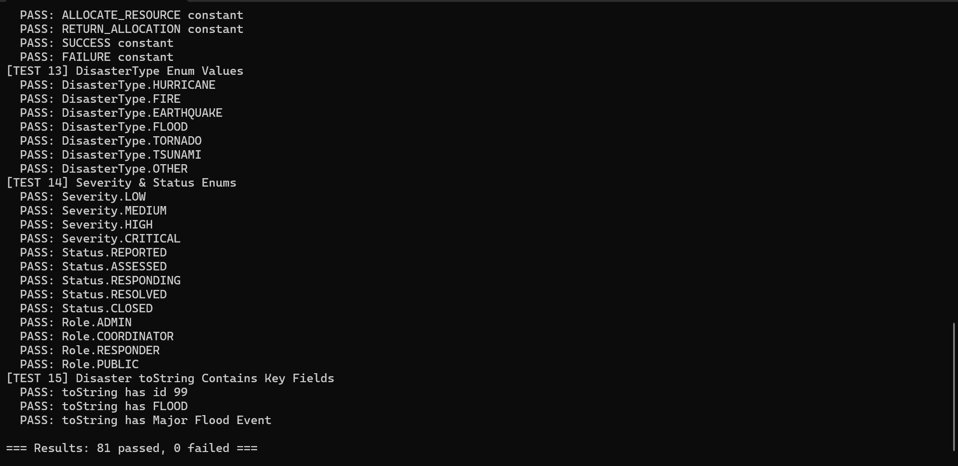
Figure 5: Automated Test Results — 81 Passed, 0 Failed
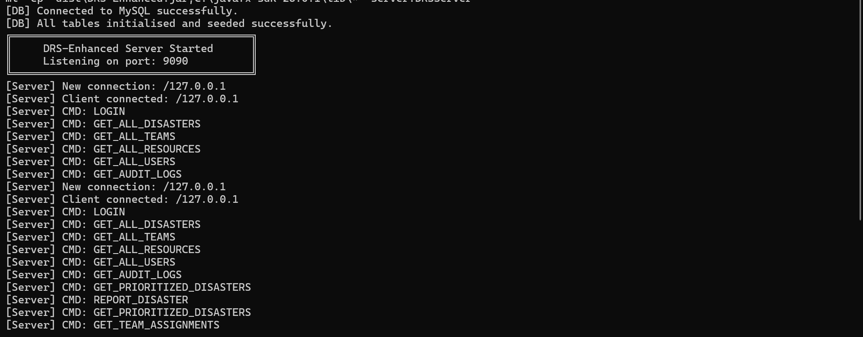
Figure 6: Server Console — MySQL Connected, Port 9090, Client Commands Logged

5. Application Screenshots

5.1 Authentication
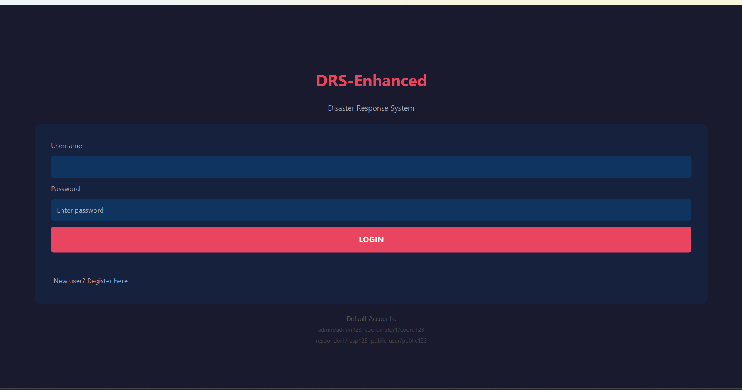
Figure 7: Login Screen — Dark theme, default credentials shown
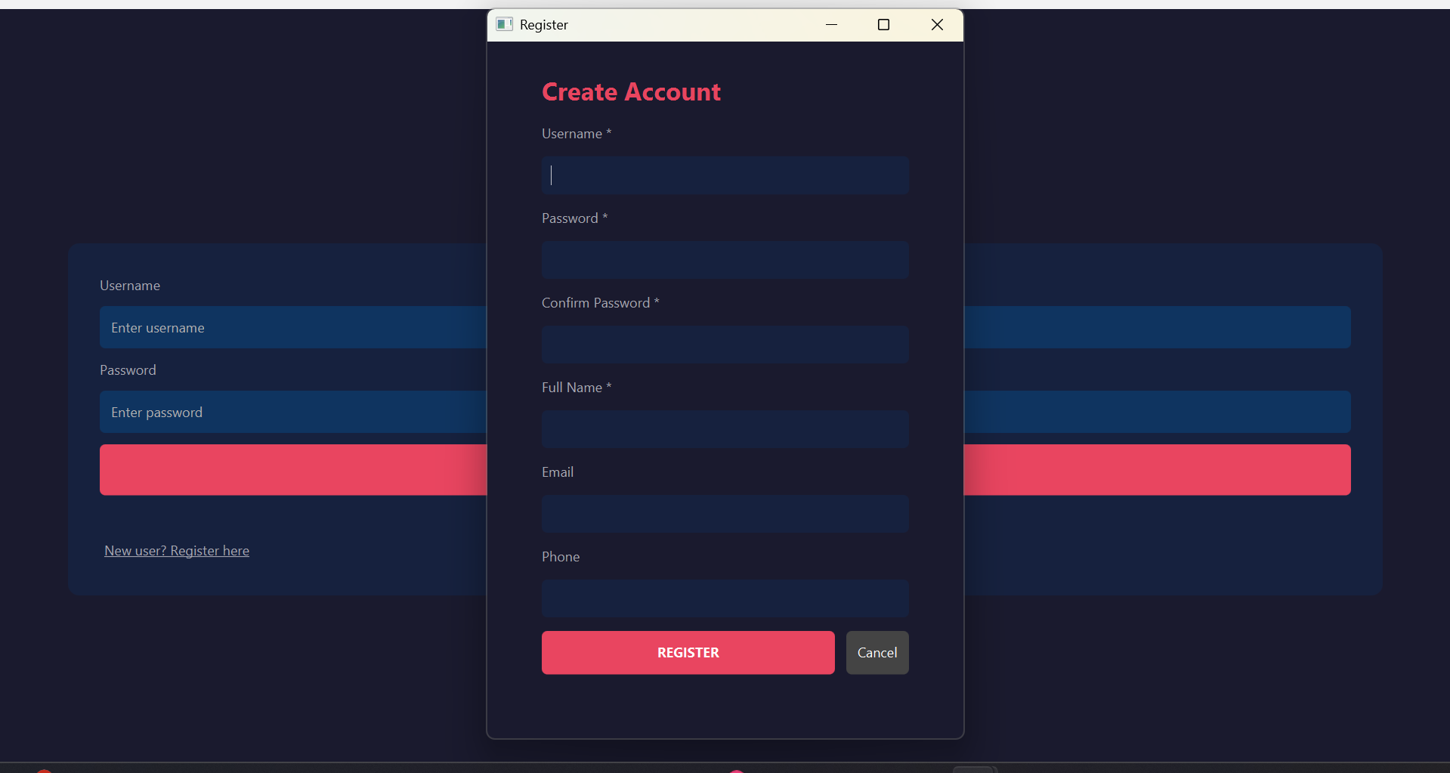
Figure 8: Registration Screen — New user creation

5.2 Main Dashboard and Disaster Management
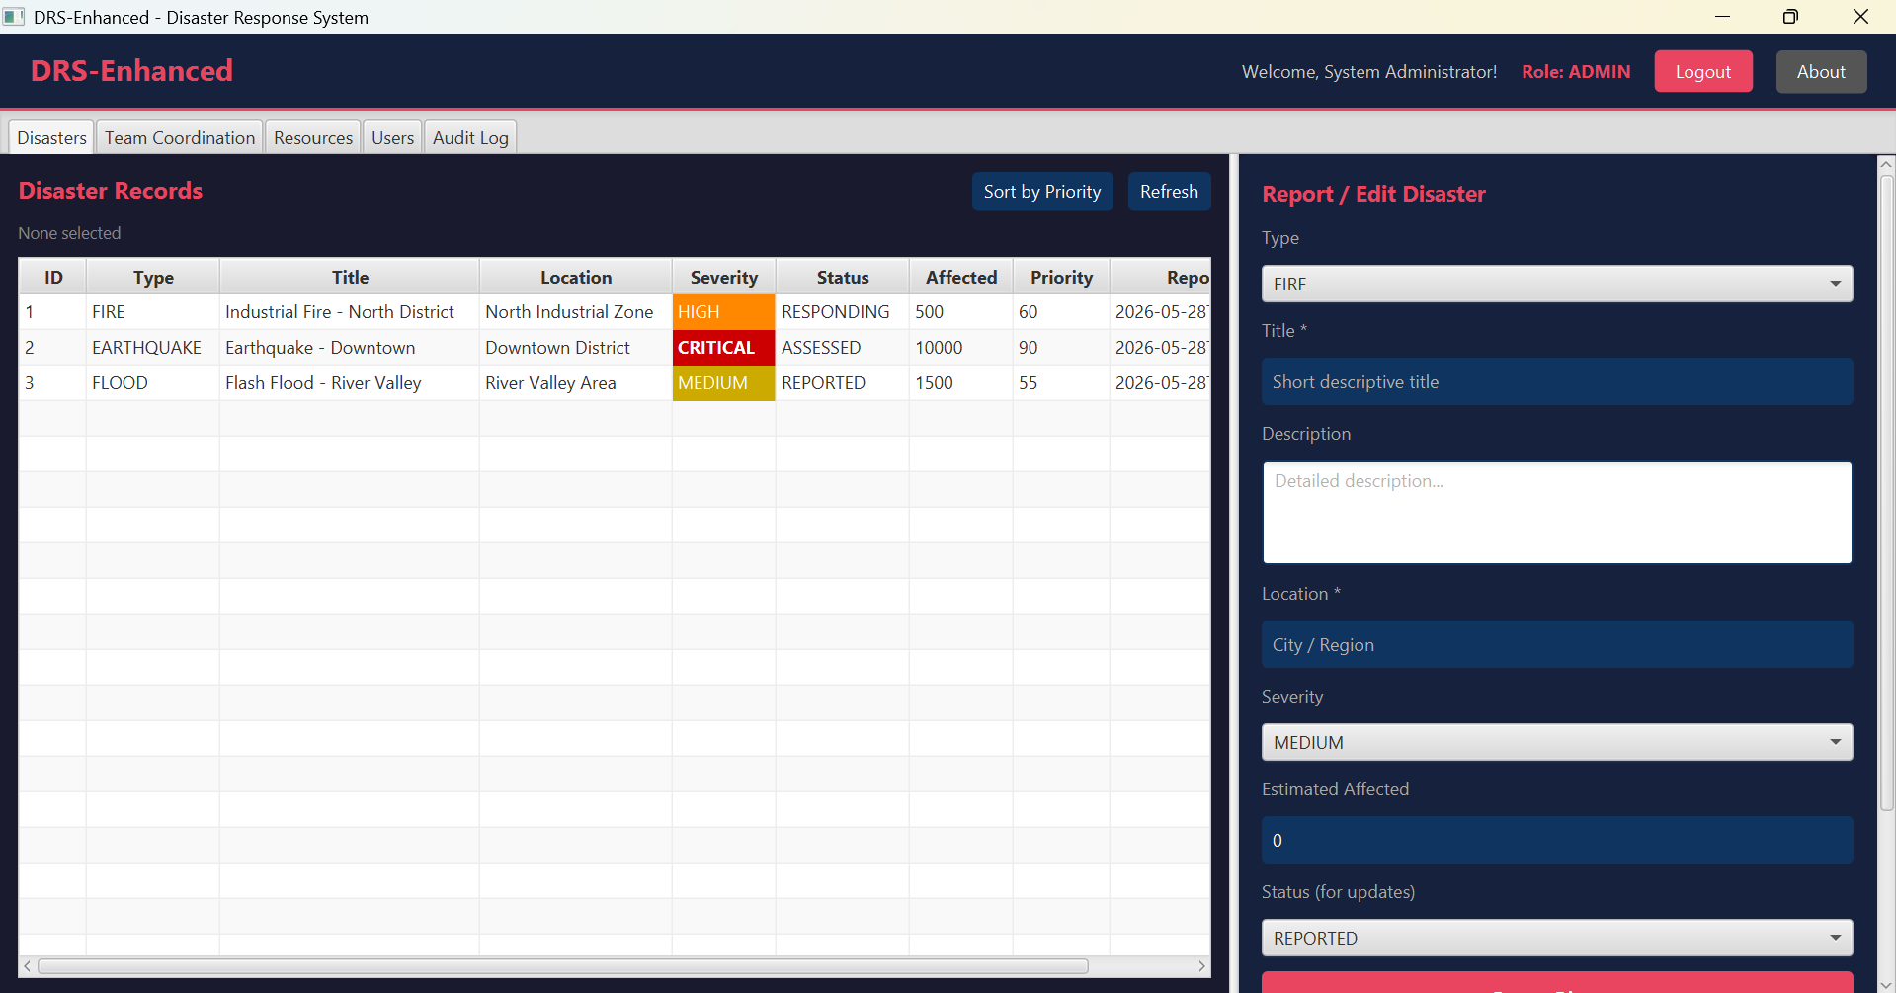
Figure 9: Main Dashboard — ADMIN role, all tabs visible, disasters loaded
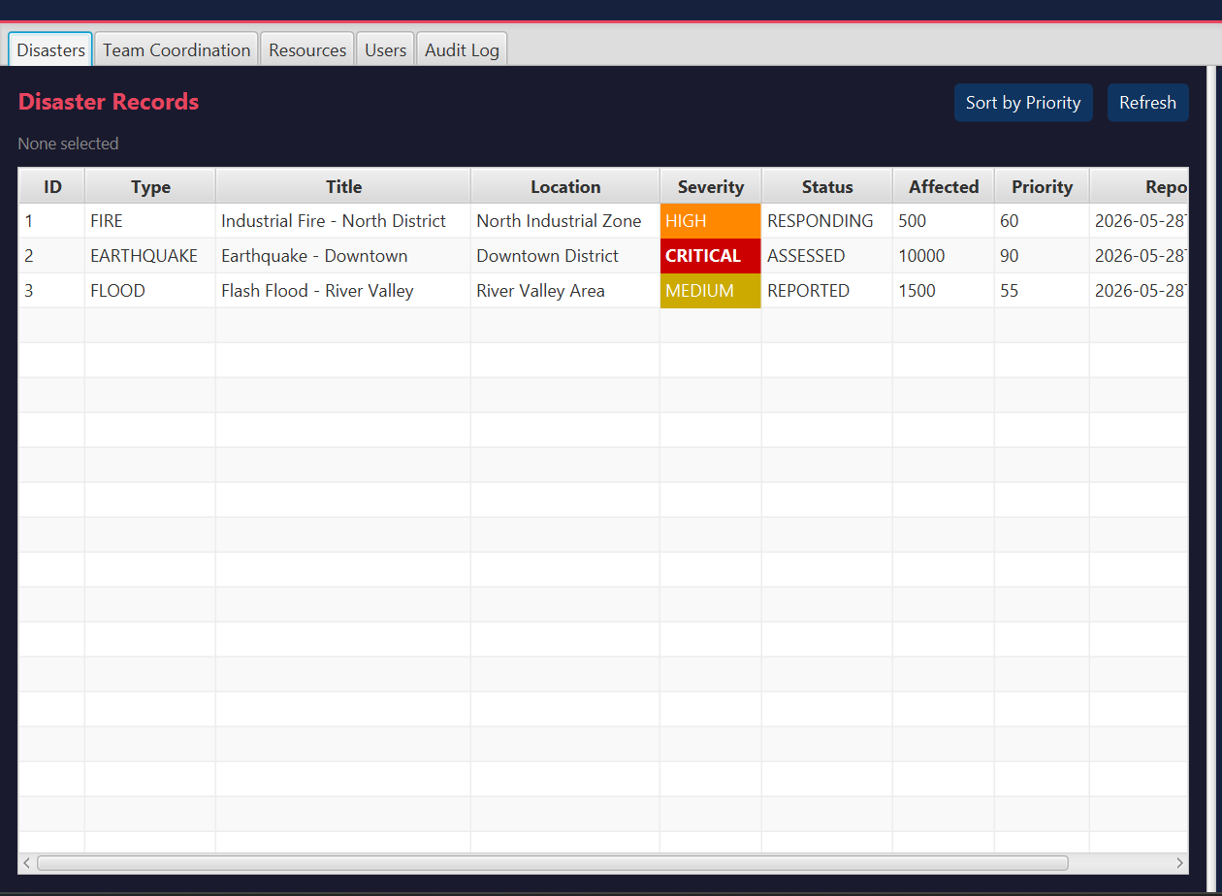
Figure 10: Disaster Records — CRITICAL=red, HIGH=orange, MEDIUM=yellow
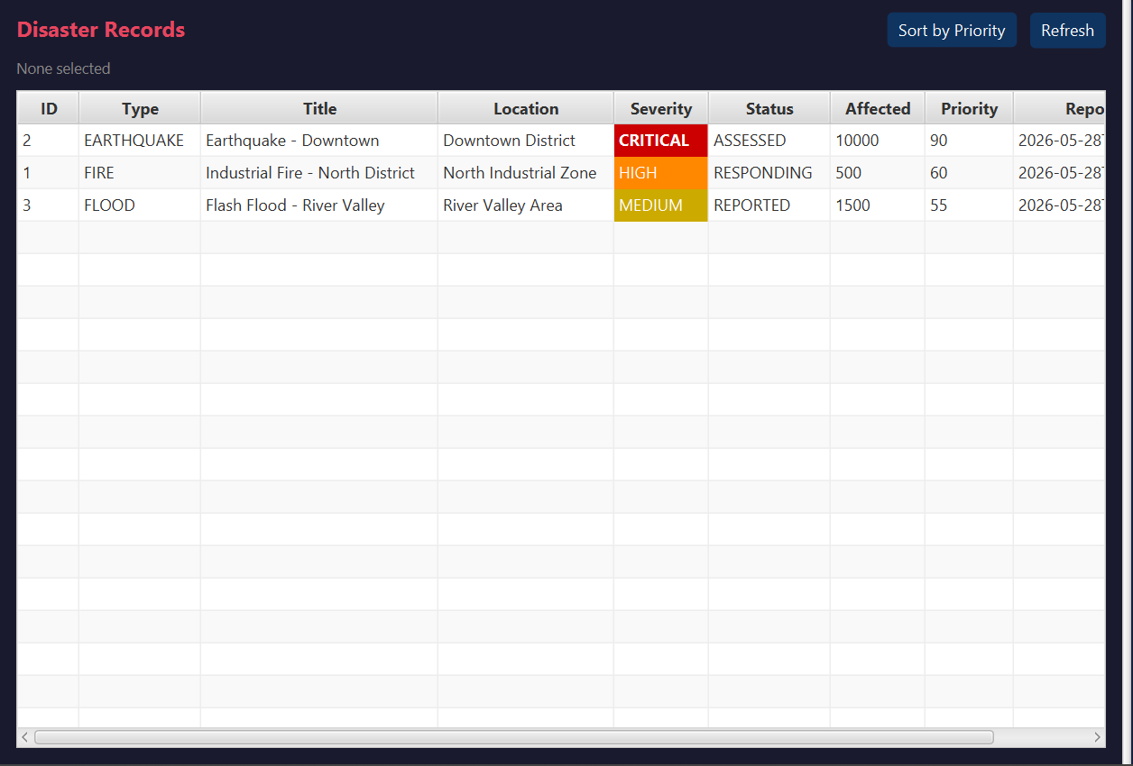
Figure 11: Priority Sort — EARTHQUAKE score 90 moved to top
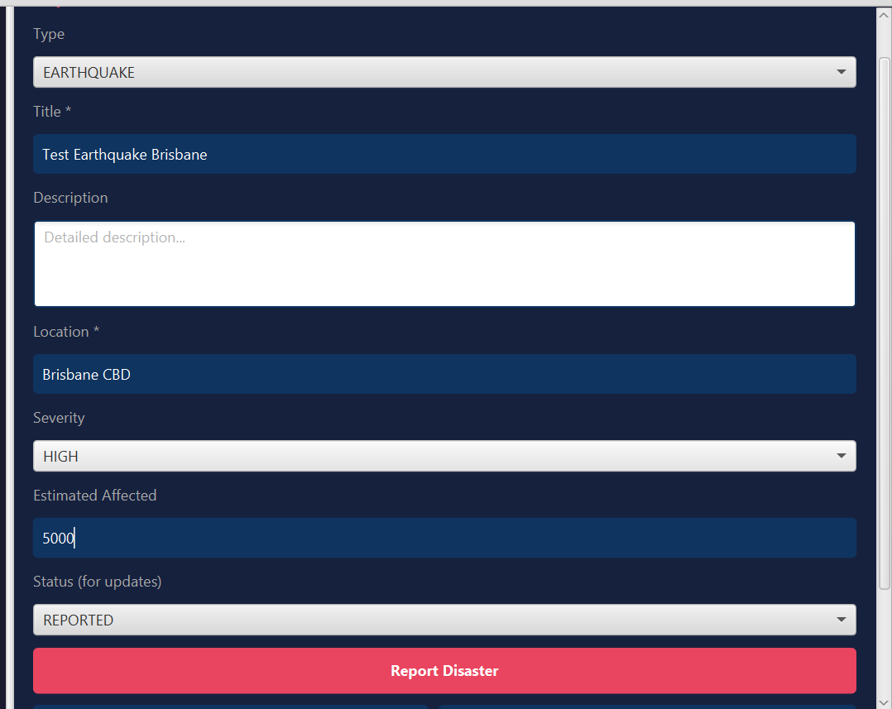
Figure 12: Report Form — EARTHQUAKE, Brisbane CBD, HIGH, 5000 affected
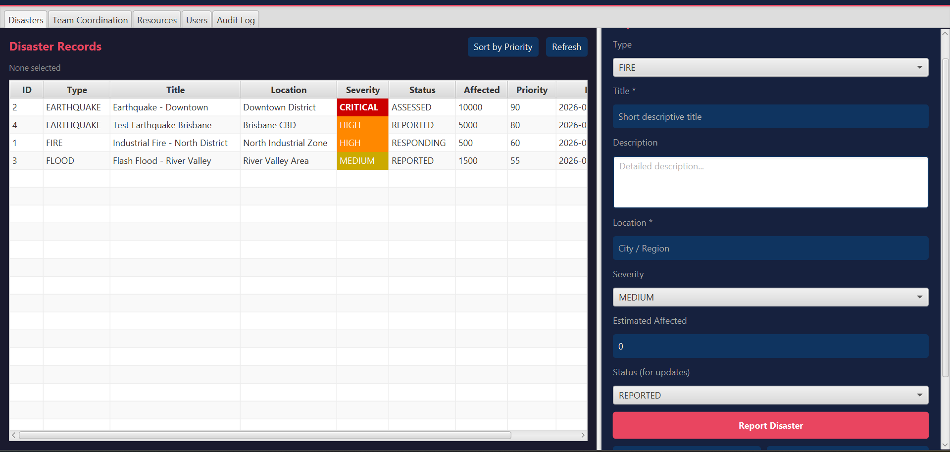
Figure 13: After Report — Test Earthquake Brisbane added as ID 4

5.3 Feature 1: Team Coordination
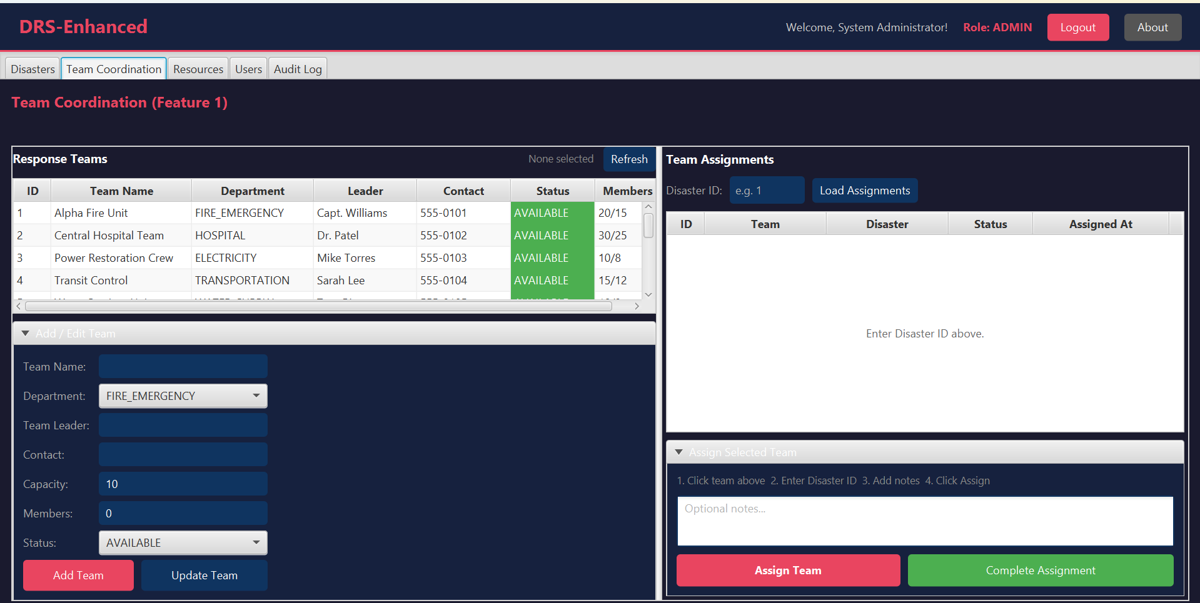
Figure 14: Team Coordination — 6 teams all AVAILABLE (green)
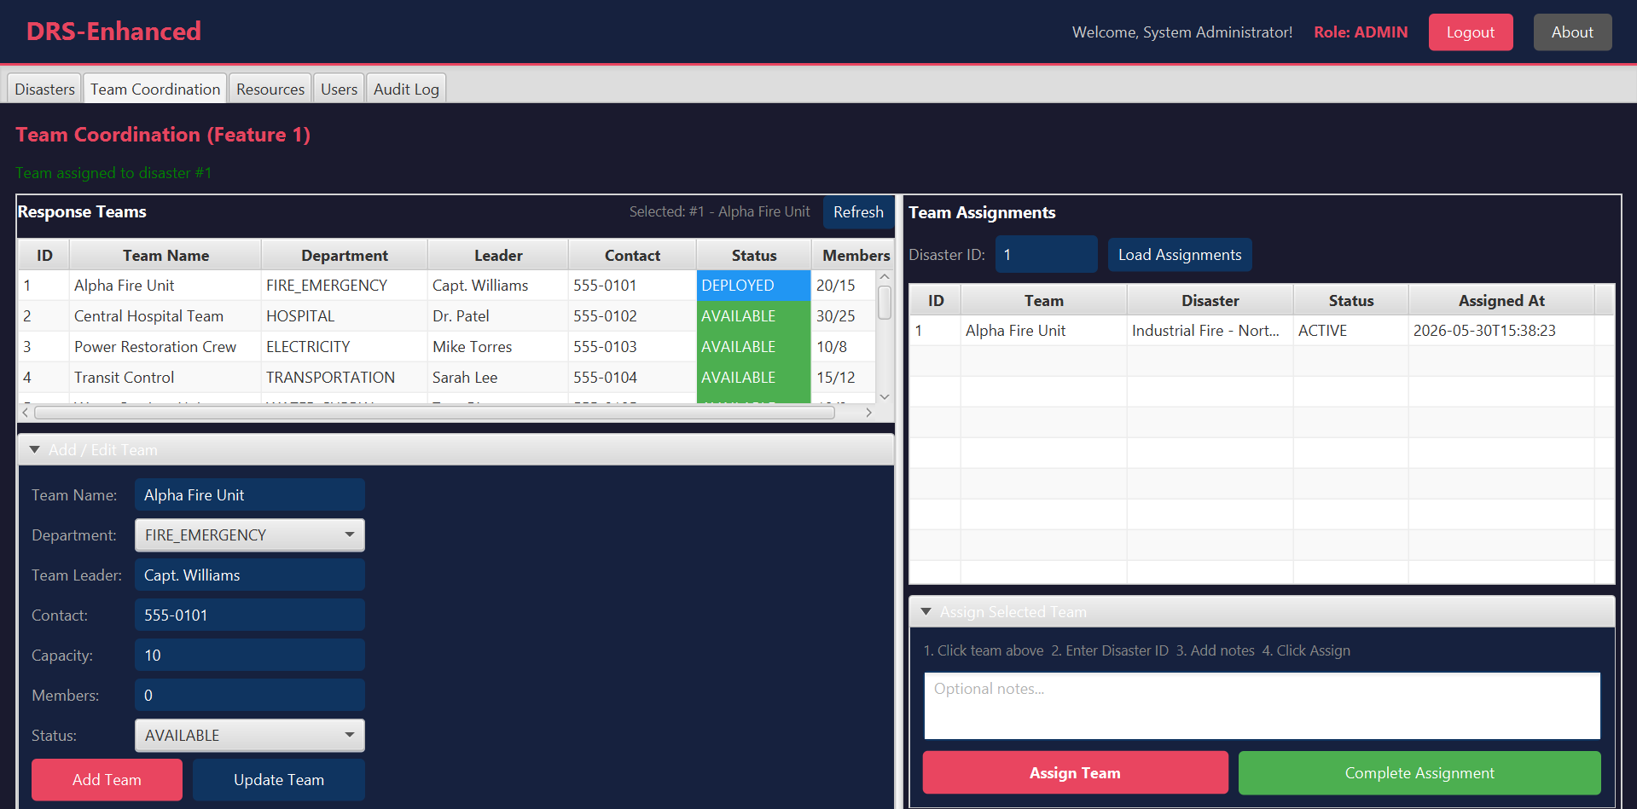
Figure 15: Team Assigned — Alpha Fire Unit DEPLOYED (blue) to Disaster #1
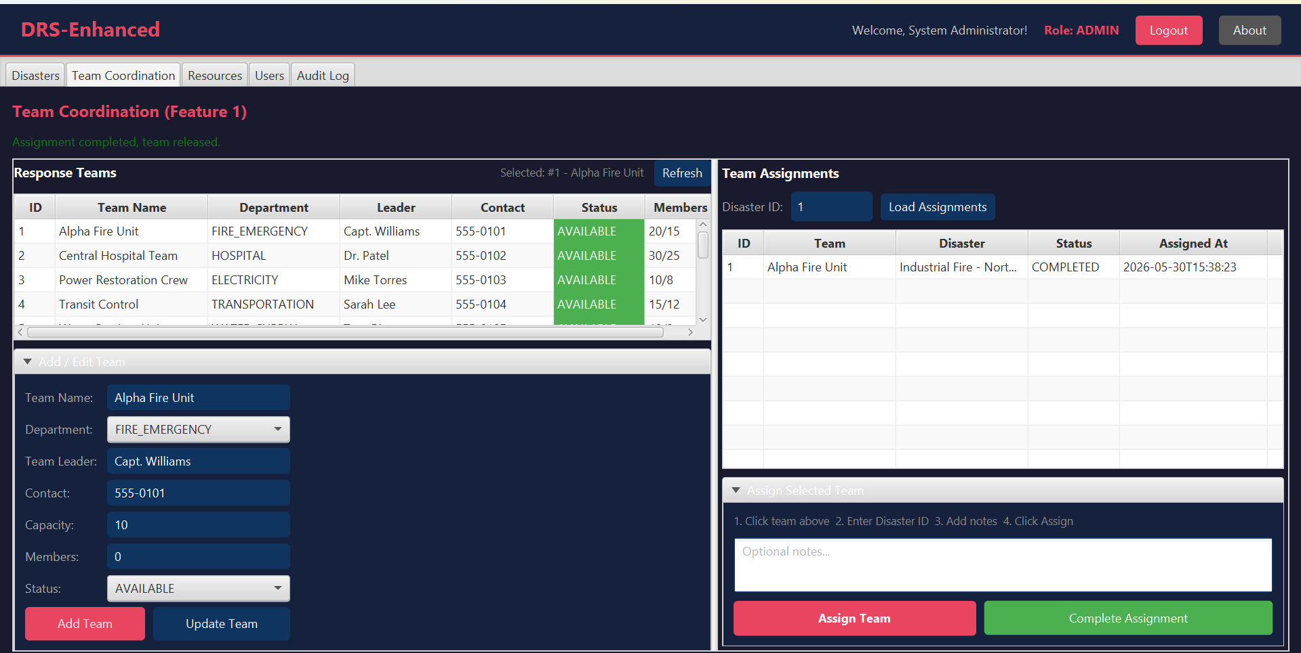
Figure 16: Completed — Team AVAILABLE again, assignment COMPLETED

5.4 Feature 2: Resource Management
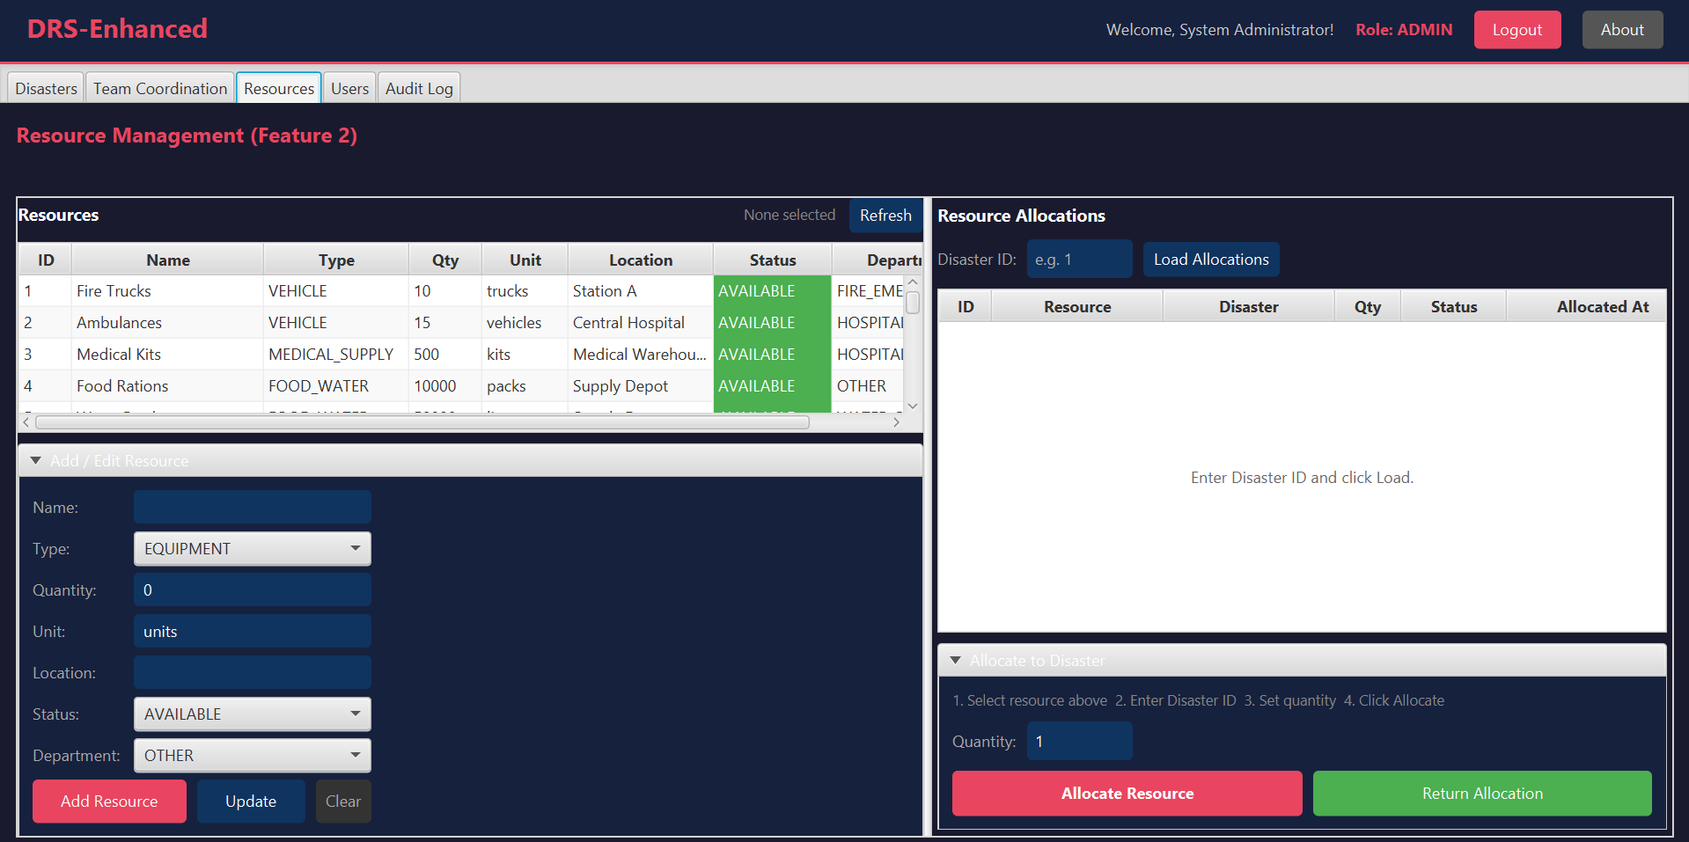
Figure 17: Resources — 10 items with quantities and AVAILABLE status
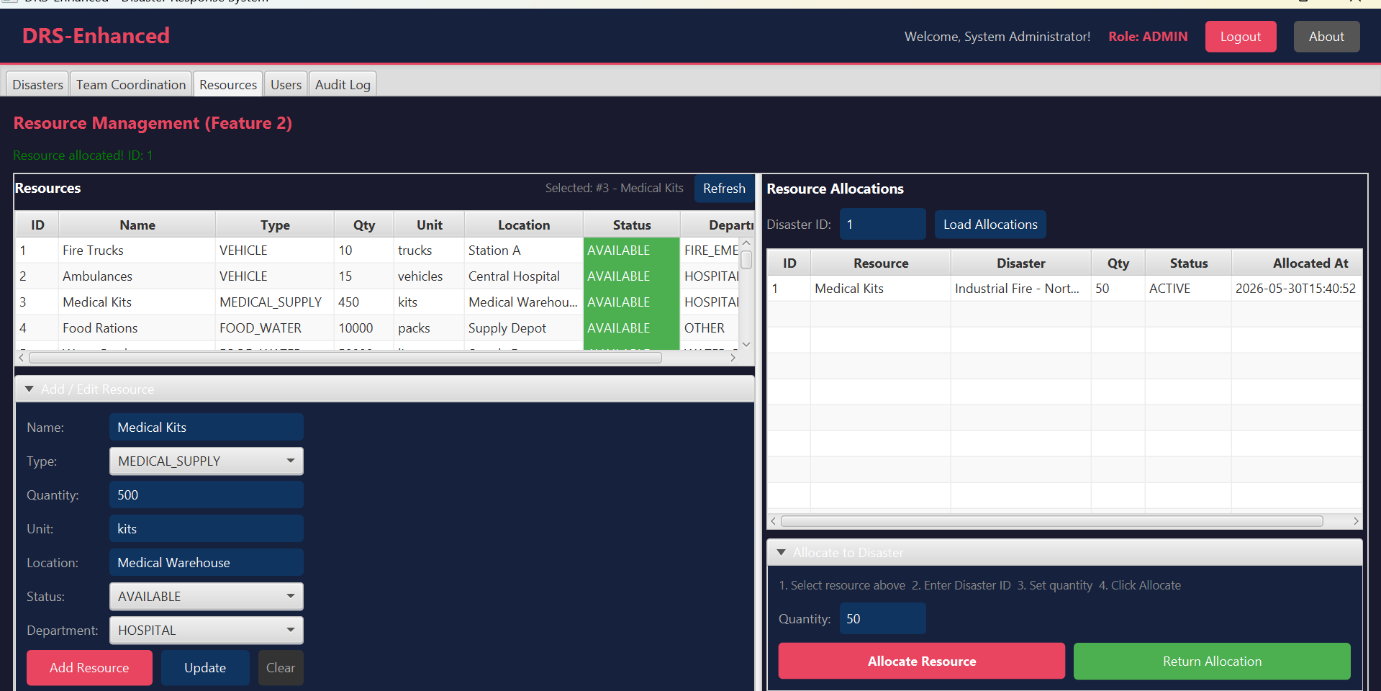
Figure 18: Allocation — Medical Kits 50 units allocated, qty 500→450

5.5 Administration
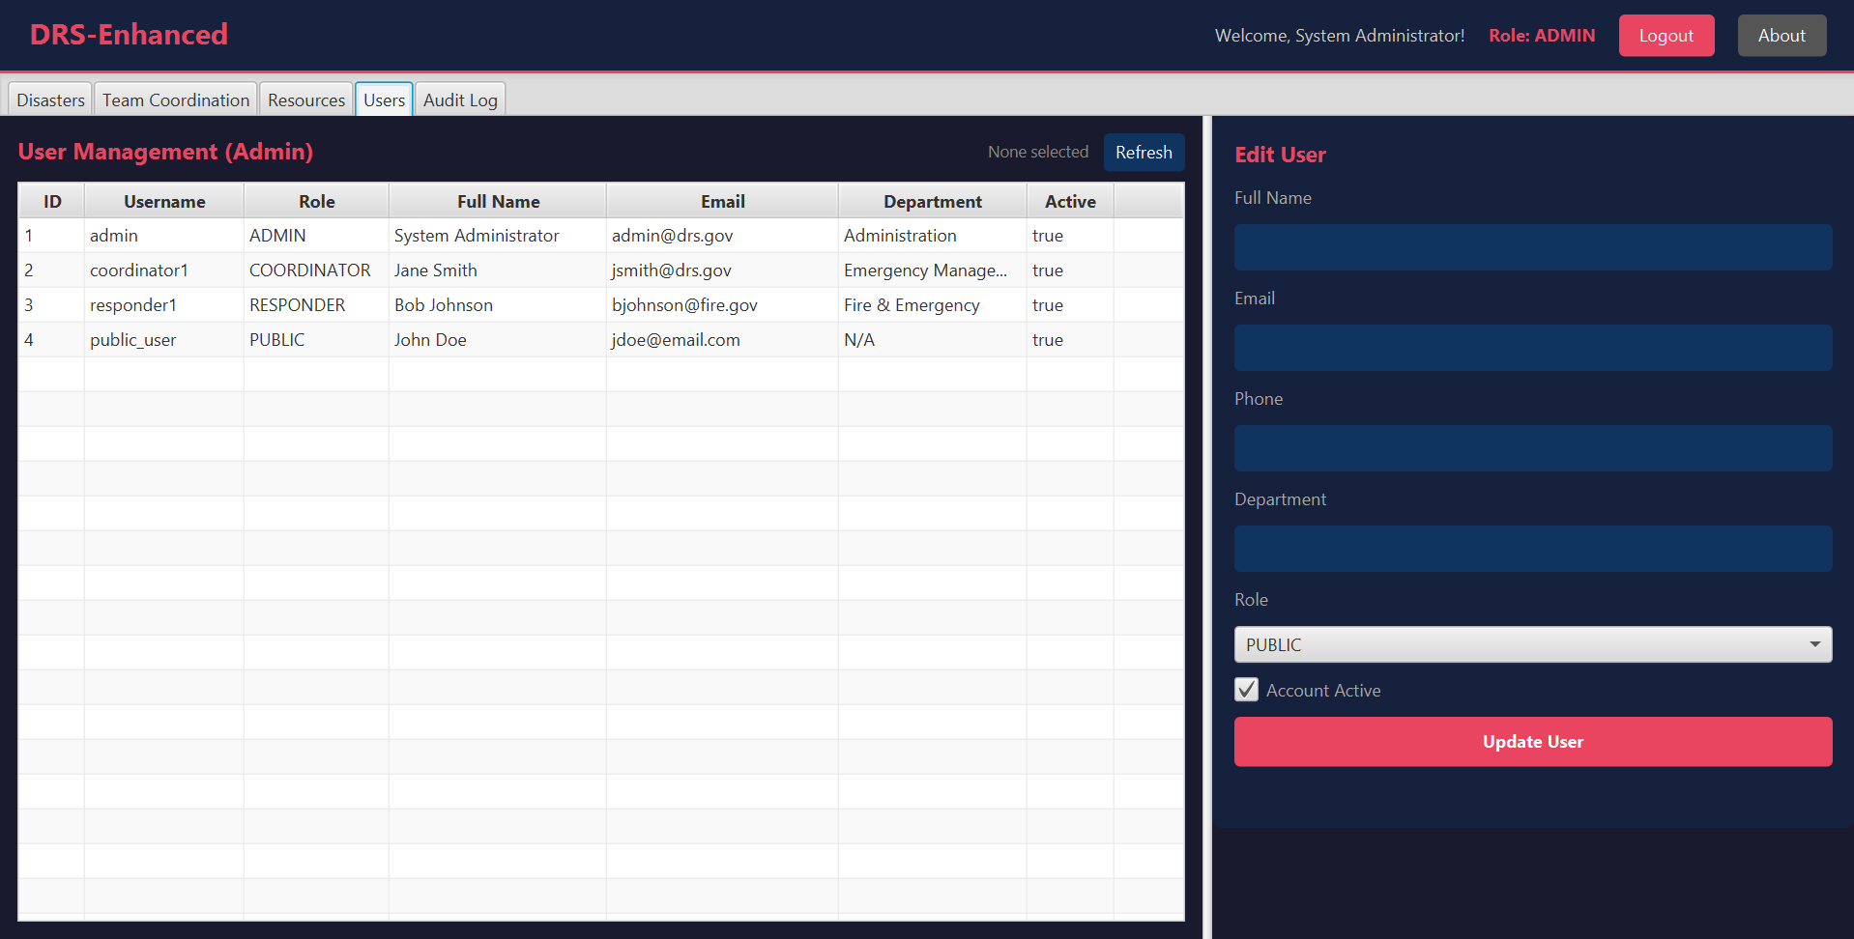
Figure 19: User Management (Admin) — 4 users with roles and contacts
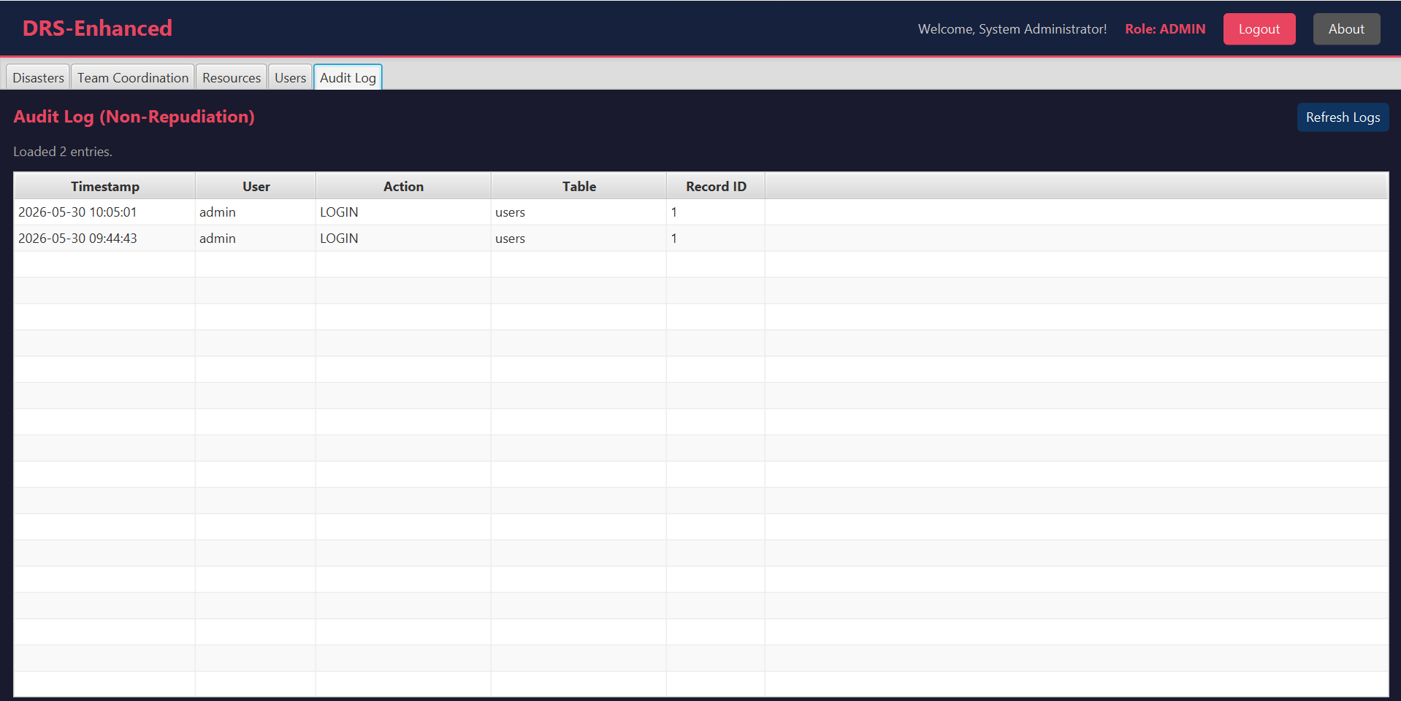
Figure 20: Audit Log (Non-Repudiation) — Login events with timestamps

5.6 NetBeans Project Structure
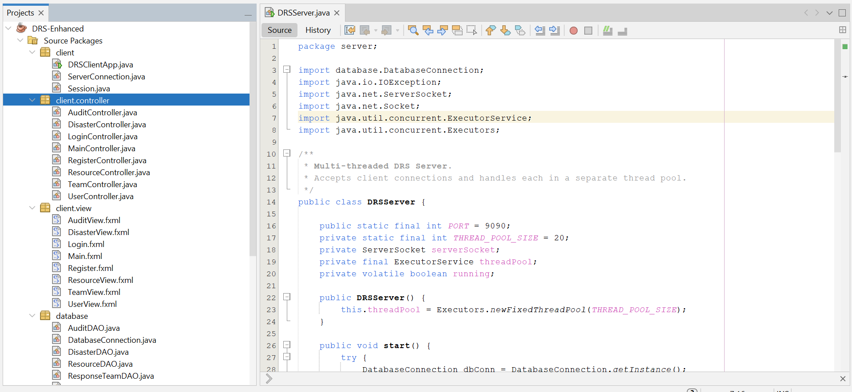
Figure 21: NetBeans — MVC packages: model, database, server, util, client

6. Conclusion
The project ‘DRS-Enhanced' was a success and has been completed with a fully functional distributed Java application to fulfill all requirements outlined in the COIT20258 Assignment 3 specification. The system consists of a client implemented in JavaFX with an MVC structure, a server implemented with multiple threads using an ExecutorService thread pool with 20 concurrent connections on port 9090, and a relational database implemented on MySQL with 7 tables (created by the system).
The two other domain-specific features were added and successfully tested. Feature 1 (Team Coordination) allows the coordinators to coordinate response teams, deploy teams to active disasters and automatically change their status from AVAILABLE to DEPLOYED and complete assignments and change the team status back to AVAILABLE. Feature 2 (Resource Management) allows coordinators to monitor physical resource inventories, to allocate resources during disaster events in automatic fashion, and to redeposit resources to replenish stock levels, and provides colour coded notification for low and depleted levels of resource.
Security was ensured by the use of the SHA-256 password hashing algorithm, the AES-128 data encryption algorithm, and role-based access control with four user roles, as well as using a detailed audit log that records all important operations with a user stamp, user identity, concerned table and record identifier, affording non-repudiation. The MVC architectural pattern resulted in a clean separation of concerns in the model, view, controller, database, server, and utility layers, which increased maintainability and extensibility.
There were two levels of testing. All 81 assertions were passed for the 15 test methods performed by the automated DRSTest class in all Model Classes, Utility Methods, protocol constants, and enumeration values. There are 23 test cases in Manual functional testing, all these test cases generated expected results; Logon validation, Disaster report, Priority sorting, Team assignment, Resource allocation, User management and Audit logging.
The project illustrates the practical use of various features of the distributed systems design: client-server, multi-threading, JDBC database integration, MVC design pattern and software security in a real-life disaster management domain.

7. References
Bass, L., Clements, P., & Kazman, R. (2021). Software architecture in practice (4th ed.). Addison-Wesley Professional.
Beck, K. (2022). Test-driven development: By example (Anniversary ed.). Addison-Wesley Professional.
Coppola, D. P. (2020). Introduction to international disaster management (4th ed.). Butterworth-Heinemann.
CQUniversity. (2026). COIT20258 Assignment 3 specification. CQUniversity Australia.
Fowler, M. (2018). Refactoring: Improving the design of existing code (2nd ed.). Addison-Wesley Professional.
Gamma, E., Helm, R., Johnson, R., & Vlissides, J. (2019). Design patterns: Elements of reusable object-oriented software (30th Anniversary ed.). Addison-Wesley Professional.
Haddow, G., Bullock, J., & Coppola, D. P. (2021). Introduction to emergency management (7th ed.). Butterworth-Heinemann.
Oracle. (2023). JavaFX 21 documentation. https://openjfx.io/javadoc/21/
Oracle. (2024). MySQL 8.0 reference manual. https://dev.mysql.com/doc/refman/8.0/en/
Stallings, W. (2022). Cryptography and network security: Principles and practice (8th ed.). Pearson.

8. Appendix

