**Table of Contents**

1. **Requirements Definition**

A list of the functional and nonfunctional business requirements for the system.

1. **Functional Model**

An activity diagram and a use-case diagram that illustrate the basic

processes or external functionality that the system needs to support.

1. **Structural Models**

A set of CRC cards and class diagram that describe the structural aspects of the

to-be system.

**1. Requirements Definition**

**Nonfunctional Requirements**

1. **Operational Requirements**
   1. Responsive, accessed on desktop and mobile
2. **Performance Requirements**
   1. Recipes pull up in reasonable time
   2. Recipe uploads in reasonable time
3. **Security Requirements**
   1. Only recipe creator can edit/delete
4. **Cultural/Political Requirements**
   1. Disclaimer for medical issues/not to replace medical advice etc.

**Functional Requirements**

1. **View Recipe Box**
   1. Logged in user sees their customized recipe box
      1. User recipe box (rb) image
      2. Favorites section pulls up favorited recipes
      3. Upload recipe button works when logged in
   2. Guest sees Kamida recipe box
      1. Generic rb image
      2. Favorites section requires login
      3. Upload recipe button requires login
2. **View Health Concern Category (HCC)**
   1. User sees info in HCC in manageable, non-overwhelming way
   2. HCC pulls up associated recipes
   3. Refine recipes
3. **View Recipes**
   1. Logged in user can favorite recipe
      1. Favorite recipe by health benefits & taste separately
   2. Logged in user can comment
   3. Shareable on other platforms
4. **Upload Recipe**
   1. Requires logged in
   2. Review and confirm

**2. Functional Model**

**Use Case Diagram**

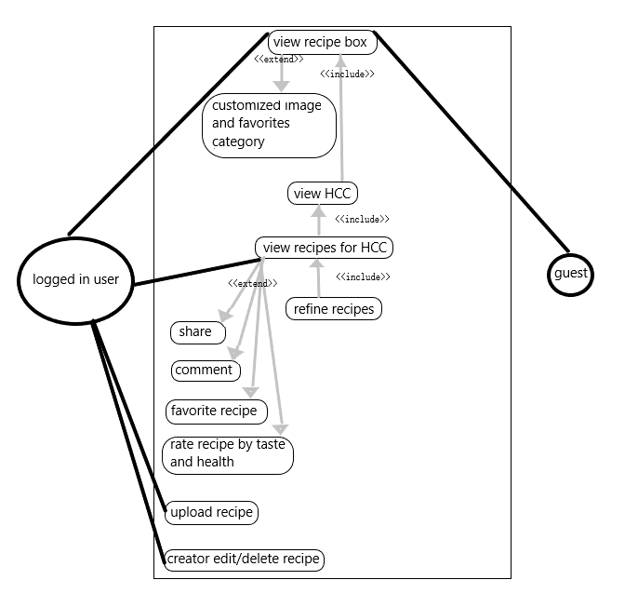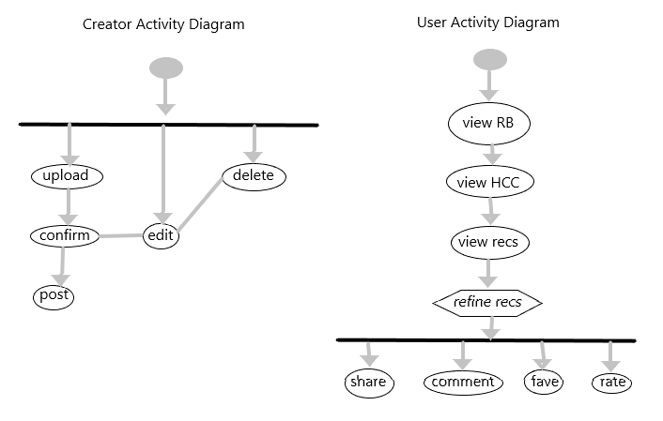

**3. Structural Model**

**Class Responsibility Collaboration CRC cards**

**Class Name: RecBox**

1. **ID: 1**
2. **Type:** concrete
3. **Description:** box is homepage of app, contains HCC/fav/upload, user can customize image,
4. **Responsibilities:** 
   1. Opens
   2. Shows links to HCC, fav category, upload button
   3. Links open HCC and Recs
   4. Only logged in user can open fav category & upload button
5. **Collaborators:** HCC, HCRecs, User
6. **Attributes:**
   1. Image
   2. HCC – text
   3. User logged in – bool
7. **Relationships:**
   1. **Generalization (a-kind-of):**
   2. **Aggregation (has-parts):** HCC & HCRecs
   3. **Other Associations:** User

**Class Name: HCC**

1. **ID: 2**
2. **Type:** concrete
3. **Description:** health concern category
4. **Responsibilities:**
5. **Collaborators:** RecBox, HCRecs
6. **Attributes:**
   1. HC info:
      1. HC – text
      2. Info – text
      3. BadNutrients – text
      4. GoodNutrients – text
      5. Tips – text
      6. Veggies – text
      7. Fruits – text
      8. Grains & Nuts – text
      9. Protein – text
      10. Dairy & Fermented – text
      11. Herbs, Oils, Sauces & Other – text
      12. Sources – text
7. **Relationships:**
   1. **Generalization (a-kind-of):**
   2. **Aggregation (has-parts):**
   3. **Other Associations:** RecBox

**Class Name: HCRecs**

1. **ID: 3**
2. **Type:** concrete
3. **Description:** all recipes for HCC
4. **Responsibilities:**
   1. Refine
5. **Collaborators:** User, RecBox
6. **Attributes:**
   1. Intro RecInfo:
      1. Title – String
      2. TotTime – Number
      3. Serves – String
      4. Cost – String
      5. Skill – String
      6. Meal – String
      7. Category – String Array
      8. Cuisine – String
      9. Creator – String
      10. Date – String
   2. Rating
7. **Relationships:**
   1. **Generalization (a-kind-of):**
   2. **Aggregation (has-parts):** Rec
   3. **Other Associations:** User, RecBox

**Class Name: Rec**

1. **ID: 4**
2. **Type:** concrete
3. **Description:** specific recipe
4. **Responsibilities:**
   1. Share
   2. Rate
   3. Delete
   4. Edit
5. **Collaborators:** User, HCRecs
6. **Attributes:**
   1. Comments
   2. Favorited by user
   3. Rated by user
   4. Rating
   5. RecInfo:
      1. Title – String
      2. PrepTime – Number
      3. CookTime – Number
      4. TotTime – Number
      5. Ingredients – String Array
      6. Steps – String Array
      7. Serves – String
      8. Cost – String
      9. Skill – String
      10. Meal – String
      11. Category – String Array
      12. Cuisine – String
      13. Tools – String Array
      14. Tips – String
      15. Creator – String
      16. Date – String
7. **Relationships:**
   1. **Generalization (a-kind-of):** HCRecs
   2. **Aggregation (has-parts):**
   3. **Other Associations:** User

**Class Name: User**

1. **ID: 5**
2. **Type:** concrete
3. **Description:**  logged in
4. **Responsibilities:**
   1. Pick HCC
   2. Refine HCRecs
   3. Pick rec
   4. Share
   5. Comment
   6. Favorite
   7. Rate
   8. Upload
   9. Edit
   10. Delete
5. **Collaborators:**
6. **Attributes:**
   1. RecBox image
   2. Favorite recs
   3. Comments
   4. Uploads
7. **Relationships:**
   1. **Generalization (a-kind-of):**
   2. **Aggregation (has-parts):**
   3. **Other Associations:** RecBox, HCRecs Rec

**Class Diagram**

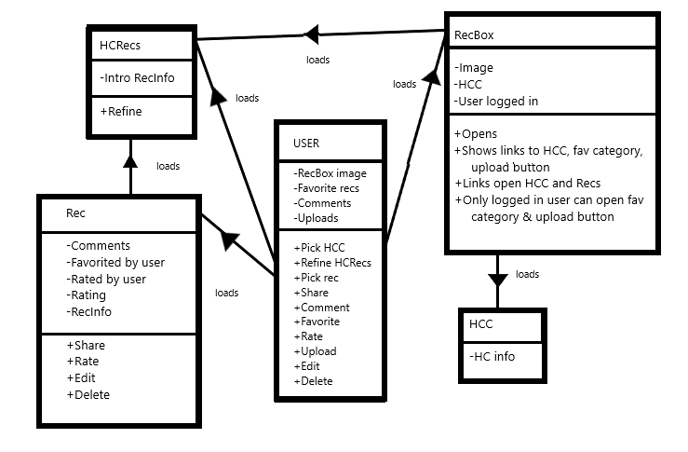

**4. HCC Requirements**

**JSON Template:**

{

“hc”: “”

, “causes”: []

, “info”: []

, “bNutrients”: []

, “gNutrients” : []

, “tips”: []

, “Veggies”: []

, “Fruit”: []

, “Grains”: []

, “Protein”: []

, “Dairy”: []

, “Other”: []

, “Sources”: []

}

**Food Template:**

{“ing”: “”, “good”: “”, “contains”: “”, “note”: “”}

**Requirements:**

* Good – per serving
  + Nutrients >20%
  + Omega3s 10mg
* Notes:
  + High sugar >10mg per serving
  + High sat fat >15%
  + High omega3:omega6 ratio is 1:10