Big Data Tools: Hive Practice HQL

1. **Login: hirwuser150430**

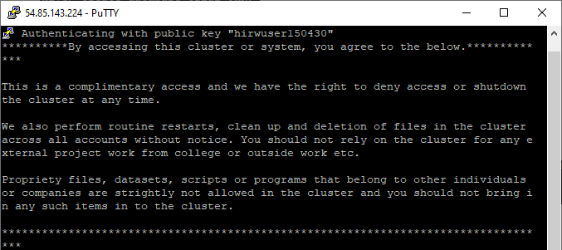****

1. **Enter into hive shell**

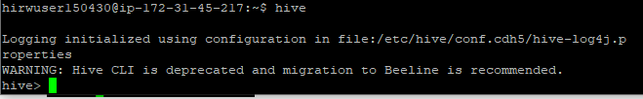

1. **Display existing databases**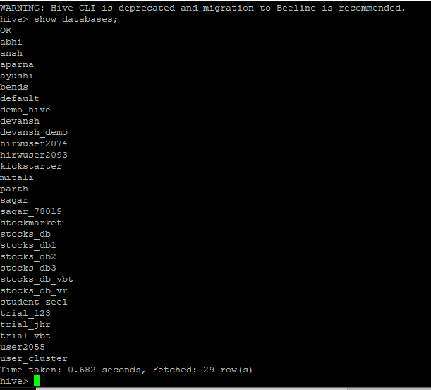
2. **Create a database**

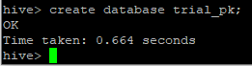

1. **use that database**

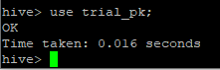

1. **Create a table stocks_db**

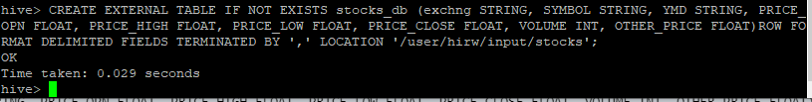

1. **Display existing tables in that database**

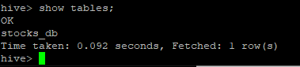

1. **Display records of that table (up to 100 records)**

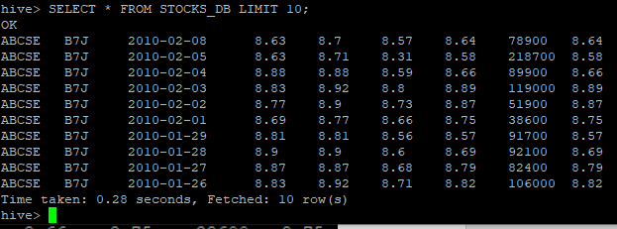

1. **Describe the structure of that table**

