**Practical – 2**

1. List all the files and directories under /user/hirw/input in HDFS.

Command - **hadoop fs -ls /user/hirw/input**

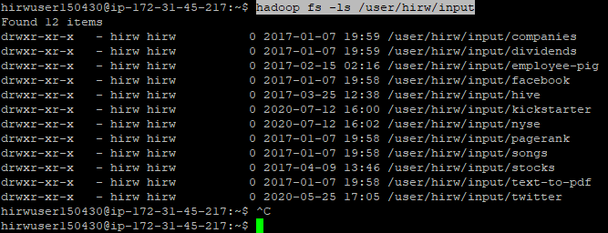

1. Create a directory in HDFS named ilovebigdata on HDFS.

Command - **hadoop fs -mkdir ILOVEBIGDATA**

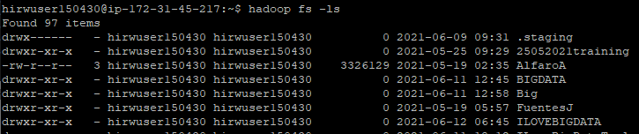

1. Copy the file dwp-payments-april10.csv from /hirw-workshop/input/hdfs to ilovebigdata directory in HDFS.

Command - **hadoop fs -copyFromLocal /hirw-starterkit/hdfs/commands/dwp-payments-april10.csv ILOVEBIGDATA**





1. Display the content of file dwp-payments-april10.csv under ilovebigdata in hdfs.

Command - **hadoop fs -cat /ILOVEBIGDATA/dwp-payments-april10.csv**



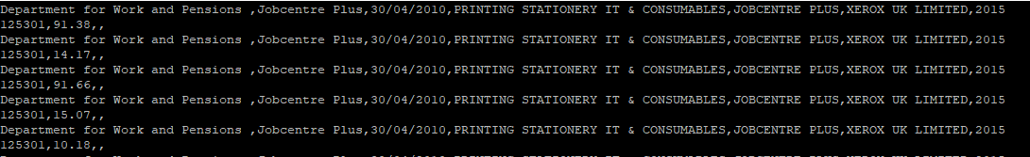

1. Create directory with name mynewdirectory in HDFS.

Command - **hadoop fs -mkdir /mynewdirectory**





1. Copy dwp-payments-april10.csv from ilovebigdata to mynewdirectory in HDFS.

Command - **hadoop fs -cp ILOVEBIGDATA/dwp-payments-april10.csv MYNEWDIRECTORY**



1. Set the replication factor of dwp-payments-april10.csv under mynewdirectory directory in HDFS to 2.

Command **- hadoop fs -setrep 2 MYNEWDIRECTORY/dwp-payments-april10.csv**



1. check health of mynewdirectory in HDFS (chmod)(fsck) - **hdfs fsck /user/hirwuser150430/MYNEWDIRECTORY -files -blocks -locations**

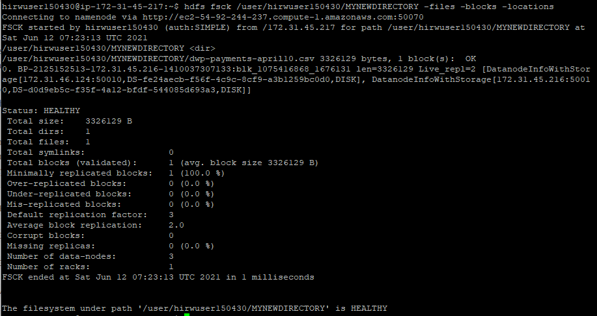

1. Bring the file dwp-payments-april10.csv under ilovebigdata directory to the local file system.

Command - **hadoop fs -copyToLocal ILOVEBIGDATA/dwp-payments-april10.csv**



**Note - Since I don’t have rights to make changes in the local system, here is the command and its output.**