PRACTICAL - 6: Working with NoSQL Databases. (MongoDB)

1. Install MongoDB on your operating system. (Windows/Linux/Mac)

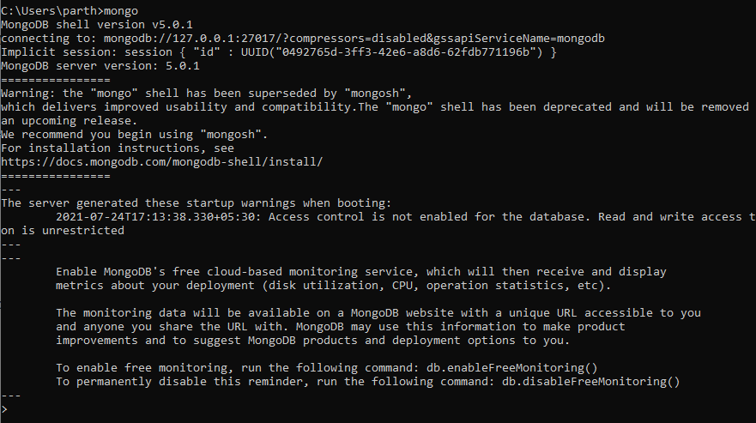

1. Create a database of your name on MongoDB. verify whether the database shows in the list or not.



1. Create a collection named “stories” and verify whether the database shows in the list or not.

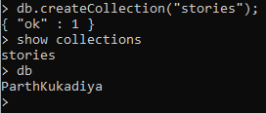

1. Create documents under stories, where various documents contains: time of putting the story, name of the person who viewed the story, comment on the story, number of shares of the story and so on.



1. Enlist all the documents under the collection stories. – Just like the sql query of “select \* from the stories”.

