**PRACTICAL - 7: Working with NoSQL Databases. (MongoDB)**

1. Consider the domain of an ecommerce website, opting for mongoDB as their database solution.

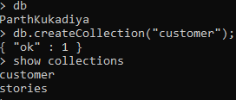

1. Run the basic CRUD (Create, Read, Update, Delete) operations for the domain asked using the queries of your choice.

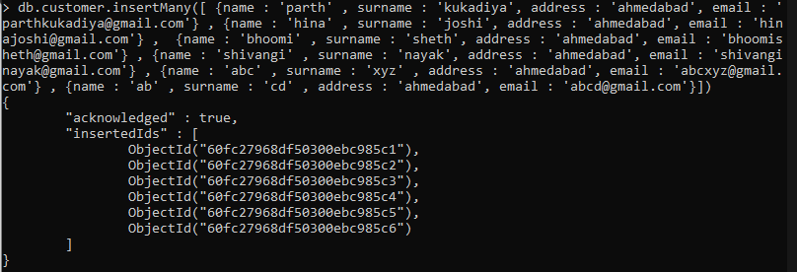

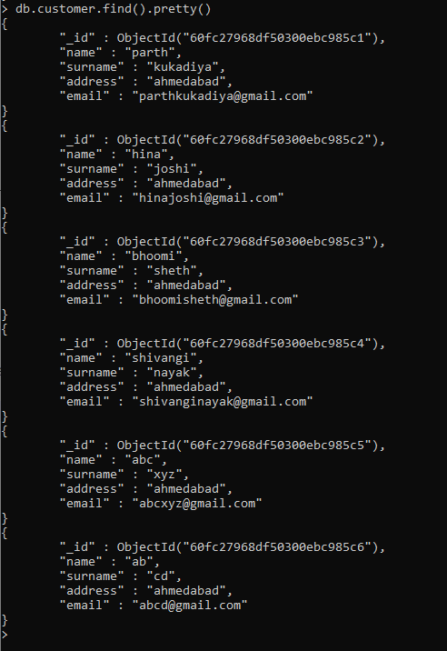

Update: -

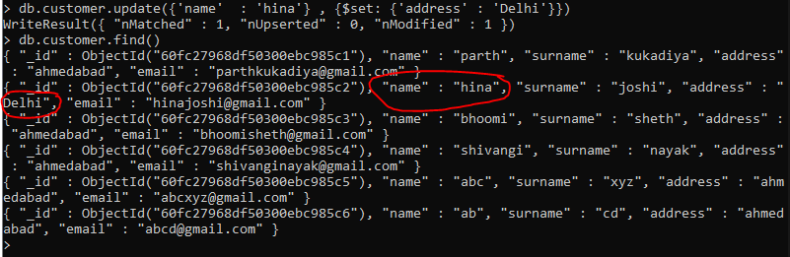

Remove: -

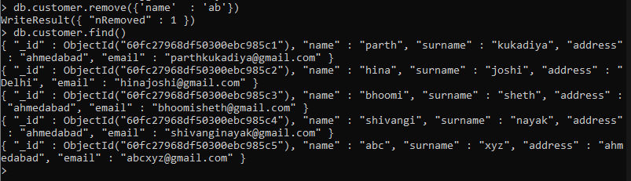

1. Run the queries of your choice which are Where Clause Equivalents of RDBMS in MongoDB.

