Supporting documents for April 2026
Expert – KE14: Mr. Phaykeo CHANTHALANGSY

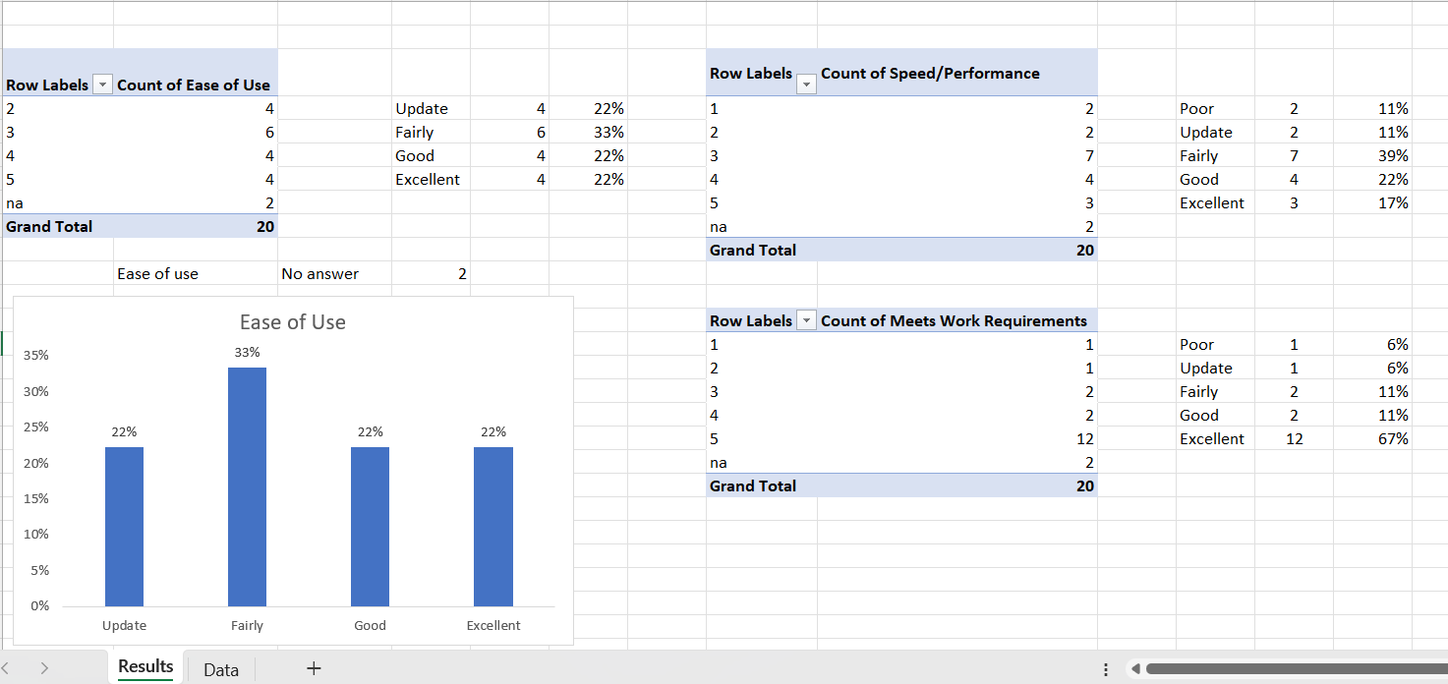
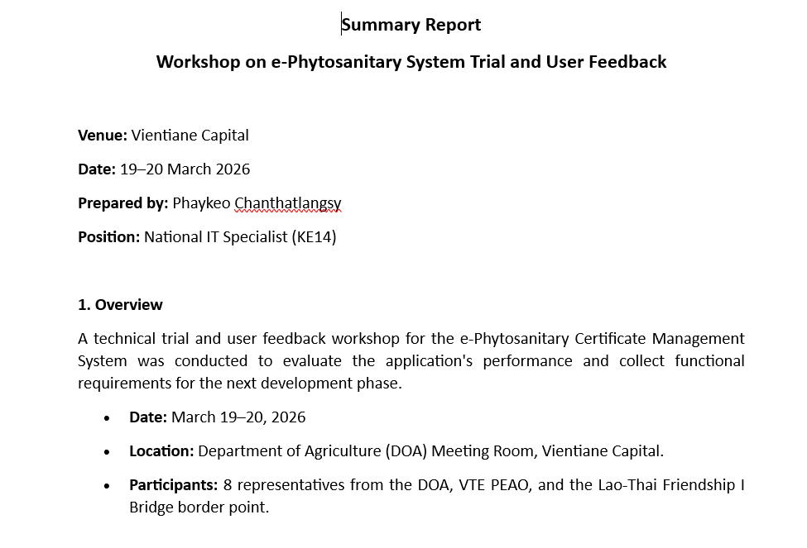
- Incorporate the users’ comments and feedback, and prepare summary report from the trial of database system in VTE

- Coordinate the draft User Guide for end-users with DOA for its comments and feedback, finalize and submit the document to DOA

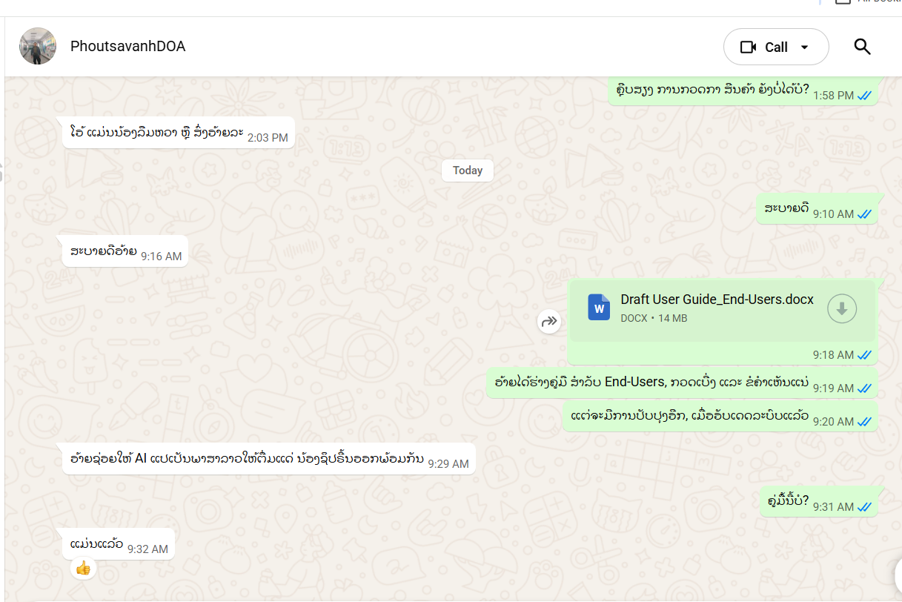

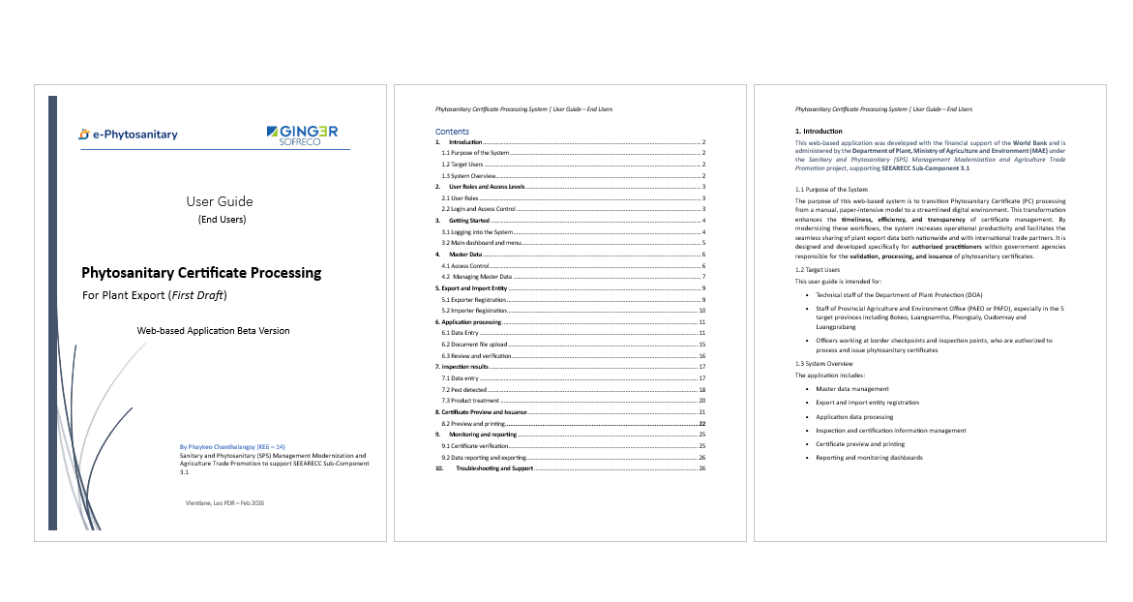

- Reorder the main menu across the system: Dashboard Export entity Import entity Application Inspection Certificate and update My Profile section
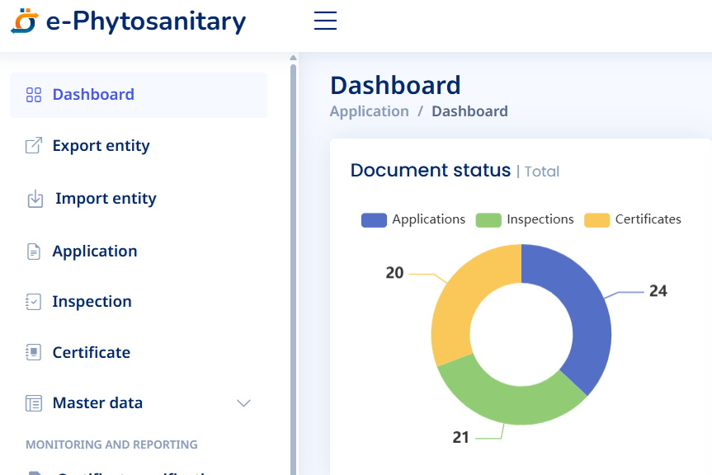

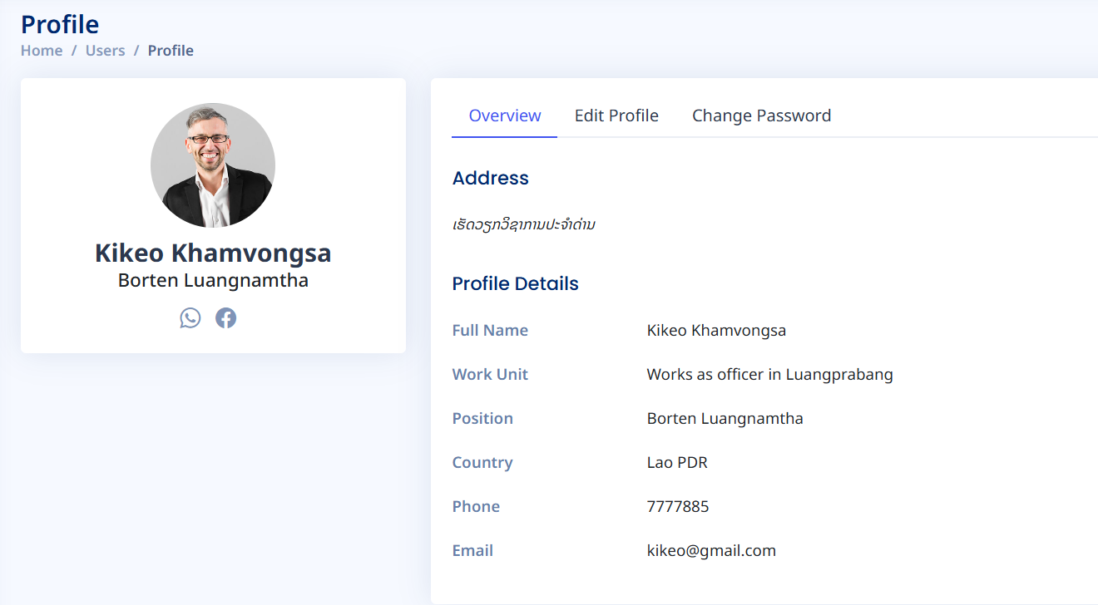

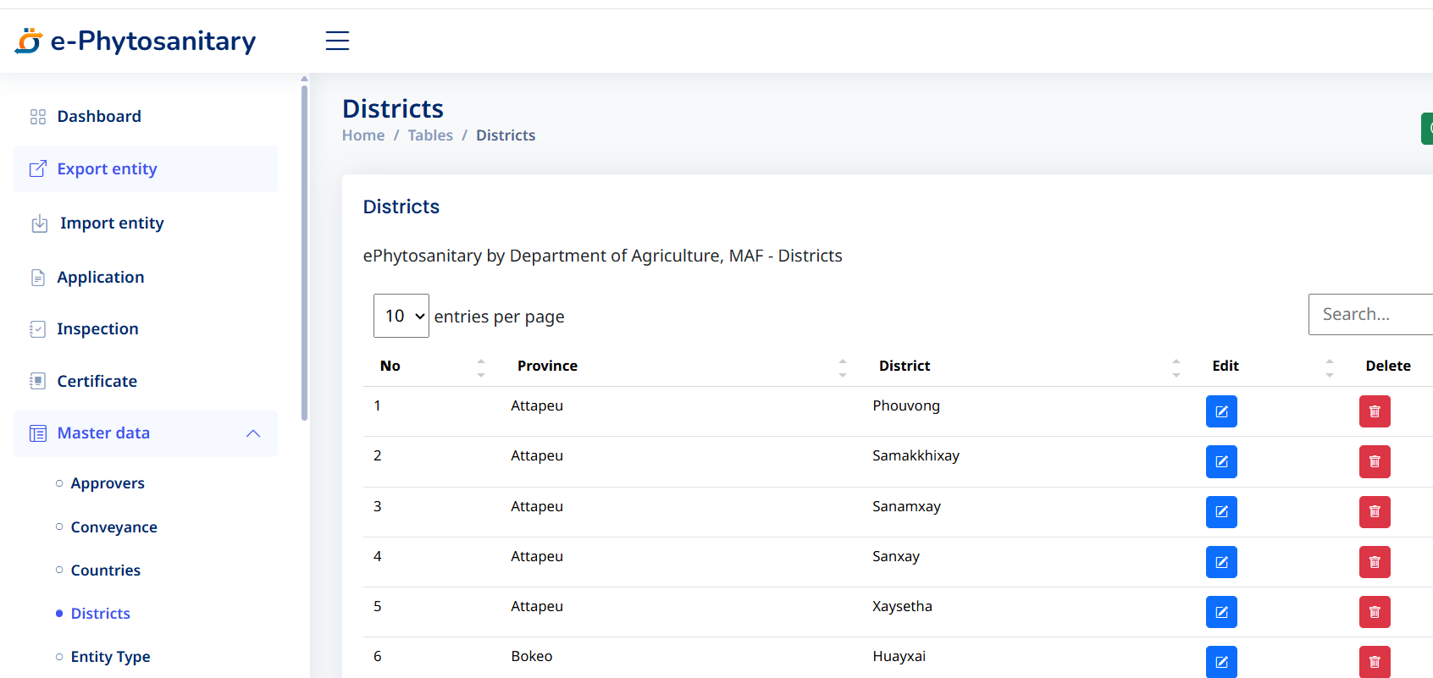
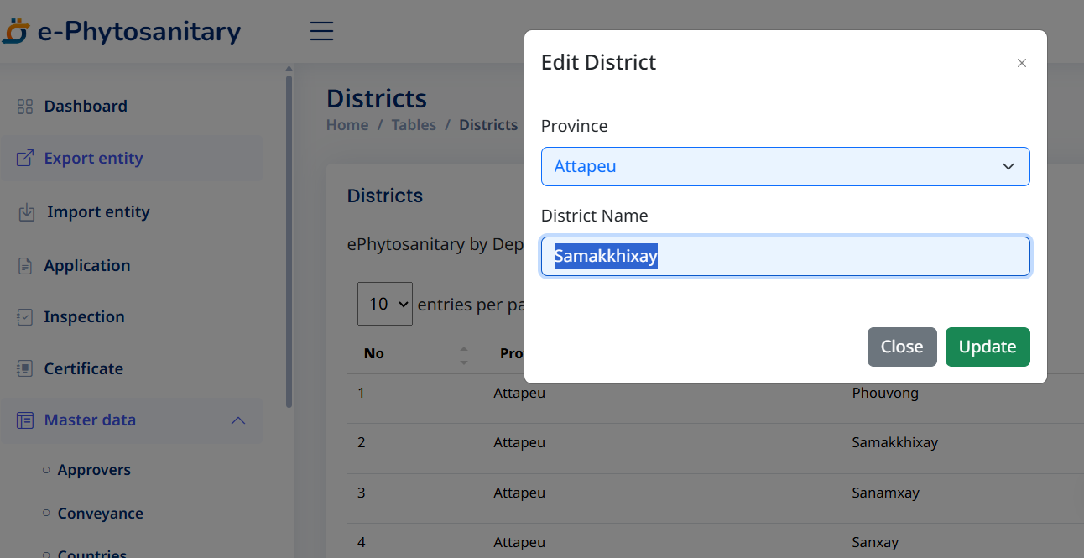
- Update Master data by creating UIs of District and Province

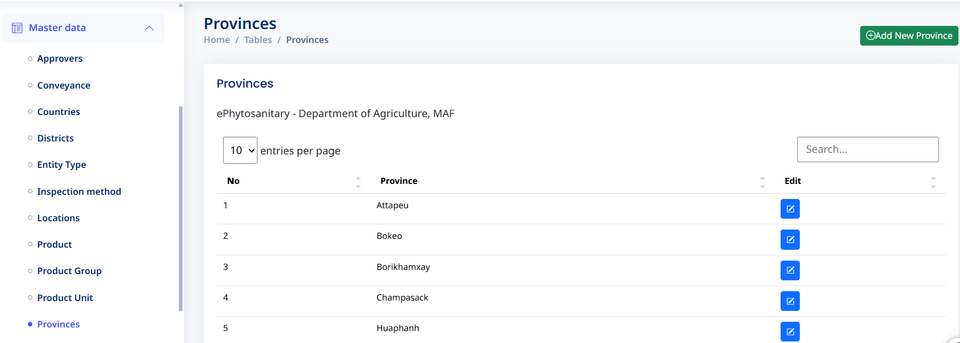

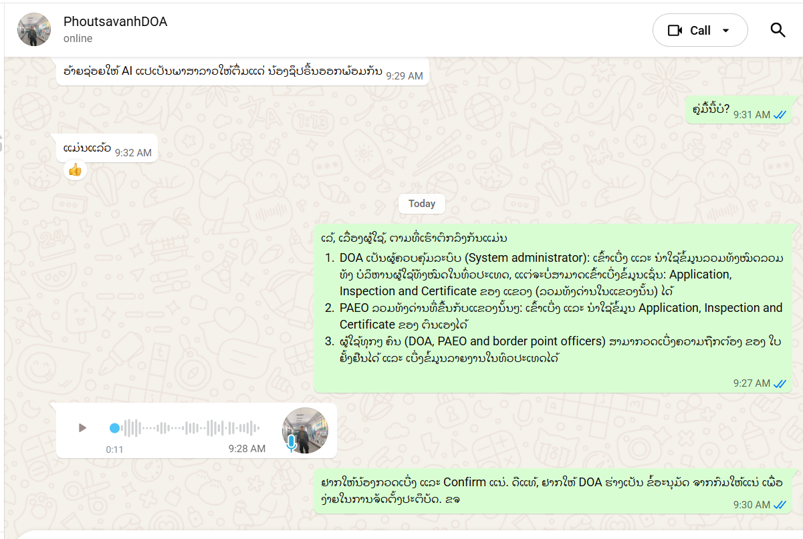
- Coordinate and discuss with DOA on the system users’ roles and permission to ask for clarification and certification

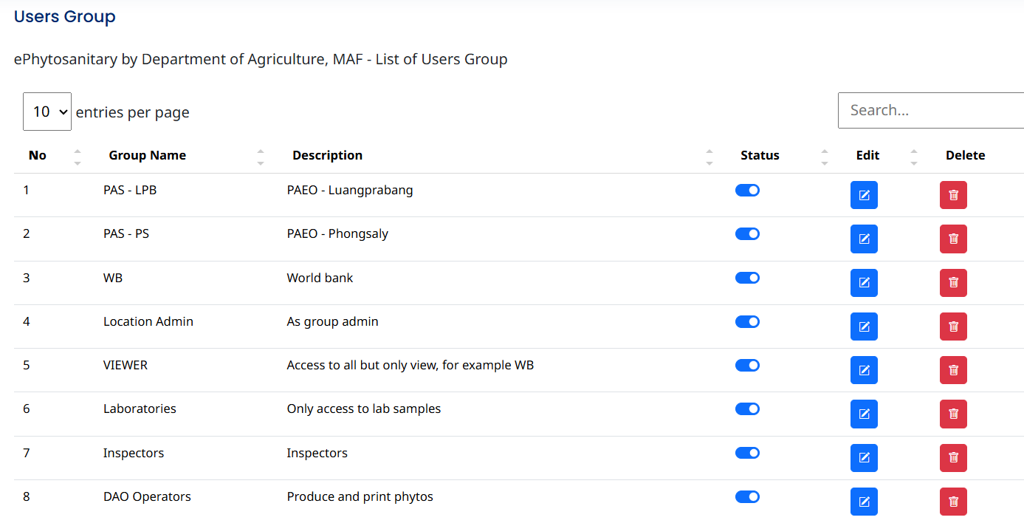
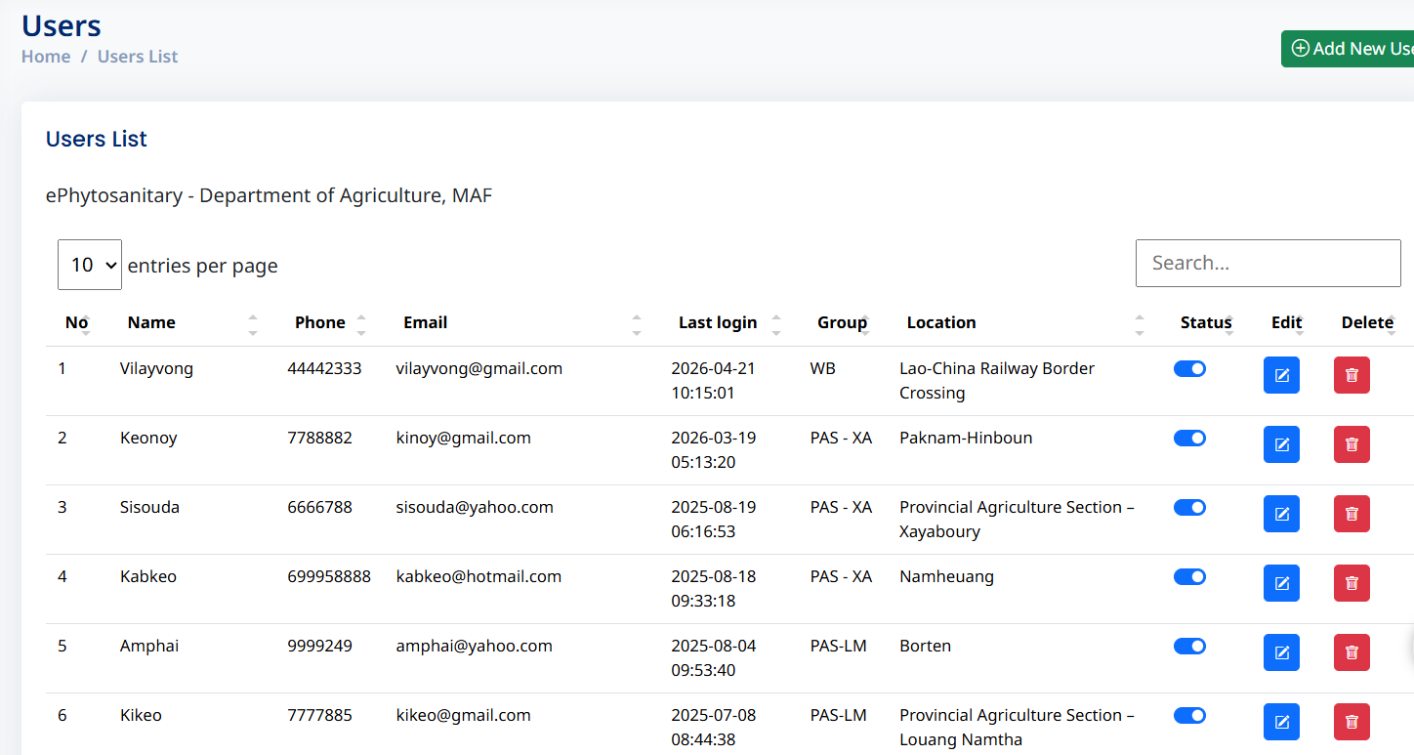
- Update IUs of Users and User group by applying toggle status to the UIs and setting mandatory fields in the forms

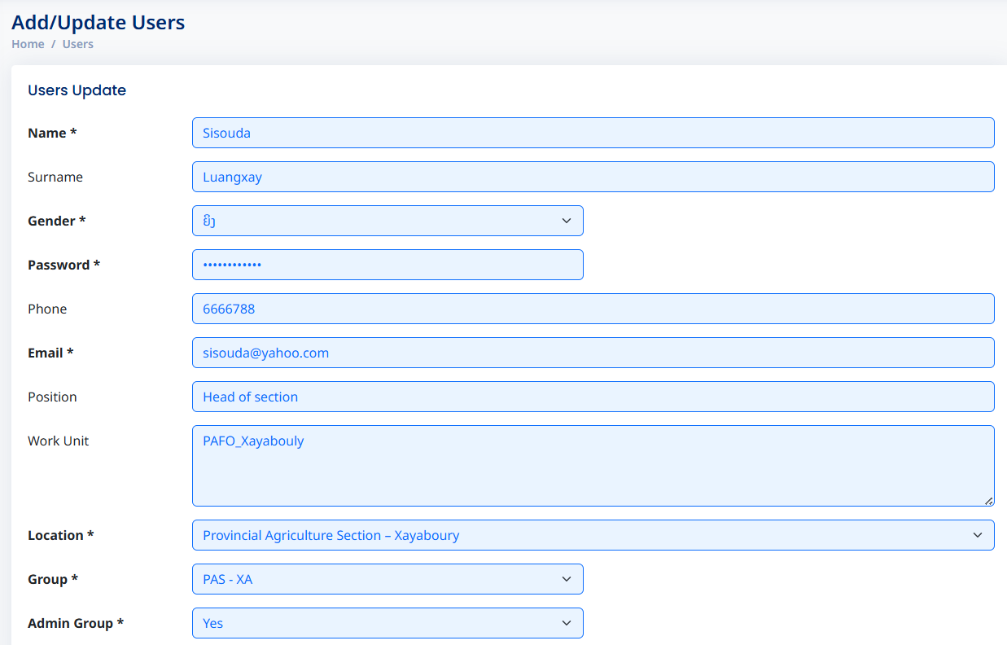
- Update main dashboard by removing the link text with appropriate icons
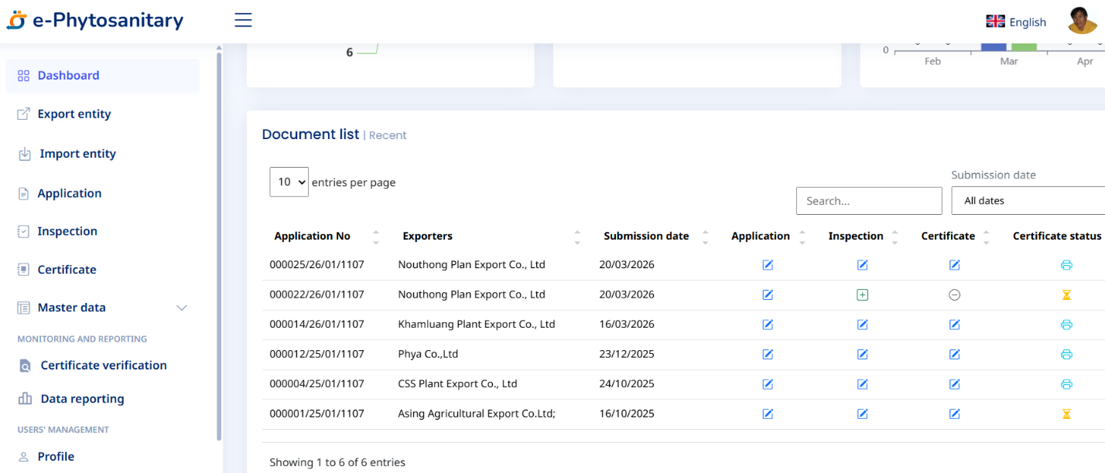

- Update system modules and data structure for connecting to group permission
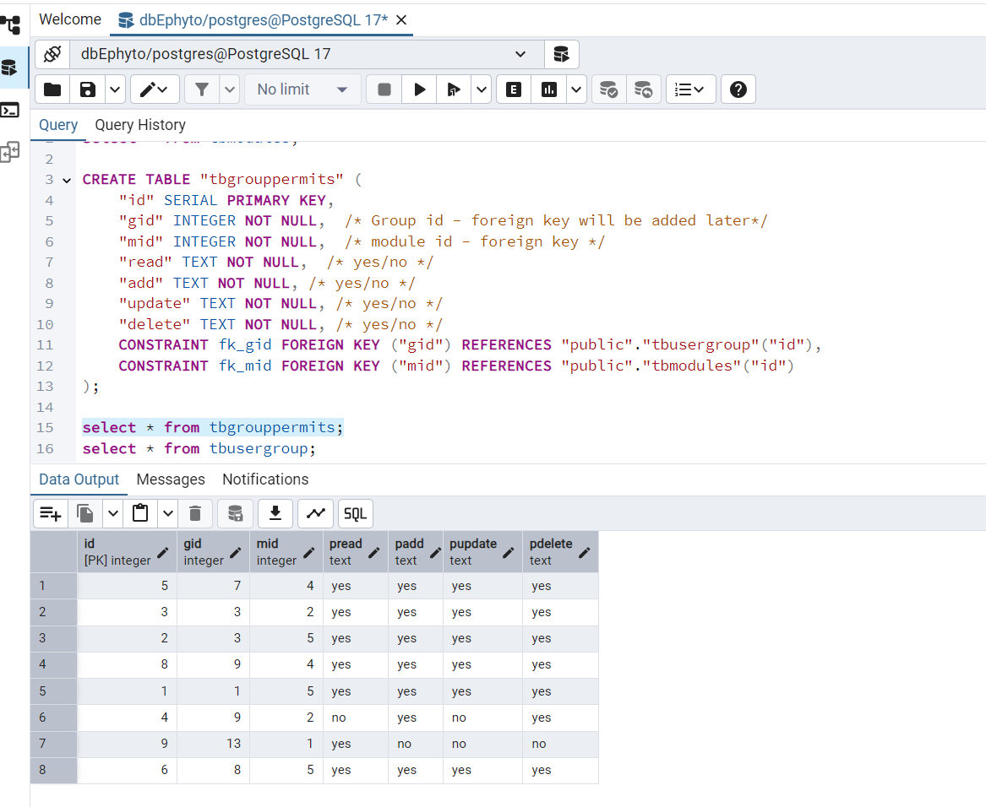
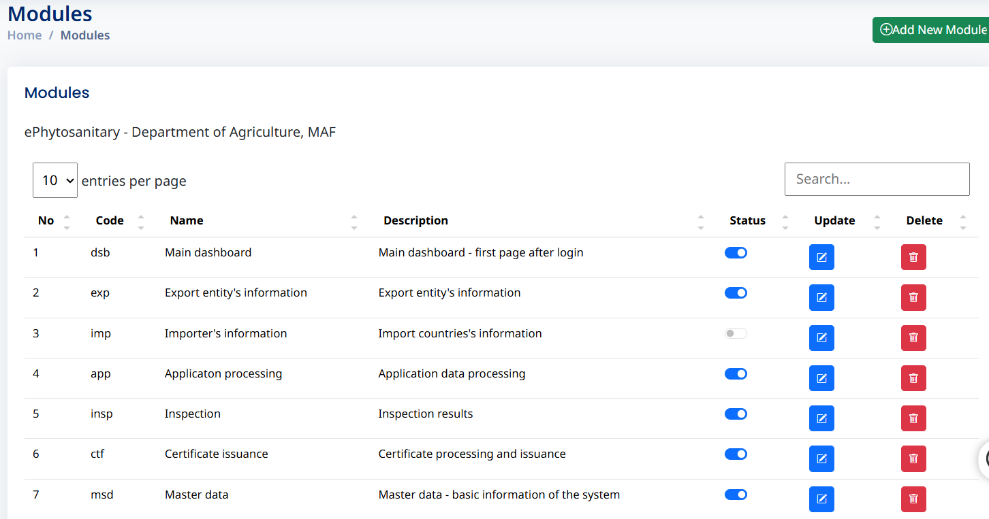

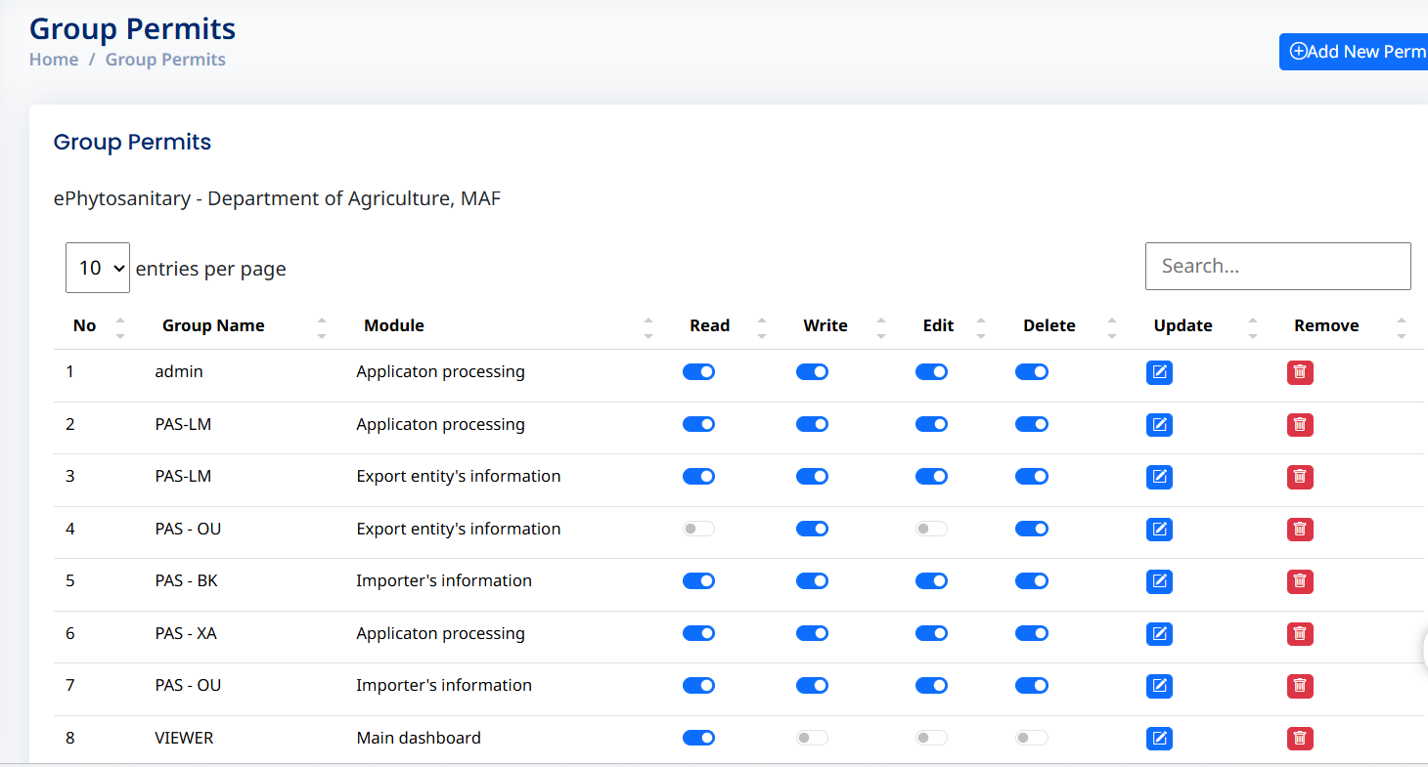
- Apply all the toggle status (RBAC) to group and module permission, and update the data structure of group permits
