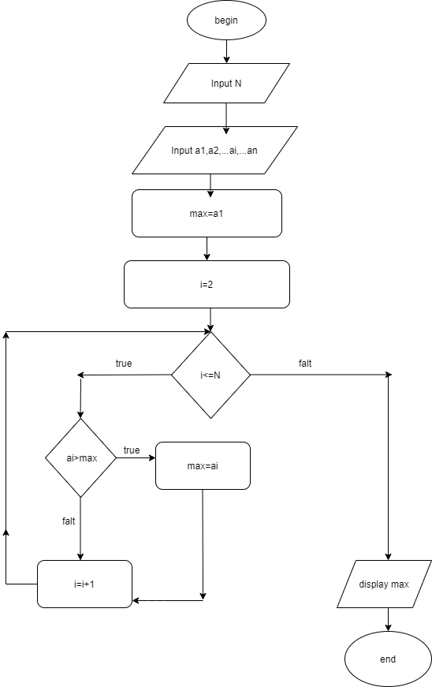Tim gia tri lon nhat trong day so

Begin

Input n

Input a1,a2….ai…an

max=a1

i=2

while i<=n

do

( if ai>max

Max=ai

end if)

i=i+1

end do

display max

End