pts Dict {point lbl: Coordinates(x, y) nodes Dict {point:(line lbl, +/-1)
'Origin': (0, 0), 'd': [[('D', 0, 21), ('E', 0, 10), ('F',0,0)], 1],
'a': (14, 7), 'b': [[('B', 1, 0), ('C', 0, 19), ('D', 1, 0)], 4],
'b': (6, 12), 'a': [[('A', 1, 21), ('B',1,0), ('E', 0, 9)], 2]}
'c': (10, 9), (-ve represents flow out of node and +ve
'd': (12, 8), represents flow into node) (only after the
'e': (13, 13), Node_Frm has been opened does data exist
'f': (13, 10)} in the self.nodes dictionary.)

runs Dict {Line Lbl:[[(start pt),(end pt)], new_pt]
'A': [('Origin', 'a'), 1],
'B': [('Origin', 'b'), 1],
'C': [('b', 'c'), 1],
'E': [('b', 'e'), 1],
'F': [('e', 'f'), 1],
'G': [('f', 'a'), 0],
'H': [('a', 'd'), 0]}

loops Dict {loop number:[[Cx, Cy, radius], [line labels around loop]]
1: [[10.75, 10.590909090909092, 1.1347147127533175], ['C', 'E', 'F', 'G', 'H', 'D']],
2: [[6.557377049180328, 6.234972677595629, 2.5742388746945712], ['A', 'B', 'C', 'D', 'H']]} in clockwise order

poly_pts Dict { Ln_Select [list of lines around loop
loop number:[points around the polygon] 'C', 'E', 'F', 'G', 'H', 'D'], resets after
1: [(6, 12), (13, 13), (13, 10), (14, 7), (10, 9), (12, 8)]} each loop is completed.
2: [(0, 0), (6, 12), (12, 8), (10, 9), (14, 7)]}in clockwise order
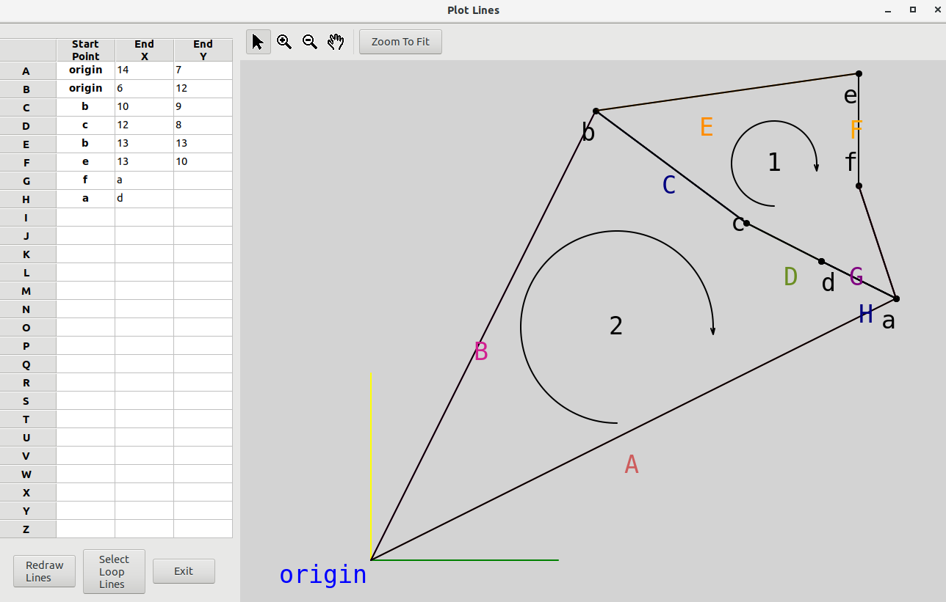
Points Used:

origin 14 7
origin 6 12
b 10 9
c 12 8
b 13 13
e 13 10
f a
a d

self.runs[‘A’][0] = [('Origin', 'a')]
self.runs[‘A’][0][0] = ('Origin', 'a')
self.runs[‘A’][0][0][0] = 'Origin'

