Pipe Specification Database Program

Philosophy
The intent of this program is to provide a tool that will generate and maintain an industrial quality piping specification document as well as track the need for updates and revisions. It is not an engineering tool that well specify the material or component ratings need for the fluid the specification is being applied to. That step requires input and reviews from the Materials/Inspection, Process and Piping engineering groups. However it is designed to help in eliminating error which may occur once the material is selected and the component ratings have been set.
The program has been developed in python 3 using SQLite as the database, other programs and modules, as is this program, are OpenSource and can be used by anyone for non-commercial applications.
Python 3 was selected for its easy of use, SQLite was selected because it limits the number of access points which allow modifications to the actual database. There is no appreciable limit to the number of connections allowed to view the data. It is the intent of this program that only a small group be allowed to change the data due to its sensitive nature and related safety issues. For this reason the program is actually developed in two parts. One part is for the field Users, it has no entry point into the database for any use other than viewing and printing. The second part is is used by the Administrator, this allows for viewing, printing and changes to the database.

Structure
The indexing of the piping specification is based on a Commodity Code and a Material Specification such as BFW-1AG2. The commodity code BFW standing for Boiler Feed Water, in actual fact it would point to a specific commodity property for BFW. The Material Specification 1AG2 breaks down into 4 items:

- The first digit is the class rating, representing 150#
1 150#
2 300#
3 600#
4 900#
5 1500#
6 2500#
7 3000#
8 6000#
- The second letter represents material type, in this case Carbon Steel, some possible alternates would be:
A Carbon steel
B Chrome Moly Steel
C Other "Low" Alloys
D 304 Stainless Steel
E 316 Stainless Steel
F Other 300 series Stainless Steels
G Duplex Stainless Steel
H Other Stainless Steels
- The third digit further narrows the material down to its material grade, in this case G represents A106-B/A53 Gr B, other grades maybe;
A A106-B
B A106-B, high temperature
C A333 Grade 6, low temperature
E A53 Gr B (seamless or ERW)
D Galvanized
F Unassigned Carbon steel
G A106-B/A53 Gr B

- The last digit tells the user the corrosion allowance, in this case 2 represents .08”
1 0.04”
2 0.08”
3 0.012”
4 0.16”
5 0.2”
6 0.24”
7 0”
The information in anyone of these tables can be modified as needed by the end user.
Since it is understood that most industrial users already have Piping Codes designated and may not want to or be able to use the BFW-1AG2 designation there is an override of this which can be specified by the end user; it is designated as the Pipe Code and can be anything up to 15 characters long. By default this Pipe Code will save as the ‘BFW-1AG2’ format. There is also some flexibility in the BFW-1AG2 format, the commodity code can be up to 6 characters long, the material code can be up to 5 characters long.
The database has been built on the bases of it being used for ASME B31.1 Power Piping Code and B31.3 Process Piping Code. With this in mind several of the support tables have already been populated with data, naturally this data can be deleted or modified as needed, some caution should be exercised if this is done. Say you changed the description for the ‘G’ designation in ‘1AG2’ what ever you changed the ‘A106-B/A53 Gr B’ to would be reflected in all references to this item across the database. To help give an idea of the extent this could affect, the database itself consists of over 115 tables each pulling data from one or several other tables.

Part 1 - The User Interface

Installation

Windows

Linux

Mac OS

Getting Started

The Forms
NOTE: The views of the various forms will vary slightly depending on the operating system you are using.

Start-Up Window
The first screen you see when starting the program is the form to open the appropriate database. The location of the database will depend on your IT group and the security they require. It can be stored on your personnel hard drive or on a secure server. So before you can go any further you need to have been given access tot he database. They all that is needed, click the “Open DataBase” button and navigate to the file using the pop-up file manager.
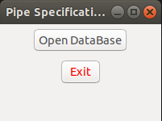Figure 1

Commodity Selection Window

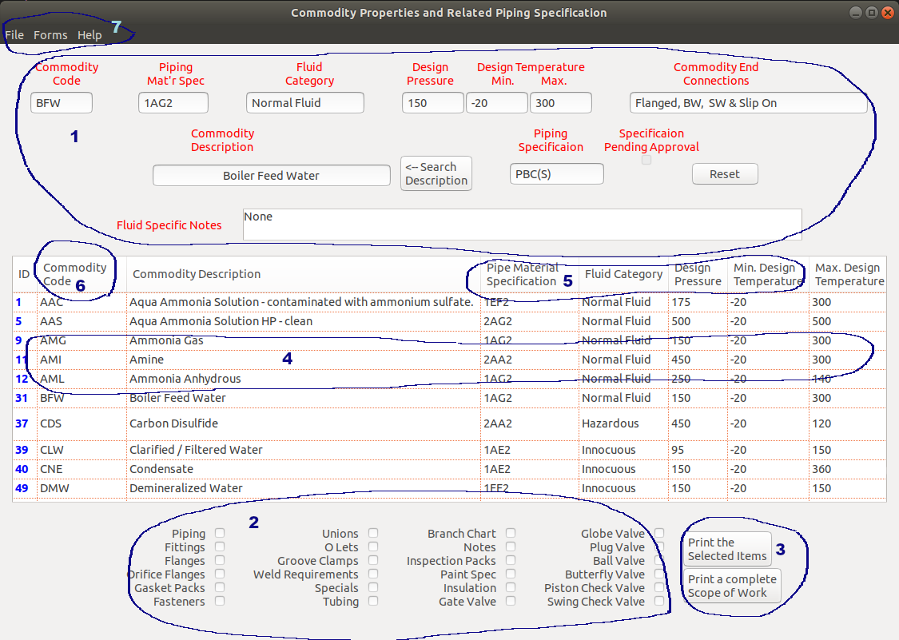Figure 2
The main user form is the next window to open. It has 5 main areas to look at;
- Section1 shows the data related to a selected commodity property. This area remains blank until an item is double clicked in the listing just below. The reset button will clear the boxes.
- Section 2 is a listing of all the various components making up a commodity property specification. Select the check boxes that you want to print the information for and then click the “Print the Selected Items” button to the right, section 3. The file manager will pop-up and you will be asked for a file name to store the pdf files under. All the forms will merged and printed as one file. See Appendix I for a sample print out.
- Section 3, apart from the button mentioned above there is a button labelled “Print a complete Scope of Work”. Clicking this item will print all the items shown in section 2, and will print it as a single pdf file using the name and directory you select in the pop-up file manager. You can see the sample print out for this Commodity Property in Appendix II. Note the commodity property of the print out reflects the Pipe Code specified as PBC(S) and not the default of
BFW-1AG2.
- More about the main table; you need to select a commodity property by double clicking in order to activate the two print buttons. You can drag various columns to rearrange the table as you like. Double clicking on the header for Commodity Code or Pipe Material Specification will allow you to sort the columns alphabetically (ascending or descending). Double clicking on any item in the table will revert it back to its original order. There is also a handy search option in Section 1. If you are not sure of the Commodity Code you can enter a part of the description in the “Commodity Description” and press the “<-- Search Description” button. It will then populate the table with all the Commodity Properties containing the phrase in the main table. The button label will change to “Restore Table” enabling you to get back to the original information.
- The form menu has three drop down sub-menus; File, Forms, Help.
- The Forms menu has a drop down of 7 separate items, as shown.
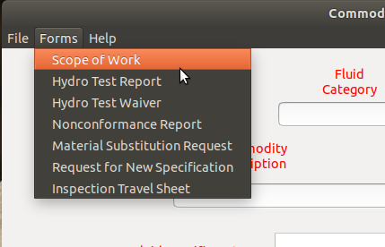Figure 3
The “Forms” menu item calls up the various .html forms available for completion and filing or submission. The forms will appear in your default browser ready for completion. Once a form is completed, it should be saved as under a different file name as an .html file format. It can then be saved as a .pdf file and merged with other .pdf files to complete the Scope Of Work package, more on this in the discussion of the File menu. The intent of the .html format is that it can easily be passed along to other reviewers and approvals. Once everything has been completed it can be converted to a .pdf file. Some .html forms can also be imported into the pipe specification database by the administrator. Samples of these forms can be found in Appendix II.
- The “Scope of Work” form is used as part of the completed piping package provided to the fabricator, and outlines such things as supplied documents, contacts, project information etc.
- The “Hydro Test Report” is partial completed form to issued to the fabricator before completion of the piping fabrication and will be completed and submitted once fabrication is tested and accepted.
- The “Hydro Test Waiver” should be filled out by the project lead and submitted to the QC manager or delegate for comment and sign off. The document can then be converted to .pdf format and included in the piping package.
- The “Non-conformance Report”, the “Material Substitution Request & “Request for New Specification” are all special reports that as .html forms can be imported into the database for future reference and historical review, by the administrator. All of these reports require multiple reviews and sign offs, all this should be done in the .html file format if possible. If it not possible at any stage these .htmls can be converted to .pdf format. The is done by using the “Convert HTML to PDF” option in the “File” menu drop down. Note once it is converted to .pdf format it cannot be converted back to .html.
- Selecting the “Inspection Travel Sheet” calls up a new program window which lists possible inspection hold points. Individual or multiple items can be selected and then added to a list which will be added to a an Inspection Travel Sheet in .pdf file form.
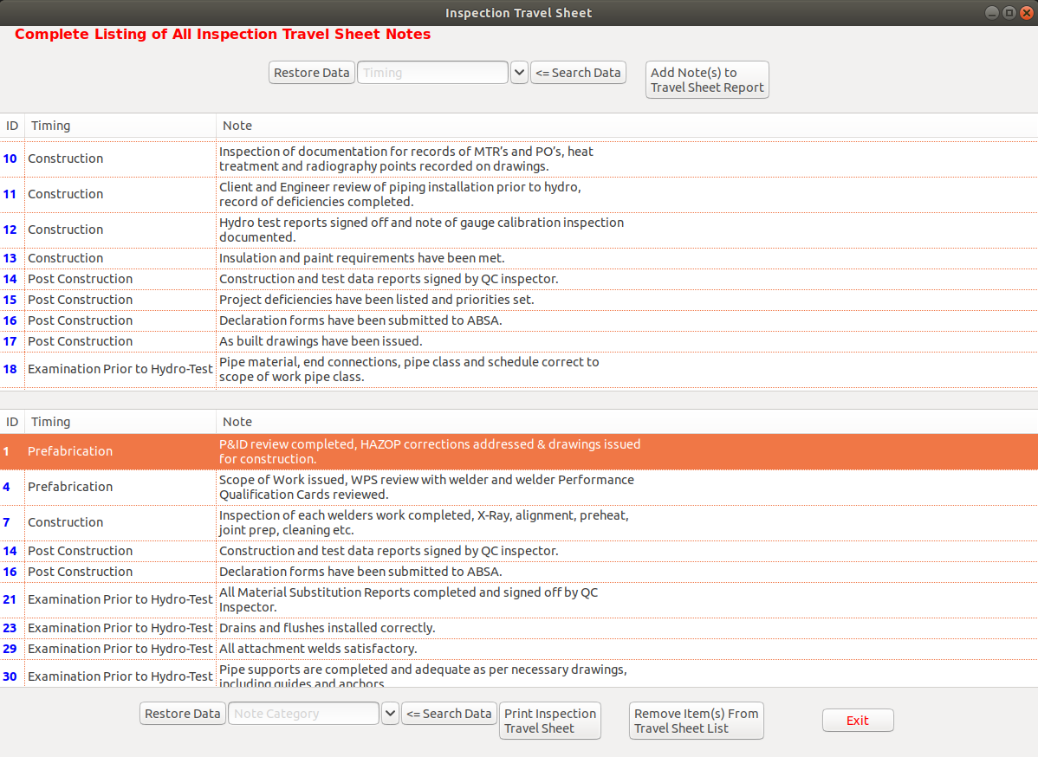Figure 4

The Inspection Travel Sheet is actually designed to convey inspection hold points for the piping fabrication. Typically it is completed by the QC department and fabricator inspectors if applicable. A sample can be seen in Appendix II 'Inspection Travel Sheet'. When the above window opens the lower table is empty. It is populated by selecting items from the upper table and clicking the “Add Note(s) to Travel Sheet Report”. Each row of data includes a ‘Timing’ item which represents when the inspection point should be completed during fabrication. The ‘Note’ column is the description of what is needed. Additional notes and timing points can only be added by the program administrator. You can remove notes from the lower table by high lighting the item(s) and clicking the “Remove Item(s) From Travel Sheet List”. You can search the table data using the timing field in the drop-down list boxes and clicking the “<== Search Data” button. The “Print Inspection Travel Sheet” button will print a .pdf file of the selected items.
- The first menu item; “File”, opens 5 selections to handle various documents generated by this program.
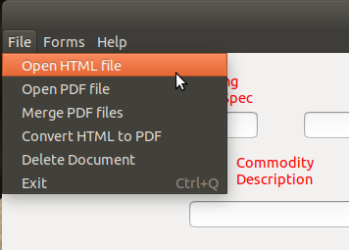Figure 5
- The seven HTML forms, previously mentioned, can be opened using the “Open HTML file” selection. They can then be reviewed and modified or converted using your default webbrowser,
- Once the .htlm form is completed it can be converted to a .pdf file by selecting the “Convert HTML to PDF” option.
- Of course once they are saved as .pdf files they can be opened using the “Open PDF file” option or by using your default PDF viewer.
- The “Merge PDF file” will merge any PDF file, even those not generated with this program. It can be used to build onto the Scope Of Work package.
- The “Delete Document” will open your file manager so a file(s) can be selected and deleted. Note this will delete any file selected not just .pdf and .html files.
- The “Exit” item is pretty self explanatory, it closes this form and returns you to the initial start-up form where the database was selected.

- The “Help” menu item is typical for most programs and contains 3 options.
- The second option “Use of Form” gives a very brief description of the form itself and some guidance on its usage.
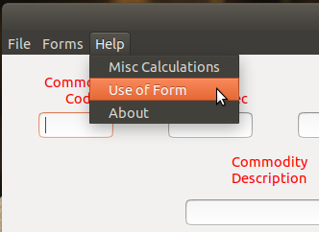Figure 6
- The “About” bring up a simple window explaining minor details of the software.
- Up to the first item which provides access to a new window which allows the user to do some basic calculations. The window is shown below.
The calculation window is used to provide the user with a tool to check wall thickness for both plain end and threaded pipe. It also provides the ability to calculate the hydro test pressure. The Allowed Stress will need to be sourced from applicable code sources such as ASME Section II.
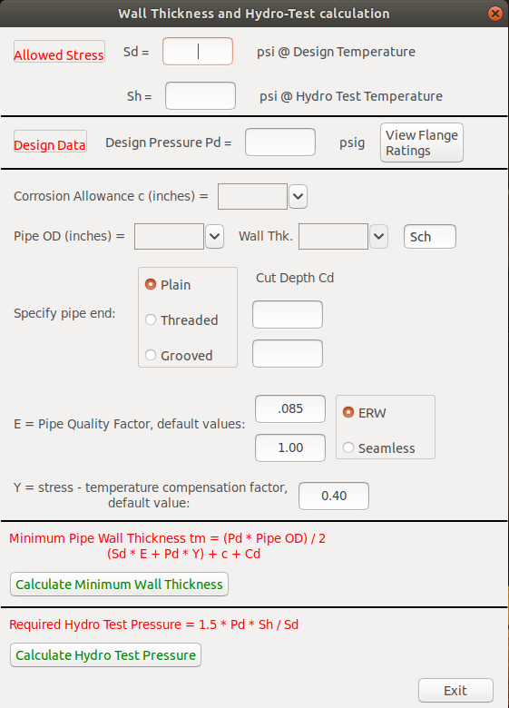Figure 7
Allowable Stress
For B31.3 = tensile strength at temp/3
For B31.1 = tensile strength at temp/3.5

The Design Pressure can be based on the Commodity Property value or more preferred if this value is less than the flange rating then the flange rating maybe applied. There is a button “View Flange Ratings” that will show the different values based on the material type and grade (see the next form description). Both the Allowed Stresses and Design Pressure are needed for either the Hydro Test and Wall Thickness Calculations.
The center section is need only for the Wall Thickness Calculation. The corrosion allowance should be based on the value indicated in the pipe material code specified for the commodity property. Pipe OD and Wall Thk. Are selected from drop down lists, the pipe schedule is specified based on this information. Cut Depth is also specified based on Pipe OD and Wall Thk. And the type on end connection. The Quality factor can be sourced from B31.1 or B31.3, typical values are;
E=.6 for furnace butt weld joint, continuous weld joint and straight seams
E=.85 for electrical resistance weld joint, straight or spiral seams
E=1 for 100% X-ray of double butt weld joint, straight or spiral seams

The Y value referred to as the Thickness or Temperature Compensation Coefficient can be calculated based on wall thickness > Pipe OD / 6:
Y = (d+2*c) / (D + d + 2*c) where c = mechanical allowance (cut depth + corrosion allowance)
d = pipe inside diameter
D = pipe outside diameter
for t < D / 6 :

MATERIAL | Temperature
MATERIAL | <900 | 950 | 1000 | 1050 | 1100 | >1150
Ferritic Steels | 0.4 | 0.5 | 0.7 | 0.7 | 0.7 | 0.7
Autenitic Steel | 0.4 | 0.4 | 0.4 | 0.4 | 0.5 | 0.7
Other Ductile Material | 0.4 | 0.4 | 0.4 | 0.4 | 0.4
Cast Iron | 0.0

Once the data has been entered click either of the Calculate buttons to see the answer.

The flange Pressure Temperature Rating curve can be accessed from the calculation form as previously indicated. The only input needed is to specify the Pipe Material Code, which should be that specified for the Commodity Property. If the user wishes to know corresponding maximum pressure (or temp.) corresponding to a temperature (of press.) simple enter it in the corresponding box at the bottom of the form and press Enter.
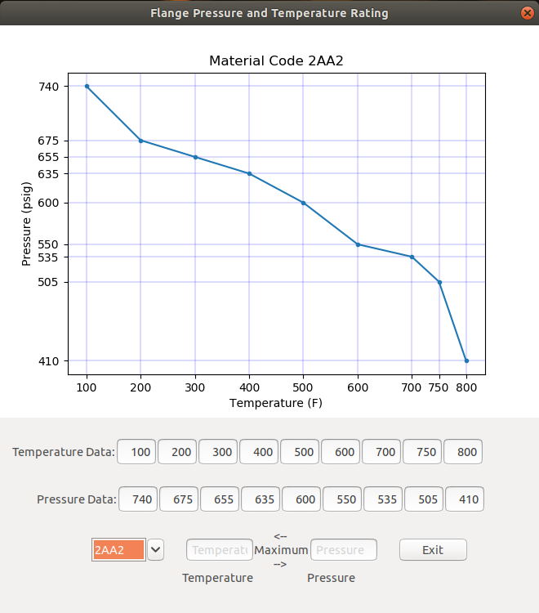
Figure 8

Part 2 - The Administrator Interface

Installation

Windows

Linux

Mac OS

Getting Started

The Forms
NOTE: The views of the various forms will vary slightly depending on the operating system you are using.

Start-Up Window
The initial start-up screen for the Administrator is show to the left. It allows for the selection of the database, using the standard file manager. Once the database is selected the administrator clicks the “Sign Into Database” bring up the user sign in and password form. You will notice that as the buttons are selected and steps completed the button color changes from green to yellow and the next step turns green. Red selection areas are not available.
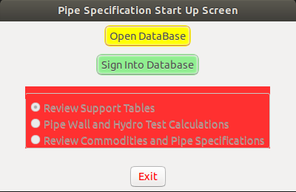Figure 9

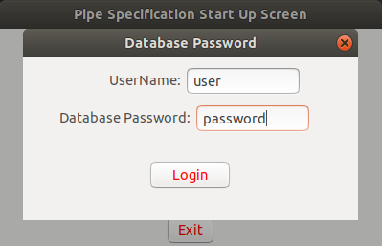Figure 10

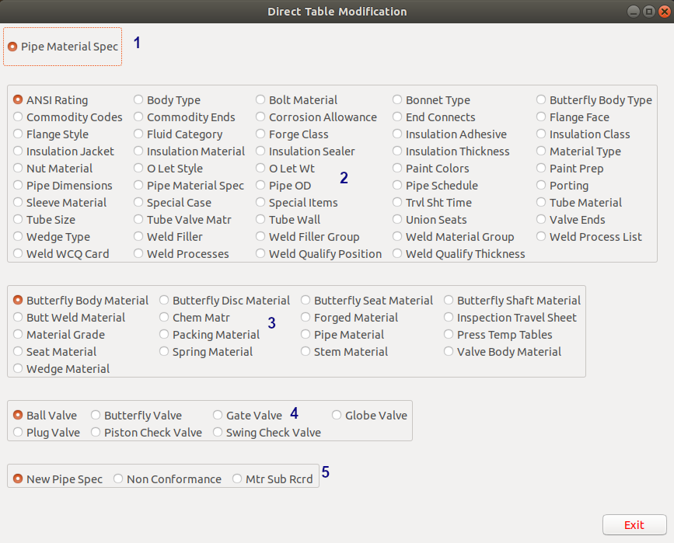Figure 11

The first available option to select after the access to the database is granted is the “Review Support Tables”. This tables provides access to 77 of the database tables directly. The first table selection (#1) is the “Pipe Material Spec”. This is where the pipe material codes can be built based on the data in the 6 drop down lists.
You can select a material code directly to see what it represents, or build a specification code and see if it already exists, the instructions on the form will show how. You can even delete a specification code provided it is not associated with any other tables, the program will warn you if it is. Once you have built the specification and searched to confirm it does not already exists, the “Build Specification” button will be enabled.
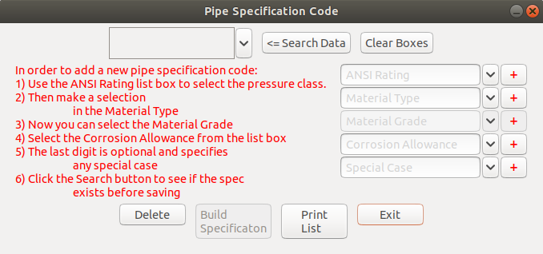Figure 12
The buttons with the red + show up on several of the forms to come they are used to drill down into the tables associated with the drop down list next to them. A representative form will appear enabling you to add/modify or delete items to the table. The changes will then be made in the corresponding drop down list.
Section 2 is the largest, however the forms called are all the same structure only the data shown will be different. They are the base level forms / tables and for the most part contain the information that is used to build the specification and drop down lists. This means a lot of them are also accessible by using the red + buttons next to the drop down lists.

This a typical form, the upper table which is scroll-able vertically and horizontal as needed. Items can be added to or modified in the table as per the note in red. Rows can also be deleted, but; only if they are not associated with another record. The program will notify you with a pop-up message if that is the case. It should be noted that modifications to any record will be represented in all occurrences of that information, so if it is a unique change it is best to save it as a new record.
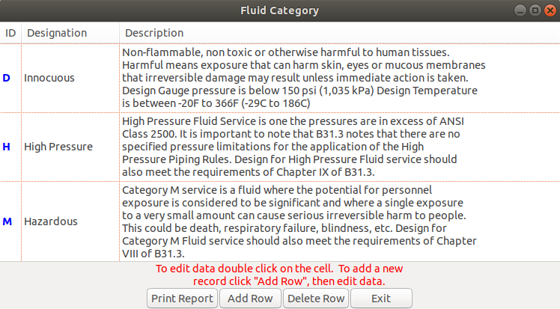Figure 13
The “Print Report” button will print all the data in the table. Later you will see how to print specific sections.
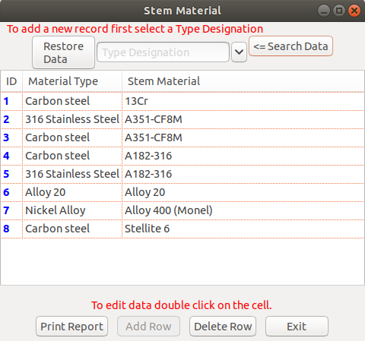Figure 14
Section 3 is not a lot different from section 2 other than it usually draws on information from the section one tables. Again the forms are the same with only the data being different.
Adding data to the table is slightly different, first you need to narrow down the information by selecting, in this case a ‘Material Type’ from the drop down list, then click “Search Data”. The information in the table will now show only materials related to this type. Adding and deleting will now be the same as for Section 2 forms, as well printing.

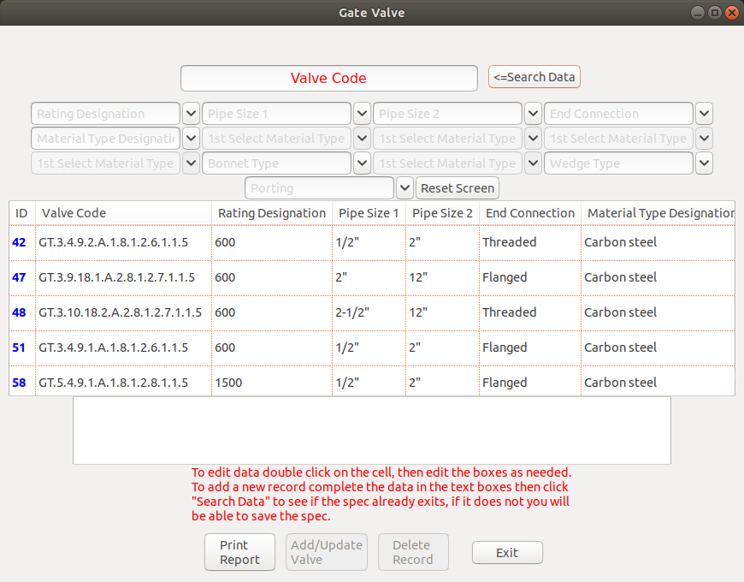Figure 15
Section 4 forms are for the database valves, the forms vary slightly to represent the variation in the material and information used to define each valve type. The general use and navigation is the same however.

Upon opening one of the valve forms you will see a table with all the specified valves in the database. Editing can be done only using the array of text boxes at the top of the form. Scroll through the table of valves and double click on the record of interest. This will place the data in the upper text boxes. When you complete editing the information you click the “<== Search Data” button this will check to see if a valve with the same valve code already exists. If it does not, the “Add/Update Valve” button will be enabled, once you click this button you will be presented with two options, as below. Pretty straight forward select the choice you want and click the “OK” and the changes will be shown in the main forms table.
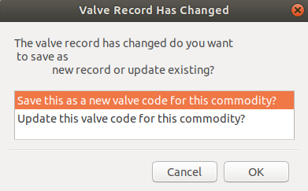Figure 16

Now to make a new valve from scratch, click the “Reset Screen” to clear the text boxes. Now you can start selecting the components from the drop down lists. You will note that some drop down lists are not available until previous boxes are selected. In the form shown several of the material selection boxes require that the material type first be selected. If you are building a carbon steel valve it will limit materials of construction to a typical carbon valve. If there is a material missing in one of the component drop down lists you will need to go to the support forms and add the record to the table needed. When you complete editing the information you click the “<== Search Data” button this will check to see if a valve with the same valve code already exists. If it does not, the “Add/Update Valve” button will be enabled and you will be able to save the valve data.
You can click “Delete Record” to remove a selected valve, provided it is not associated with any other tables, the program will warn you if it is.
The “Print Report” button will print all the data in the table. Later you will see how to print specific sections.

The last section on the Support Form, section 5, calls up the forms showing the data saved from the three .html documents. The .html documents are the Non-conformance, Material Substitution Record and Request for New Pipe Specification. These html documents where discussed in a previous section. Again the forms are similar enough that covering one should be sufficient.
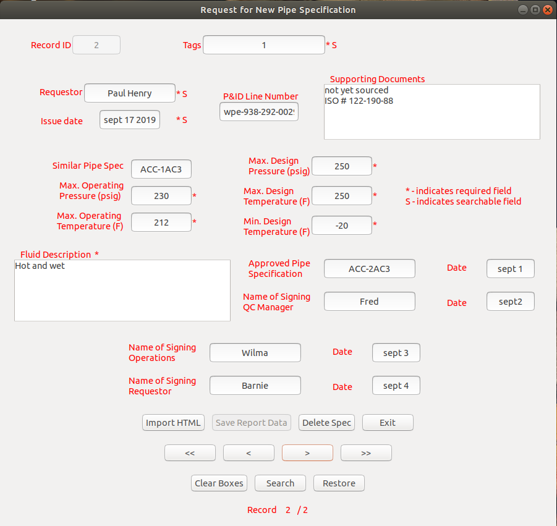Figure 17
The forms have 5 basic areas. The first area is the upper section containing all the text boxes holding the database information. You will note that beside some text boxes there are *’s and S’s. Any box with a * means information is required, the S means the box can be used to search the database. To search input the string you are looking for into the box and click “Search”, one or more of the boxes can be used in the search.
The next section of the form is the first row of buttons. If any data in the text boxes is changed the “Save Report Data” is enabled, you will be prompted to save the changed form as a new record or update the existing record, typically you will be updating a record. The “Import HTML” button enables importing of an existing .html form into the database, you will only be able to import a Non-conformance .html document into the Non-conformance data form, as with the Request for new pipe Spec and Material Substitution .html documents. When the import button is clicked the file manger screen will open and you can navigate to the .html document to be imported. Once the document is selected it will automatically show up in the data form, you will be able to modify the data at this point and add such things as tags for searching. Once done click the “Save Report Data” and the information will stored in the database. Old or duplicate records can be deleted with the “Delete Spec” button. The next row of buttons are used to navigate the data and work in conjunction with the line indicating the number of records available and your position, Record 2/2. They are (left to right), move first, move back, move next and move last.
The bottom row of buttons modify the screen information; “Clear Boxes” removes all the data from the screen, “Restore” brings back the original data, “Search” was previously mention.

Back to the Start Up form figure 9 and the second selection option “Pipe Wall and Hydro Test Calculations”, this information has already been covered in a previous section.
The last selection option on the Start Up form is “Review Commodity and Pipe Specifications”, this pulls up the following form;
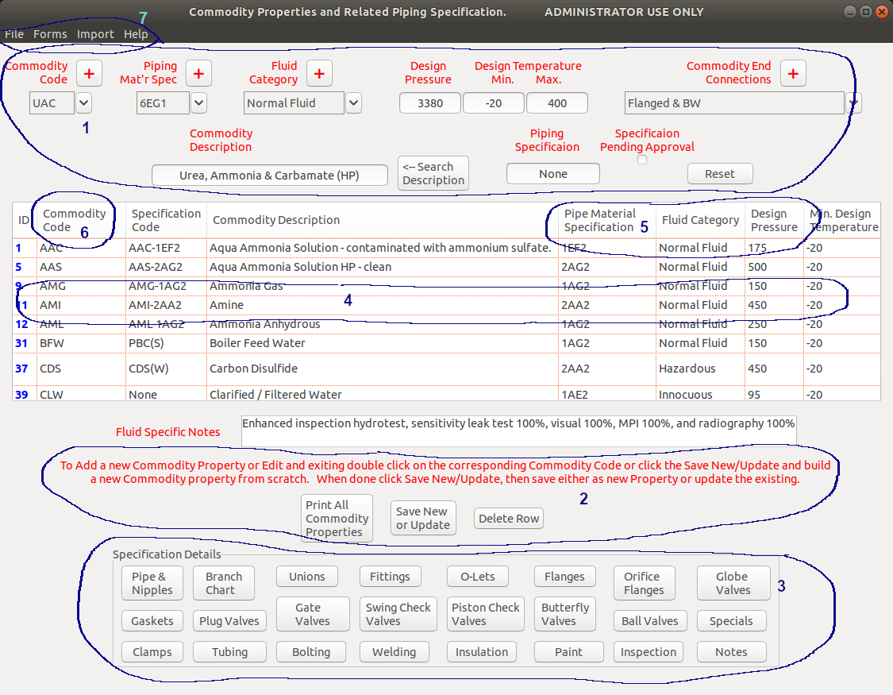Figure 18

This form is very similar to the User form previously covered. The sections noted as 4, 5,and 6 are the same. Section 1 appears the same but the text boxes and drop down lists are editable, they also have the familiar red + buttons next to the drop down lists, to drill down to the related tables.

Jumping up to the Menu item 7 it is also duplicated with the additional item “Import”. The “File” item, “Forms” item and “Help” item have all been covered earlier. The “Import” item has also be covered previously, it will call up the same .html documents so that their information can be imported into the database as discussed in figure 11 section 5.
The lower two sections of the form are new;
Section 2 is used to print, modify/add or delete from the table data. Using the “Print All Commodity Properties” will do just that and print the records seen in the table. If a record is selected in the table and the “Delete Row” is clicked the selected commodity property will disappear from the list. The “Save New or Update” button has dual purpose. If you double click a commodity property in the table so that its data populates the text boxes you will be able to modify the data. Once the data changes are completed and you click the “Save New or Update” button you will be presented with a screen showing two option; Save as new Commodity Property or Update the existing Commodity Property. Make your selection and click OK and the changes will be reflected in the lower table and database. This is a simple was to create a new commodity property based on an existing property. To add a new commodity property from scratch first make sure the text boxes are cleared by pressing the “Reset” button, then click on the “Save New or Update” button, this will prepare the system for new changes. The text boxes and drop down lists will now be enabled and the information input. Once done click the “Save New or Update” button once again the changes will be reflected in the table and database.
Section 3 brings up the individual forms for each of the components indicated on the buttons, these buttons are only enabled after a commodity property has been double clicked. The item selected commodity property form it will show in the selected component form, if an item has been linked to the commodity property. If there is no component linked to the commodity property a note will appear at the top of the component form when it opens. It should be made clear that all changes made in the component form called up from the Commodity Property will be saved against the selected Commodity Property. You will be given an option to save the record as a new record or an update to any modified record, but they will be saved against the commodity property. If your intent is to modify a record with out saving it to the commodity property there are two choices, modify it as shown in the following description then select to “Delete From Commodity” this will save the record but remove the link tot he commodity property. The other option is to go back to the Support Form and modify the data from that screen.
When you access a form with a commodity selected it shows the associated records. If there are no records a message across the top of the component form will stating “The Item(s) have not been setup for this Commodity Property'. Clicking the “Print Report” will print just the related record.
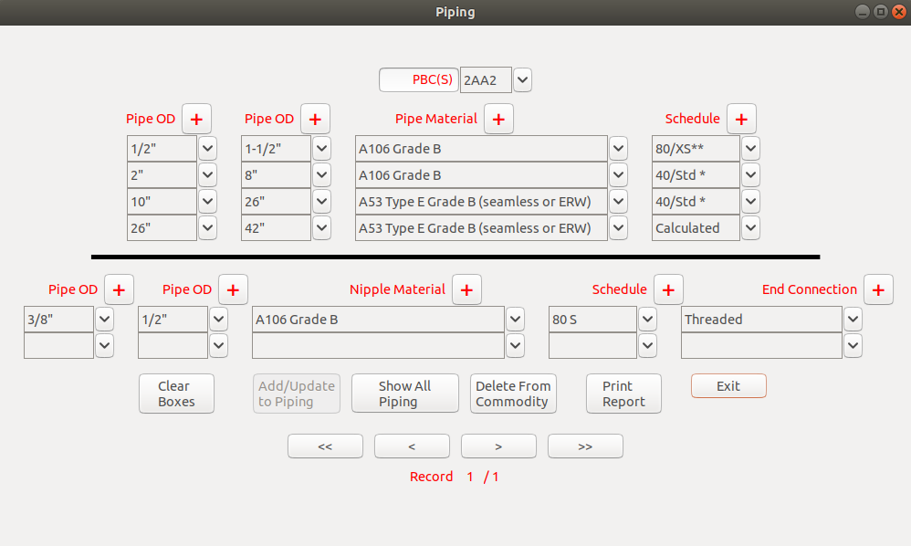Figure 19
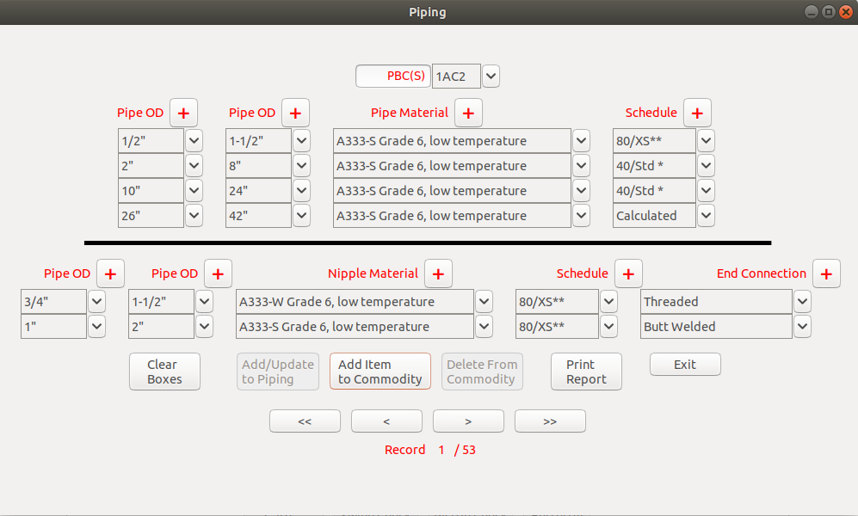Figure 20
Clicking the “Show All Piping” will not effect the record associated with the commodity property however; you will now be able to review all the Piping configuration records. You will also note the “Show All Piping” button will change to “Add Item to Commodity” and the “Delete From Commodity” button will be disabled. You can use the navigate button to move through the records in this case there are 52. If you wish you can save an existing record to the commodity property replacing the original or you can elect to modify an existing record and save it to the commodity property. The “Add / Update to Piping” will be enabled as soon as one of the text boxes is modified. The save process will give you two options 1) save a new piping record and add to commodity property or 2) revise existing piping record then add to commodity property. If you want to create an new record from a clean slate click the “Clear Boxes” and the visible data will be removed, as soon as you state the new record the “Add / Update to Piping” button will be enabled. If you do not wish to change the original piping configuration associated with the commodity property click the “Exit” button.
Again you’ll also notice the familiar red + buttons next to the drop down lists, used to drill down to the related tables.
The above Piping & Nipple form is the same as the forms for (minor variations maybe seen but the operation will be the same):
- Tubing
- Fasteners
- Insulation
- Fittings
- O-Lets
- Flanges
- Unions
- Orifice Flanges
- Groove Clamps
- Gaskets
- Painting
- Inspection

There are a total of 7 different valves defined in this specification. They all use the same basic form again with minor variations, but the operation does remain the same. The upper section of text boxes shows the data of any valve which is double clicked on in the lower table. This upper area is where the valves can modified or new ones specified. The screen at the left shows the valves related to a specific commodity property. If there is a valve which needs to be removed from the commodity simple select it in the table and click the “Remove Record” this does not delete the valve from the database it simple removes the link to the commodity property. The “Reset Screen” button just below the text boxes will remove any information in the text boxes. The intent is so a new valve can be specified, if you wish to modify an existing valve double click on it and make the changes. The “Add / Update Valve” button will not be enabled until a search is done for the new valve code, this is the red text string in the upper text box. If the valve does not exist you will then be able to save it otherwise the button will indicate it is an existing valve. A modified valve can be saved as a new valve or an update to the existing, either way the valve will be linked to the commodity code.
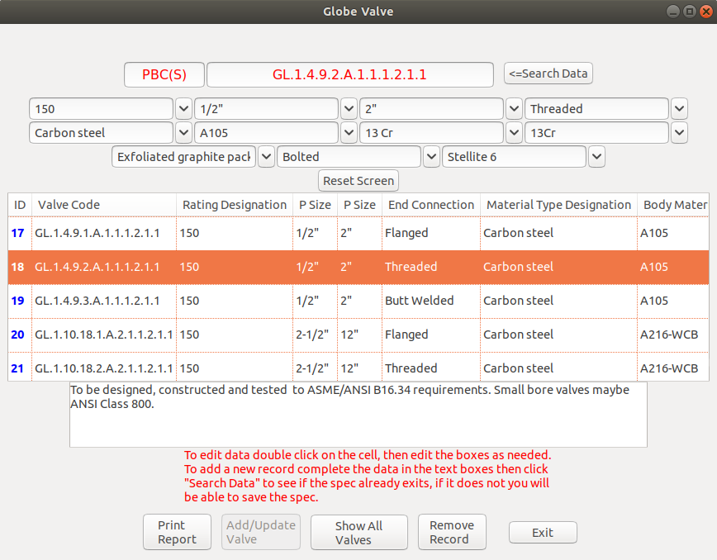Figure 21
As before the “Show All Valves” button will change the form to show all the valves of the specified style in this case globe valves. The “Show All Valves” button will now say “Add Valve to Commodity” but will be disabled until a valve is selected in the table. Again if the selected valve is modified you will have a choice, after searching to confirm it does not already exist, to save it as a new valve to the commodity code or update the selected valve and save it to the commodity code.
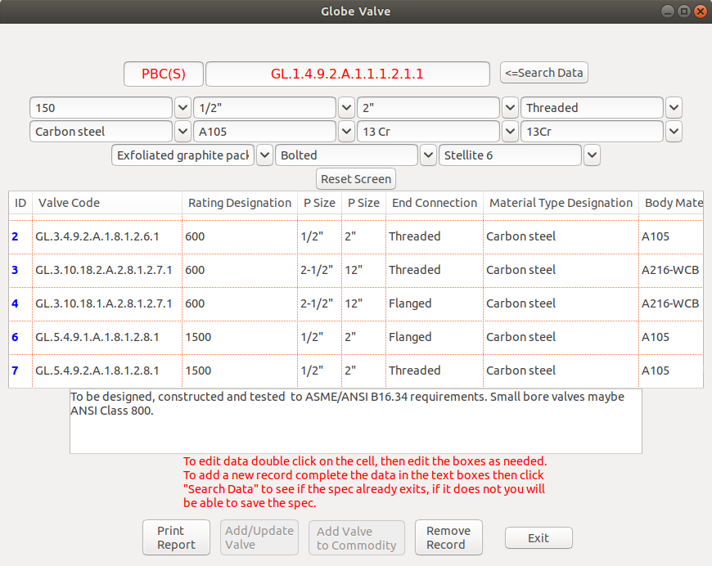Figure 22
NOTE: if you select to update the modified valve description and save it to the commodity code, you will be changing the valve description for all references to that valve. If you are not sure you want this to occur it is best to select save as a new valve to the commodity property.

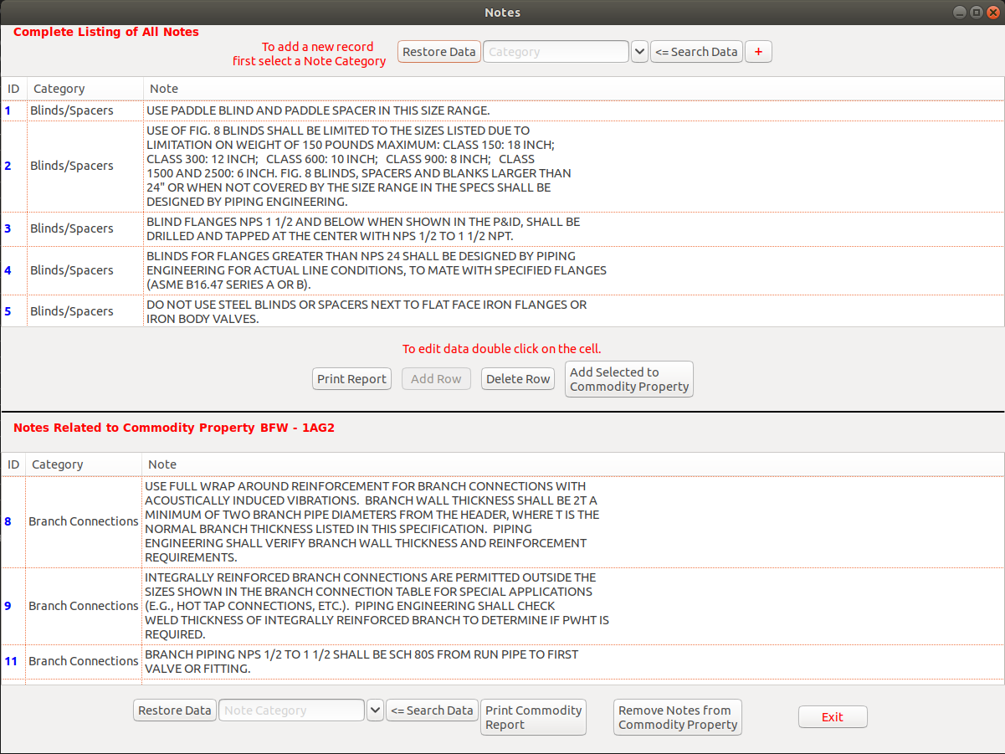Figure 23

The form which shows the notes related to a commodity code and the form which shows special items, such as strainers, expansion joints etc as show on the same form structure. The above form shows the Notes which can be related to a specific commodity property. The top table shows all the available notes they are separated into categories for easier searching. The actual Note Categories can be edited by using the “Support Form” and selecting “Note Category” or by selecting the red + button and using the Category pop-up form. Adding a new Note can be done once the Category has been selected in the drop down list, this will enable the “Add Row” button. Clicking it will generate a new row of data with the Category already specified, the new row will be located the bottom of the table, double click on the Note column and enter the new note. The data will be saved when the cell losses focus.
The other aspects of the form have been covered previously.
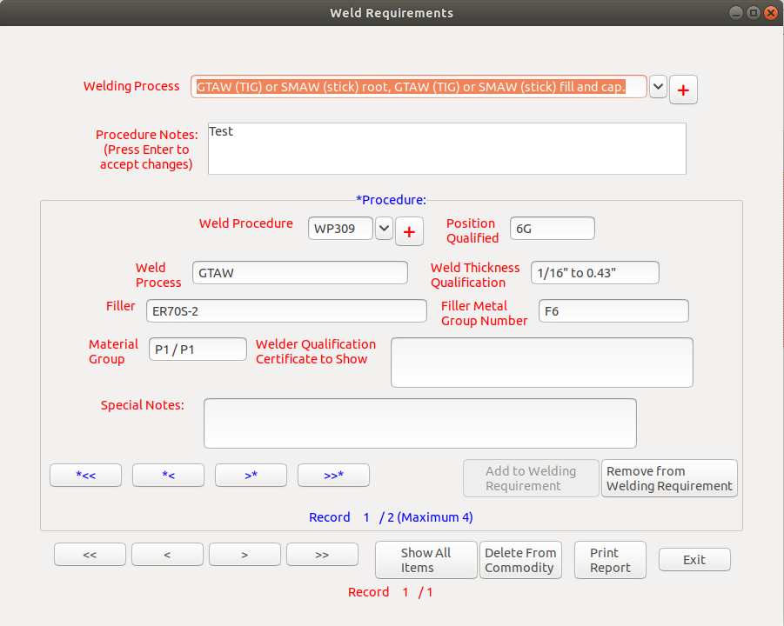Figure 24
The Welding Requirements form is actual two forms combined. The top section and buttons along the bottom are for the actual Weld Process. The center panel shows the procedures that go into defining the specific welding process. The administrator can add or edit the Welding Processes using the red + buttons next to the drop down list, or by selecting “Welding Processes” on the “Support Forms” .
If you change to Welding Process shown in the drop down list you will be given the option to save the change as a new Weld Requirement for the commodity property of to update the existing one for the commodity property..
The Procedure section can specify up to 4 different procedures such as root, fill, cap, butter etc. Each procedure can be added to or deleted from the welding requirements from within this form. To do so will however be reflected in all commodity property using this Welding Requirement, it is best to reselect the Welding Process and save a new Welding Requirement for the commodity property. The 3 lower buttons behave as in previous forms;
- “Print Report” will print all the welding requirements if the “Select All Items” has been clicked or just the commodity related Welding Requirement if a commodity property has been specified.
- “Delete From Commodity” will remove the link between the Welding Requirement and the commodity property, it will not delete the Welding Requirement from the database.
- “Show All Items” will show all welding requirements, this allows for assignment of a different welding requirement to the commodity property. The button label will change as noted in the form below to allow for this reassignment.
NOTE: this is form does not present a complete Welding Process Specification (WPS), a fully detailed specification should be provided by the fabricator and approved by the owner. This is intended to convey the owners requirements for this specific Commodity Property.
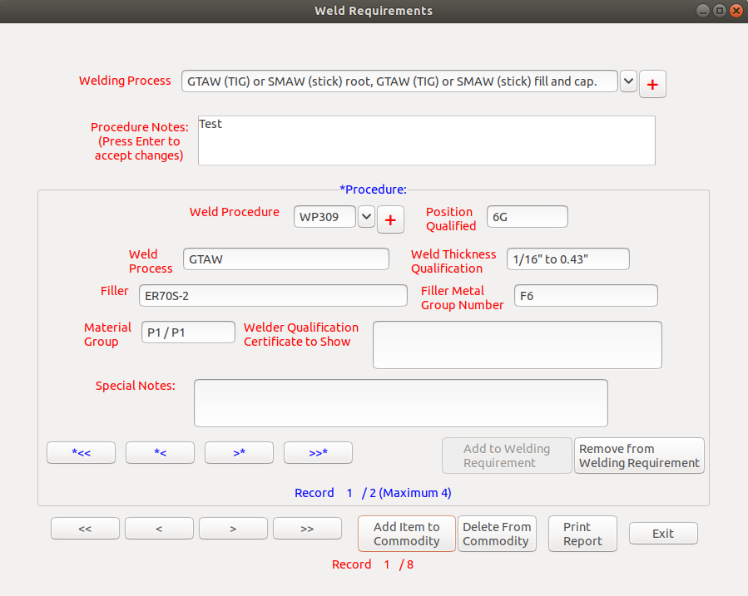Figure 25

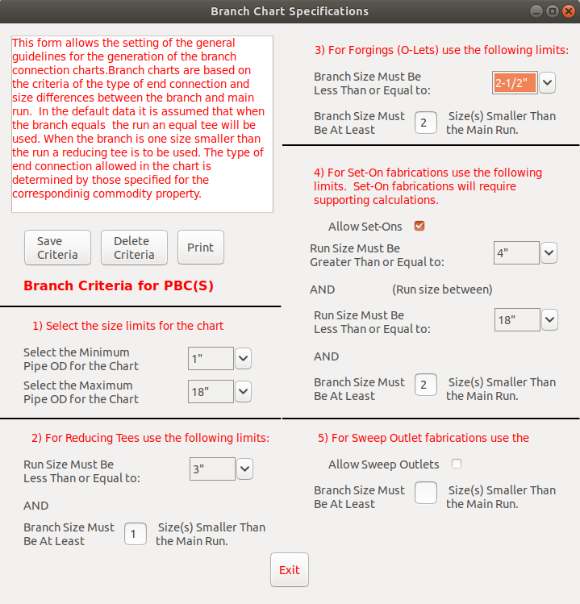Figure 26
The form to the left Branch Chart Specification is likely the most complex of the forms to use. It will allow for the size range specification of what type of branch connection to use and the size range of the chart, section 1 does this. Section 2 is used to specify the maximum size of pipe run which can use a reducing tee and how may sizes the branch pipe must be small than the run. For example if you are specifing a sock weld spec you may not want to use reducing tees on sizes greater than 3” and you want the branch to be within 1 size of the run pipe. The same philosophy fallows for section 3 O-Lets regardless of the o-let type. Section 4 applies to the use of set-on fabricated branches. You specify a minimum and maximum run sizes followed by a maximum size difference for the branch to run size in this case if a run of 6” was selected the branch cannot be 5” or 4”. The if check box “Allow Set-Ons” is not checked the information will be ignored and set-ons not allowed. Section 5 Sweep Outlets are typical and are used mostly for hot-tap type connections, but they can be specified here it needed.

APPENDIX I
The sample shown is that provided when the “Print Complete Scope of Work” button is clicked.

Report Printouts (.pdf file formats):

'Piping'  'Fittings'  'Flanges'  'Orifice Flanges'  'Gasket Packs'  'Fasteners'  'Unions'  'O-Lets'  'Groove Clamps'  'Weld Requirements'  'Specials'  'Tubing' | 'Branch Chart'  'Notes'  'Inspection Packs'  'Paint Spec'  'Insulation'  'Gate Valve'  'Globe Valve'  'Plug Valve'  'Ball Valve'  'Butterfly Valve'  'Piston Check Valve'  'Swing Check Valve'

APPENDIX II
Approval forms

As .html file format
'Scope of Work'
'Hydro Test Report'
'Hydro Test Waiver'
'Non-conformance Report'
'Material Substitution Request'
'Request for New Specification'

As .pdf file format
'Scope of Work'
'Hydro Test Report'
'Hydro Test Waiver'
'Non-conformance Report'
'Material Substitution Request'
'Request for New Specification'
'Inspection Travel Sheet'

