Multi-View Rendering for 3D Understanding: Camera Strategies That Actually Work
Why your renders are blank, how to fix them, and why 28 views beat 1 by 88% for duplicate detection

My First 1,000 Renders Were Completely Blank
I had the pipeline wired up. The mesh loaded fine — 12,000 vertices, a nice detailed chair. nvdiffrast was initialized, the GPU was warm, the MVP matrices looked reasonable. I hit run on my first batch of 1,000 models and went to get coffee.
When I came back, I had 28,000 PNG files. Every single one was a transparent rectangle.
I spent four hours debugging this. I checked the vertex data — valid. The face indices — correct. The projection matrix — textbook. The rasterizer output — all zeros. The mesh was there, the camera was there, and yet somehow the camera couldn’t see the mesh.
The problem was embarrassingly simple: my camera was looking at the origin [0, 0, 0], but the mesh’s center of mass was at [3.2, 0.8, -1.4]. The camera was faithfully rendering an empty patch of space while the actual geometry sat off-screen.
This is the blank-image trap — the single most common rendering failure in 3D ML pipelines. It’s the kind of bug that doesn’t crash, doesn’t throw an error, and produces files that look right at a glance (they’re valid PNGs, they’re the right resolution, they have an alpha channel). You only notice when your downstream model performs terribly and you trace it back to training on thousands of empty images.
This post shares the hard-won lessons from rendering 171,136 images across 3,056 3D models for 3D-DupBench, the benchmark I built for near-duplicate detection (see Part 1 of this series). I’ll cover the camera strategies that actually work, the textured vs. silhouette rendering tradeoff, the specific code patterns that prevent blank renders, and why nvdiffrast changed the economics of multi-view rendering.
If you’re building a 3D ML pipeline that touches rendering — whether for classification, retrieval, generation, or reconstruction — the next 15 minutes will save you a week of debugging.
This is Part 2 of 5 in the series “Detecting 3D Near-Duplicates at Scale.” Part 1 covered the end-to-end pipeline and the DINOv2 embedding strategy.

Why Render at All?
Before diving into camera strategies, it’s worth asking: why not just work with 3D geometry directly?
The format chaos problem. 3D meshes come in a zoo of formats — OBJ, glTF/GLB, STL, PLY, FBX, USD, OFF — each with different conventions for coordinate systems, face winding, material encoding, and vertex attributes. An OBJ file stores vertices as ASCII text with v x y z lines. A GLB packs the same data as binary buffers with accessor metadata. An FBX might embed a scene graph with multiple geometry nodes, each with its own transform. Writing robust geometry comparison code that handles all of this is a research project in itself.
2D models are better. The computer vision community has poured a decade of effort into training massive image models. DINOv2, trained self-supervised on 142 million curated images, produces features that generalize remarkably well to novel visual tasks. No 3D-native model comes close to this scale of pre-training. By rendering 3D meshes into 2D images, we can leverage these powerful representations for free.
Rendering normalizes everything. A mesh stored as .obj, .glb, or .ply renders to the same pixels from the same viewpoint. The pixel representation doesn’t care about vertex ordering, face topology, or coordinate system conventions — exactly the variations that make direct geometry comparison brittle. Rendering is a lossy operation, but the information it preserves (visual appearance, silhouette, spatial structure) is precisely what matters for similarity tasks.
This idea isn’t new. Chen et al. (2003) proposed Light Field Descriptors — essentially multi-view silhouette images — for 3D shape retrieval over two decades ago. What’s changed is that modern vision foundation models like DINOv2 and CLIP can extract orders-of-magnitude richer features from those rendered images than handcrafted descriptors ever could.

Camera Configurations: Where to Point the Cameras
The first design decision in multi-view rendering is where to place the cameras. This determines what geometric information is captured and what’s lost. I evaluated four configurations, from trivial to comprehensive.
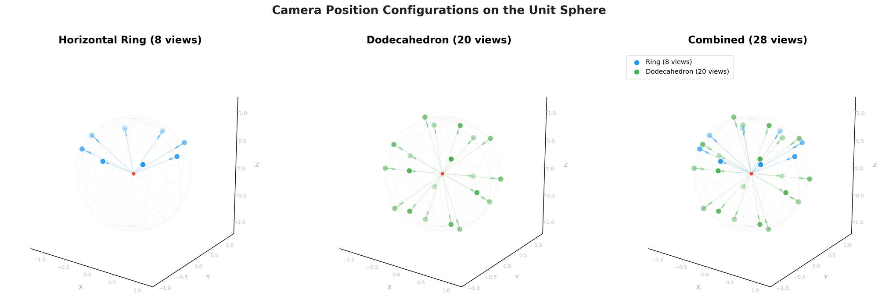 Figure 1: Three camera configurations visualized on the unit sphere. Blue dots show the 8-view horizontal ring at 30° elevation. Green dots show 20 dodecahedron vertices for near-uniform coverage. The combined 28-view setup (right) provides comprehensive coverage with manageable compute. Image by author.

Single view: The front-facing baseline
The simplest approach: one camera, one image. This is what most 3D asset thumbnails use — a front-facing shot that shows the “best angle.” It captures maybe 30% of the model’s surface geometry. The back, bottom, interior cavities, and occluded details are completely invisible.
For near-duplicate detection, single-view is fatal. Two models might look identical from the front but differ significantly elsewhere. In our evaluation on ModelNet40, single-view thumbnails achieve a retrieval mAP of just 0.263 — barely useful for finding duplicates.

Horizontal ring: 8 views at fixed elevation
Eight cameras evenly spaced around the model at 45° azimuth intervals, all at 30° elevation. This captures the full horizontal profile — what you’d see walking around the object — but misses top and bottom views entirely.
def compute_ring_cameras(n_views=8, elevation_deg=30.0):
"""8 cameras at 45° intervals, fixed elevation."""
cameras = []
for i in range(n_views):
az = i * (360.0 / n_views) # 0°, 45°, 90°, ..., 315°
cameras.append((az, elevation_deg))
return cameras
The ring is the workhorse of multi-view rendering. It’s simple, predictable, and captures the most discriminative views for most objects (tables, chairs, vehicles — anything with a natural upright orientation). The 30° elevation avoids the foreshortening you’d get at 0° while still capturing the “showcase” angles.

Dodecahedron: 20 views with near-uniform coverage
Twenty cameras placed at the vertices of a regular dodecahedron, projected onto the unit sphere. This provides near-uniform coverage of the full viewing sphere — top, bottom, and every angle in between.
def compute_dodecahedron_cameras():
"""20 cameras at regular dodecahedron vertices."""
phi = (1 + math.sqrt(5)) / 2 # Golden ratio ≈ 1.618
verts = []
# 8 cube vertices
for s1 in [-1, 1]:
for s2 in [-1, 1]:
for s3 in [-1, 1]:
verts.append((s1, s2, s3))
# 12 vertices on coordinate planes using golden ratio
for s1 in [-1, 1]:
for s2 in [-1, 1]:
verts.append((0, s1 * phi, s2 / phi))
verts.append((s1 / phi, 0, s2 * phi))
verts.append((s1 * phi, s2 / phi, 0))
# Normalize to unit sphere and convert to (azimuth, elevation)
cameras = []
for v in verts:
x, y, z = v
r = math.sqrt(x*x + y*y + z*z)
el = math.degrees(math.asin(y / r))
az = math.degrees(math.atan2(x, z))
cameras.append((az, el))
return cameras
The dodecahedron gives superior geometric coverage compared to a ring, but the views aren’t optimized for human-intuitive angles. Some views are from directly above or below, which can be less informative for objects with a natural “up” direction.

Combined: 28 views (our choice)
We use both: 8 ring cameras + 20 dodecahedron cameras = 28 total viewpoints. Is there redundancy? Yes — some dodecahedron vertices are close to the ring elevation. But the redundancy is harmless and the combined coverage ensures no part of the model goes unobserved.
def compute_all_cameras():
"""Combined 28 cameras: 8 ring + 20 dodecahedron."""
ring = compute_ring_cameras(n_views=8, elevation_deg=30.0)
dodec = compute_dodecahedron_cameras()
return ring + dodec # 28 total viewpoints
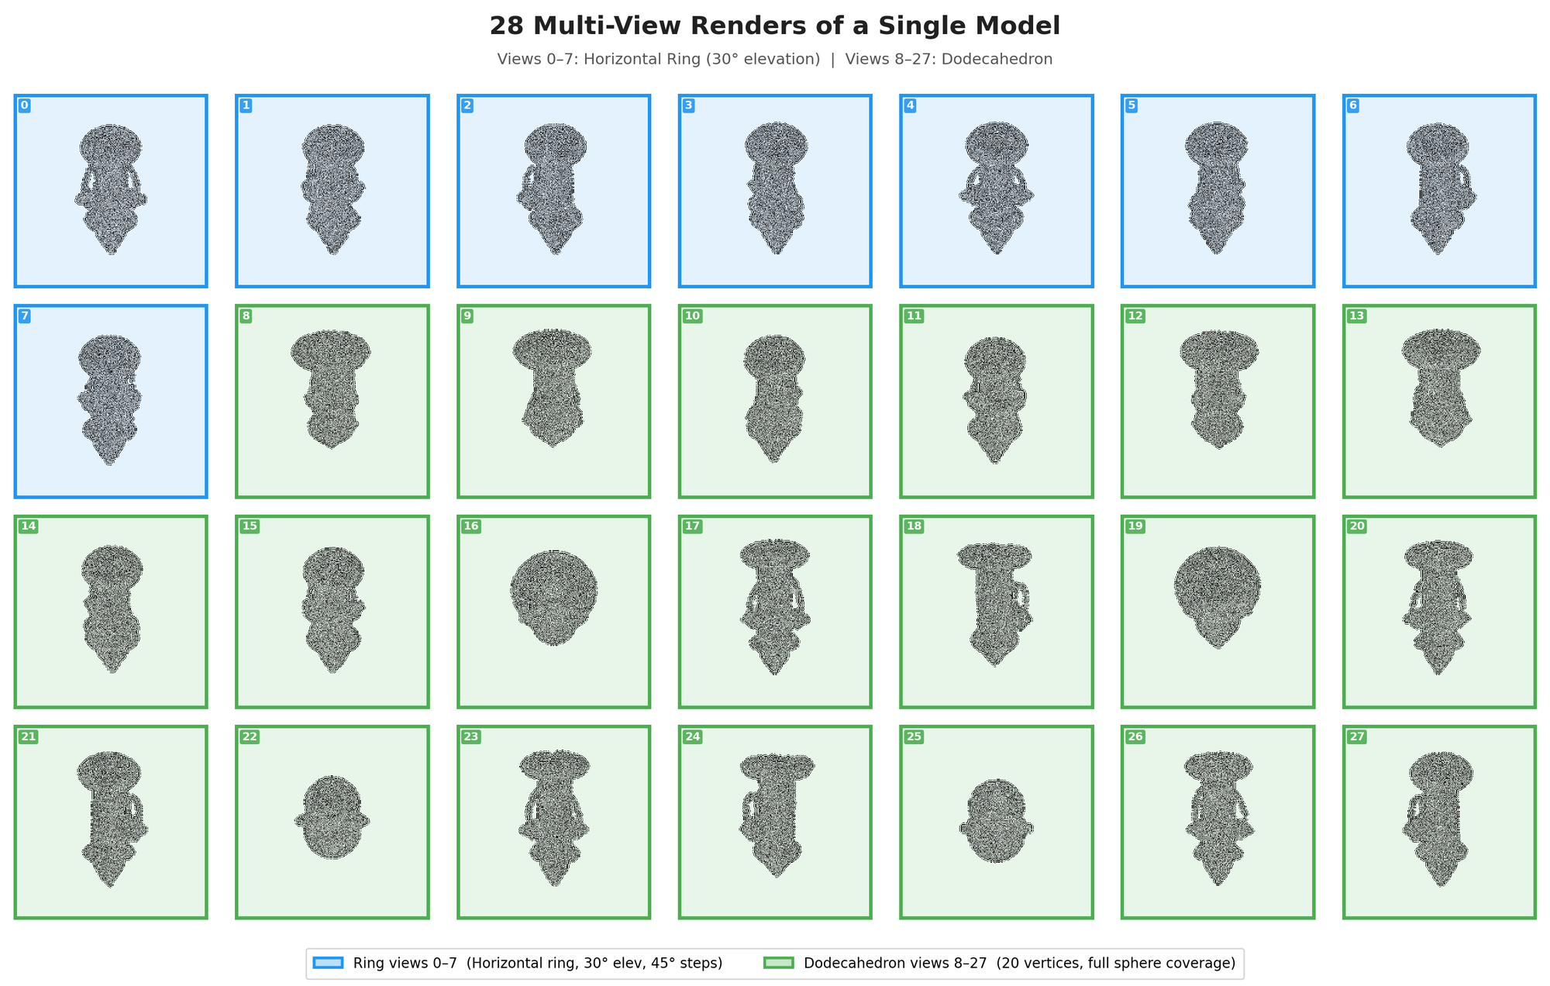 Figure 2: All 28 rendered views of a single Objaverse model. Views 0–7 (blue, top rows) form the horizontal ring at 30° elevation. Views 8–27 (green, bottom rows) are dodecahedron vertices covering the full sphere. Image by author.

How many views do you actually need?
This is an empirical question, and the answer is: more helps, but with sharply diminishing returns.
I ran a systematic ablation comparing 1, 8, and 28 views for embedding retrieval (DINOv2-Giant), and 2, 4, 6, and 8 views for the full rescoring pipeline:
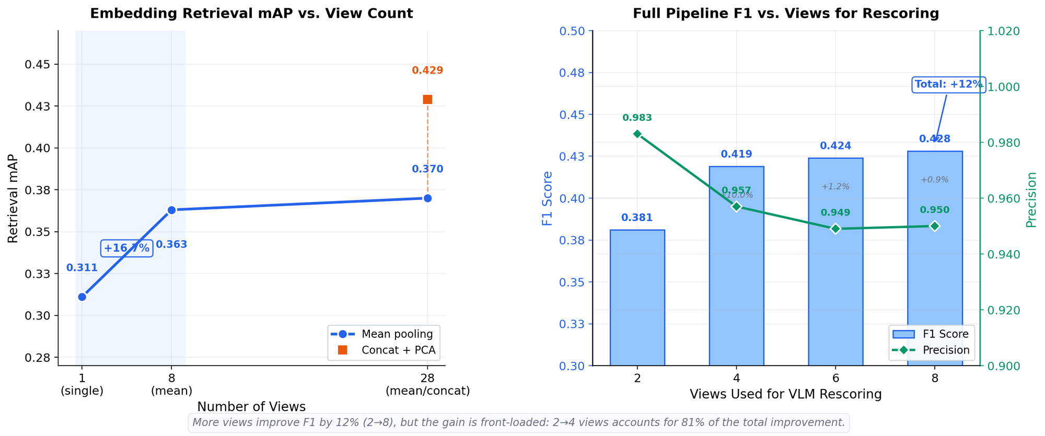 Figure 3: Left — Embedding retrieval mAP jumps +16.7% from 1→8 views, but only +1.9% from 8→28 with mean pooling. The concat+PCA aggregation strategy adds another +15.9% at 28 views. Right — Full pipeline F1 improves +12% from 2→8 rescoring views, with most gains from 2→4. Image by author.
Views | Embedding mAP (mean pool) | Full Pipeline F1
1 | 0.311 | —
2 | — | 0.381
4 | — | 0.419
8 | 0.363 | 0.428
28 | 0.370 (mean) / 0.429 (concat+PCA) | —
Table 1: View count vs. performance. The single-view to 8-view jump (+16.7% mAP) justifies the compute cost. Beyond 8 views, concatenation+PCA aggregation matters more than adding views.
The single biggest insight: going from 1 view to 8 views gives you a 16.7% mAP improvement. Going from 8 to 28 views with mean pooling gives just 1.9% more. The real trick for extracting value from 28 views is the aggregation strategy — concatenating all per-view embeddings and reducing with PCA yields 0.429 mAP, a 15.9% improvement over mean pooling at the same view count.
For the rescoring pipeline (which uses multi-angle visual comparison rather than embeddings), the pattern is similar: 2→4 views accounts for 81% of the total improvement.

Textured vs. LFD Rendering: Do Textures Help?
Every model is rendered in two modes:
- Textured: Full material colors and vertex colors preserved, with Lambertian shading. Shows the model as it was authored — textures, colors, and all.
- LFD (Light Field Descriptor): Uniform white-plastic surface (RGB 0.82), pure geometry with Lambertian shading. Strips away all appearance information, isolating shape.
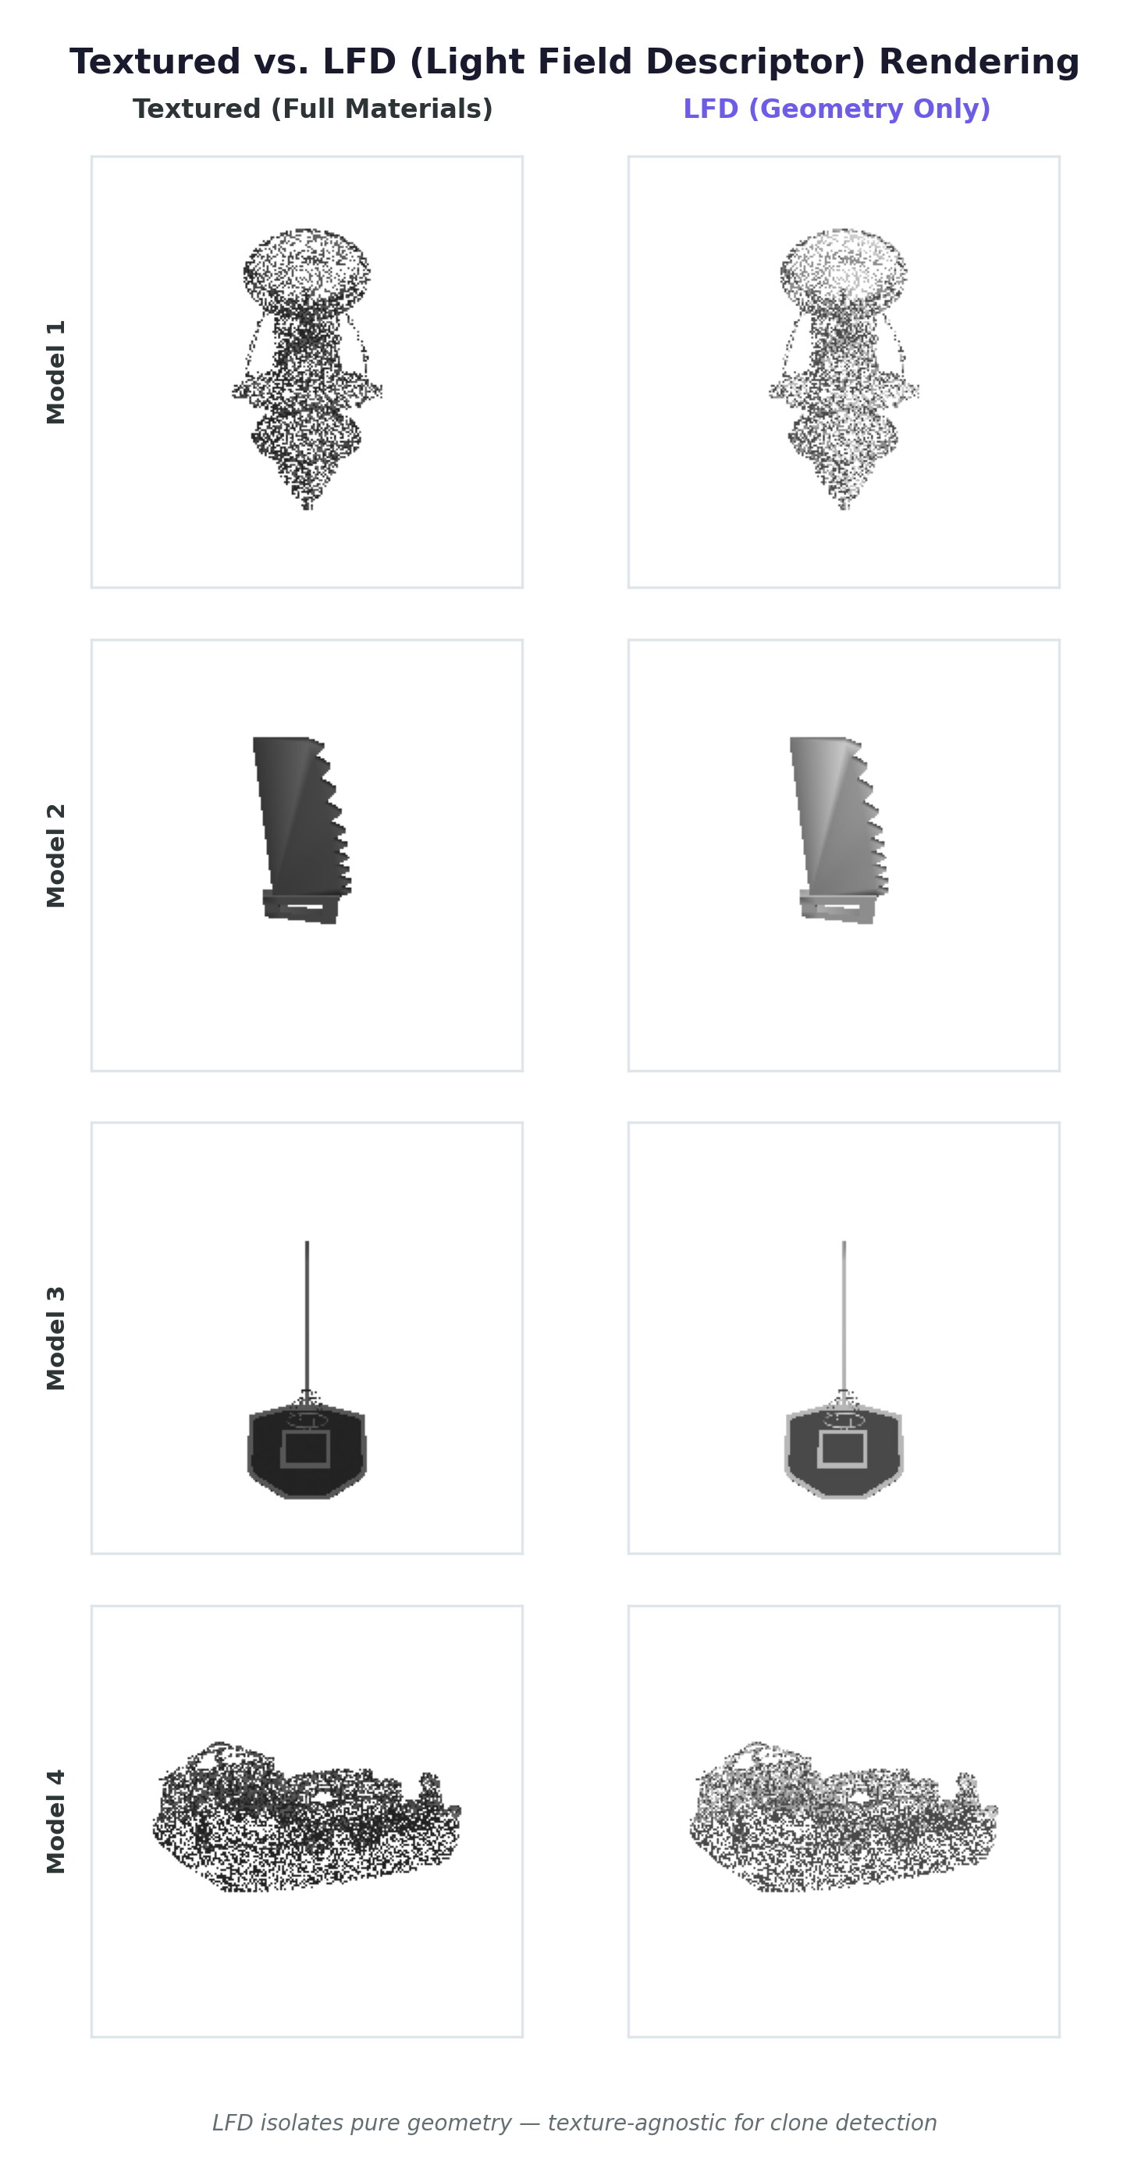 Figure 4: The same four models rendered with textured materials (left) and LFD/white-plastic geometry-only mode (right). LFD removes all texture information, forcing similarity comparisons to rely on shape alone. Image by author.
Which mode produces better embeddings? The answer surprised me: it barely matters.
Render Mode | Rescorer Precision | Rescorer Recall | Rescorer F1
Textured | 0.896 | 0.267 | 0.411
LFD | 0.926 | 0.280 | 0.430
Table 2: Textured vs. LFD rendering performance on the full rescoring pipeline. LFD achieves slightly higher precision (+3.3%) and F1 (+4.6%), suggesting that stripping textures reduces false positives from texture-based confusion.
DINOv2 extracts structural features that transcend surface appearance. Whether the model is rendered with realistic materials or as a gray silhouette, the vision model captures the same underlying geometry. This is good news for datasets where textures are missing or inconsistent (common in CAD models, scientific meshes, and format-converted assets).
That said, the two modes capture different failure modes:
Textured rendering is better when you want to detect visual duplicates — same model with the same texture applied. It catches re-uploaded copies that preserve the original appearance. But it can be misled by texture changes: two geometrically identical chairs with different upholstery might score as dissimilar.
LFD rendering is better when you want to detect geometry clones — same shape regardless of texture. It catches models that have been re-textured, re-colored, or stripped of materials. Our pipeline uses both modes and combines their evidence, getting the best of both worlds.

The Blank-Image Trap: The Bug That Doesn’t Error
This section exists because I’ve seen this bug in every 3D rendering pipeline I’ve ever worked with, and I’ve spent more time debugging it than any other single issue. It deserves a thorough explanation.

The root cause
The standard look_at camera setup takes three arguments: eye (camera position), target (where the camera points), and up (which direction is “up”). The naive approach sets target = [0, 0, 0] — the world origin:
# THE WRONG WAY — target is hardcoded to origin
def compute_mvp_wrong(cameras, radius=2.5):
proj = projection_matrix(fov_deg=45, aspect=1.0, near=0.1, far=10.0)
mvps = []
for az, el in cameras:
eye = spherical_to_cartesian(az, el, radius=radius) # Fixed radius!
view = look_at_matrix(
eye=eye,
target=[0, 0, 0], # BUG: assumes mesh is at origin
up=[0, 1, 0]
)
mvps.append(proj @ view)
return np.array(mvps)
This works perfectly when the mesh is centered at the origin with unit scale. The problem is that most meshes are not centered at the origin. A mesh exported from Blender might have its origin at the artist’s world origin, which could be meters away from the geometry. A mesh re-exported from one format to another might accumulate transform offsets. A mesh from a scene file might be positioned relative to a scene graph root that isn’t [0, 0, 0].

The second failure: fixed camera distance
Even if you normalize the mesh to the origin, a fixed camera distance (radius=2.5 in the example above) causes problems. A model with a bounding box diagonal of 0.1 will appear as a tiny speck. A model with a diagonal of 50 will overflow the view frustum, showing only a fragment.
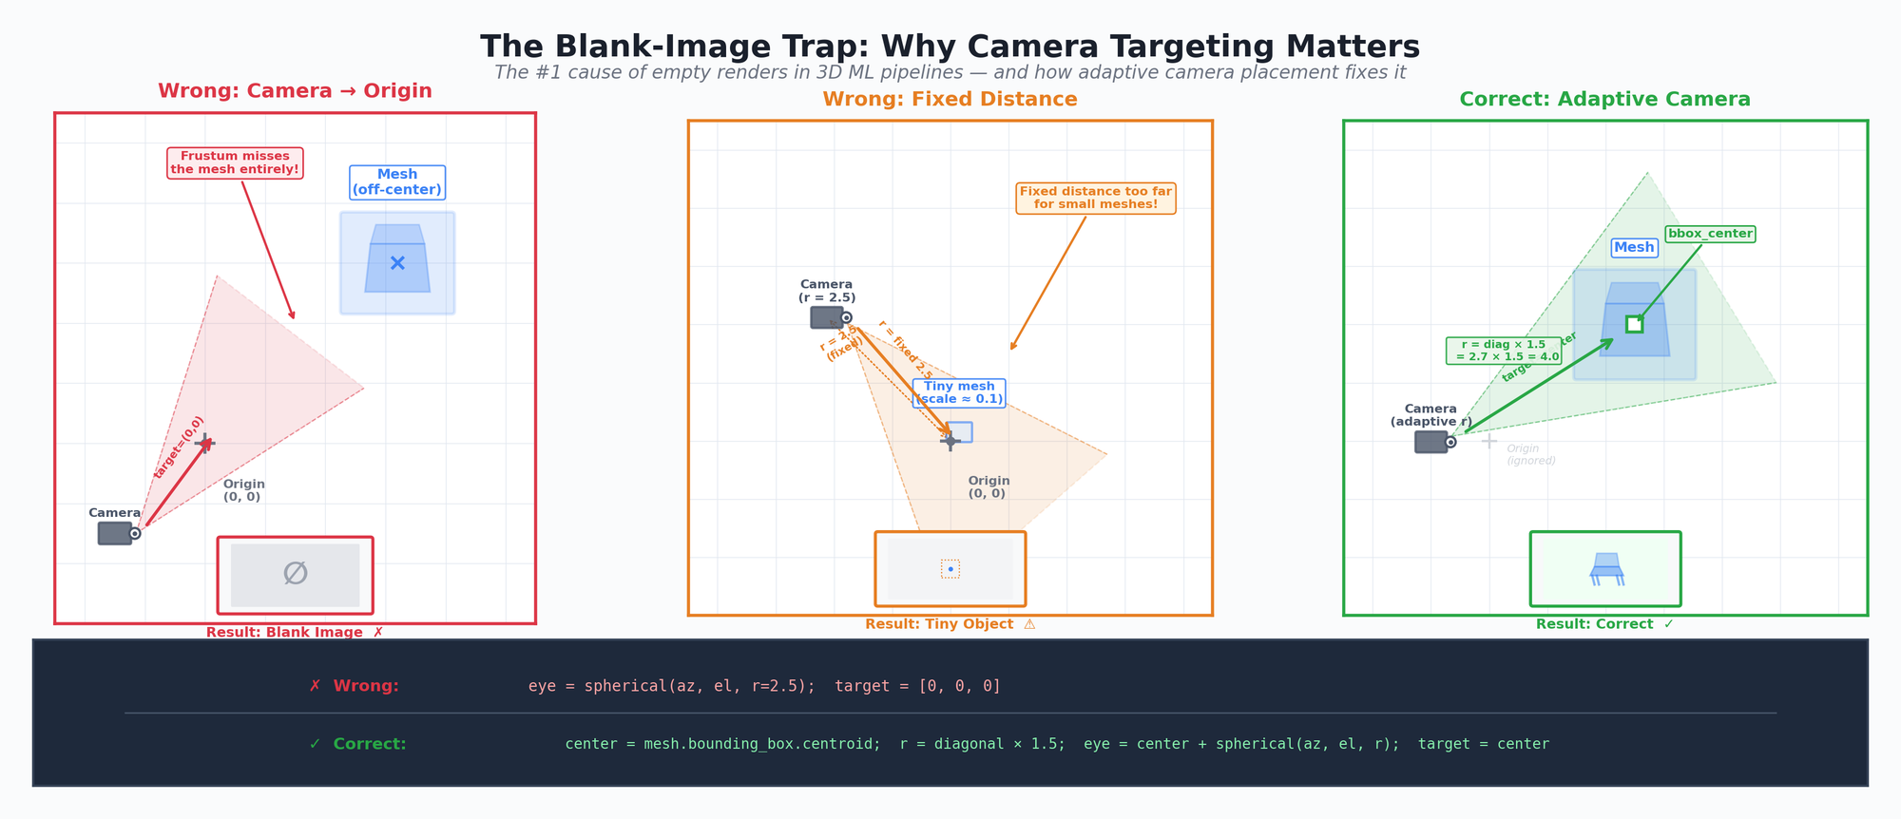 Figure 5: Three rendering scenarios. Left — camera aimed at the origin misses an off-center mesh entirely. Center — fixed camera distance renders a tiny mesh as a speck. Right — adaptive camera targeting and distance produce a correctly framed render. Image by author.

The fix: mesh-adaptive camera targeting
The solution is two lines of math:
def compute_mvp_matrices(vertices, cameras):
"""Compute MVP matrices adapted to the actual mesh geometry.
CRITICAL: Camera looks at bounding-box center, NOT the origin.
Camera distance scales with bounding-box diagonal.
"""
bbox_min = vertices.min(axis=0)
bbox_max = vertices.max(axis=0)
center = (bbox_min + bbox_max) / 2.0 # WHERE to look
diagonal = np.linalg.norm(bbox_max - bbox_min)
radius = max(diagonal * 1.5, 0.5) # HOW FAR away
# Adaptive near/far planes prevent z-fighting
proj = projection_matrix(
fov_deg=45, aspect=1.0,
near=radius * 0.01,
far=radius * 20.0
)
mvps = []
for az, el in cameras:
direction = spherical_to_cartesian(az, el, radius=radius)
eye = center + direction # Camera orbits the MESH CENTER
view = look_at_matrix(eye, center, [0, 1, 0])
mvps.append(proj @ view)
return np.array(mvps, dtype=np.float32)
The key changes:
- center = (bbox_min + bbox_max) / 2.0 — The camera looks at the mesh’s bounding-box center, not the world origin. This guarantees the mesh is in the camera’s field of view regardless of where it sits in world space.
- radius = diagonal * 1.5 — The camera distance scales with the mesh’s size. The 1.5 factor provides enough margin that the mesh fits within a 45° field of view with room to spare. Clamped to a minimum of 0.5 for degenerate cases.
- near = radius * 0.01, far = radius * 20.0 — The near and far clipping planes scale proportionally. Fixed clipping planes (e.g., near=0.1, far=10.0) cause z-fighting artifacts on very large meshes and clip geometry on very small ones.

An alternative: normalize first
An alternative approach is to normalize the mesh before computing camera matrices:
def normalize_mesh(vertices):
"""Center at origin and scale to unit bounding box."""
centroid = (vertices.min(axis=0) + vertices.max(axis=0)) / 2.0
vertices = vertices - centroid
max_extent = np.abs(vertices).max()
if max_extent > 1e-8:
vertices = vertices / max_extent # Scale to [-1, 1]
return vertices
This lets you use a fixed camera setup since all meshes are now origin-centered and unit-scaled. We use both: normalize the mesh and compute adaptive MVP matrices. Belt and suspenders — because the cost of a blank render is much higher than the cost of a redundant normalization step.

Validation: catch what slips through
Even with correct camera targeting, some renders will be blank or degenerate. Meshes with zero-area faces, collapsed geometry, or extreme aspect ratios can produce valid-looking but empty renders. We validate every image:
def check_render(path):
"""Validate a rendered image. Returns status string."""
try:
img = np.array(Image.open(path))
if img.shape[2] == 4: # RGBA
alpha = img[:, :, 3]
if alpha.max() == 0:
return "blank_alpha" # All transparent
fg_mask = alpha > 0
if fg_mask.sum() < 10:
return "blank_alpha" # Near-empty
rgb_fg = img[:, :, :3][fg_mask]
if rgb_fg.std() < 1.0:
return "flat_color" # No visual detail
return "ok"
except Exception:
return "corrupt"
On our 3,056-model dataset, this validation caught: - 232 blank alpha images (0.14%) — meshes with degenerate geometry - 1,485 flat color images (0.87%) — meshes that rendered but had zero visual detail - 0 corrupt or missing — the pipeline is reliable - 99.0% pass rate overall
Tier | OK | Issues | Notes
Source | 10,451 | 245 | Some source models have degenerate geometry
T1 | 31,350 | 738 | Format conversion occasionally drops faces
T2 | 31,533 | 555 | Scale changes can create edge-case framing
T3 | 31,936 | 152 | Vertex noise paradoxically helps framing
T4 | 32,086 | 2 | Near-perfect render quality
T5 | 32,063 | 25 | Minor topology artifacts
Table 3: Render validation results by clone tier. 171,136 total images, 99.0% pass rate. Issues are concentrated in format-conversion and source-mesh degenerate geometry.

nvdiffrast: GPU-Accelerated Rendering at Scale
Why nvdiffrast over the alternatives? In one word: speed.
Traditional 3D rendering options for Python ML pipelines include Blender (feature-rich but heavy), Pyrender/trimesh (convenient but CPU-bound), and Open3D (good for visualization, slow for batch rendering). nvdiffrast is different: it’s a CUDA-native rasterizer built for machine learning workloads. It runs entirely on the GPU, skips the overhead of a full rendering engine, and produces the rasterization output (depth, normals, attributes) that ML pipelines actually need.

Performance: the numbers
We rendered all 3,056 models × 28 views × 2 modes = 171,136 images on a single Tesla T4 GPU:
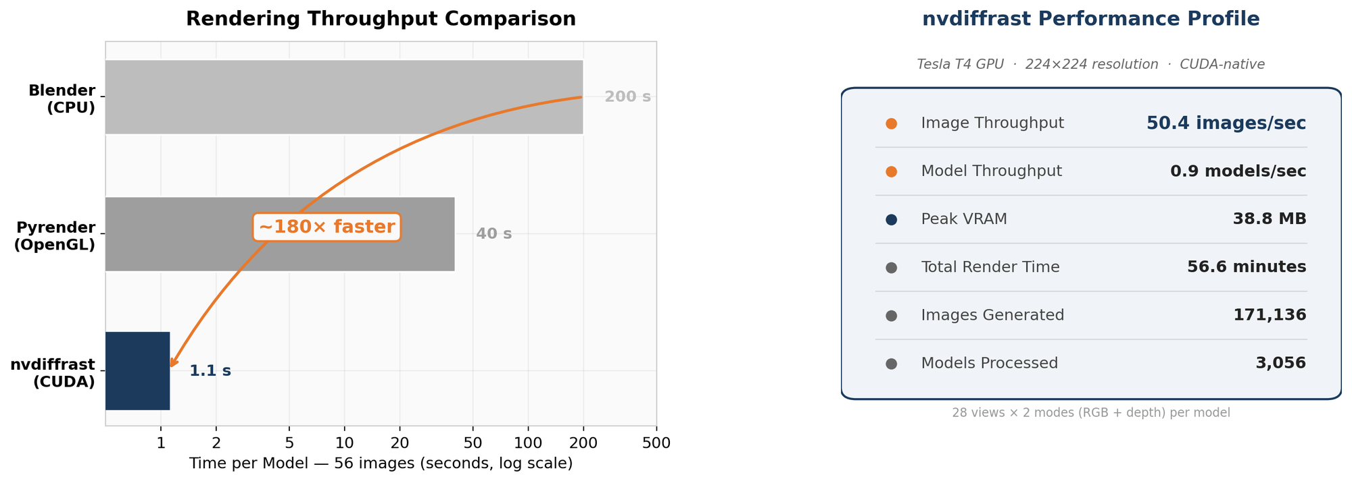 Figure 6: Left — nvdiffrast is ~180× faster than Blender and ~36× faster than Pyrender for batch multi-view rendering. Right — Performance profile on the Tesla T4 showing efficient GPU utilization with just 38.8 MB peak VRAM. Image by author.
Metric | Value
Total render time | 56.6 minutes
Throughput | 50.4 /home/lightsail-user/3d-dataset-storage/3d-dedup-repo/blog/figures/post-2_sec, 0.9 models/sec
Mean time per model | 1.1 sec (28 views × 2 modes)
Median time per model | 0.285 sec
Peak GPU VRAM | 38.8 MB
Total images | 171,136
Image resolution | 224 × 224
Table 4: nvdiffrast rendering performance on Tesla T4. The mean/median discrepancy reflects that a few models with very high face counts (up to 80K faces after decimation) take significantly longer — up to 50.7 seconds for the worst case.
The peak GPU memory of 38.8 MB is remarkable. For context, loading a single DINOv2-Giant model for inference takes ~4.5 GB. The renderer is memory-trivial, which means you can run rendering and embedding extraction on the same GPU without memory contention.

Quick-start code
Here’s the minimal nvdiffrast rendering loop:
import nvdiffrast.torch as dr
import torch
import numpy as np
# Initialize once per session
glctx = dr.RasterizeCudaContext() # CUDA context
def render_views(glctx, vertices, faces, mvp_matrices, img_size=224):
"""Render a mesh from multiple viewpoints using nvdiffrast.
Args:
vertices: (V, 3) float32 numpy array
faces: (F, 3) int32 numpy array
mvp_matrices: (N, 4, 4) float32 numpy array
Returns:
List of (H, W, 4) uint8 numpy arrays (RGBA)
"""
device = "cuda"
verts = torch.tensor(vertices, dtype=torch.float32, device=device)
faces_t = torch.tensor(faces, dtype=torch.int32, device=device)
# Homogeneous coordinates for matrix multiplication
verts_homo = torch.cat([
verts,
torch.ones(verts.shape[0], 1, device=device)
], dim=1) # (V, 4)
# Compute vertex normals for shading
v0, v1, v2 = verts[faces_t[:, 0]], verts[faces_t[:, 1]], verts[faces_t[:, 2]]
face_normals = torch.cross(v1 - v0, v2 - v0, dim=1)
face_normals = face_normals / (face_normals.norm(dim=1, keepdim=True) + 1e-8)
vert_normals = torch.zeros_like(verts)
for j in range(3):
vert_normals.index_add_(0, faces_t[:, j], face_normals)
vert_normals = vert_normals / (vert_normals.norm(dim=1, keepdim=True) + 1e-8)
# Pack normals for interpolation (need 4 components)
normals_4 = torch.cat([
vert_normals,
torch.ones(vert_normals.shape[0], 1, device=device)
], dim=1).unsqueeze(0) # (1, V, 4)
# Render each viewpoint
images = []
for i in range(len(mvp_matrices)):
mvp = torch.tensor(mvp_matrices[i], dtype=torch.float32, device=device)
# Transform to clip space
clip_verts = (verts_homo @ mvp.T).unsqueeze(0) # (1, V, 4)
# Rasterize — the core nvdiffrast operation
rast, _ = dr.rasterize(glctx, clip_verts, faces_t,
resolution=[img_size, img_size])
# Interpolate normals at each pixel
normals, _ = dr.interpolate(normals_4, rast, faces_t)
normals = normals[0, :, :, :3] # (H, W, 3)
# Lambertian shading
light_dir = torch.tensor([0.3, 0.5, 0.8], device=device)
light_dir = light_dir / light_dir.norm()
diffuse = torch.clamp(
torch.sum(normals * light_dir, dim=-1, keepdim=True), 0, 1
)
ambient = 0.35
color = 0.82 * (ambient + (1 - ambient) * diffuse) # White plastic
color = color.expand(-1, -1, 3) # (H, W, 3)
# Alpha mask from rasterization
mask = (rast[0, :, :, 3:4] > 0).float()
# Compose RGBA
rgb = (color.clamp(0, 1) * 255)
alpha = mask * 255
img = torch.cat([rgb, alpha], dim=-1)
images.append(img.byte().cpu().numpy())
return images
The key call is dr.rasterize() — it takes clip-space vertices and face indices and outputs a rasterization buffer with per-pixel primitive IDs, barycentric coordinates, and depth. Then dr.interpolate() uses those barycentric coordinates to smoothly interpolate any per-vertex attribute (normals, colors, UVs) across each triangle. The whole thing runs in CUDA, and there’s no CPU-GPU data transfer during the per-view loop.

A note on differentiability
nvdiffrast’s headline feature is differentiable rendering — gradients flow through the rasterization operation, enabling end-to-end optimization of 3D geometry from image losses. We don’t use this for duplicate detection, but it’s a powerful capability for future work like inverse rendering, 3D generation, and mesh optimization. The same rendering code that produces our multi-view embeddings could, in principle, be used as a differentiable decoder in a 3D autoencoder.

Practical Advice for 3D Rendering Pipelines
Having rendered 171,136 images and debugged more edge cases than I’d care to admit, here’s the practical wisdom I’d pass along to anyone building a multi-view rendering pipeline.

Resolution: match your downstream model
We render at 224 × 224 pixels — the native input resolution of DINOv2’s ViT backbone. This avoids any resizing or interpolation at embedding time, preserving the sharpest possible features. If you’re using a model that expects 384 × 384 (like some ViT-L configurations), render at that resolution directly. The compute cost difference is modest (rasterization scales with pixel count, not linearly), and avoiding resize artifacts is worth it.

Alpha channel: transparent backgrounds
Always render with an alpha channel (RGBA, not RGB). A transparent background means the vision model sees only the object, with no background bias. This is critical for embedding quality — a gray or white background adds spurious pixel values that shift the embedding in model-specific ways.
# RGBA compositing — transparent background
mask = (rast[0, :, :, 3:4] > 0).float()
alpha = mask * 255
rgb = (color.clamp(0, 1) * 255)
img = torch.cat([rgb, alpha], dim=-1) # (H, W, 4)

Mesh decimation: cap face count
Large meshes (100K+ faces) slow down rasterization without improving visual quality at 224px. We decimate meshes above 80,000 faces using quadric edge decimation:
if mesh.faces.shape[0] > 80_000:
mesh = mesh.simplify_quadric_decimation(80_000)
This caps the worst-case render time without visible quality loss at our target resolution.

Handle complex scenes
Many OBJ and glTF files are scenes — they contain multiple geometry nodes, each potentially with its own transform. Loading with trimesh.load(path, force='mesh') concatenates everything into a single mesh, but it can fail on complex scenes. The robust approach is to fall back to scene loading and manually concatenate:
try:
mesh = trimesh.load(path, force='mesh')
except Exception:
scene = trimesh.load(path, process=False)
if isinstance(scene, trimesh.Scene):
meshes = [g for g in scene.geometry.values()
if isinstance(g, trimesh.Trimesh) and g.faces.shape[0] > 0]
mesh = trimesh.util.concatenate(meshes)

Memory management
nvdiffrast is memory-efficient (38.8 MB peak in our pipeline), but errors can leak GPU memory. Always wrap the rendering loop in a try/except that calls torch.cuda.empty_cache() on failure:
try:
images = render_views(glctx, vertices, faces, mvps)
success += 1
except Exception as e:
failed += 1
torch.cuda.empty_cache() # Prevent memory leaks from failed renders

Checkpoint frequently
On a 3,000-model dataset, a crash at model 2,999 without checkpointing means re-rendering everything. We checkpoint every 200 models:
if (idx + 1) % 200 == 0:
with open("render_checkpoint.json", "w") as f:
json.dump({"rendered": list(rendered_ids)}, f)
# Monitor disk space
st = os.statvfs(str(render_dir))
free_gb = (st.f_bavail * st.f_bsize) / (1024 ** 3)
if free_gb < 20:
print("WARNING: Low disk space. Stopping.")
break
Our 171,136 images consumed 1.6 GB of disk space — modest, but worth monitoring for larger datasets.

Putting It All Together
Here’s the complete rendering recipe that powers the 3D-DupBench pipeline:
- Load and normalize the mesh (handle scenes, decimate large meshes)
- Compute 28 camera positions (8 ring + 20 dodecahedron)
- Compute mesh-adaptive MVP matrices (look at bbox center, scale distance to diagonal)
- Render 28 views × 2 modes (textured + LFD) using nvdiffrast
- Validate every image (check for blank alpha, flat color, corruption)
- Checkpoint progress every 200 models
The total cost: 56.6 minutes on a Tesla T4 for 3,056 models → 171,136 images, with 99.0% validation pass rate and 38.8 MB peak GPU memory. That’s less than $1 of GPU compute on a cloud instance.
The full rendering code is available in the companion repository. The key file is render_multiview.py — 850 lines that handle everything from mesh loading to validation to checkpointing.

What’s Next
With 171,136 images rendered and validated, the next step is turning those images into searchable vector representations. In Post 3 — Embedding Extraction and Vector Search, I’ll cover:
- DINOv2 vs. CLIP: which vision foundation model produces better 3D embeddings, and why
- Aggregation strategies: mean pooling vs. max pooling vs. concatenation+PCA — why the right choice gives a 16% mAP boost
- FAISS at scale: how to build an index that searches 1 million models in under 1 millisecond
- The bakeoff: 32 embedding configurations compared head-to-head
The rendering pipeline in this post is the foundation that makes all of that possible. Get the renders right, and everything downstream benefits. Get them wrong, and you’re training on blank images.

This is Part 2 of 5 in the series “Detecting 3D Near-Duplicates at Scale.”
- Part 1: Pipeline Overview and Key Results
- Part 2: Multi-View Rendering (this post)
- Part 3: Embedding Extraction and Vector Search
- Part 4a: 3D-DupBench and the ModelNet40 Audit
- Part 4b: Results & Production

References
- Chen, D.-Y., et al. “On Visual Similarity Based 3D Model Retrieval.” Computer Graphics Forum, 2003. Paper
- Laine, S., et al. “Modular Primitives for High-Performance Differentiable Rendering.” ACM Transactions on Graphics, 2020. Paper | GitHub
- Oquab, M., et al. “DINOv2: Learning Robust Visual Features without Supervision.” arXiv:2304.07193, 2023. Paper
- Gadhave, S., et al. “Contamination in Commonly Used Benchmark Datasets for Point Cloud Analysis.” DMLR Workshop, ICML 2023. Proceedings
- Deitke, M., et al. “Objaverse: A Universe of Annotated 3D Objects.” CVPR 2023. Paper

