Product Brief - Team Software Project 2
Our Product
Overview
Within our project, we aim to create a threat-analysing scanner for Twitter. The scanner will be created as a web application that will allow users to scan accounts for potential threatening behaviour that is considered to be anti-social, and provide the user with a detailed report at the click of a button on what the algorithm has determined to be dangerous. The user then has the option to disregard the report, or review it and make changes based on what they consider to be the main threat.
Our web application will be named Tweet Guard Threat Scanner, and will aim to provide a user-friendly, quick environment that gives an accurate and detailed reflection of the threat or lack thereof that may lie within the user's Twitter followers.
Overall, the aim is to create a simple, sleek and minimalistic web app that offers users an easy way to filter out any negativity, antisocial behaviour or danger from their twitter feed with the click of a button. We aim to create an algorithm that is accurate, helpful and will grow stronger as more users use it.

Why Is It Needed?
In digital times, digital crimes are also rocketing. People need a way to keep themselves safe from online threats like sexual predators, fraud accounts, internet trolls, etc. Our web application will warn its users whenever a “threatening account” tries to interact with them. This will be perfect for people such as children, women and others who face the most threat online.

Twitter is an open platform where people can look at and talk about current affairs across the globe. With differing points of view, some people may have a perspective on a topic which might be controversial or offensive to other users. Some may also exploit the platform for malicious purposes.

Twitter has a system in place where if a user believes something violates the platform’s rules they can report it. This helps to indicate to the Twitter team that something is going on and they can then decide whether or not to take corrective measures. E.g. They may enforce a user to delete their Tweet, or suspend their account permanently (if a more serious/repeat offence is committed).
Violations are grouped under three separate categories:

1. Safety
This includes violent threats, terrorism, child sexual exploitation, harrassment, discriminational hate (e.g racism), intentions/encouragement of self-harm or suicide, sensitive media, and illegal activity.

2. Privacy
Includes disclosing other people’s private information, and non-consensual nudity.

3. Authenticity
Includes spam, civic integrity, impersonation, synthetic media, and copyright/trademark.

Although the reporting of these violations on Twitter helps to make the platform a safer place, there are a few problems that it does not address:

- It is inefficient to depend on Twitter staff to go through each user report and determine what action should be taken. This takes too long for threats to be identified and eliminated, meaning more users are vulnerable for a longer period.
- Users will be completely oblivious to a harmful account as they cannot see if it has been previously reported before.
- There is no threat alert so it is not obvious when a threat is received. Because of this, reporting is more likely to occur after harm is caused.
- What some users don’t consider a threat, others might. Hence, smaller threats are often ignored, because there aren’t enough users reporting them.

The web application will quickly solve these problems:
- Reported information is stored in a database, so threatening accounts can immediately be identified by users.
- Users will now be able to scan for harmful accounts and see all details of previous reports.
- Whenever a threatening appearing account tries to interact with a user, the user will be able to quickly discover if other people have had the same problem, or if our algorithms have detected said threatening behaviour.
- The web application will show a danger level so that threats of all sizes are accounted for. This allows users to make their own decisions on how restrictive they would like their account to be.

So What Does It Do, And How Does It Do It?
In our web app, the main function that we are choosing to implement is a “scan” function, which uses sentiment analysis and machine learning to provide a full report on a user’s Twitter followers, giving an overall view of whether the scanned users are considered dangerous, untrustworthy, or harmful. We aim to implement at least one criteria on which a user can be determined as untrustworthy or dangerous, with racism within the tweets of a user at the forefront as our principle area of development.

The scan function can be used in two different ways:

- The user can search for a specific account and receive a full report on the account.
- The user can enter their own Twitter handle and be given analysis of all of their followers under a selected criteria on which they choose to search, documented as a full report which highlights the dangerous users, and, if possible, will give an option to unfollow a specific user or mass unfollow all threatening accounts.

When an account is scanned, a full report is either taken from our database, or, if the account is not already present in it, our sentiment analysis techniques will scan the account’s recent activity and return the report to the user, adding it to the database for future users’ scans in the process. The returned report will contain information such as an overall “danger level” of the account, the amount of reports/flags our system or other uses have made on an account in the last month, the common reason for reporting and even some of the tweets in question that may contain said threatening qualities or anti-social behaviour.

The user will then even be given a chance based on the mentioned tweets to agree or disagree if there was indeed antisocial behaviour involved and to block/mute/unfollow the user, which with machine learning will make the algorithm stronger/more accurate for the next user. Another feature we will be adding is a standalone report function, where users can manually send in a report on an account they believe to be threatening. Again, this will benefit the sentiment analysis algorithm to become more accurate and to recognise a threat more quickly, while also allowing for our users to alert each other on accounts that are threatening and that may have flown under the radar of our algorithm.

We would like to add more features as time goes on, and one main feature we would like to add in future is a fact checker. With this feature, a user could enter a tweet URL and be returned an answer on whether what is stated is true or false. We feel it would be relevant in today’s society, with reports of “fake news” being broadcasted on a daily basis. It again would be implemented with machine learning techniques.

Defined Use Case

This application can be used by new and existing Twitter users to scan any existing followers they have, by entering in their own Twitter handle. It can be used to flag any potentially dangerous or untrustworthy accounts, along with giving the user the option to unfollow a subset, or all of the flagged accounts. The application can be used to scan any new followers by entering in their Twitter handle and a full report on the account, including the danger level.

We would hope for this to be a great tool for users to screen new followers, so the decision can be made as to whether the user should follow back or not.

What Other Solutions Are Out There?

There are currently no solutions on the market that deal with this problem. Software security companies such as Proofpoint, FraudWatch International and Mandiant offer solutions to a problem that comes underneath the same category of social media threat protection. However they only protect branded social media accounts (different target market) and only solve a subset of the problems our product deals with.

Their security solutions monitor a wide range of social media sites for fake or fraudulent accounts impersonating a client’s brand. They monitor and detect specific threats across these platforms, alerting the client when a potential impersonator is found which then must be confirmed by the client before the account is subject to removal.

Our product aims to give protection to all users of the Twitter platform specifically because it is where the problem we are addressing is most prominent.

Project objectives & flexibility/constraints

 | Target | Tolerance
Scope | Web Application  Reporting System  Database of reported threatening accounts  Threat alert  Danger Level  Scan function (Search specific account for report)  Sentiment analysis & machine learning | If time left over after necessary features are completed:  Can extend functionality to scan all of your followers/ mutual accounts/ unknown accounts sending message requests  Fact Checker to determine if a tweet provides true or false information
Time | 7 weeks | None as we may finish early but then scope/functionality will be extended
Cost | No costs | --
Quality | Front end of application implemented in HTML, CSS, JavaScript, etc.  Use a Python Web framework to speed up development  Back end database implemented with SQLite  Twitter API used for filtering keywords | Can use Bootstrap to implement front end  Can use Flask framework instead of Django (maybe more lightweight for the purpose of the project)  Database implementation is flexible  Tweepy has what we need but pull limit of 3k followers
Risks | Team member becomes ill or cannot complete task for other reason | Spread the remainder of the task workload among other members
Benefits | There are benefits to making the design look nicer or extending functionality to add more useful features | If time is an issue it is more beneficial to keep to a simpler design and to focus on required features only

Our Team
Overview - Roles
We analysed our strengths and weaknesses and for the next 2 weeks have allocated roles which will be reviewed and re-evaluated as the project progresses, when people find out what they enjoy/ are struggling with.
- Evan Dunbar - Sentiment Analysis research and development
- Conor McGavin - Back-end, infrastructure
- Conor Heeney - Front-end design and development
- Mark Daly - Front-end design and development
- Joel McKenna - API Research and Implementation, incl. Twitter APIs
We aim to understand each other’s roles and work closely and collaboratively to produce an environment where one team member will be able to work independently of another, but know what is expected of them to produce from other team members. This ensures fairness and that there is never one person that feels they are doing everything. We aim to closely follow a plan and reassess on a weekly basis on where the project is, and where it needs to be.

Our Approach
We will be taking an Agile approach to the project using Scrum techniques. Week one was about laying out the core features of the application, dividing out the initial jobs and deciding on the prospective technologies to use. This led us to an end-of-week goal of producing the product brief. Week two is when we begin to focus on how we go about implementation. The first task is to set the technologies to use in stone, followed by planning how each aspect will be designed, and set up the initial structure of the database, with a lot of learning and research needed in order to iron out the strengths and weaknesses of our team, discover any limitations or setbacks that may occur during development phase, and to create a project plan that we will be able to follow. The start of week 2 is also when we have our first Scrum meeting, which will help us to collaborate on progress so far and find a direction for the process. We also plan to have a meeting at the end of each week to assess the challenges we faced, and to predict future issues. We hope this will lead us to answers that we can then present in the Scrum meetings to eliminate as many problems early on in development as we can.

Project Evolution
Week 1-2
Implementation Decisions
We decided on the Flask framework for building our lightweight web application.
We used bootstrap in order to create a full-featured front-end with a professional looking style.
Inside Flask, we used SQLAlchemy in order to create and manage the database, which was SQLite, but will be converted to PostgreSQL when the site is finally deployed.
The TweePy library proved to be extremely important in fetching twitter profiles, displaying them and pulling tweets from a user.
Challenges / Limitations
The fetching and scanning of an entire account with a very high amount of followers can be extremely slow from first impressions and this is something that must be looked at.
Maximum of 3000 tweets pulled per user at a time, however this should be ok as recent tweets are the most important.
Requirements Change
At the beginning of week two we had to make the decision to get rid of “scan for all threats” functionality as we came to the decision that it was too complex and not even overly useful, as most user’s would rather scan for something specific. Will leave it in “could have” in case we decide it could become useful later on in the weeks.
MoSCoW (at beginning)
Must Have:
Scan Function - scan all followers and scan specific person for all threats
Report Function
Database of Reports
“Total reports by user” page
User lookup with scans and reports
Should Have:
Login functionality w/ or w/o twitter integration
Scan for specific threat
Threats - racism, sexism
Account summary / profile with calculated danger level and other statistics
Could Have:
Fact checker
Won’t Have (this time around):
N/A

Gannt Charts
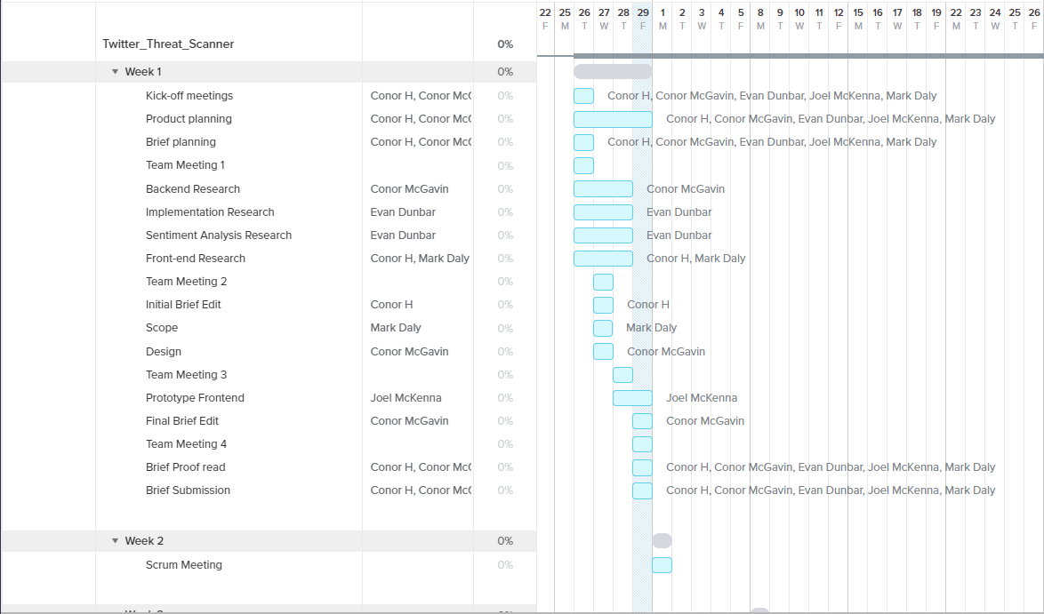
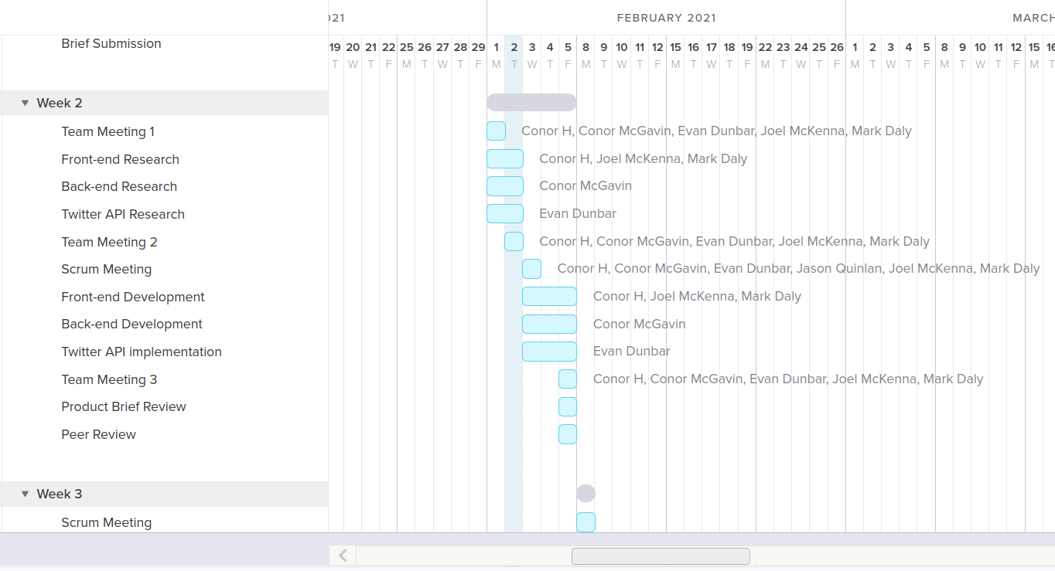

Conclusion

We hope this document puts into perspective both our vision of our product and our vision for good team communication and planning.

We are happy with our current product specifications and although we feel we have a lot to cover, we hope this product can continue to evolve, with more functionality and polish than is outlined in this document.

Thank you for taking the time to read this.

References

Idea Origin - Social Media Threat Alert
Twitter Rules - https://help.twitter.com/en/rules-and-policies/twitter-rules

