**Product Brief - Team Software Project 2**

RED - changes made due to other comments e.g Highlighted words and sentences in bold to improve readability

GREEN - changes made by our own decision e.g Gantt chart

**Overview**

Within our project, we aim to create a threat-analysing scanner for Twitter. The scanner will be created as a web application that will allow users to scan accounts for potential threatening behaviour that is considered to be anti-social, and provide the user with a detailed report at the click of a button on what the algorithm has determined to be dangerous. The user then has the option to disregard the report, or review it and make changes based on what they consider to be the main threat.

Our web application will be named **Tweet Guard Threat Scanner,** and will aim to provide a **user-friendly, quick environment that gives an accurate and detailed reflection** of the threat or lack thereof that may lie within the user's Twitter followers.

Overall, the aim is to create a **simple, sleek and minimalistic web app** that offers users an easy way to **filter out any negativity,** antisocial behaviour or danger from their twitter feed with the click of a button. We aim to create an algorithm that is accurate, helpful and will grow stronger as more users use it.

**Why Is It Needed?**

**In digital times, digital crimes are also rocketing.** People need a way to keep themselves safe from online threats like sexual predators, fraud accounts, internet trolls, etc. Our web application will warn its users whenever a “threatening account” tries to interact with them. This will be perfect for people such as children, women and others who face the most threat online.

Twitter is an open platform where people can look at and talk about current affairs across the globe. With differing points of view, some people may have a perspective on a topic which might be controversial or offensive to other users. Some may also exploit the platform for malicious purposes.

Twitter has a system in place where if a user believes something violates the platform’s rules they can report it. This helps to indicate to the Twitter team that something is going on and they can then decide whether or not to take corrective measures. E.g. They may enforce a user to delete their Tweet, or suspend their account permanently (if a more serious/repeat offence is committed).

Violations are grouped under three separate categories:

**1. Safety**

This includes violent threats, terrorism, child sexual exploitation, harrassment, discriminational hate (e.g racism), intentions/encouragement of self-harm or suicide, sensitive media, and illegal activity.

**2. Privacy**

Includes disclosing other people’s private information, and non-consensual nudity.

**3. Authenticity**

Includes spam, civic integrity, impersonation, synthetic media, and copyright/trademark.

Although the reporting of these violations on Twitter helps to make the platform a safer place, there are a few problems that it does not address:

* It is **inefficient to depend on Twitter staff** to go through each user report and determine what action should be taken. This takes too long for threats to be identified and eliminated, meaning more users are vulnerable for a longer period.
* **Users will be completely oblivious to a harmful account** as they cannot see if it has been previously reported before.

Removed 2 sentences to be concise^

The web application will quickly solve these problems:

* **Reported information is stored in a database,** so threatening accounts can immediately be identified by users.
* **Users will now be able to scan for harmful accounts and see all details of previous reports.**
* Whenever a threatening appearing account tries to interact with a user, the user will be able to **quickly discover if other people have had the same problem,** or if our algorithms have detected said threatening behaviour.
* The web application will show a danger level so that **threats of all sizes are accounted for**. This allows users to make their own decisions on how restrictive they would like their account to be.

**So What Does It Do, And How Does It Do It?**

In our web app, the main function that we are choosing to implement is a “scan” function, which uses **sentiment analysis and natural language processing** to provide a full report on a user’s Twitter followers. We aim to implement at least one criteria on which a user can be determined as dangerous, with **racism** within the tweets of a user at the forefront as our principle area of development.

Removed sentences for brevity and to avoid repetition^

The scan function can be used in two different ways:

* The user can **search for a specific account** and receive a full report on the account.
* The user can enter their own Twitter handle and be given analysis of up to 50 of their most recent followers under a selected criteria on which they choose to search, documented as a **full report which highlights the dangerous** users, and, if possible, **will give an option to unfollow a specific user or mass unfollow all threatening accounts.**

When an account is scanned, a full report is either taken from our database, or, if the account is not already present in it, we will scan the account’s recent activity and return the report to the user, adding it to the database for future users’ scans in the process. The returned report will contain information such as an overall “danger level” of the account, the amount of reports/flags our system or other uses have made on an account in the last month, the common reason for reporting and even some of the tweets in question that may contain said threatening qualities or anti-social behaviour.

When a users tweets are pulled it is pased through a logistic regression model,First test train split is ran on our dataset to split it . Our model is trained to recognise hate speech by passing our dataset and pulled data through a TfidVectorizer; TF-IDF is a measure of originality of a word by comparing the number of times a word appears this is then passed to our model which uses logistic regression or binary regression which will provide a 0 or 1 out based on the TF_IDF from our test and training data of which tweets it considers to be threatening.

Added paragraph on ideas of NLP/sent ^^ give reader an idea of how we’re producing our reports and if it is effective

Removed unnecessary repetition of “our sentiment analysis techniques” and replaced it with an actual description of how it actually works

The user will then even be given a chance based on the mentioned tweets to agree or disagree if there was indeed antisocial behaviour involved and to block/mute/unfollow the user.

Another feature we will be adding is a standalone report function, where users can manually send in a report on an account they believe to be threatening. This will allow for our users to alert each other on accounts that are threatening and that may have flown under the radar of our algorithm.

Removed sentences here to be more concise.^

We would like to add more features as time goes on, **and one main feature we would like to add in future is a fact checker**. With this feature, a user could enter a tweet URL and be returned an answer on whether what is stated is true or false. We feel it would be relevant in today’s society, with reports of “fake news” being broadcasted on a daily basis. Again, it would be implemented with our natural language processing and machine learning techniques.

**What Other Solutions Are Out There?**

There are currently no solutions on the market that deal with this problem. Software security companies such as Proofpoint, FraudWatch International and Mandiant offer solutions to a problem that comes underneath the same category of social media threat protection. However they only protect branded social media accounts (different target market) and only solve a subset of the problems our product deals with.

Their security solutions monitor a wide range of social media sites for fake or fraudulent accounts impersonating a client’s brand. They monitor and detect specific threats across these platforms, alerting the client when a potential impersonator is found which then must be confirmed by the client before the account is subject to removal.

Our product aims to give protection to all users of the Twitter platform specifically because it is where the problem we are addressing is most prominent.

In the past, there has been research done into similar topics that has produced varying results, with some reports of bias towards certain groups of people. We feel that due to the nature of our web app, with its main aim of producing a report for a user for them to then decide if what they have seen is untrustworthy or dangerous, this bias is obsolete. Only the outside bias of a user could influence the quality of our service.

Removed define used case due to repetitive nature of it

**Project objectives & flexibility/constraints**

|  |  |  |
| --- | --- | --- |
|  | **Target** | **Tolerance** |
| **Scope** | Web Application  Reporting System  Database of reported threatening accounts  Threat alert  Danger Level  Scan function (Search specific account for report)  Sentiment analysis & machine learning | If time left over after necessary features are completed:  Can extend functionality to scan all of your followers/ mutual accounts/ unknown accounts sending message requests  Fact Checker to determine if a tweet provides true or false information |
| **Time** | 7 weeks | None as we may finish early but then scope/functionality will be extended |
| **Cost** | No costs | -- |
| **Quality** | Front end of application implemented in HTML, CSS, JavaScript, etc.  Use a Python Web framework to speed up development  Back end database implemented with SQLite  Twitter API used for filtering keywords | Can use Bootstrap to implement front end  Can use Flask framework instead of Django (maybe more lightweight for the purpose of the project)  Database implementation is flexible  Tweepy has what we need but pull limit of 3k followers |
| **Risks** | Team member becomes ill or cannot complete task for other reason | Spread the remainder of the task workload among other members |
| **Benefits** | There are benefits to making the design look nicer or extending functionality to add more useful features | If time is an issue it is more beneficial to keep to a simpler design and to focus on required features only |

**Our Team**

**Overview - Roles**

We analysed our strengths and weaknesses and for the next 2 weeks have allocated roles which will be reviewed and re-evaluated as the project progresses, when people find out what they enjoy/ are struggling with.

* Evan Dunbar - Sentiment Analysis research and development
* Conor McGavin - Back-end, infrastructure
* Conor Heeney - Front-end design and development
* Mark Daly - Front-end design and development
* Joel McKenna - API Research and Implementation, incl. Twitter APIs

**Our Approach**

**Changed this section to remove the need to document the specifics of each week**

We will be taking an Agile approach to the project using Scrum techniques. The typical routine for a week involves our Scrum meeting with the product owner and the whole team. This is where we discuss reflections on the previous week and what needs to be done in the upcoming week. We then have a meeting with the development team, where we discuss the distribution of tasks among members. We then work on our own tasks, separately for the most part. About halfway through the week, we have another meeting to discuss progress and issues. Towards the end of the week, we create the Gantt chart for the week and update the product brief to reflect any changes to the specification.

We aim to understand each other’s roles and work closely and collaboratively to produce an environment where one team member will be able to work independently of another, but know what is expected of them to produce from other team members. This ensures fairness and that there is never one person that feels they are doing everything. We aim to closely follow a plan and reassess on a weekly basis on where the project is, and where it needs to be.

**Bug Fixes Since Beta**

* Fixed issue where three letter usernames didn’t scan and gave no flash messages.
* Fixed issues with the view tweet button on scan results pages.
* Fixed issue where a Twitter user’s ID can be inputted to scan form.
* Fixed issue with total reports page.
* Fixed issue where view total reports page link wasn’t working.
* Fixed errors when user prepends the @ symbol when entering username to scan. (User shouldn’t be able to do this)
* Fixed login/logout issues.
* Fixed visual issues on smaller screens.

**Removed Evolution section Week 3- made document too long, decided to make it a standalone document**

**Gantt Chart**

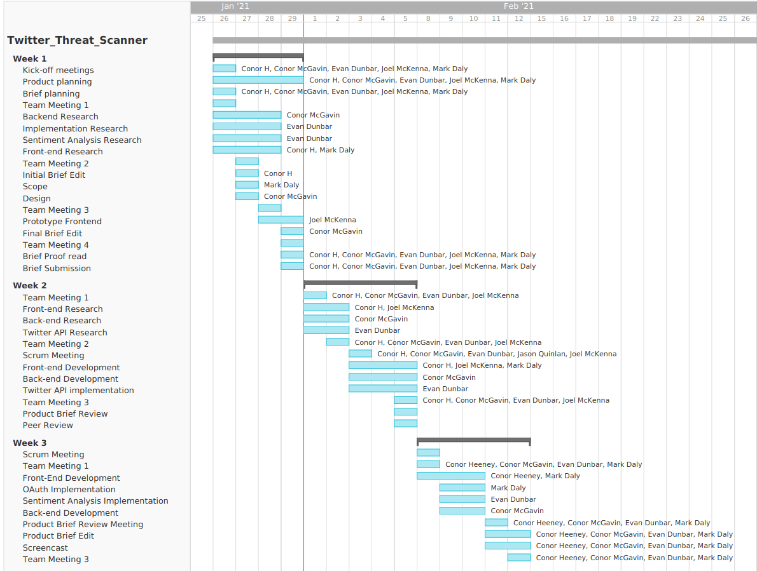

**Conclusion**

We hope this document puts into perspective both our vision of our product and our vision for good team communication and planning.

We are happy with our current product specifications and although we feel we have a lot to cover, we hope this product can continue to evolve, with more functionality and polish than is outlined in this document.

Thank you for taking the time to read this.

**References**

Idea Origin - [Social Media Threat Alert](https://www.codementor.io/@mahil/10-web-app-ideas-you-can-build-as-side-projects-1bimcrdepx)

Twitter Rules - <https://help.twitter.com/en/rules-and-policies/twitter-rules>