Q5. Write an android program for Notification.
MainActivity.java
package com.example.notieg;
import static com.example.notieg.R.id.btn;
import android.app.Notification;
import android.app.NotificationChannel;
import android.app.NotificationManager;
import android.app.PendingIntent;
import android.content.Context;
import android.content.Intent;
import android.net.Uri;
import android.os.Build;
import android.os.Bundle;
import android.view.View;
import android.widget.Button;
import androidx.activity.EdgeToEdge;
import androidx.appcompat.app.AppCompatActivity;
import androidx.core.app.NotificationCompat;
import androidx.core.graphics.Insets;
import androidx.core.view.ViewCompat;
import androidx.core.view.WindowInsetsCompat;
public class MainActivity extends AppCompatActivity {
NotificationManager nm;
Button btn;
@Override
protected void onCreate(Bundle savedInstanceState) {
super.onCreate(savedInstanceState);
EdgeToEdge.enable(this);
setContentView(R.layout.activity_main);
ViewCompat.setOnApplyWindowInsetsListener(findViewById(R.id.main), (v, insets) -> {
Insets systemBars = insets.getInsets(WindowInsetsCompat.Type.systemBars());
v.setPadding(systemBars.left, systemBars.top, systemBars.right, systemBars.bottom);
return insets;
});
btn = findViewById(R.id.btn);
if(Build.VERSION.SDK_INT >= Build.VERSION_CODES.O)
{
NotificationChannel ch = new NotificationChannel("CHANNEL1","SIESCOMS",
NotificationManager.IMPORTANCE_HIGH);
ch.setDescription("SIESCOMS Channel");
nm = (NotificationManager) getSystemService(Context.NOTIFICATION_SERVICE);
nm.createNotificationChannel(ch);
}
btn.setOnClickListener(new View.OnClickListener() {
@Override
public void onClick(View v) {
Notify();
}
});
}
private void Notify() {
Intent notify_intent= new Intent(Intent.ACTION_VIEW, Uri.parse(("https://siescoms.edu.in")));
notify_intent.setFlags(Intent.FLAG_ACTIVITY_NEW_TASK);
PendingIntent pintent = PendingIntent.getActivity(this,
0,notify_intent,PendingIntent.FLAG_IMMUTABLE);
NotificationCompat.Builder bld = new NotificationCompat.Builder(
this,"CHANNEL1");
bld.setSmallIcon( R.drawable.baseline_whatsapp_24)
.setContentTitle("College Website")
.setContentText("Open College Website")
.setPriority(NotificationManager.IMPORTANCE_HIGH)
.setAutoCancel(true);
bld.setContentIntent(pintent);
nm.notify(0,bld.build());
}
}
AndroidManifest.xml

<?xml version="1.0" encoding="utf-8"?>
<manifest xmlns:android="http://schemas.android.com/apk/res/android"
xmlns:tools="http://schemas.android.com/tools">
<uses-permission android:name="android.permission.POST_NOTIFICATIONS"/>
<application
android:allowBackup="true"
android:dataExtractionRules="@xml/data_extraction_rules"
android:fullBackupContent="@xml/backup_rules"
android:icon="@mipmap/ic_launcher"
android:label="@string/app_name"
android:roundIcon="@mipmap/ic_launcher_round"
android:supportsRtl="true"
android:theme="@style/Theme.Notieg">
<activity
android:name=".MainActivity"
android:exported="true"
android:windowSoftInputMode="adjustResize">
<intent-filter>
<action android:name="android.intent.action.MAIN" />
<category android:name="android.intent.category.LAUNCHER" />
</intent-filter>
</activity>
</application>
</manifest>

OUTPUT -
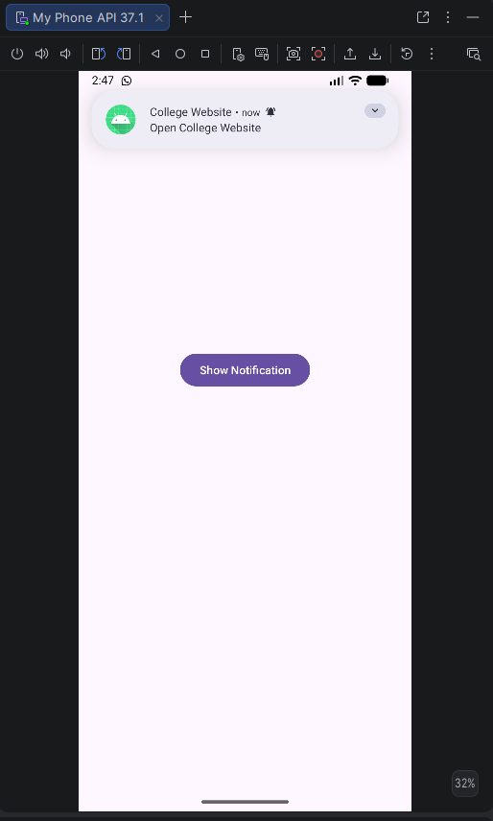
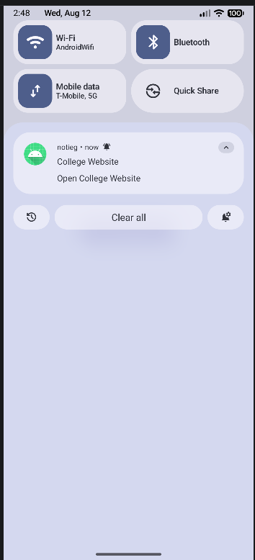

After clicking the notification - college website should open

