RAMSES

Relief Aid Management System for Emergency Shipments

World Food Program
Lilongwe

© Paul Kirkaas
February 1995

Ramses
User and Technical Manual

Table of Contents
Introduction:
Overview:
Motivation:
Features:
Future Directions:
Drill Down:
Blow Up:
Specifications:
Technical Support:
Operation:
Start Up:
Entry / Data Input
Internal Distribution:
Add NEW Waybill
Delete Waybill
Go To Waybill
Adding New Waybills:
Waybill/ATC Number:
Target Month/Period:
SI Number:
Truck Registration Number
Transporter
Routing:
Mileage/KMS
Dates:
Cargo:
Unit Shipping Cost
Calculated Fields
Finishing Entry:
Incoming Shipments:
Waybill Number
Foreign Port
Collection Point / EDP
Transporter
SI Number
Commodity:
Dates:
Unit Weight & Numbers of Units:
Calculated Fields
Finishing Entry:
Distribution Plans
Target Tonnage
Target Populace
Serviced Populace
Data Analysis and Reporting:
Printing Reports:
Report Types:
Domestic Movements:
Customization Dialog Box:
Period:
Scope:
Resolution:
Reports:
ByArea:
BySI:
ByTransporter:
Incoming Shipments:
External to EPA:
Aggregates:
Balances in EDP’s
Transport and Storage Costs:
Comparisons:
Center and ATC Mileage Differences
Verification:
Centers:
Domestic Transporters:
International Transporters:
Waybill Checklist:
International Delivery Checklist:
Maintenance / Administration:
Installation and Setup:
Loading External Shipment Records from another Database
Data Verification:
Reference Tables:
Domestic Transporters:
International Transporters:
Default Transport Rate:
Ports:
Countries:
SI Numbers:
Commodities:
EDP’s, Districts, EPA’s and Centers:
Routine Maintenance and Backup:
Data Compaction:
Backup:
APPENDIX Sample Reports:
Figure 1 Report: By Area
Figure 2 Report: By SI
Figure 3 Report: External to EPA by SI
Figure 4 Report: Balances in EDP's
Figure 5 Report: Transport and Storage Costs

RAMSES I

Relief Aid Management System for Emergency Shipments

Introduction:

Overview:
This program keeps track of shipments of commodities as they are brought into the country, stored, and disbursed through distribution centers around the country.
The basic unit of input is the waybill, of which there are two classes:
- Incoming Shipments: These record the importation of food shipments into the country from the most proximate port of lading. Keeping track of this information tells you how much food from different donors you have brought into the country and, combined with the data from internal distribution, below, tells you how much food you should have left undistributed in your warehouses at any given time.
- Internal Distribution: This is the shipping record/waybill (also called Authority to Collect, or ATC) of shipments from the local storehouse (called an EDP) to the local Distribution Center, where the food is actually disbursed to the hungry. Keeping track of this information tells you how much you have distributed to the people -- in total, by region, by district, by month, by year to date, by Donor, by SI, etc. In addition, this module has an automatic billing / charge calculation component. It calculates the expected transport charges based on the tonnage and distances. This can be used to verify the bills issued by the transporters, and calculate transport charges by area, SI, period, etc, or any combination thereof.
Each of these datasets can be recorded and reported on separately and independently of each other, but together they combine synergistically to give a much better overall picture; for instance, to estimate how much food you have left in a warehouse, you have to know how much has come in and how much has gone out.

Motivation:
There are several other commodity tracking programs available -- why another? Let’s face facts -- some of these other systems can be difficult to interfais with. Workers (and even managers) in the development community occasionally have more important issues to struggle with than computer literacy. DOS based packages, while potentially sophisticated, have not been noted for ease of use. The guiding principle behind every phase of Ramses development has been ease and clarity of use. This has of course been a goal in other systems, but Ramses benefits from the advantage of being developed in the Microsoft Windows environment, which is structurally more user friendly than DOS.
Because Ramses uses the latest software development tools, the development cycle is much faster. This means that new features can be added quickly and cheaply, allowing for quick customization for specialized needs. For example, this version of Ramses was developed in three months for a cost of less than US$6000 (not counting the time, effort and costliness of management). This makes customization possible in locations around the world which have been unable to use existing standard packages because of unique local conditions, but have heretofore been unable to afford the standard costs of customized programs, which typically cost tens to hundreds of thousands of dollars and take a year or more to develop.
Ramses also attempts to provide a bigger picture by combining low level distribution data with large scale grain movements to track the grain from foreign port to needy recipient.

Features:
If data is entered correctly (the greatest vulnerability of the system) Ramses can report:
- How much relief food was picked up, distributed, lost, or damaged throughout the country by Distribution Center, EPA, District, EDP and/or SI Number; for any given month or range of months.
- Calculate expected transporter charges by individual shipment, center, EPA, district and EDP totals for a given month or range of months for verification of transporter billing.
- Compare all transporters used in a given period to report on total mileages, charges, tonnages carried and lost, and percentage of load lost or damaged for each transporter. Can be used to identify patterns if some transporters have consistently high losses, etc.
- Compare food targeting (in Metric Tons) with actual deliveries for any month or range of months by EPA, District and EDP.
- How many tons were delivered to each EDP, how many tons were distributed from each EDP, and thus how many tons should be remaining at each EDP (by SI or in aggregate), for any selected period.
- Trace SI commitments from foreign ports of loading to domestic EDP’s, districts, and EPA’s. For each SI, report the total commitment amount; the amount of initial commitment which has been collected from the external ports and delivered to the EDP’s, the amount of that which has been actually disbursed at the distribution centers, and the balance of the committed amount not yet delivered to the EDP’s.

Future Directions:
This version of Ramses provides a framework of basic services for essential reporting. Some future goals include:

Drill Down:
(Greater detail and analysis in-country)
- Transport Cost Projections: With the data already collected for Targeting and Distribution Centers, it will be possible to estimate transport costs for any period (month, quarter, total emergency duration), by district, region, SI, etc.
- Beneficiary Reporting: Again, with the data already collected, Ramses II will report on number of beneficiaries expected, number reached, average distribution per beneficiary, by district, region, month, etc.
- Distribution / Delivery Comparisons: Food that gets delivered to centers but not distributed to recipients is a big problem. Ramses II will identify and report those centers which have the greatest problems.
- Food Budget Projections: Project total grain requirements or by district or EPA for any given month, period, or duration of entire relief project.
- Collect data directly from the transporter on uplift information. Ramses now collects data only when shipments have been received at the district and the completed waybill has been forwarded to TLU. Consequently, the data is typically weeks or months old, and there is no way to identify shipments which have been loaded and sent out from the warehouse but not received, or waybills that have been lost. The transport broker typically collects the essential uplift information every day on a primitive dBase or spreadsheet system. Ideally, this data should be provided on disk by the transport broker and loaded automatically into Ramses II to provide up to the minute sit reps (situation reports) and to help track shipments which have gone astray.
- Food for Work: Food Accounting Module -- Collect data on food for work projects, participants, beneficiaries; HSD’s (Homo Sapiens Days) of work projected, performed, paid, etc.

Blow Up:
(Bigger Picture)
- Track the shipments and commitments farther back to the source. This information is generally available, but occasionally not well co-ordinated. In those rare instances when a donor expresses interest in the disposition and status of its donation, incorporating this data into Ramses II will allow WFP to print up a quick but complete status report while the donor waits on hold from, say, an unnamed capital of the world’s remaining superpower.
- Combining the large and small pictures, Ramses II will use future shipping schedules with the Targeting Projections to plan shipments, reduce storage costs and spoilage, and monitor grain reserves compared with projected arrivals and requirements.

Specifications:
Ramses is a Windows program. It requires the Microsoft Windows environment (3.1 or higher), a super VGA color display (600x 800), and an IBM compatible PC with at least 6 Megabytes of memory, 386 CPU or higher. Ramses will take about 15 megabytes of hard disk space.
Almost all IBM type PC’s have high resolution super VGA displays, but are set up in standard VGA mode by default. To set up windows in Super VGA mode on your machine, or if you are confused by these specifications, see your local System Administrator. Ramses can in fact work with standard VGA and only 4 megabytes of memory, if you have very patient data entry personnel.
Ramses is expandable, and can import data and files with DBase, FoxPro, Paradox, Lotus, Excel, Informix, Oracle, etc. This means that it can import and use data which was entered on other systems -- spreadsheets, databases, or any of the existing WFP commodity tracking packages -- FACTS, INTERFAIS, NOMAD, etc.

Technical Support:
Ramses was developed on the Microsoft Access development platform. To do any modifications to it, you must have access to an experienced Access developer. In case of any questions, contact:
Paul Kirkaas
268 Broadfield Road
New Rochelle, New York 10804
USA
Tel (+1) (914) 235 1512

Operation:
The operation of Ramses is divided into three areas:
Entry / Data Input
Reporting / Data Output
Maintenance / Administration
Often these functions will be carried out by three separate people. This can be dangerous, as often each assumes the others are carrying out responsibilities they are not. Unless care is taken with each stage of the system, incorrect information will be reported and possibly acted upon for some time before the problem is detected. Furthermore, the longer errors are allowed to propagate within the system, the more difficult it becomes to correct them. The implementing agency must be willing to undertake the responsibility of operating the system properly, or it is better off without it.
In particular, the system administrator is responsible for maintaining the reference tables. The reference tables record which distribution centers are being used; in which EPA’s, Districts and EDP’s the centers are located and the standard mileages to them. The reference tables record which SI numbers are current and allowed to be entered into the Waybills; which transporters, which commodities the system recognizes and accepts. If the system administrator is unavailable and no one else knows how to perform this function, data entry will likely come to a stop.
The system administrator is responsible for ensuring proper organization and completeness of the data. The data entry person is responsible for entering the data provided; usually not for tracking down the data and making sure it is complete and correct. It is also the job of the Sys Admin to make sure the data entry personnel understand what they are entering, thus preventing mistakes before they occur.
The Sys Admin must regulate access to the computer to keep it clear of viruses and careless users. The Sys Admin must check and maintain the file system on the computer, periodically checking for cross linked references in the FAT’s, lost clusters, file fragmentation, and other potentially serious problems before they cause major breakdowns. The sys admin must perform periodic (hopefully daily, AT LEAST WEEKLY) backups of the critical data so that if there is a major breakdown, the system can be set up on another computer with latest backup installed, ready to run just where you left off, within a few hours. Finally, as department and project managers around the world have discovered, the most important purpose of the system administrator is to have someone to blame in the event of a crisis.
There is too great a tendency among newly computerized organizations to neglect the managerial involvement in a data processing system once it is up and running smoothly; but this is a recipe for eventual program failure. It’s like buying a new car and then trying to save money by not changing the oil. The engine blows up, you’re out $20,000, and you blame Toyota. Don’t let this happen to you.

Start Up:
To start Ramses, double click on the Ramses icon: . This will start up the program with the initial switchboard screen. From this screen, the user selects from the data entry choices, the reporting choices, or the system management choices. All the different components and screens are reached by clicking on a series of windows command buttons, each of which opens another screen and often another set of choices, as illustrated:
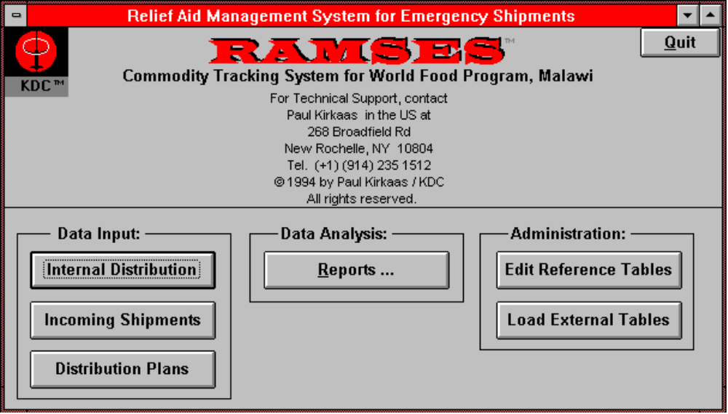
We discuss first the data entry.

Entry / Data Input
There are three types of data which are entered.
The Internal Distribution screen records the shipments within the country, from the EDP’s to the final distribution sites/centers. This entry is based on the Waybills/ATC’s used by the shippers and tracks what commodities went where; who took them, how much was lost or damaged, etc.
The Incoming Shipments screen records the shipments which enter the country from the external port. This is important because it tracks what provisions and SI commitments were actually received into the country, and allows us to determine what stores should be remaining in each of the EDP’s.
The Distribution Plans screen accepts entry of the distribution plans (how much maize to be distributed where) for each month for each EPA, along with estimates of the serviced population.
As a general note: If you are having difficulty, or regret your entry, pressing the escape key once undoes the changes or additions to the current field. Pressing the escape key twice undoes the changes or addition for the entire waybill record.
The entry screens are accessed by clicking on one of the three command buttons on the main switchboard screen, as below:
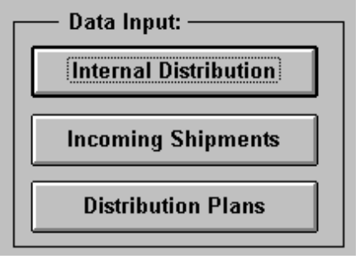

Internal Distribution:
Internal distribution entry is based on the paper waybills/ATC’s. The standard transportation charge per kilometer is subject to change with the economy and different batches of waybills may have different transport charges. Therefore, the first screen which opens asks the user if he/she wants to change the default shipping charge used for the next batch of new entries. The user must click Okay (if he/she has made any changes) or Cancel (if there is no change to be made, Cancel will be faster). After that, the waybill entry screen opens.
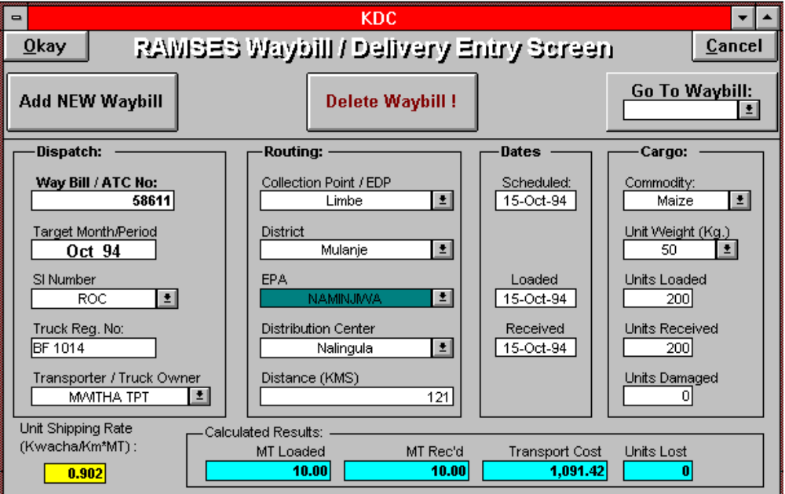

There are three options provided at the top of the Waybill/ATC Entry screen:

Add NEW Waybill
This is the default state in which the screen opens. All fields are blank except for fields with default values; the system is prepared to accept entry for a new record.

Delete Waybill
This will delete the current waybill displayed in the screen. The user will be asked to confirm the deletion to prevent accidental erasure.

Go To Waybill
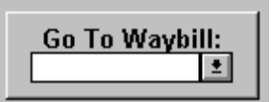
This presents a white entry box with a grey down arrow next to it. To go to a particular waybill, the user can either enter the waybill number directly into the white box, or click on the grey arrow to choose the existing waybill number from a list of all waybills in the system. It is even possible to use a combination of these techniques; that is the user may type in only the first two digits of the waybill number, then click on the arrow to choose from a list of only those waybills beginning with those two digits.
After pressing enter or tab, the screen will load the record containing the information from the specified waybill. The user can then modify or correct information recorded there; or delete the entire waybill by using the delete button described above.

Adding New Waybills:
Each waybill is entered once, in the following sequence:

Waybill/ATC Number:
The Waybill number uniquely identifies the record being entered. It is the only way to trace back the information to the original shipment record. It is essential that this number is entered correctly; thus the user must enter this number twice, to ensure accuracy. In order to prevent the accidental entry of the same waybill several times, duplicate waybill numbers are not allowed. Note however, in the Incoming Shipment entry screen, because waybills are issued by several different shipping agents, there are sometimes two different shipments with the same waybill number. For incoming shipments, therefore, the system accepts duplicate waybill numbers, after warning the user that a waybill with that same number has already been entered.

Target Month/Period:
The target month is the month for which this shipment has been allocated. Usually, this is the same month as the month of the shipping date, but occasionally allocations for one month are shipped early in the next. It is important to keep track of the target month for allocation and planning summaries.
The Waybill / ATC forms have a space provided for Period, which is the target month. This field is occasionally filled in by the issuer of the ATC, and occasionally not. The issuers should be provided with instructions on how to fill in the ATC’s to meet the data entry requirements, but until this is done, the month of scheduled shipment date is used as the target month.
The entry for Target Month/Period is in the form of 3 letter month abbreviation followed by a space and the year; e.g., Jan 96

SI Number:
Only existing SI commitments already registered in the system are allowed in this field. Therefore, the user is limited to the list of SI numbers available from the pull down list. Again, the user may enter the number directly into the field, or select the SI directly from the list.

Truck Registration Number
This field is used to track trucks used, in order to identify any patterns of unusual usage, loss, or damages. Sometimes two registration numbers are given -- use only the first one listed. Enter the registration number without any spaces -- for example, enter BH1607 rather than BH 1607. Otherwise, they will be recorded as different registration numbers and different trucks.

Transporter
As above, the Transporter is tracked in order to identify potential problem patterns; for example if a particular transporter has a pattern of both atypical transport losses as well as atypically heavy usage by the shipping agent.
The transporter is selected from a pull down list of existing transporters.

Routing:
The routing is specified from the EDP to the District to the EPA to the Distribution Center. It must be entered in that particular order, as the EDP determines the possible districts, the district determines which EPA’s, and the EPA determines the available Centers.
The waybill/ATC form was designed before EPA’s were used in distribution tracking, however, and the EPA is not recorded on the waybill. Until new waybill forms are designed, therefore, the EPA is not selected directly in this release of the program. Instead, the user selects the district, and then selects the center directly thereafter. Since Ramses knows what centers lie in each EPA, it uses the center chosen to look up the appropriate EPA and fills in the EPA after the center is chosen. This is automatic and requires no input form the user.
In order to ensure accuracy, the user is required to verify the choice of center.

Mileage/KMS
This field records the mileage (kilometers) traveled by the transporter to calculate the billing charge. This is usually a standard mileage based on the accepted distance from the EDP to the Distribution Center. Thus, mileages are stored with the center in the database, and if the mileage field has not already been filled in, the software automatically fills it in with the standard distance to the center when the center is chosen as above.
However, in some cases, different, non standard mileages are used. For example, a bridge or road may be washed out during the rainy season, requiring the truck to take a detour and thus incur a longer transport route. In this case, the user can override the default value provided by the system and manually enter the non standard mileage for the particular shipment.

Dates:
Three shipment dates are entered -- the scheduled date; the date of pick up, and the date of delivery.

Cargo:
This section records information about what was actually carried -- the commodity, the unit weight, number of units loaded, number received, and damages. The tonnages are calculated automatically from the unit weight * number of units, and are displayed at the bottom of the screen in blue highlight for reference and verification.
In order to balance the conflicting goals of accuracy and ease of use, the system compares the entries for the number of units loaded to the number of units received. In most cases these two numbers are the same, and thus provide a basis for verification of entry. If the numbers are the same, the computer accepts both silently. If the numbers differ, the computer pops up a message box informing the user that the two entries were different. This is not always an error, as the numbers are different in the case of shipment losses, so the user has the choice of confirming that the variance was deliberate, or can make the necessary correction if the difference was the result of an entry error.
The number of units damaged is the number of units which were delivered in a damaged condition. This is an important point, as the entry clerk often will include the number of units lost, that is, not delivered, in this field. This is wrong. The number of units lost is calculated automatically from the difference between the number of units loaded and the number of units received.

Unit Shipping Cost
Typically, the user should never have to enter or modify this field. It should be constant and the same for all shipments made at the time the given rate was in effect. The field is therefore filled in automatically for all new records with the default value specified at the time the entry phase is started. However, errors can occur, and the user is provided access to this field in order to go back and correct any errors which may have occurred in an earlier entry phase. Because it is not a usual entry field, it is highlighted in yellow, and the cursor will skip over this field unless the user specifically moves to it with the mouse.

Calculated Fields
These fields allow no entry, but show the results of calculations derived from the entered data, such as metric tonnages, amounts lost, etc. This information is provided to allow the user to make a quick verification of the data entered. For example, loads are often reported in both numbers of units and metric tons. The user is required only to enter the number of units, but can see the calculated tonnages and compare them the tonnages reported on the waybills to confirm the entry and calculations.

Finishing Entry:
As long as the user has more waybills/ATC’s to enter, he/she can tab past the last field on the screen, and Ramses will automatically open up a new blank record to continue the next entry. As a time saving convenience, the user will be asked if he/she wishes to continue using the same center as for the previous entry, as the waybills often come in batches by center.
When the user has finished entering the current entry session, he/she clicks on the Okay button to end the session and save the work.

Incoming Shipments:
The screen for Incoming Shipments is similar to that for Internal Distribution.
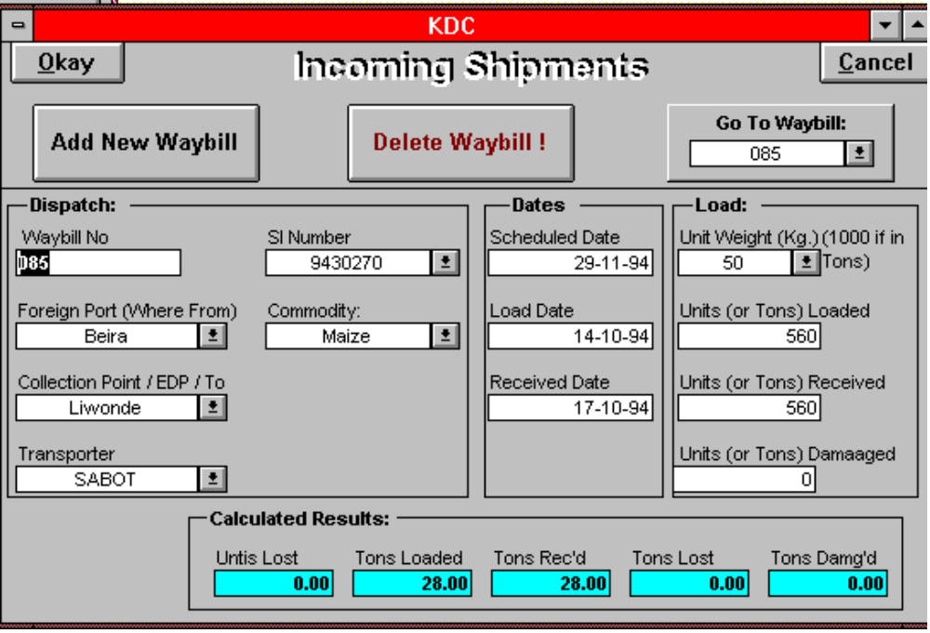
There are three large buttons at the top, to enter new shipments, to delete and modify (Go To) existing shipments. The only difference in going to an already entered waybill is that in the Incoming Shipments segment of Ramses is possible to have two waybills with the same number (for reasons outlined below and above in the discussion on entry of waybill numbers). Therefore, when choosing the waybill from the pulldown list of the Go To button, the user must look for not only the waybill number, but the SI numbers and origins of the shipment as well (all of which are provided in the pulldown list) to confirm the correct choice of the waybill.
The entry is simpler in this section, because less detail is being followed.

Waybill Number
Enter it, and enter again for confirmation. Again, since multiple shipping agents from various nations are used for incoming shipments, it is possible that on occasion, different agents will issue the same waybill numbers. Therefore, unlike the case with Internal Distribution above, duplicate waybill numbers are accepted, though the user is warned by the system and must confirm his/her desire to enter the same waybill number twice.

Foreign Port
This is the most immediate external foreign port of loading whence the commodity is imported into the country and delivered to the EDP. It is not the country of origin, but rather the most proximate port of loading.

Collection Point / EDP
This is where the imported commodity is delivered to, for later distribution to the domestic centers.

Transporter
This is the transporter carrying the shipment. The transporter is selected from a pull down list similar to the above for internal distribution, but the list of transporters is different, as these are international transporters.

SI Number
Exactly as above; the SI number is selected from a list of SI’s already entered into the system.

Commodity:
What is being imported. Typically, this is Maize, and that is what the field defaults to. The user can select another commodity from the list.

Dates:
As above; the scheduled date, the date of loading, the date of delivery / receipt.

Unit Weight & Numbers of Units:
This is a source of occasional confusion. Loads, losses, damages, etc are sometimes reported in units, sometimes in metric tons. The most direct and logically aesthetic way to deal with these two types of situations is to simply consider a ton as one unit. Thus, when loads are reported in tons, the unit weight is set to 1000, and all the units are in metric tons. In fact, the unit weight defaults to 1000 Kg. (One Metric Ton), so no adjustments are required to record the load, damages, etc in tons.
Yet during entry, the unit weight is occasionally left at 1000 while the number of units are recorded in Kg; so that a 45 ton load becomes 45,000 tons. A few errors of this sort can quickly distort reporting results. Thus, particular care is required in this regard.
To keep the user mindful of this distinction, a small message box is flashed just before the user begins entering the load amounts.

Calculated Fields
As above, these fields allow no entry, but show the results of calculations derived from the entered data for a quick verification of the data entry process.

Finishing Entry:
As above. As long as the user has more waybills to enter, he/she can tab past the last field on the screen, and Ramses will automatically open up a new blank record to continue the next entry. When the user has finished entering the current entry session, he/she clicks on the Okay button to end the session and save the work.

Distribution Plans

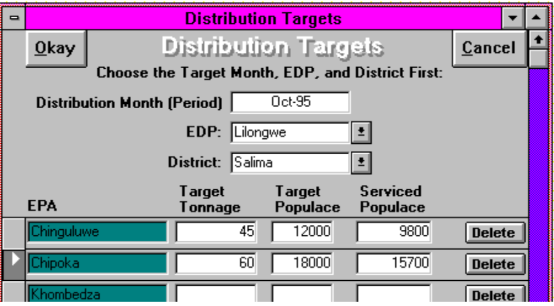
To enter distribution plans, the user clicks on the Distribution Plans button on the main switchboard, which opens up the distribution plans / targets entry screen. Plans are set by month per EPA. The user must first enter the month of the plan. The EDP and District must be chosen in that order -- then the list will automatically be filled with all EPA’s of that district.

Target Tonnage
This is the number of metric tons of relief food planned for this EPA in this month. This information is used on the monthly distribution reports produced by Ramses which show how close the distribution came to meeting its goals.

Target Populace
How many people are expected to be assisted this month at this EPA.

Serviced Populace
After the actual distribution, District Commissioners are meant to file reports on who and how many were assisted by each distribution. These monthly EPA aggregates can be entered here.
Click on Okay to finish the entry process.

Data Analysis and Reporting:
Reports are selected from the Report Selection Switchboard:
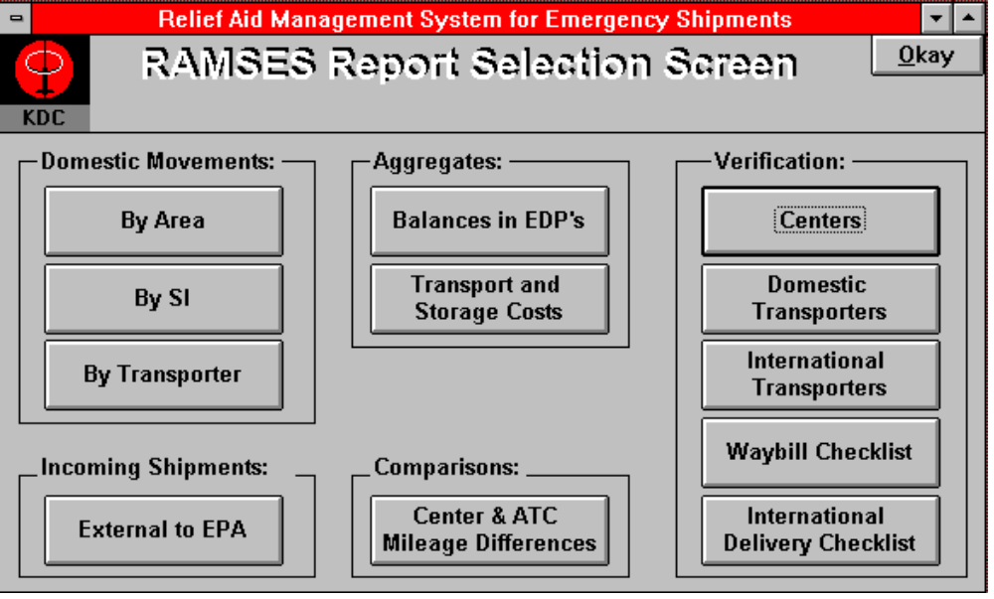
Several report types are provided by Ramses. Furthermore, many of these reports are very flexible and can be customized by the user at run time. Thus it is important for the user to have a good understanding of the reporting structure in order to enable him/her to construct and extract the most useful information.
There are five groups of reports. Two of them, the Verification group and the Comparison group, are mostly used to help the system administrator maintain and verify the system.
The Domestic Movements group contains reports that offer various ways to examine the internal distribution of commodities from EDP to center. Movements can be analyzed by area, SI/Donor, or transporter.
The Incoming Shipments group contains the External to EPA report which tracks SI commitments from the foreign ports all the way down to the EPA distributions, showing total deliveries, undistributed balances remaining in EDP’s, etc..
The Aggregates group contains a single, simple one page report, Balances in EDP’s. The External to EPA report mentioned above reports balances in EDP’s by SI number; the Balances in EDP’s report here reports balances in each EDP for all SI’s, and the total of all the EDP’s in the country.
For illustrative examples of reports described below, see appendices.
To open the report selection screen, click on the Data Analysis / Reports... button on the main switchboard screen.

Printing Reports:
To print a report, click on the button for the report you wish to print. First, a customization dialog box will open, asking to specify the details on which you wish to report (dates, area, etc). When you have defined the parameters for the report, click on the Okay button of the dialog box. A preview of the report will then appear on the screen (this may take a few minutes). If you are satisfied with the preview and wish to print the report, click on the File menu option (Top left corner of the screen), then click on the Print ... sub menu item to open the print dialog box, In this box you can select the page range you want to print, the printer you want to print to, etc. When you have made your choices, click Okay in the print dialog box to send the report to the printer.

Report Types:

Domestic Movements:
The domestic movements group
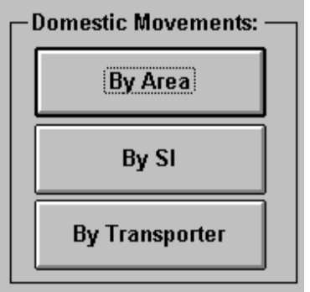
offers reports which analyze the distribution of relief food from the EDP down to the level of individual distributions. When one of these reports is selected, a customization screen opens to offer the user the chance to define. The customization screen is different for each report, but in all three cases they share a common structure and conceptual design.

Customization Dialog Box:
The dialog box / customization screen illustrated below is for the most general report -- By Area. The other boxes are similar.
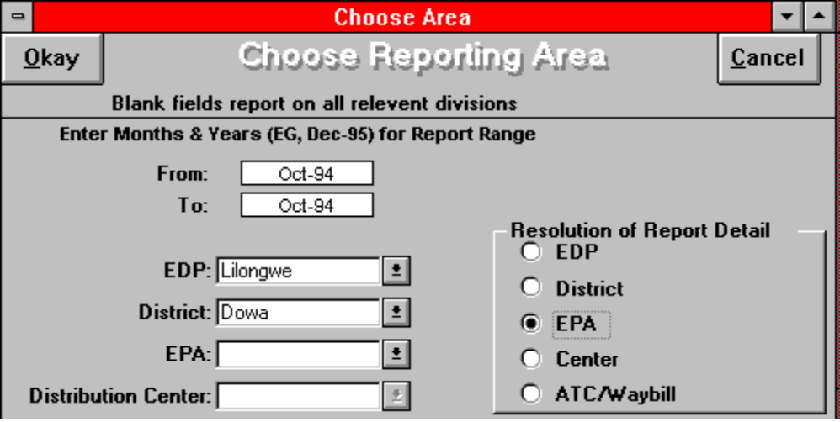
The customization box can be conceptually divided into three sets of choices -- period, scope and resolution.

Period:
The first decision to be made is the period of the report. This is entered by starting month through ending month (inclusive). That is, if October is specified as the start (from) month, and December as the end (to) month, the report will include the results for the entire three month span.
By default, after the user enters the starting month, the finishing month is automatically filled in with the same month. This results in the standard single month report; in the example above, for the month of October. Thus, the user can choose to report shipments and totals for the month, for the quarter, or for the entire famine year.

Scope:
By choosing the scope of the report, the user can choose to limit the data reported on to a particular EDP, District, EPA or Distribution Center. Blank fields select for all values, so that in the example above, the report will be limited to shipments within the Lilongwe EDP and the Dowa district; but all EPA’s and Centers within Dowa will be reported on.
The choices at each level are determined by the choices made before -- note in particular the dependence upon the choice of reporting period. That is, the choice of districts that would appear in the District Pull Down list are not necessarily all the districts served by the Lilongwe EDP, but only those districts which have received distributions from the Lilongwe EDP in the month of October 1994. This prevents reporting on non-existent shipments, but can be confusing if the user can not find a Salima district under Lilongwe EDP when he/she knows that district exists.

Resolution:
This allows the user to specify the degree of detail reported on. The default resolution is the greatest detail -- down to the each individual ATC/Waybill/Distribution detail for period and centers selected.
The next level of resolution (Centers) reports only the totals for the centers selected in the period -- not the details on each individual delivery.
The level above that (EPA) reports on the totals for the EPA’s, and so on.
So in the sample customization dialog box above, the report would show for the month of October, 1994, the totals for all deliveries to all the EPA’s in the Dowa district of the Lilongwe EDP.

Reports:

ByArea:
As in the example given above, reports on all shipments for a given month or range of months, by EDP, District, EPA, and Center. You can select the particular area on which to report, as well as how much detail (individual shipments, center totals, EPA totals, District totals, etc) you want to see.

BySI:
In appearance, very much like the ByArea report above, except that the first grouping is by SI -- so that for each SI selected, you see the delivery totals (sub grouped by EDP, District, EPA and Center) and shipment details for that SI only.

ByTransporter:
In this case, the report is grouped first by Transporter, then by Truck Number, and then sub grouped by EDP, District, EPA, Center. This report allows you to look for patterns among transporters -- if one transporter has excessive losses, etc.

Incoming Shipments:

External to EPA:
This report traces SI commitments from the most proximate external port (Harare, Beira, etc) to their arrival at the local EDP, then its eventual disbursement out to the EPA’s.

Aggregates:

Balances in EDP’s
This report shows the totals for all shipments brought into the EDP’s from abroad, the totals of all shipments distributed from the EDP’s to the distribution centers, and the difference between the two, which is how much one would expect should still be at the EDP warehouses.

Transport and Storage Costs:
The user must enter the reporting period desired, and the average storage rate per ton for the period. Ramses calculates the total transport and storage charges as follows:
The storage costs are calculated from the total tons received (imported) in the period in question. The calculated storage cost for these shipments are based on the current practice of a fixed cost per ton, regardless of length of storage period.
The transport costs are based on the tons distributed out of the EDP’s to the distribution centers. When selecting the distributions by period, the target month of the distribution is used -- that is, if a shipment was scheduled to go out in October as part of the October uplift, but was actually transported on 3 November, it will still be included in the October report, not the November.
So this report shows the average storage cost per ton, the number of tons received, and total storage costs for shipments received in that period.
On the next line, it shows the average transport cost per ton of all distributions made in this period, the total tonnage distributed, and the total transport cost.
Finally, it totals the two for a combined shipping and transport cost for the period.

Comparisons:

Center and ATC Mileage Differences
Ramses records standard shipping distances from EDP to distribution center. Sometimes an individual shipment is forced to use a detour, and therefore charges based on a mileage different from the standard mileage. This report lists all waybills where the charged mileage is different from the standard mileage. This can be used to look for suspicious patterns of excessive charging, or can be used to check for mistakes of mileage data entry.

Verification:
This group of reports is used to ease administration and maintenance. They are used to help assure data accuracy and completeness.

Centers:
This report lists by EDP, District and EPA, a list of all Distribution Centers stored in the system, along with the Standard Mileages. It also lists the average mileages for all centers for every EPA, District and EDP.

Domestic Transporters:
This report lists all Domestic Transporters recorded in the system. Domestic Transporters are those which only transport relief shipments within the country, from EDP to Distribution Center.

International Transporters:
This report lists all International Transporters stored in the system. These are the Transporters which are sent into the country from foreign ports, bringing shipments to the EDP.

Waybill Checklist:
This report lists all relevant information stored for the domestic (internal) shipments by ATC/Waybill Number -- for all waybills, or for a specified range of waybill numbers.

International Delivery Checklist:
This report lists all relevant information stored for the incoming (international) shipments -- for all waybills, or for a specified range of shipment months.

Maintenance / Administration:
As system administrator, you have important responsibilities. One of these responsibilities is to keep a system log or notebook. This is for your own convenience and reference, so you know what you did when; and also so someone else can pick up where you leave off when you move on to a more rewarding job where your computer expertise is appreciated and reasonably compensated.
One of the most important functions of a system log is to record user complaints, problems and requests. Any first generation software system will have irregularities; that is to say, bugs. If a user finds a problem with the system, document it! If you don’t write it down, it will never get fixed. Users also often discover the need for new features. Write those desires down as well -- if anyone ever does try to enhance the system, he or she will be far more effective with the information your log will provide.

Installation and Setup:
Ramses comes on four 3 ½ inch floppy disks. The system is installed by entering Windows and running the program called setup.exe on disk 1. The setup program will prompt you for any actions required. The default installation directory is c:\bin\kdc. You are advised to use this directory as the installation directory unless you have a particularly good reason for not doing so.
There are two files in particular the administrator needs to understand. The file emuacode.mdb contains the program code for Ramses. The file emuatbls.mdb contains all the data and tables for Ramses.
It is this second file, emuatbls.mdb, that will differ after being installed on different machines. It is this file which must be backed up regularly (daily) on diskette to make sure that even if there is a problem with the computer, you never lose more than one day’s worth of data.
The administrator should maintain several copies of the original installation diskettes at different locations in order to be able to install the software on different machines. Just copying the files in the c:\bin\kdc directory from one machine to another won’t work.
Another issue to consider is the challenge of keeping the reference tables synchronized if Ramses is running on two different machines and you want to combine the data from the two.

Loading External Shipment Records from another Database
- On the Source Machine: Copy the file emuatbls.mdb (described above, in the directory c:\bin\kdc) onto a floppy disk.
- Send the Disk to the Destination Machine
- On the Destination Machine: Insert the diskette containing the file emuatbls.mdb into floppy drive A:. DO NOT COPY THE FILE ONTO THE C: DRIVE !!! The disk must be in drive A:.
- Start Ramses on the destination machine with the diskette in drive A:. In the Administration section of the main screen, click on the button labeled “Load External Tables”
- When the Confirm Load message box comes up, click on “Okay” to acknowledge your understanding that this procedure is not reliable and requires manual verification until the release of Ramses II.

Data Verification:
Data entry must be verified. This is an unavoidably tedious task. There are some reports which attempt to make the task somewhat tractable. These are the Comparison and Verification reports described above. The “Center and ATC Mileage Differences” report will highlight differences between the standard and recorded distances from EDP to Center. This report may or may not help identify problems with waybill entry, Distribution Center entry, or unscrupulous transporters.
The other reports in the verification section just print out the contents of the database tables for manual checking. You would be well advised to trim down the lists of Transporters. Only a fraction of the many existing in the database are currently being used, and the excess records take up space, slow down waybill entry, and can cause mistakes because of the similarity of so many transporters listed -- for example, when the entry clerk has to choose between Y. HABIB, Y.A. HABIB and YUSEF HABIB.
One strategy for doing quick and dirty waybill verification is to compare the district billing totals on the ByArea report with the district billing totals from the shipper (for the same month, of course). If the totals are the same for a given district, you would probably prefer to assume that the waybill entries for that district were correct in the essential details -- or at least, correctly record what was written on the waybill, which may not be the same thing.

Reference Tables:
The reference tables provide standard lookup information to ensure data consistency and detailed information.
Take, for example, the SI number. It would have been possible (and far easier) to design the system to let the user just enter the SI number directly into the Waybill form. That’s how some other, less sophisticated systems work. There are two deficiencies to this approach:
There is no check to make sure that the SI number entered is a valid SI. It is very easy to make a typographical error when entering hundreds of records a day. By having a table of valid SI numbers, we can check the number entered by the user to make sure it is among the existing SI numbers.
By having a separate table of SI numbers, we can keep track of more detail, such as who the donor is, how much the total commitment for that SI, what dates we expect the food to be delivered, etc. In the case of Distribution Centers, we can keep a list of standard mileages to the center. And so on.
Since a single error in a reference table can affect HUNDREDS or even THOUSANDS of records in the waybill tables, it is that much more important that the reference tables be kept correct, complete and up to date.
The procedure for updating most of the reference tables is straight forward. Because of the complexity of the relationships between EDP’s, Districts, EPA’s and Distribution Centers, this is moderately more complex.

This is the Reference Table Switchboard screen. You get to it by clicking on the Edit Reference Tables button on the main switchboard illustrated above.
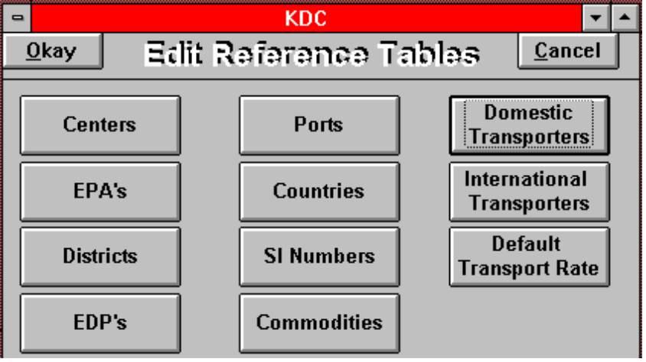

Lets start with the easy ones first, so from right to left:

Domestic Transporters:
Click on this button to get a window into the Domestic Transporter Reference Table:
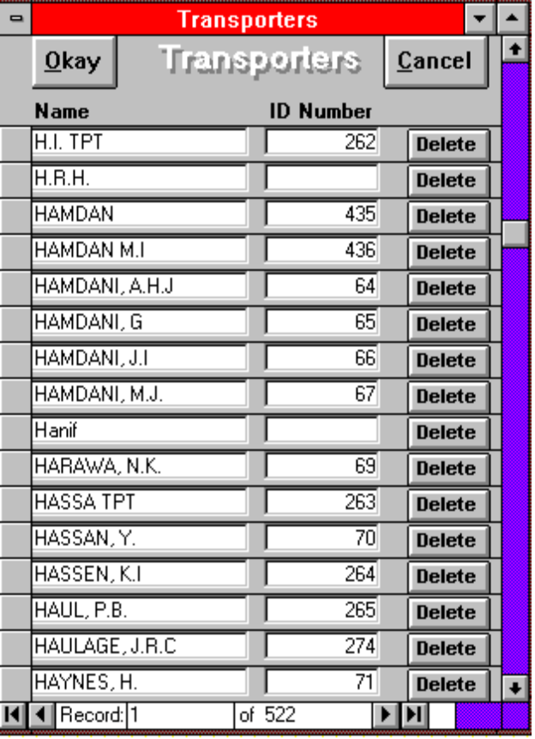
You may note the difficult choice facing the data entry clerk who finds the name “Hamdani” scrawled on the waybill. Note also the number of records in the transporter database. You will see there is a field for transporter ID number. Someday this field might be used to resolve such ambiguities, but the ATC/Waybill entry procedures must be changed first to incorporate this feature.
When you first open this Transporter screen, it will come up with a single, blank entry. Don’t worry; that’s okay -- you haven’t accidentally deleted the whole Transporter list. Unfortunately, it’s far more common to add a new transporter to the list than to take one off, and because the list is so long it would take forever to scroll down past the last entry, which is where new entries are made. So as a convenience to the user, this screen opens by default on a new record.

International Transporters:

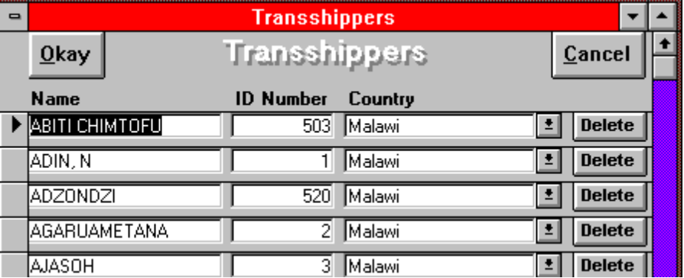
International transporters are called here Transshippers to distinguish them from domestic transporters. Transshippers are those who carry the goods from the foreign port into the country. You will see that this form is much as above, only here there is an additional country field which is meant to indicate the transporter’s country of origin. Note that the country of origin for all the transshippers shown here is Malawi. That is either odd or a data entry problem. It’s your job as Sys Admin to figure out which.

Default Transport Rate:
This is the transport rate in Kwacha / (Km * Tons) that is filled in automatically in the ATC entry form for new records. Changing this rate here does not change the rate that is stored in ATC’s that have already been entered.

Ports:

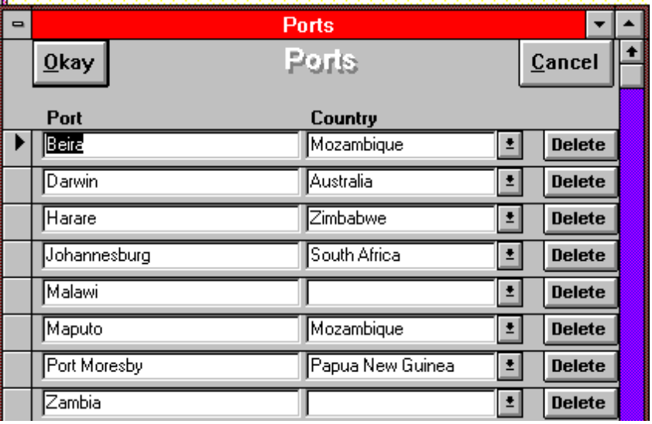

This is a list of foreign ports of lading used in the Incoming Shipments entry. The only input is Port and Country. It seems simple enough -- almost self explanatory. But you can see in this short list that Zambia is listed as a port and not a country, and since this system is currently located in Malawi, Malawi wouldn’t seem to qualify as a foreign port. But then again, maybe it does -- if Malawi is the source of some of its own relief Maize. It’s the job of the System Administrator to investigate these questions.

Countries:
A list of the countries. It is used in the SI table to make sure donors are identified uniformly -- so that you can report, for instance, on the total donations from the US for all SI’s. If the donor name were not linked to a data table, three different SI, all from America, might be entered in the computer as from 3 different countries -- one from the US, one from USA, and one from America. By forcing a reference to the country table, we ensure that each country is represented in only one way, which allows for aggregate reports.

SI Numbers:

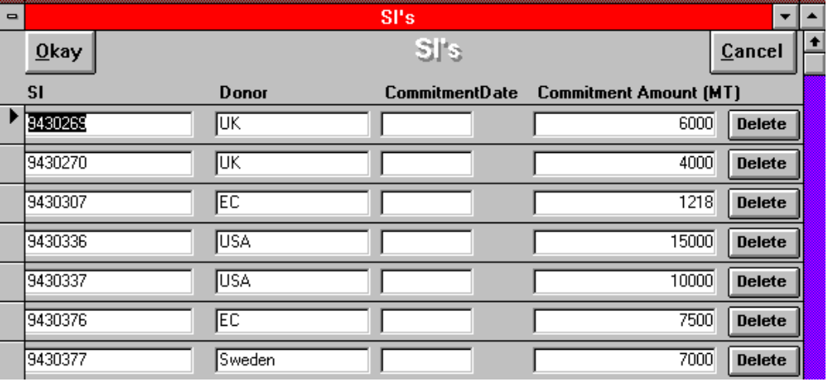

The SI table tracks SI’s by donor, commitment date, and commitment amount. Commitment date is not always available, but commitment amount should be included to estimate how much more grain can be expected in on a given SI.

Commodities:
A list of the commodities that will appear as commodity choices on the waybill entry.

EDP’s, Districts, EPA’s and Centers:
These will be a nightmare for you initially. In concept, it’s quite simple -- it’s a simple inverted tree structure, with the Malawi as the trunk. It has three main branches -- the EDP’s. Each EDP has several smaller branches, the Districts. The districts themselves are divided into EPA’s, which then have Centers as their twigs So to enter a new district, you must first select which EDP it is in. To find or modify and existing District entry, you must get to it by starting from the EDP. This is why you have to select the EDP first when you click on the Districts button.
To enter a new EPA, you must first determine which district it lies in. But to find the district, you must first identify the EDP. So to enter a new EPA, you have to choose first the EDP, which then allows you to choose one of the districts within that EDP you have chosen, which then allows you to enter a new EPA into that district, or to find and modify an existing one.
Each EPA contains a number of Distribution Centers. To add a new distribution center to the list, you have to first go through the whole selection process of EDP, District, EPA and Center. This is especially important with distribution centers, as there are about 500 of them around the country, and there are several centers in different districts with the same name. So the only way to distinguish between them is by the district and EPA they lie in.
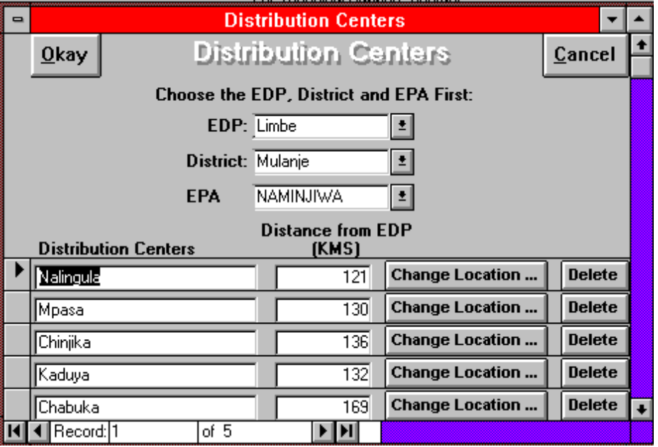

The Distribution Centers Entry screen has two features not found in the others -- the standard distance to the center, and the Change Location button. The standard distance is the agreed upon mileage between the EDP and the center.
The Change Location button opens another screen, which allows you to reallocate one center to a different location -- if EPA boundaries are redrawn, or, more likely, if a center was entered into the wrong EPA.
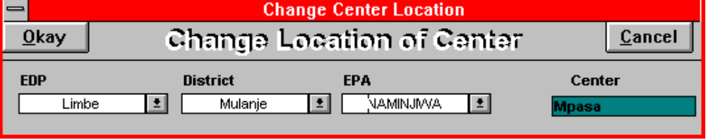
Again, a simple enough idea -- if the Mpasa Distribution Center belongs in another EPA, select that other EPA (by changing EDP and District as well if you have to) and click Okay. Your center will now be found in the new EPA selected.
This Change Location button should also be implemented to move the EPA’s from one district to another, and for the districts to move from one EDP to another. This is especially important if WFP adds a new EDP in the middle of an uplift and wants to shift a number of districts there. Unfortunately, the project ran out of time and money long, long before this feature could be implemented.

Routine Maintenance and Backup:
Routine maintenance of course includes the maintenance and verification of data as described above, but also includes additional aspects which must be performed on a regular basis.

Data Compaction:
The file containing the Ramses data (emuatbls.mdb) will grow with time. Some of that growth is the inevitable consequence of data accrual. Much of the growth, however, is just wasted space, and the result of records that are deleted or moved. This wasted space can be recovered, but it must be done manually, outside of Ramses.
The best way to do this is to create a new Icon / Program in the KDC windows group. To do this, do the following:
- Select and open the KDC windows group.
- In the Program Manager menu, click on FILE/NEW
- When the “New Program Object” dialog box pops up, select “Program Item” and click “Okay”.
- When the “Program Item Properties” dialog box appears, fill in the fields as follows:
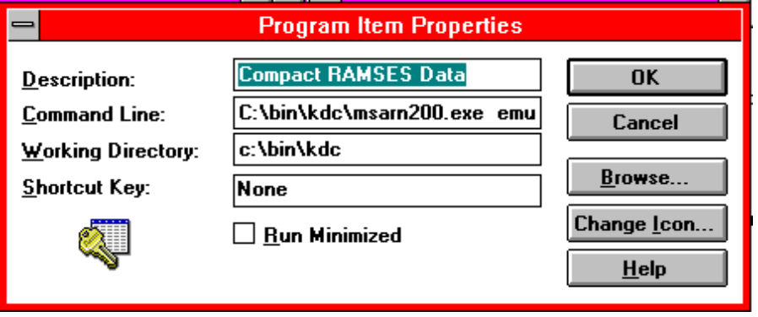
The full text for the command line is:
C:\bin\kdc\msarn200.exe emuatbls.mdb /compact emuatbls.mdb /ini c:\windows\kdc.ini
- Click “OK”
This will create the Compact RAMSES Data icon in the KDC group.
This is run simply by double clicking on the icon WHILE RAMSES ITSELF IS NOT RUNNING!!! This should be done periodically, as it makes the database faster as well as more compact. It may particularly be an issue if the data file grows larger than 1.44 Megabytes, making it inconvenient to transfer by diskette. From time to time, when the file emuatbls.mdb gets large (check the size in file manager or from DOS), double click on this icon. A dialog box will pop up and ask you if you want to replace the existing emuatbls.mdb file. It’s perfectly safe to click on Yes, because of course you already backed up this file before doing anything as dangerous as this. If there is any problem with this procedure (like the power fails in the middle of it), just restore the backed up file.
Of more interest is the Compact Ramses Data icon.
When Ramses is installed from the installation disks, it will by default create the KDC windows group and two icons. The one you will use most frequently is of course the program icon to start Ramses. You may, however, have notes the presence of the icon -- the Workgroup Administrator icon. The Workgroup Administrator can be used to set up user accounts and passwords to control who has access to what components of the Ramses system. You can set it up so that some users are allowed to enter data but not modify it; others are allowed to modify but not delete, others yet can run reports but neither enter or modify data, etc. But this is probably a higher level of security than is required in this application, and is not discussed further here.

Backup:
This section does not discuss general backup procedures, which is the subject of many expensive books and specialty software packages. These procedures should be performed on a regular basis.
However, with respect to Ramses, a simple backup procedure can be used as a compliment to the standard system backups.
The entire Ramses package comprises perhaps 35 files in various directories. The only file that changes as the system is used, however, is the emuatbls.mdb file. That means that to be able to restore a full and up to date Ramses system on another machine, you need only a copy of the original set of installation disks, and the latest copy of the file emuatbls.mdb. You install the original Ramses system, then in the installation directory (hopefully c:\bin\kdc) you copy the most recent version of emuatbls.mdb on top of the original installed version.
If you are doing this in windows, you will be asked if you are sure you want to replace the old version with the new. The answer is yes.
So to be sure you can restore Ramses and its data at any time, you need only to copy the emuatbls.mdb file from the Ramses (c:\bin\kdc) directory onto a floppy disk once a day, or at least once a week.
Remember, backups are never needed -- until they are needed.

APPENDIX Sample Reports:
Recall that reports are customized by the user at the time they are created. Thus, the first report, By Area, lists distribution totals only down to the level of EPA, while the report by SI details distributions down to the individual truck load. The user could just as easily have done it the other way around, or by district, or for all SI’s, or for just one month, or for the whole emergency period, etc.

Figure 1 Report: By Area
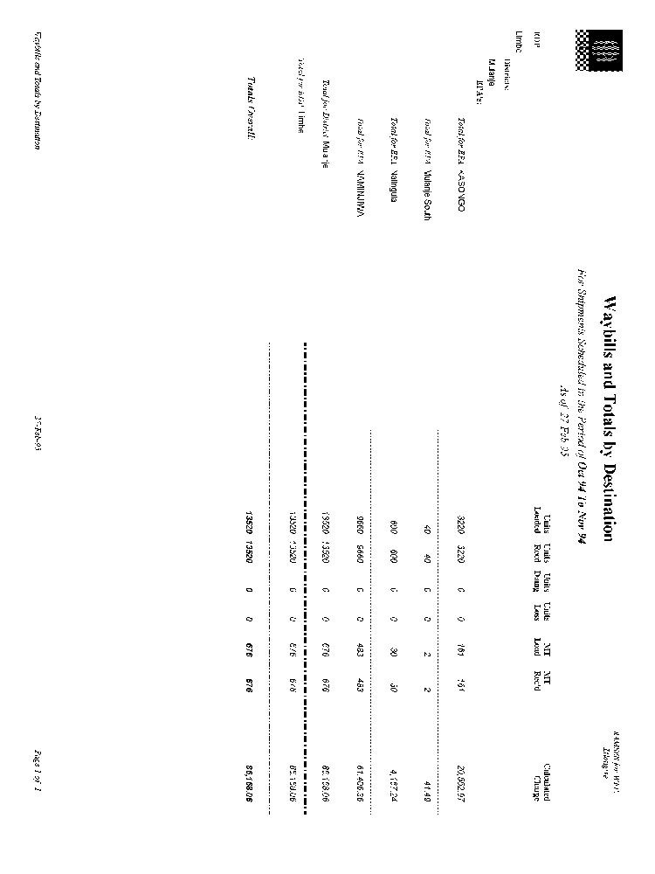

Figure 2 Report: By SI
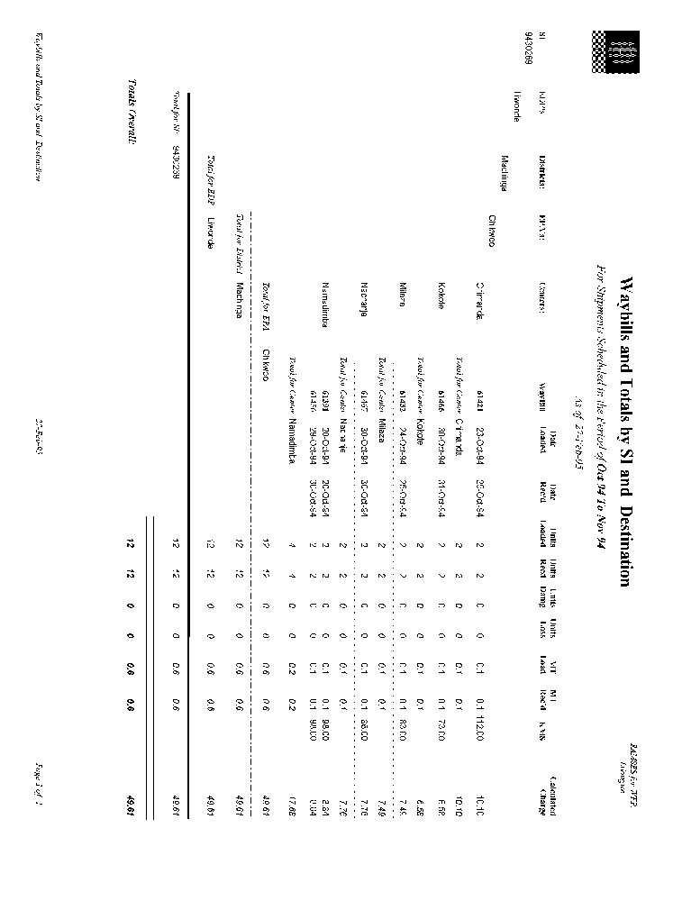

Figure 3 Report: External to EPA by SI
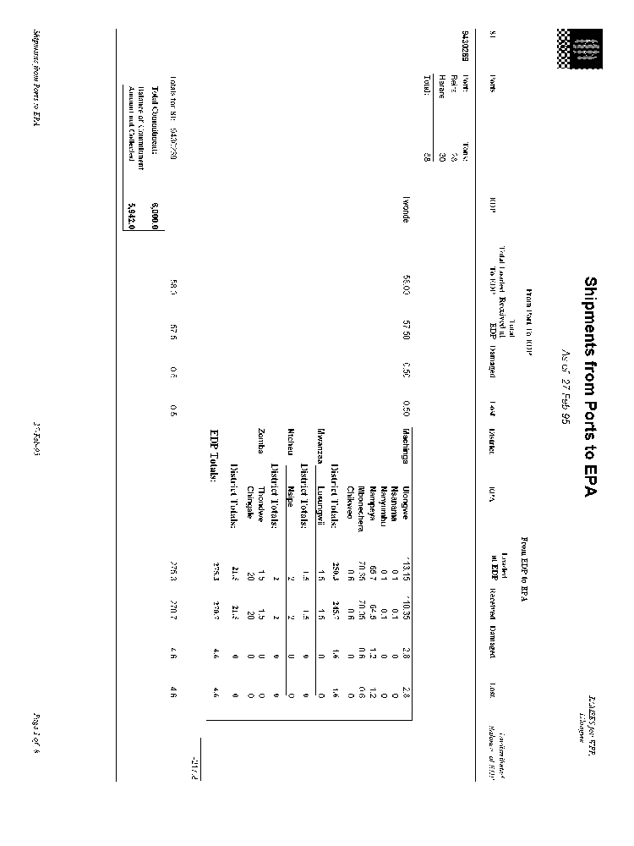

Figure 4 Report: Balances in EDP's
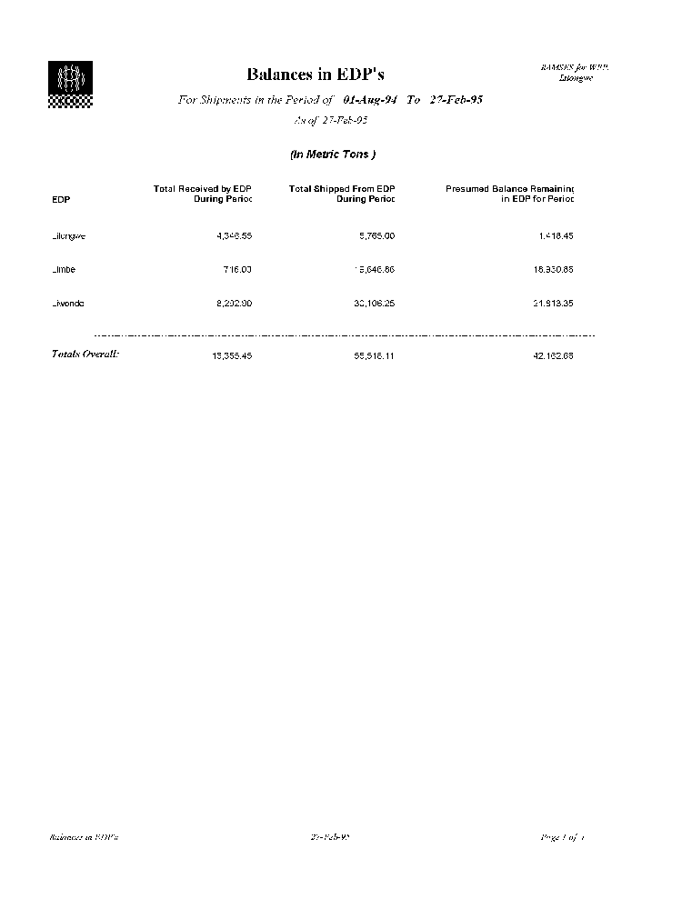

Figure 5 Report: Transport and Storage Costs
