**Lab: Band in a Box**

1. In this lab, you will create a program that takes a simple musical melody and transforms it into a complete arrangement for a three-piece band. (Don’t worry if you can’t read music!)  
     
   **Explanation of the note class**: A note is represented by a pitch: a character from ‘a’ to ‘g’, and an integer denoting an octave:  
     
   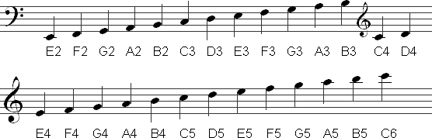  
     
   Explanation of the instrument class: This class has only a method, called play(), which takes an arraylist of notes as an argument. The arraylist of notes represents the sequential notes of a melody (assume each note is an eighth note if that means something to you). This function is designed to take the melody, and depending on the instrument type, return an appropriate set of notes for that instrument to play.  
     
   This class also has getVolume() and getInstrumentNumber(), which can be overridden, along with a setter/getter for the name of the instrument.
2. Write code for the play() method in the guitar class. The function should print the word “Guitar:”, then “play” (by printing to the screen) every note of the melody.  
     
   Example of what would be printed:  
   Guitar:

c4 c4 d4 e4 c4 e4 d4 g3 c4 c4 d4 e4 c4 c4 b3 b3 c4 c4 d4 e4 f4 e4 d4 c4 b4 g3 a3 b3 c4 c4 c4 c4

1. Following the guitar example, create a bass class that inherits from guitar. The play method for the bass should only play every fourth note and skip the others (replace them with nulls), and play the notes one octave lower than the melody (just subtract 1 from the octaves). This simulates playing on first and fifth beats of every measure only. Here’s what the bass looks like alongside the guitar:  
     
   Guitar:

c4 c4 d4 e4 c4 e4 d4 g3 c4 c4 d4 e4 c4 c4 b3 b3 c4 c4 d4 e4 f4 e4 d4 c4 b4 g3 a3 b3 c4 c4 c4 c4

Bass:

c3 c3 c3 c3 c3 f3 b3 c3

1. Next, your annoying sibling shows up and wants to join your band. They play violin, but can only play the notes corresponding to the pitches of the four strings on the violin, which are G, D, A, and E. Write a violin class where the play method only plays G’s, D’s, A’s and E’s, and skips all other notes. Alongside guitar and bass, here’s what your band looks like now:  
     
   Guitar:

c4 c4 d4 e4 c4 e4 d4 g3 c4 c4 d4 e4 c4 c4 b3 b3 c4 c4 d4 e4 f4 e4 d4 c4 b4 g3 a3 b3 c4 c4 c4 c4

Bass:

c3 c3 c3 c3 c3 f3 b3 c3

Violin:

d4 e4 e4 d4 g3 d4 e4 d4 e4 e4 d4 g3 a3